Supplementary Notes on the Figure 1 (Flowchart):
The PREVENT calculator be used for primary prevention patients (those without atherosclerotic cardiovascular disease or heart failure) only. This calculator includes both a full model and a basic model. Due to the unavailability of some required variables in NHANES, we adopted the basic model in this study. The basic model comprises nine factors: sex, age, total cholesterol, high-density lipoprotein cholesterol, systolic blood pressure (SBP), body mass index (BMI), estimated glomerular filtration rate (eGFR), diabetes status, current smoking status, and use of antihypertensive and lipid-lowering medications. For the continuous variables, the developers of the PREVENT equation defined a validated range for application. Individuals whose risk factor values fall outside these validated ranges should undergo individualized assessment and management. Therefore, participants with values outside the following validated ranges were excluded from the present study: age 30–79 years, total cholesterol 130–320 mg/dL, HDL cholesterol 20–100 mg/dL, SBP 90–180 mmHg, BMI 18.5–39.9 kg/m², and eGFR 15–140 mL/min/1.73 m². The blood pressure value used for the PREVENT equation calculation was determined by averaging the three measurements obtained during the examination.
History of cardiovascular disease (including heart failure, coronary heart disease, and stroke), hypertension, and medication use was identified based on self-reported questionnaires. Diabetes was defined by a self-reported diagnosis, use of insulin or antidiabetic medications, or meeting one of the following criteria: HbA1c ≥ 6.5% or fasting plasma glucose ≥ 126 mg/dL.
Alcohol consumption data were obtained from two 24-hour dietary recall interviews. Physical activity level was assessed based on self-reported engagement in vigorous activities (e.g., running, basketball, or similar fitness/sports activities) and moderate activities (e.g., brisk walking, regular swimming, or cycling).
Due to the absence of HCV antibody data in the 2015–2016 cycle, HCV RNA results were used as a substitute.

Supplementary Figure 1:

Based on the PREVENT calculator, the prevalence of 10-year estimated CVD risk in hypertensive adults, stratified by median BMI values (<30.39 vs. ≥30.29 kg/m²) and the presence or absence of hepatic steatosis with or without concomitant significant fibrosis. P-values were tested by the chi-squared test.
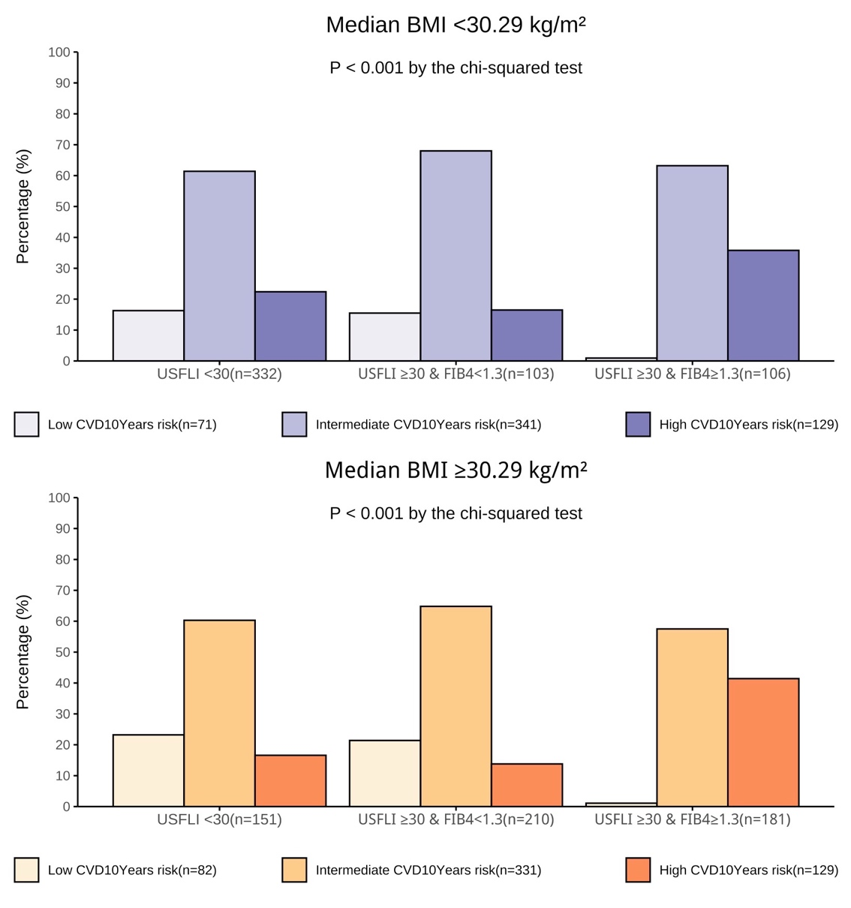
Supplementary Figure 2:
Based on the PREVENT calculator, the prevalence of 10-year estimated CVD risk in hypertensive adults, stratified by median age (<63 vs. ≥63 years) and the presence or absence of hepatic steatosis with or without concomitant significant fibrosis. P-values were tested by the chi-squared test.

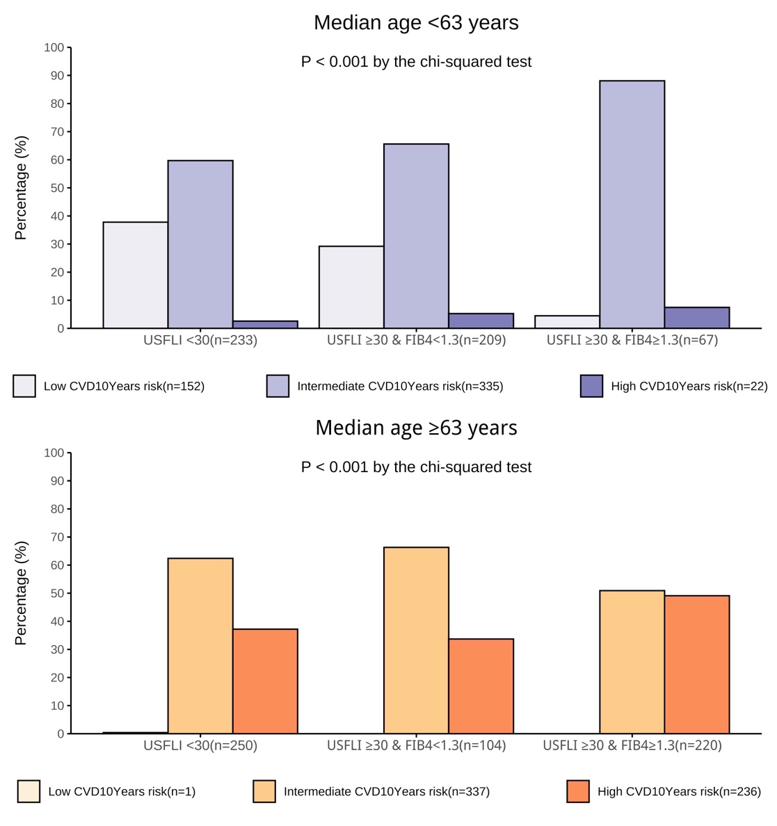
Supplementary Figure 3:
Based on the PREVENT calculator, the prevalence of 10-year estimated CVD risk in hypertensive adults, stratified by sex (men vs. women) and the presence or absence of hepatic steatosis with or without concomitant significant fibrosis. P-values were tested by the chi-squared test.

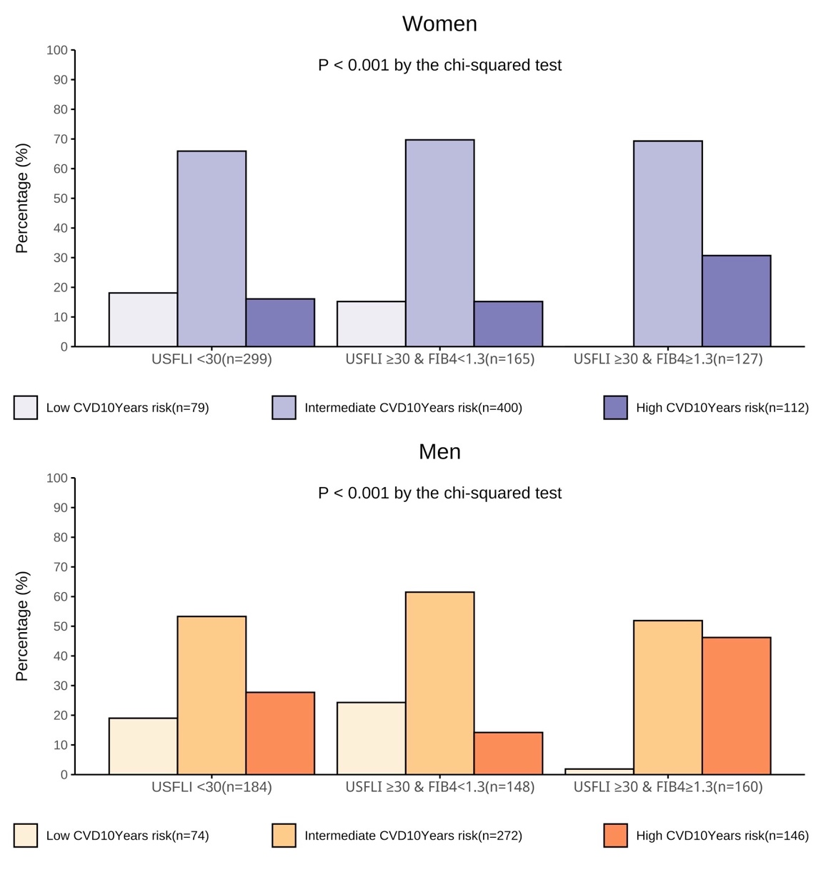
Supplementary Table 1.
Association between hepatic steatosis with or without coexisting significant fibrosis and the 10-year estimated CVD risk. In these logistic regression models, we excluded patients with missing serum HCV antibody data (for whom HCV RNA data were used as a substitute) (i.e., participants from 2015-2016).

Logistic Regression Analyses | OR (95% CI) | P-value
Y = High or moderate risk vs.
Low risk score
Unadjusted model
USFLI<30 | Ref. | -
USFLI>=30 & FIB_4<1.3 | 0.82(0.45, 1.50) | 0.514
USFLI>=30 & FIB_4>=1.3 | 9.85(2.48, 39.1) | <0.001
Adjusted model
USFLI<30 | Ref.
USFLI>=30 & FIB_4<1.3 | 0.95(0.48, 1.86) | 0.876
USFLI>=30 & FIB_4>=1.3 | 10.1(2.47, 41.4) | <0.001
Cohort size: n = 944. Data are presented as odds ratio (OR) with 95% confidence interval (CI) and were evaluated using univariate and multivariate logistic regression analyses. The dependent variable in the logistic regression model was defined as membership in the combined moderate/high CVD risk group vs the low CVD risk group. The regression models were adjusted for sex, educational level, race/ethnicity, marital status, physical activity level, PIR, and the presence of CKD, defined as an eGFR < 60 mL/min/1.73 m² or abnormal albuminuria.

Supplementary Table 2.
Association between hepatic steatosis with or without coexisting significant fibrosis and the 10-year estimated CVD risk. In these logistic regression models, we excluded patients with missing covariate data from the final dataset.
Logistic Regression Analyses | OR (95% CI) | P-value
Y = High or moderate risk vs.
Low risk score
Unadjusted model
USFLI<30 | Ref. | -
USFLI>=30 & FIB_4<1.3 | 0.87(0.46, 1.63) | 0.659
USFLI>=30 & FIB_4>=1.3 | 11.8(2.96, 47.1) | <0.001
Adjusted model
USFLI<30 | Ref.
USFLI>=30 & FIB_4<1.3 | 0.99(0.50, 1.97) | 0.973
USFLI>=30 & FIB_4>=1.3 | 11.7(2.89, 47.6) | <0.001
Cohort size: n = 961. Data are presented as odds ratio (OR) with 95% confidence interval (CI) and were evaluated using univariate and multivariate logistic regression analyses. The dependent variable in the logistic regression model was defined as membership in the combined moderate/high CVD risk group vs the low CVD risk group. The regression models were adjusted for sex, educational level, race/ethnicity, marital status, physical activity level, PIR, and the presence of CKD, defined as an eGFR < 60 mL/min/1.73 m² or abnormal albuminuria.

