Supporting information Appendix S1
Navigating multi-predator dynamic risk landscapes in anthropogenic environments: spatio-temporal plasticity in roe deer habitat selection

Contents Supporting information Appendix S1
- Table S1 Study site description
- Table S2: Information on nr of steps per month and study site
- Figure S1: Study sites hunting seasons separated by females and males
- Figure S2: Step length and turning angle distribution
- Table S3: Model outputs for diel and seasonal models
- Figure S3: Boxplot of individual random effects per study site
- Figures S4: Model results for sensitivity analyses

- Table S1: Study site descriptions
HFI: Human footprint index (Venter et al. 2016), NDVI: Normalized difference vegetation index (Pettorelli et al. 2005). Prop. Forest: proportion of forest in each study site estimated by the proportion of random steps located in forest (see Methods for more details). Legend: ‘*’ denotes sites where drive hunts with dogs occur (Elsewhere: sit-and-wait hunting); ‘§’ denotes sites with wolf presence; ‘°’ denotes reintroduced populations
Study site | Nr animals | Nr steps | Mean Location | Mean altitude | Prop. Forest | Mean HFI | Mean NDVI | Hunt  Ing | Lynx | Scena  rio
Brandenburg (DE) | 4 | 9746 | ( 12.485305 , 52.223412 ) | 98 | 0.87 | 6 | 6661 | 1 | 0 | 0, 1
Bialowieza NP (PL) | 5 | 2761 | ( 23.468192 , 52.683928 ) | 130 | 0.71 | 11 | 4874 | 1 | 1§ | 2, 3
Kaloe (DK) | 5 | 63801 | ( 10.478974 , 56.289928 ) | 29 | 0.17 | 19 | 5405 | 1* | 0 | 0, 1
Montemuro (PT)° | 5 | 79496 | ( -7.86285 , 40.938433 ) | 846 | 0.15 | 11 | 6153 | 0 | 0§ | 0
Hegau (DE) | 7 | 25585 | ( 8.727174 , 47.884143 ) | 772 | 0.51 | 19 | 5455 | 1* | 0 | 0, 1
Chize (FR) | 8 | 10681 | ( -0.429731 , 46.117316 ) | 83 | 0.3 | 6 | 6944 | 0 | 0 | 0
Matese(IT)° | 8 | 57998 | ( 14.257249 , 41.462717 ) | 1000 | 0.72 | 12 | 5864 | 0 | 0 | 0
Aspromonte (IT)° | 10 | 52058 | ( 15.917424 , 38.206289 ) | 1149 | 0.78 | 10 | 6374 | 0 | 0§ | 0
Trois Fontaines (FR) | 10 | 14597 | ( 4.916661 , 48.702951 ) | 181 | 0.6 | 7 | 6673 | 1 | 0 | 0, 1
Grimso (SE) | 12 | 68486 | ( 15.445529 , 59.683848 ) | 120 | 0.91 | 7 | 3420 | 1 | 1 | 2, 3
Arada (PT)° | 19 | 188848 | ( -8.190757 , 40.849826 ) | 950 | 0.43 | 4 | 6476 | 0 | 0§ | 0
Koberg (SE) | 24 | 87434 | ( 12.429397 , 58.153109 ) | 94 | 0.76 | 12 | 3280 | 1 | 1§ | 2, 3
Rhine Valley (DE) | 27 | 152865 | ( 7.953578 , 48.594346 ) | 139 | 0.36 | 21 | 5435 | 1* | 0 | 0, 1
Cembra (IT) | 34 | 1431304 | ( 11.179565 , 46.123256 ) | 838 | 0.89 | 23 | 6457 | 1 | 0 | 0, 1
Bavarian Forest NP (DE) | 67 | 480569 | ( 13.345103 , 48.940369 ) | 769 | 0.81 | 12 | 4193 | 1 | 1 | 2, 3
Bernese Oberland(CH) | 69 | 3035809 | ( 7.54569 , 46.580196 ) | 1051 | 0.4 | 20 | 4307 | 1* | 1 | 2, 3
Aurignac (FR) | 98 | 128909 | ( 0.884582 , 43.28619 ) | 317 | 0.14 | 10 | 6714 | 1* | 0 | 0, 1

- Table S2: Information on nr of steps per month and study site
Study site | Nr anim. | Nr steps | Jan | Feb | Sep | Oct | Nov | Dec
Aurignac – France | 98 | 128909 | 352 | 19250 | 45331 | 45540 | 9537 | 8899
Bernese Oberland - Switzerland | 69 | 3035809 | 505477 | 549506 | 534136 | 510630 | 448909 | 487151
Bavarian Forest National Park - Germany | 67 | 480569 | 119198 | 135669 | 56039 | 39311 | 51817 | 78535
Cembra – Italy | 34 | 1431304 | 244198 | 303281 | 226402 | 218691 | 196867 | 241865
Rhine Valley - Germany | 27 | 152865 | 23264 | 18260 | 28028 | 27411 | 26411 | 29491
Koberg – Sweden | 24 | 87434 | 24167 | 40326 | 0 | 2640 | 2299 | 18002
Arada – Portugal | 19 | 188848 | 21175 | 0 | 0 | 0 | 63173 | 104500
Grimso – Sweden | 12 | 68486 | 34903 | 18678 | 0 | 0 | 0 | 14905
Trois Fontaines - France | 10 | 14597 | 715 | 572 | 4741 | 4400 | 880 | 3289
Aspromonte – Italy | 10 | 52058 | 0 | 23700 | 0 | 0 | 15213 | 13145
Chize – France | 8 | 10681 | 231 | 0 | 3080 | 3256 | 2123 | 1991
Matese – Italy | 8 | 57998 | 0 | 0 | 0 | 1914 | 33154 | 22930
Hegau – Germany | 7 | 25585 | 6996 | 6226 | 3189 | 2937 | 1496 | 4741
Bialowieza National Park - Poland | 5 | 2761 | 462 | 2299 | 0 | 0 | 0 | 0
Kaloe – Denmark | 5 | 63801 | 7818 | 0 | 7744 | 9062 | 21998 | 17179
Montemuro – Portugal | 5 | 79496 | 13090 | 0 | 0 | 0 | 26003 | 40403
Brandeburg - Germany | 4 | 9746 | 55 | 1254 | 0 | 0 | 5951 | 2486

- Figure S1: Study sites hunting seasons separated by females and males

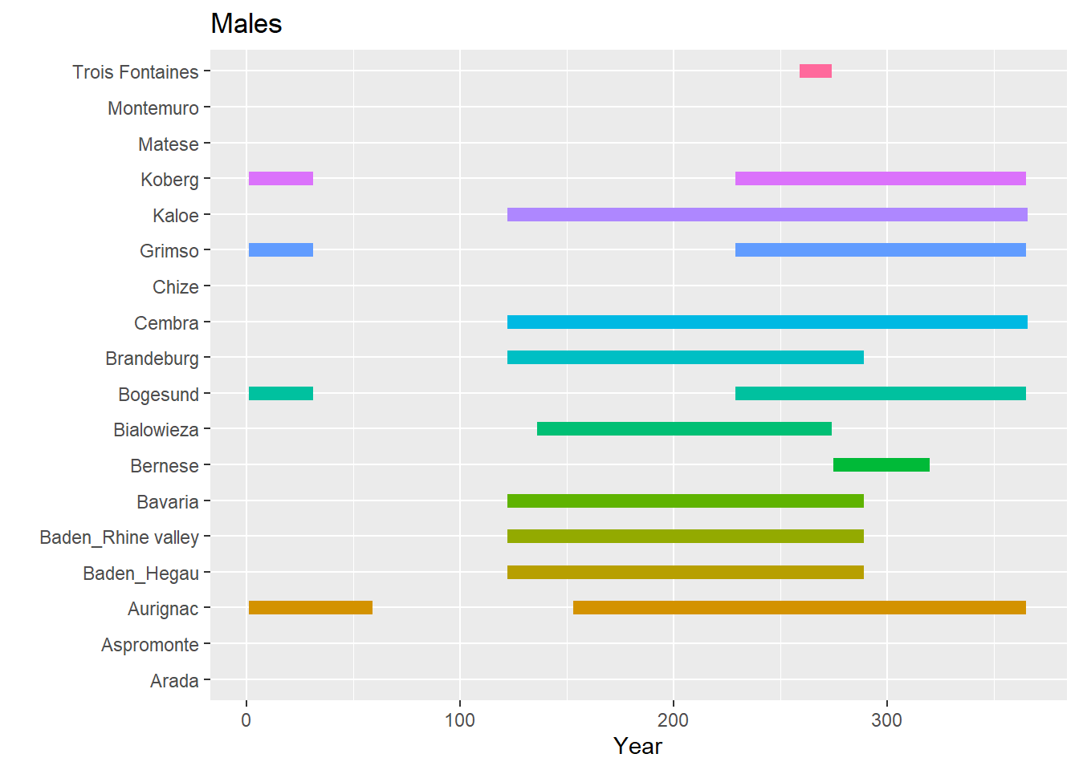
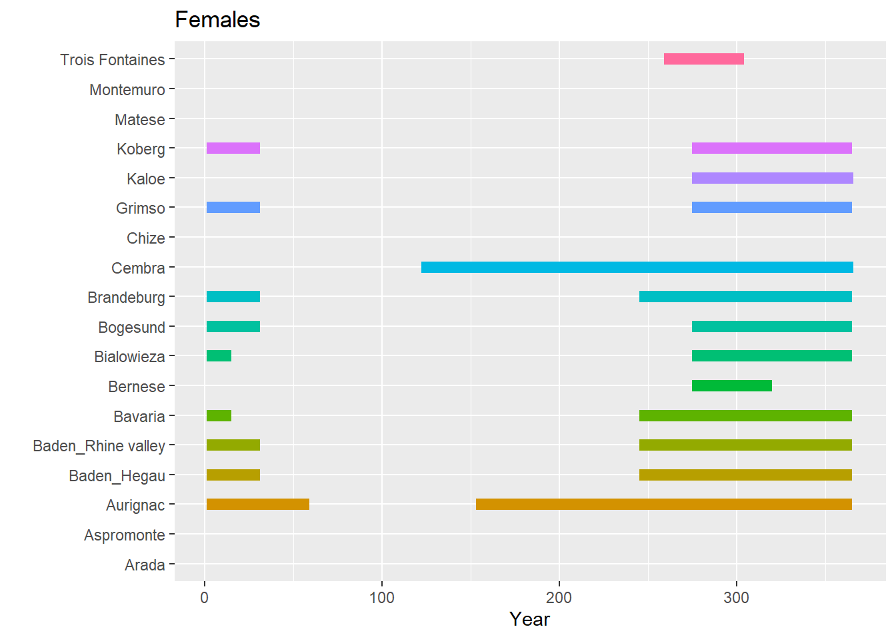
- Figure S2: Step length and turning angle distribution
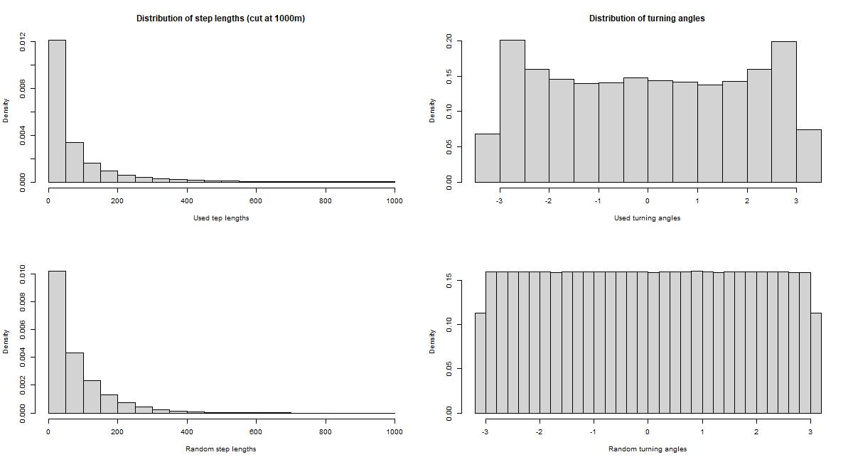

- Table S4: Model outputs
Diel models
 | Model terms | Coefficient | CI lower | CI upper
Day | Habitat | -0.567 | -0.743 | -0.391
 | Habitat:Hunting | 0.048 | -0.133 | 0.228
 | Habitat:Hunting:Lynx | -0.056 | -0.252 | 0.141
 | Habitat:Hunting:Sex | 0.138 | -0.035 | 0.312
 | Habitat:Lynx | -0.163 | -0.349 | 0.023
 | Habitat:HFI | -0.166 | -0.251 | -0.08
 | Habitat:NDVI | 0.173 | 0.117 | 0.229
 | Habitat:Sex | -0.046 | -0.212 | 0.12
 | Habitat:Season (Winter) | 0.024 | -0.083 | 0.13
 | Log step lengths | -0.083 | -0.087 | -0.78
Twilight | Habitat | -0.234 | -0.417 | -0.05
 | Habitat:Hunting | 0.035 | -0.163 | 0.232
 | Habitat:Hunting:Lynx | 0.014 | -0.202 | 0.23
 | Habitat:Hunting:Sex | -0.009 | -0.19 | 0.173
 | Habitat:Lynx | 0.071 | -0.121 | 0.264
 | Habitat:HFI | -0.081 | -0.158 | -0.003
 | Habitat:NDVI | 0.244 | 0.187 | 0.301
 | Habitat:Sex | 0.071 | -0.084 | 0.227
 | Habitat:Season (Winter) | -0.081 | -0.199 | 0.037
 | Log step lengths | 0.211 | 0.203 | 0.218
Night | Habitat | 0.046 | -0.11 | 0.202
 | Habitat:Hunting | 0.094 | -0.066 | 0.255
 | Habitat:Hunting:Lynx | -0.154 | -0.33 | 0.021
 | Habitat:Hunting:Sex | 0.081 | -0.082 | 0.244
 | Habitat:Lynx | 0.226 | 0.058 | 0.394
 | Habitat:HFI | -0.001 | -0.075 | 0.074
 | Habitat:NDVI | 0.256 | 0.208 | 0.305
 | Habitat:Sex | -0.168 | -0.328 | -0.007
 | Habitat:Season (Winter) | -0.26 | -0.365 | -0.155
 | Log step lengths | -0.107 | -0.111 | -0.104

Seasonal models
 | Model terms | Coefficient | CI lower | CI upper
Fall | Habitat | 0.369 | 0.031 | 0.706
 | Habitat:Hunting | -0.169 | -0.506 | 0.168
 | Habitat:Hunting:Lynx | 0.153 | -0.192 | 0.498
 | Habitat:Hunting:Sex | 0.069 | -0.075 | 0.213
 | Habitat:Lynx | -0.055 | -0.416 | 0.306
 | Habitat:HFI | -0.091 | -0.195 | 0.013
 | Habitat:NDVI | 0.267 | 0.189 | 0.345
 | Habitat:Sex | -0.177 | -0.385 | 0.03
 | Habitat:Daytime (Day) | -0.838 | -0.958 | -0.719
 | Habitat:Daytime (Twilight) | -0.339 | -0.453 | -0.225
 | Log step lengths | -0.026 | -0.031 | -0.021
Winter | Habitat | -0.217 | -0.351 | -0.083
 | Habitat:Hunting | -0.018 | -0.164 | 0.129
 | Habitat:Hunting:Lynx | -0.004 | -0.17 | 0.163
 | Habitat:Hunting:Sex | 0.077 | -0.09 | 0.244
 | Habitat:Lynx | 0.215 | 0.056 | 0.373
 | Habitat:HFI | 0.01 | -0.067 | 0.086
 | Habitat:NDVI | 0.277 | 0.22 | 0.333
 | Habitat:Sex | -0.024 | -0.182 | 0.135
 | Habitat:Daytime (Day) | -0.379 | -0.455 | -0.304
 | Habitat:Daytime (Twilight) | -0.12 | -0.185 | -0.055
 | Log step lengths | -0.063 | -0.067 | -0.06

- Figure S3: Boxplots for the individual random components in the final models
Diel models
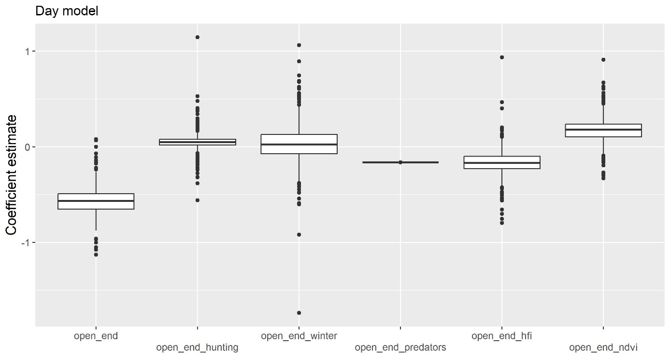

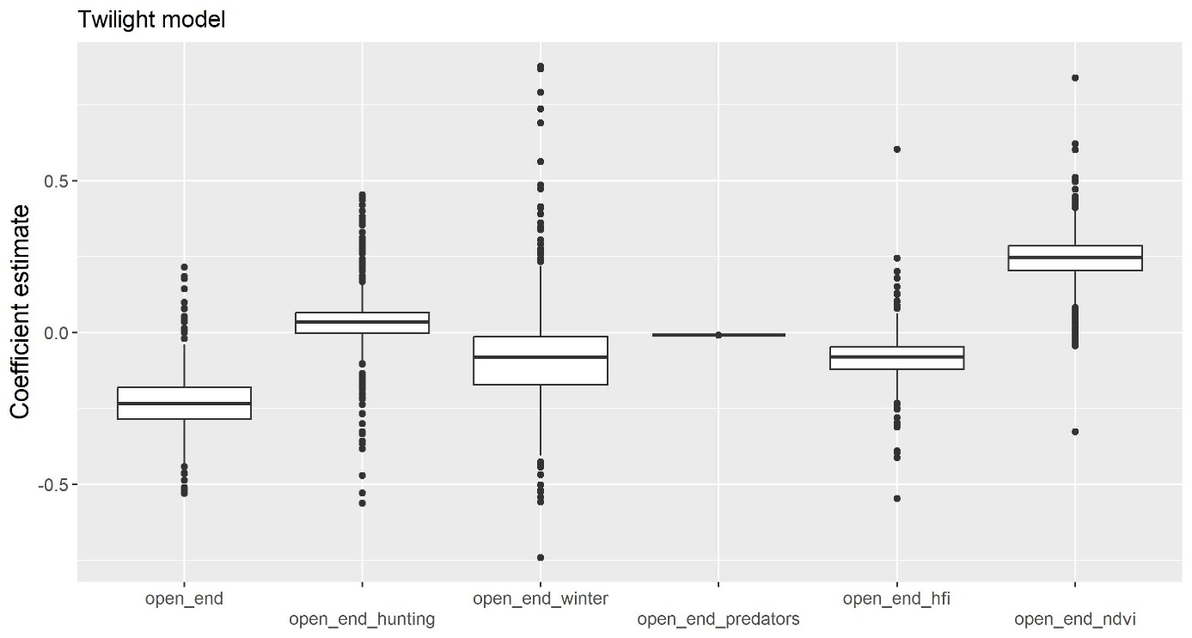

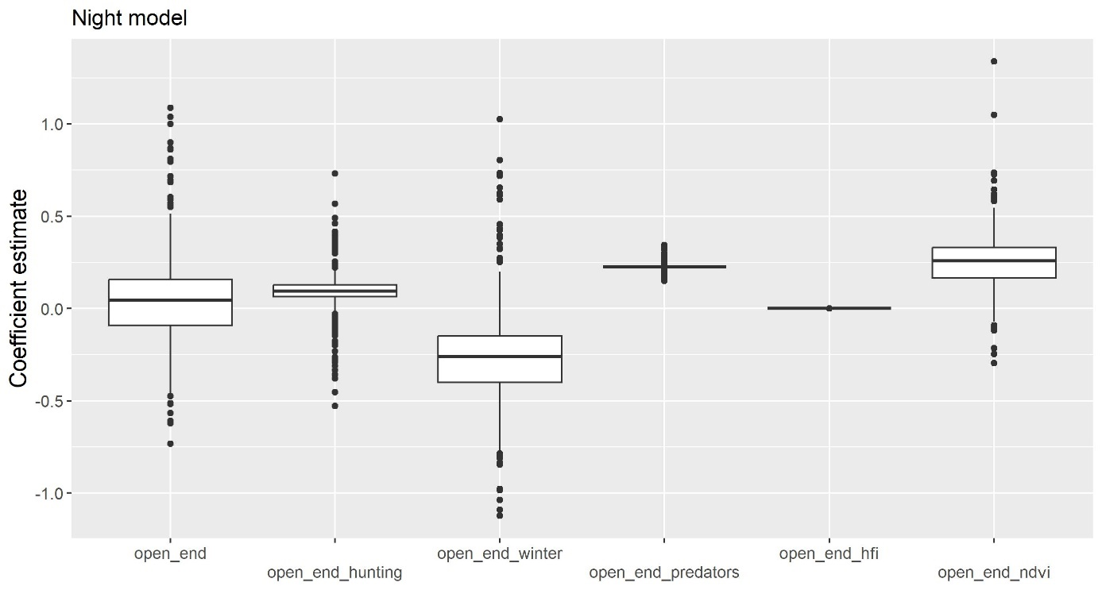

Seasonal models
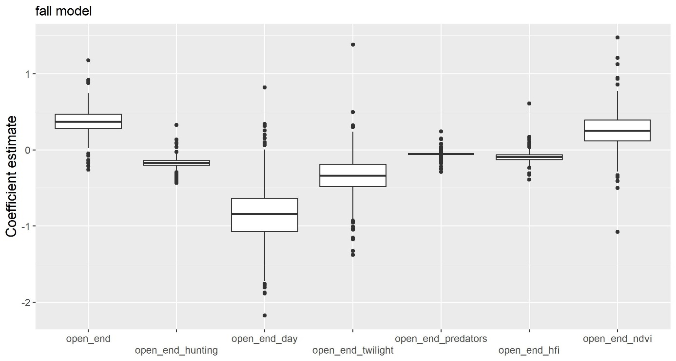

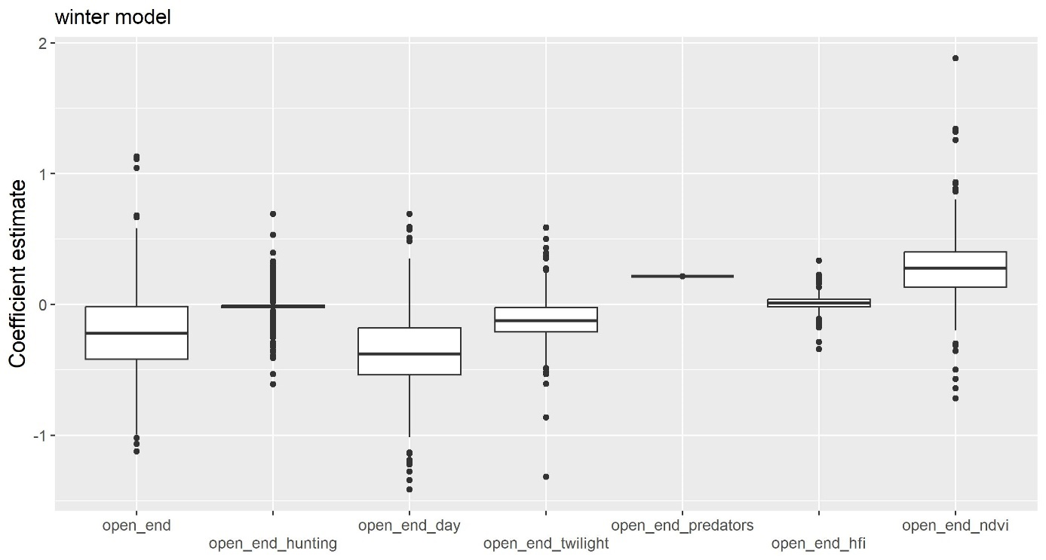

- Figures S4: Sensitivity analysis
To exclude the possibility that our findings were mainly driven by a few study sites, unbalanced data, or our choice for the tree cover density (TCD) threshold (40%) to separate open from forest habitat, we carefully tested the robustness of our findings towards input data and model specifications. We performed 8 set of diel models and 1 set of seasonal models (9 sensitivity models in total) and compared the beta coefficients for the different sensitivity models with the ones from the final models (5 models). The tested models were:
Diel models S4 A
1: final model; 2: omitting sex from the data; 3: omitting Aurignac FR (highest number of animals in the data; 4: omitting Bernese CH (highest number of steps in the data); 5: omitting study sites with introduced populations of roe deer (Arada PT, Aspromonte IT, Matese IT, Montemuro PT); 5: omitting study sites with wolves (Bialowieza NP PL, Montemuro PT, Aspromonte IT, Arada PT, Koberg SE); 6: threshold of TCD to separate open/forest at 30%; 7: threshold of TCD to separate open/forest at 50%; 8: TCD as a continuous predictor (i.e. percentage tree cover);
Note: the beta coefficients for model 8 (continuous TCD) are of opposite sign because we used forest as the reference category (i.e. we modelled selection of open habitat) for the dichotomous habitat variable (open/forest).

Habitat (forest as reference – except for continuous TCD)
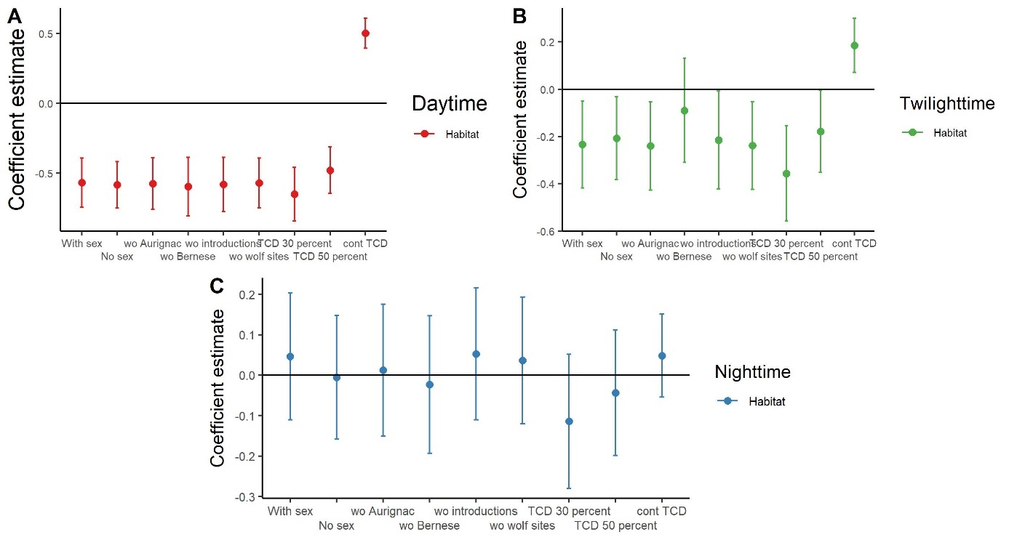

Habitat:Hunting
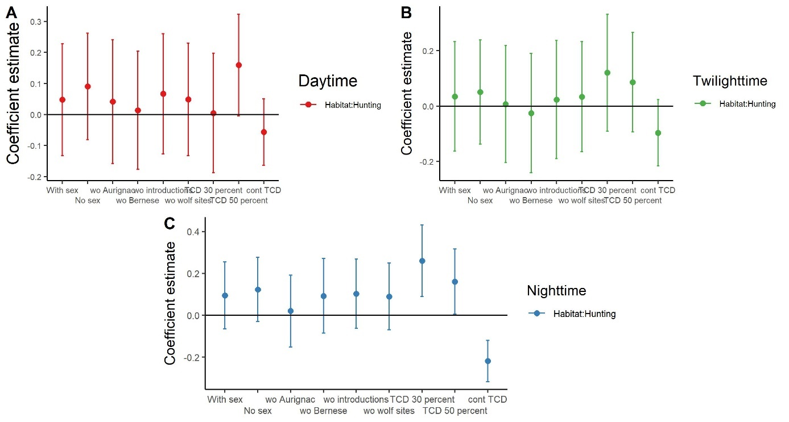

Habitat:Lynx
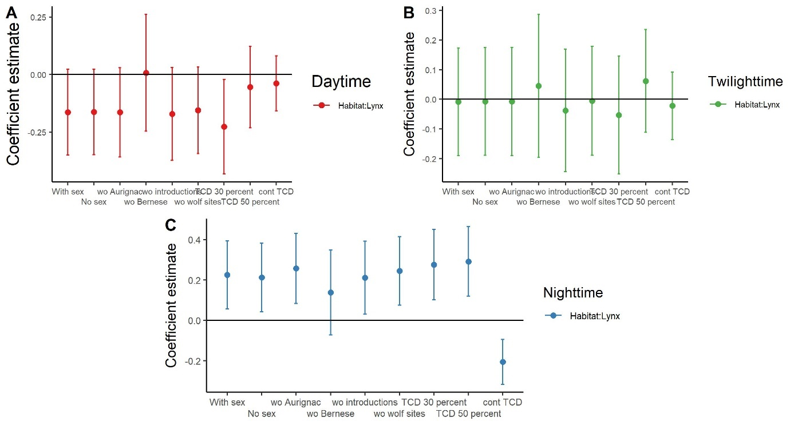

Habitat:Hunting:Lynx
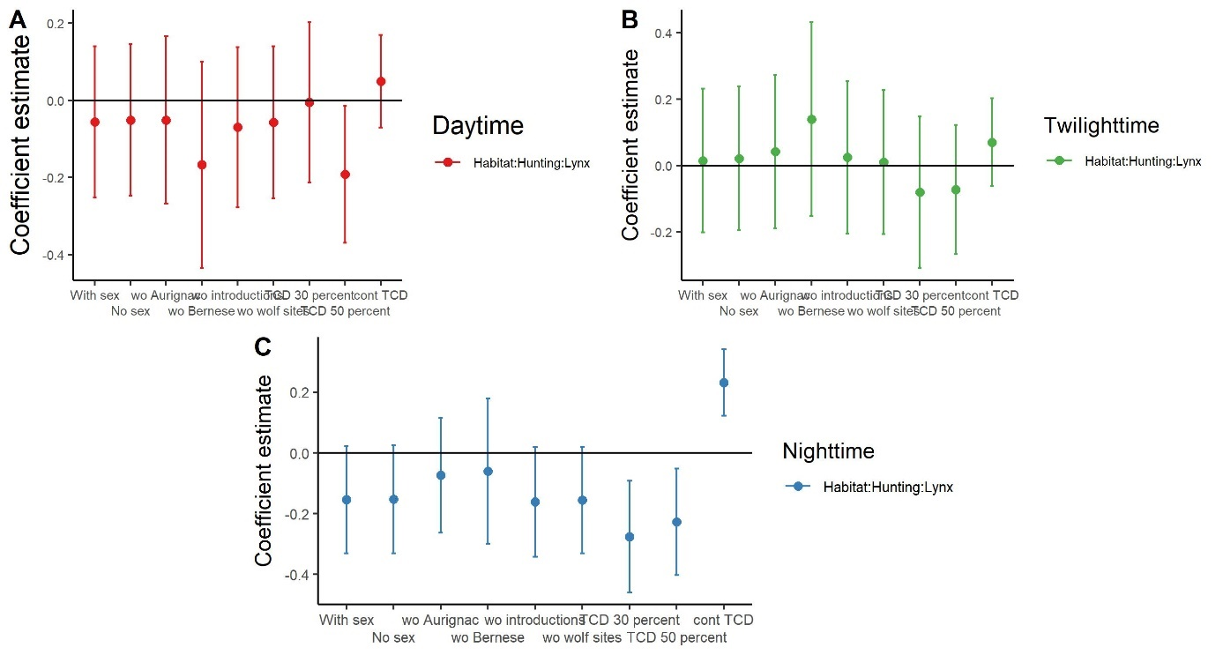

Habitat:Sex (female deer as reference category)
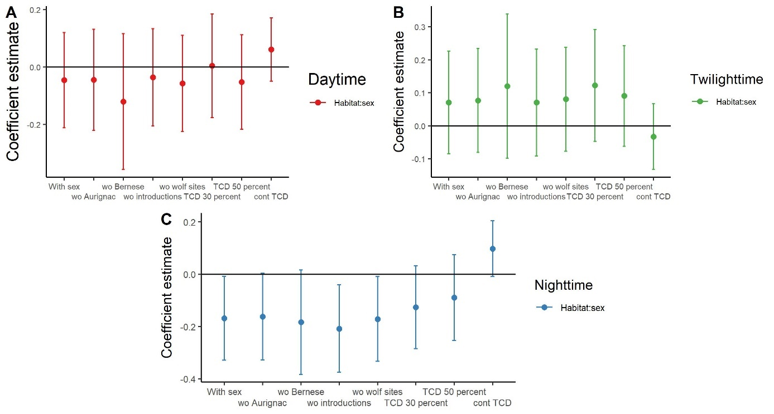

Habitat:Hunting:Sex
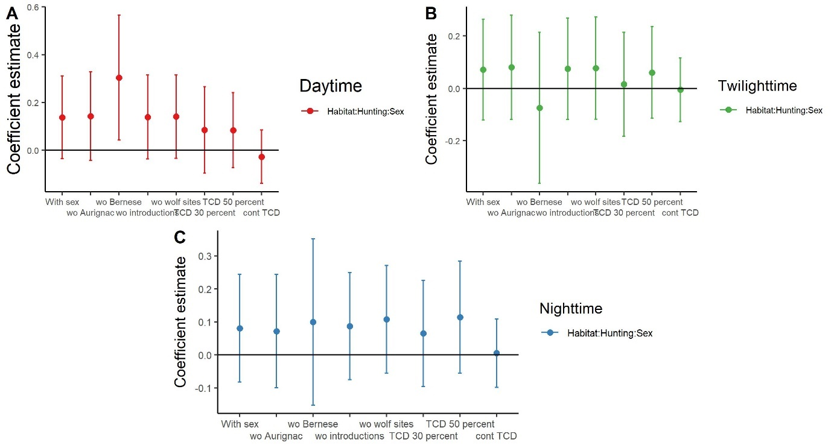

Habitat:HFI
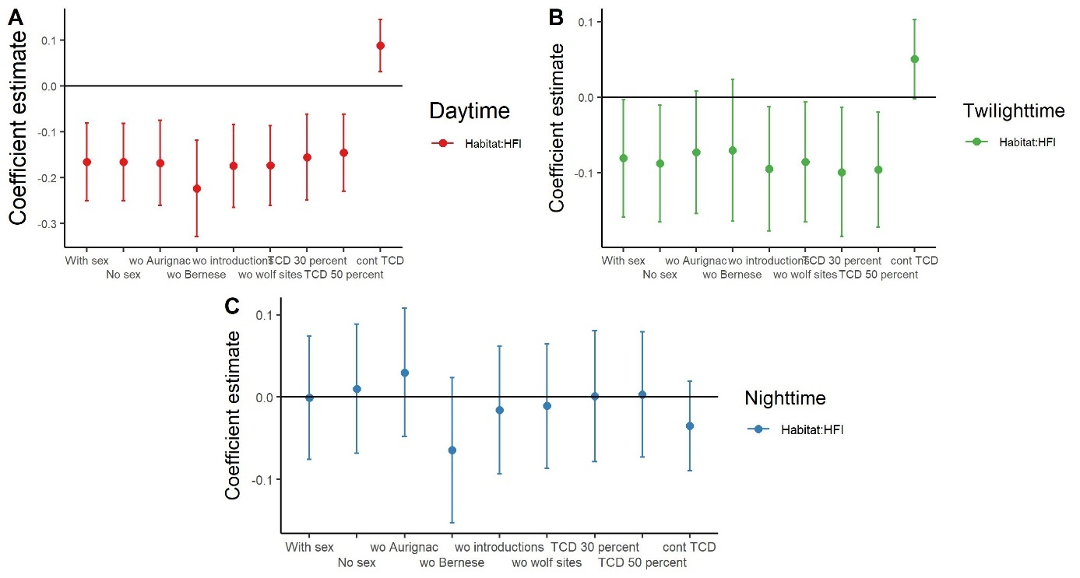

Habitat:NDVI
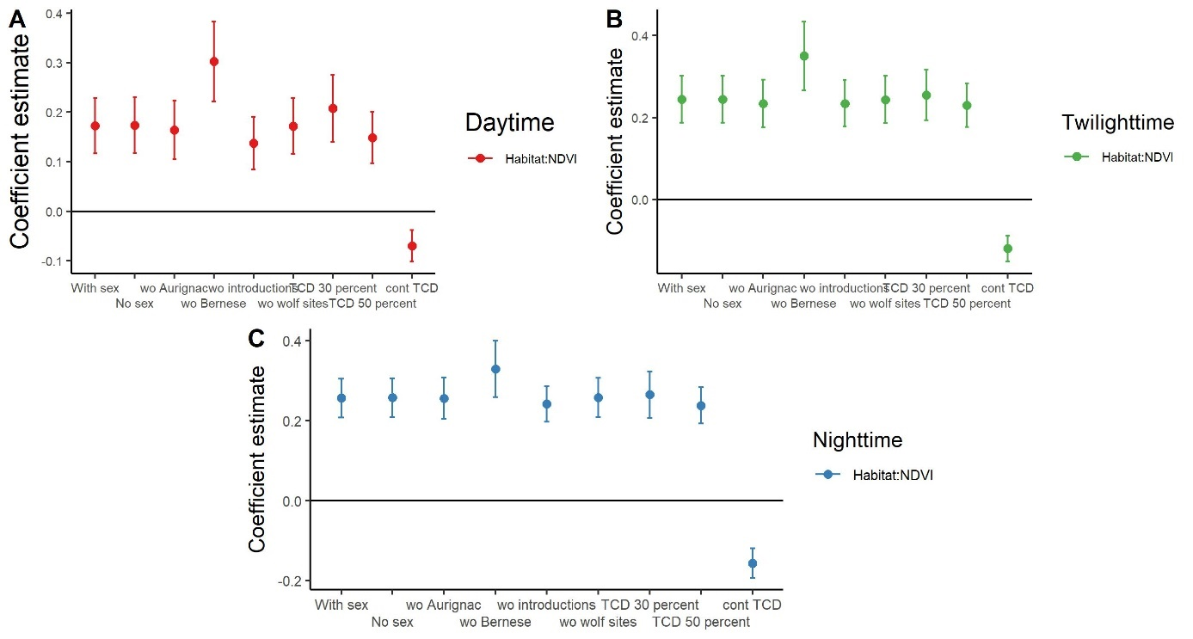

Habitat:Season
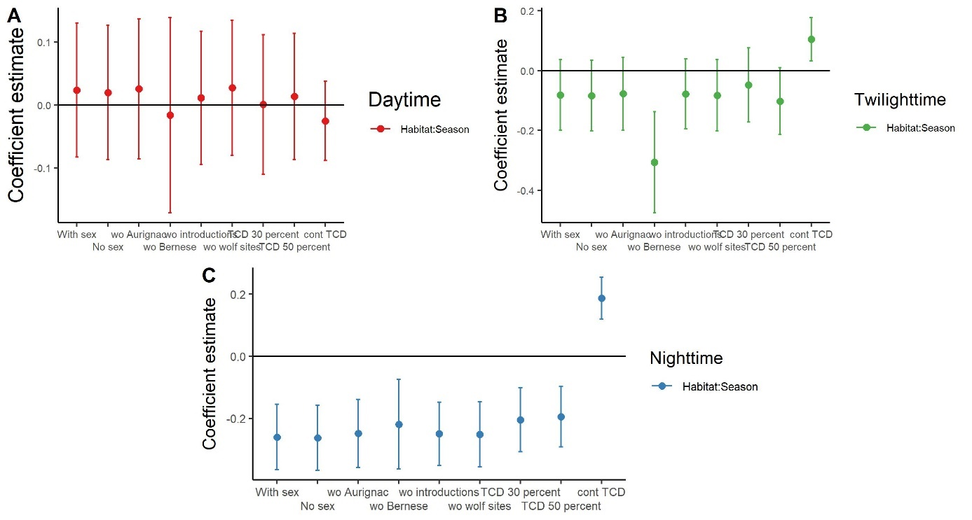

Habitat:Log step lengths
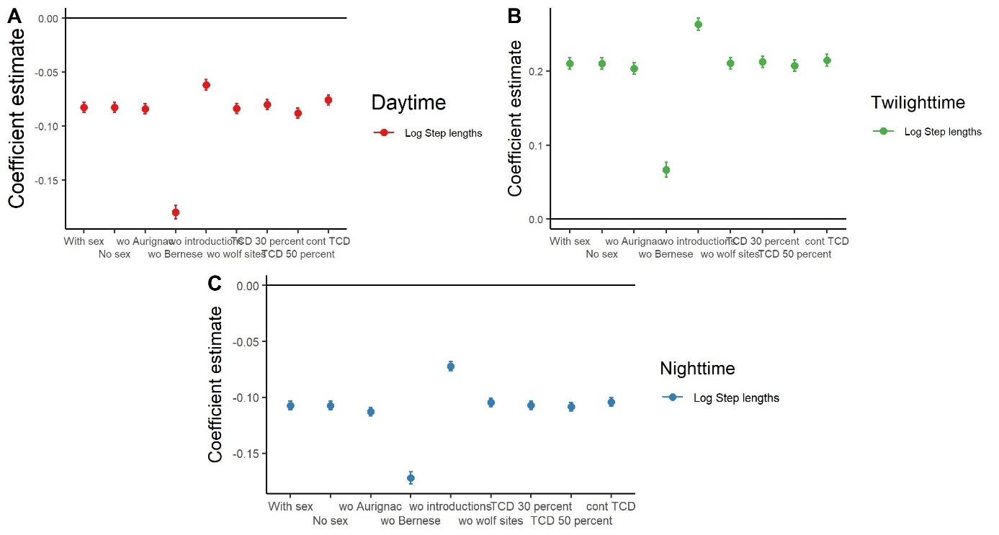

Seasonal models S4 B
1: final model (November GPS data with winter; 2: November GPS data with fall

Habitat (forest as reference category)
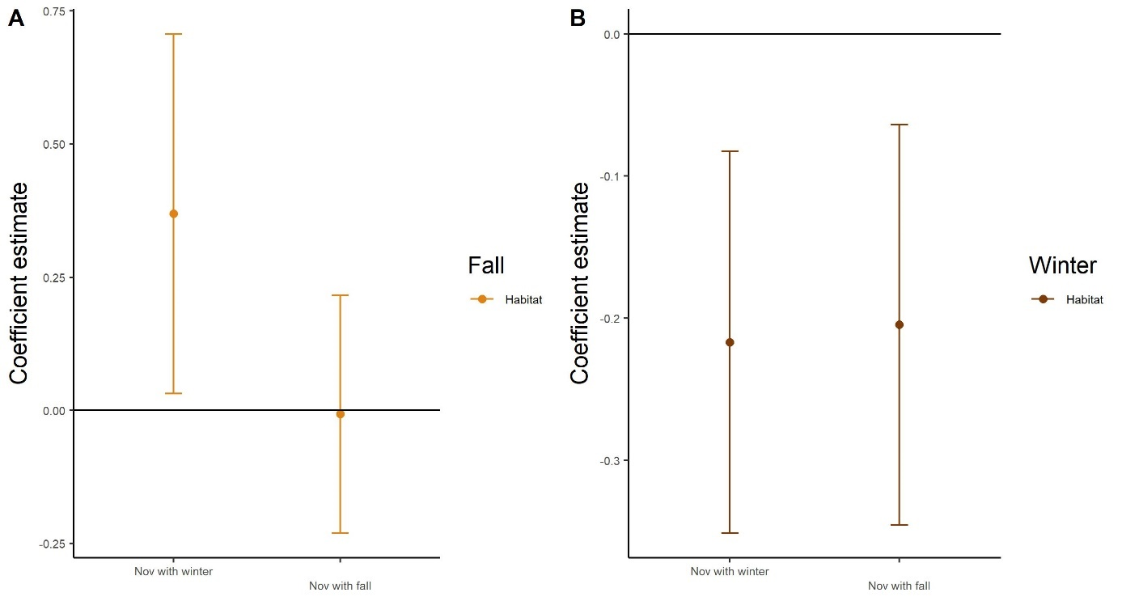

Habitat: Hunting
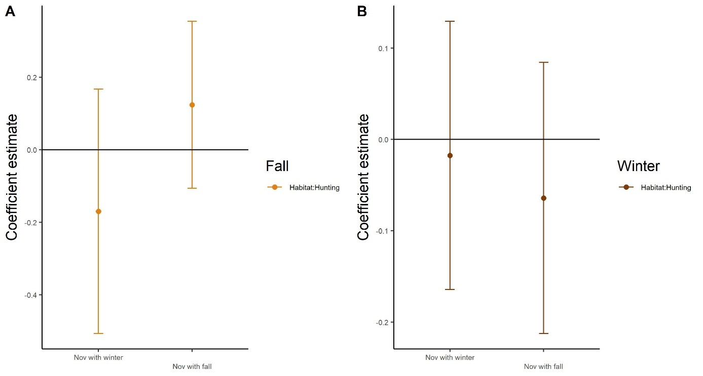

Habitat:Lynx
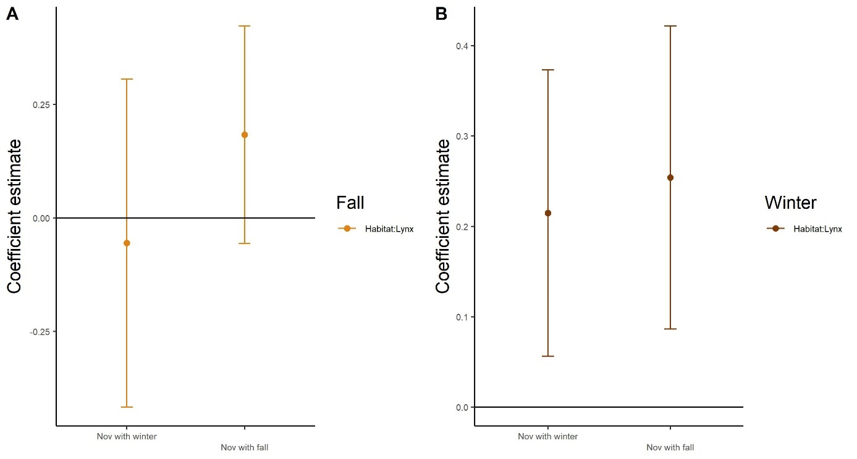

Habitat:Hunting:Lynx
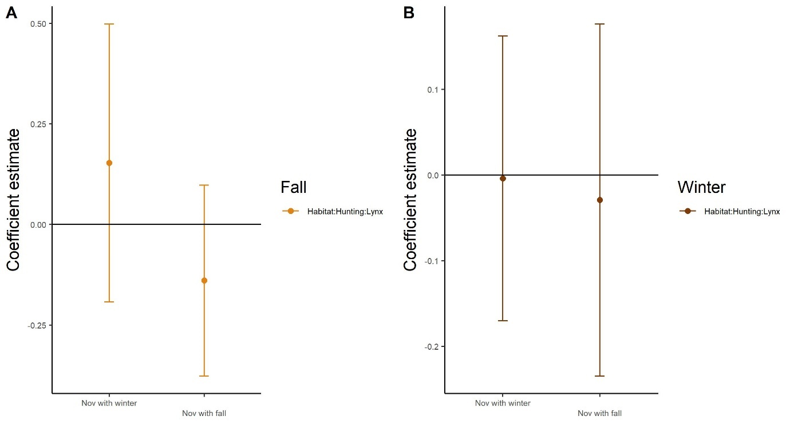

Habitat:Sex
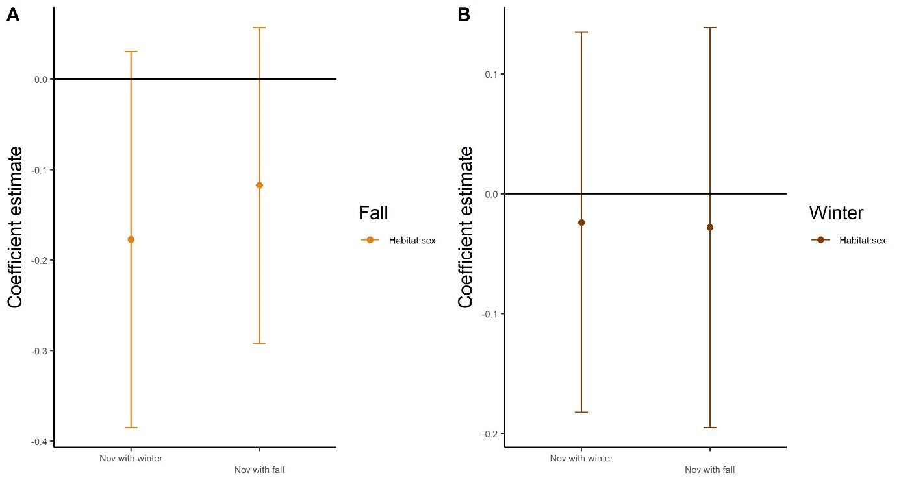

Habitat:Hunting:Sex
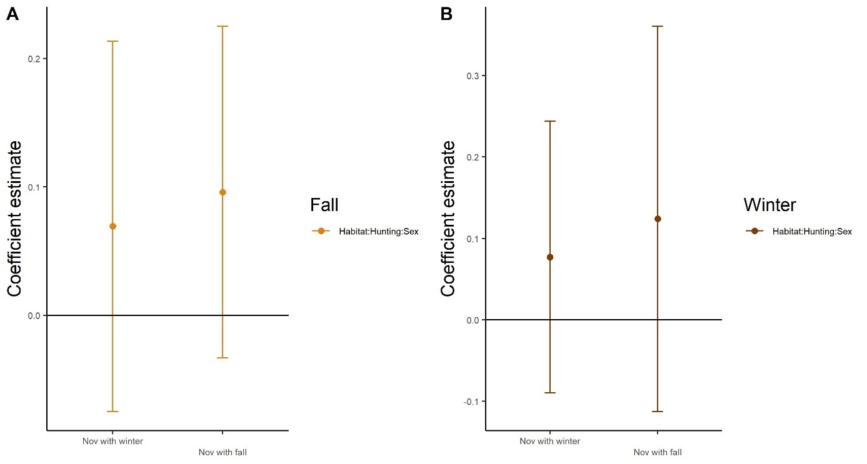

Habitat:HFI
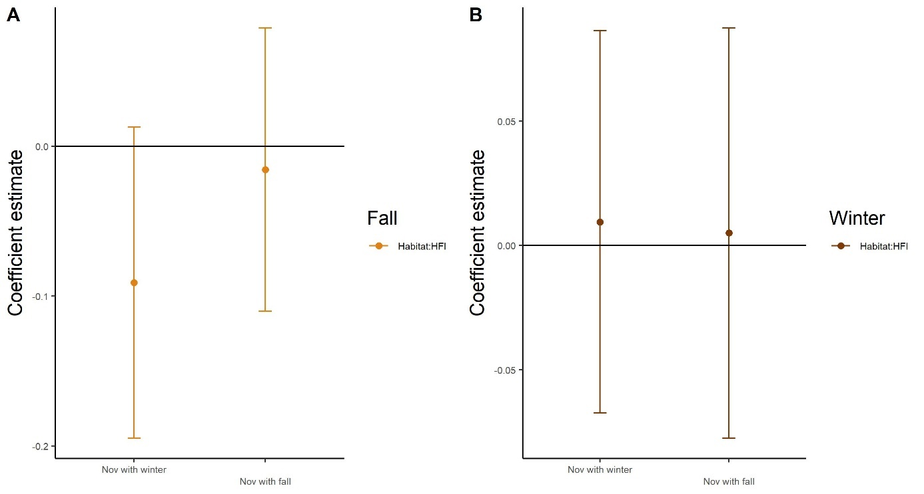

Habitat:NDVI
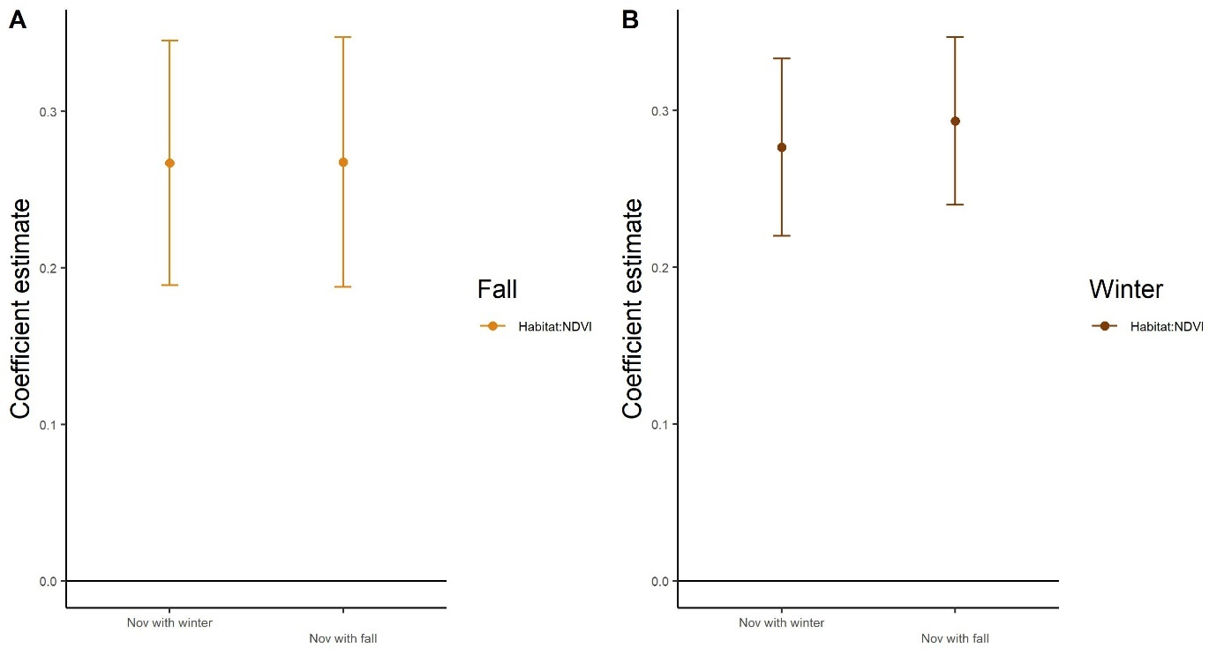

Habitat:Day
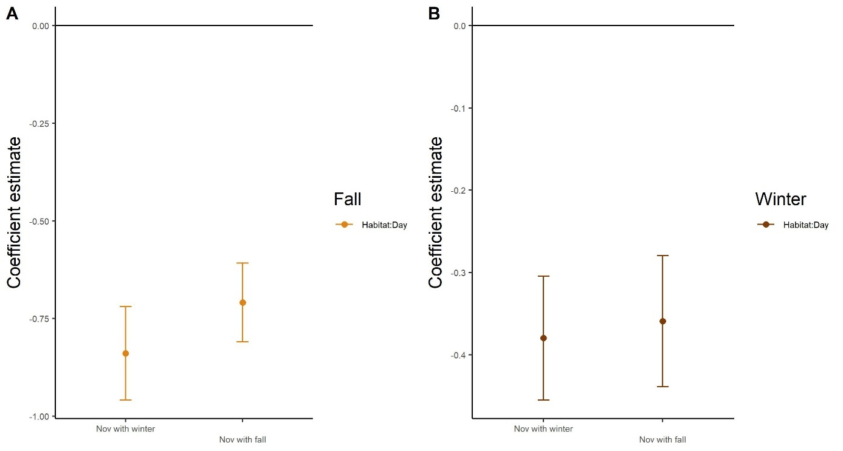

Habitat:Twilight
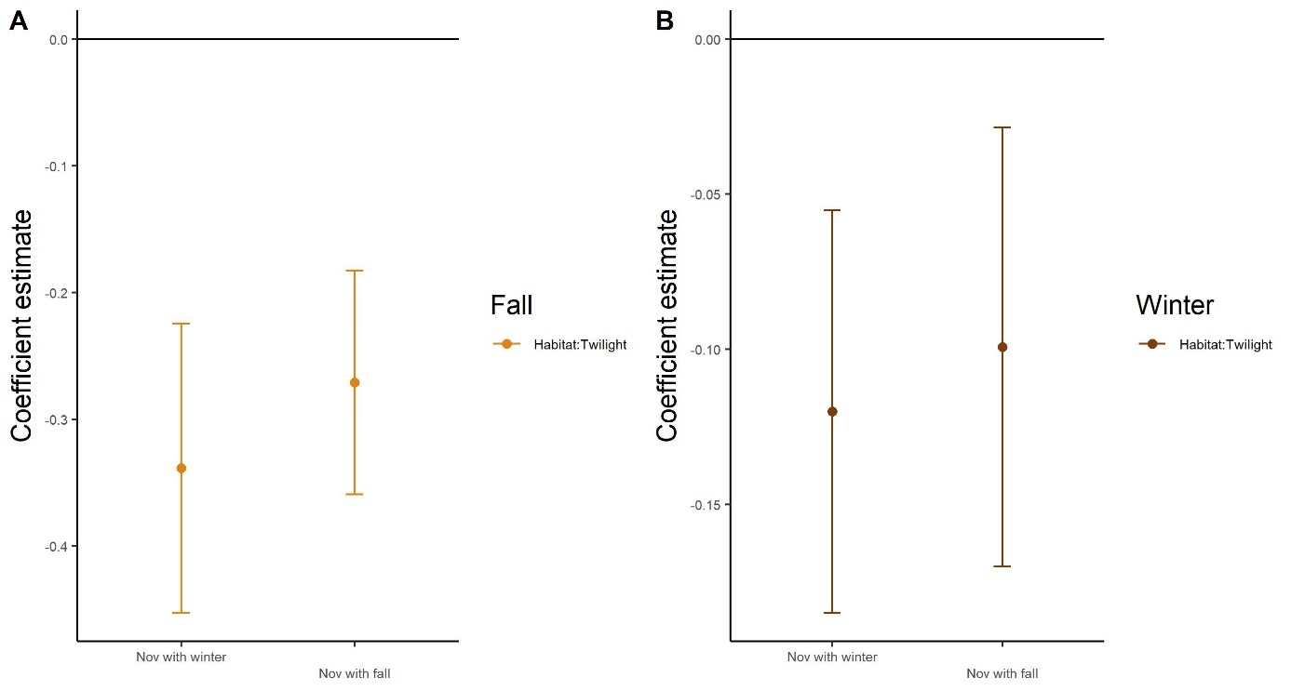

Habitat:Log step lengths
