Does ethnicity influence dementia, stroke and mortality risk? Evidence from the UK Biobank

Prof. Bruno Bonnechère^{1,2*}, Dr. Jun Liu^{1*}, Msc. Alexander Thomson¹, Prof. Najaf Amin¹, Prof. Cornelia van Duijn¹

¹ Nuffield Department of Population Health, University of Oxford, Oxford, United-Kingdom
² REVAL Rehabilitation Research Center, Faculty of Rehabilitation Sciences, Hasselt University, Diepenbeek, Belgium

Supplementary material

Supplementary Table 1: Risk factors definitions
Domain | Risk factors | Definitions | Sources
Lifestyle | Education  Low education | Participants without a college or university degree, or A levels or equivalent (academic advanced-levels, post-compulsory education) | UK Biobank Touchscreen questionnaire at baseline
Lifestyle | Alcohol consumption  None  Low  Mid  High | less than one dose per week  1-2 per week  3–4 times per week  daily or almost daily | UK Biobank Touchscreen questionnaire at baseline
Lifestyle | Body Mass Index  Obesity | >30 kg/m² calculated from measured weight and height | UK Biobank Touchscreen questionnaire at baseline
Lifestyle | Tobacco  Never  Previous  Current |  | UK Biobank Touchscreen questionnaire at baseline
Lifestyle | Physical inactivity  Yes | Participants in the low IPAQ (International Physical Activity Questionnaire) group | UK Biobank Touchscreen questionnaire at baseline
Lifestyle | Social isolation  Yes | Answer to the question “Which of the following do you attend once a week or more often?” was none (no group activity). | UK Biobank Touchscreen questionnaire at baseline
Comorbidities | Hearing loss  Yes | Answer to the question “Do you have any difficulty with your hearing?” is yes or completely deaf | UK Biobank Touchscreen questionnaire at baseline
Comorbidities | Prevalent head injury  Yes | Participants that ever had neurological / intracranial injury or trauma and fracture of skull or head before the first assessment: self-reported neurological injury, trauma, fracture of skull or head, codes S00-S09 in ICD-10, and codes 800-804 or 850-854 in ICD-9. | UK Biobank Touchscreen questionnaire at baseline
Comorbidities | Prevalent hypertension  Yes | Blood pressure medication taken from the touchscreen question “Do you regularly take any of the following medications?”, and/or the mean of twice automated reading measured blood pressure: systolic blood pressure not less than 140 mmHg, or diastolic blood pressure not less than 90 mmHg. | UK Biobank Touchscreen questionnaire at baseline
Comorbidities | Major Depression  Yes | Participant that had self-reported single episode, recurrent moderate, recurrent severe, or with codes F32 (single episode) and/or F33 (recurrent) in ICD-10 by the first assessment. | UK Biobank Touchscreen questionnaire at baseline
Comorbidities | Prevalent diabetes  Yes | 1) Answer to the question “Has a doctor ever told you that you have diabetes?” as yes; 2) self-reported diabetes, type 1 diabetes, type 2 diabetes, gestational diabetes 3) codes E10-E14 (diabetes mellitus) or O24 (diabetes mellitus in pregnancy) in ICD-10, and codes 250 (diabetes mellitus) or 2535 (diabetes insipidus) in ICD-9; 4) HbA1c ≥ 6.5% (48 mmol/mol) | UK Biobank Touchscreen questionnaire at baseline
Comorbidities | Prevalent cardiovascular disease  Yes | Based on diseases of the circulatory system from self-reported illness, codes I00-I99 in ICD-10, or codes 390-459 in ICD-9 | UK Biobank Touchscreen questionnaire at baseline
Comorbidities | Prevalent stroke  Yes | Based on the previous outcome adjudication guidelines in UK Biobank: from self-reported illness and/or ICD codes (I60, I61, I63, I64.X) | UK Biobank Touchscreen questionnaire at baseline
Comorbidities | Prevalent dementia  Yes | Based on the previous outcome adjudication guidelines in UK Biobank: from self-reported illness and/or ICD codes (F00, F01, F02) | UK Biobank Touchscreen questionnaire at baseline
Comorbidities | Prevalent dyslipidemia  Yes | Based on the cholesterol lowering medication taken from the question “Do you regularly take any of the following medications?”, and/or the National Cholesterol Education Program-Adult Treatment Panel III as either total cholesterol ≥ 240mg/dl, LDL-cholesterol ≥ 160 mg/dl, HDL-cholesterol < 40 mg/dl, or triglycerides ≥ 200 mg/dl | UK Biobank Touchscreen questionnaire at baseline
Comorbidities | Family history of dementia  Yes | Based on the questionnaires if the participants had a biological father, mother and siblings who was diagnosed withAD/dementia | UK Biobank Touchscreen questionnaire at baseline
Comorbidities | Prevalent atrial fibrillation  Yes | Based on the previous outcome adjudication guidelines in UK Biobank: from self-reported illness and/or ICD codes. | UK Biobank Touchscreen questionnaire at baseline
Ethnicity  White  Asian  African |  | White British, Irish, or any other white ethnic background  Indian, Pakistani, Bangladeshi  Caribbean, African, or any other black ethnic background | UK Biobank Touchscreen questionnaire at baseline

Supplementary Table 2: SNPs included in the dementia genetic risk score (including APOE)
SNP | Anotate (SNPid.gene or nearest genes.risk allele) | First resource (Author) | Chromosome (kunkle) | Position (Kunkle) | Effect allele (Kunkle) | Non Effect allele (Kunkle) | Beta (Kunkle) | SE (Kunkle) | Pvalue (Kunkle) | Effect allele freq (Kunkle)
rs6656401 | rs6656401.CR1.A | Lambert | 1 | 207692049 | A | G | 0·147 | 0·019 | 2·17E-15 | 0·188
rs6733839 | rs6733839.BIN1/NIFKP9.T | Lambert | 2 | 127892810 | T | C | 0·169 | 0·015 | 4·02E-28 | 0·407
rs35349669 | rs35349669.INPP5D.T | Lambert | 2 | 234068476 | T | C | 0·043 | 0·015 | 2·90E-03 | 0·48
rs6448807 | rs6448807.RP11_281P23.2.T | Witoelar | 4 | 11676144 | T | C | 0·053 | 0·016 | 8·40E-04 | 0·287
rs190982 | rs190982.MEF2C_AS1.A | Lambert | 5 | 88223420 | A | G | 0·056 | 0·016 | 2·81E-04 | 0·611
rs9271192 | rs9271192.HLA_DQA1/HLA_DRB1.C | Lambert | 6 | 32578530 | A | C | -0·092 | 0·017 | 9·02E-08 | 0·73
rs75932628 | rs75932628.TREM2.T | Kunkle | 6 | 41129252 | T | C | 0·699 | 0·1 | 2·95E-12 | 0·008
rs10948363 | rs10948363.CD2AP.G | Lambert | 6 | 47487762 | A | G | -0·083 | 0·016 | 1·77E-07 | 0·724
rs2718058 | rs2718058.GPR141/EPDR1.A | Lambert | 7 | 37841534 | A | G | 0·054 | 0·015 | 2·19E-04 | 0·631
rs1476679 | rs1476679.ZCWPW1.T | Lambert | 7 | 100004446 | T | C | 0·065 | 0·016 | 5·94E-05 | 0·712
rs11771145 | rs11771145.EPHA1_AS1.G | Lambert | 7 | 143110762 | A | G | -0·07 | 0·015 | 4·82E-06 | 0·342
rs28834970 | rs28834970.PTK2B.C | Lambert | 8 | 27195121 | T | C | -0·092 | 0·015 | 1·58E-09 | 0·634
rs9331896 | rs9331896.CLU.T | Lambert | 8 | 27467686 | T | C | 0·127 | 0·016 | 3·62E-16 | 0·613
rs7920721 | rs7920721.RP11_138I18.2/RP11_138I18.1.G | Kunkle | 10 | 11720308 | A | G | -0·078 | 0·015 | 1·94E-07 | 0·61
rs10838725 | rs10838725.CELF1.C | Lambert | 11 | 47557871 | T | C | -0·065 | 0·015 | 1·91E-05 | 0·68
rs983392 | rs983392.AP001257.1/MS4A2.A | Lambert | 11 | 59923508 | A | G | 0·115 | 0·015 | 4·76E-15 | 0·594
rs10792832 | rs10792832.RNU6_560P/RP11_12D16.2.G | Lambert | 11 | 85867875 | A | G | -0·12 | 0·015 | 7·56E-16 | 0·359
rs11218343 | rs11218343.SORL1.T | Lambert | 11 | 121435587 | T | C | 0·205 | 0·037 | 2·63E-08 | 0·96
rs17125944 | rs17125944.FERMT2.C | Lambert | 14 | 53400629 | T | C | -0·12 | 0·025 | 1·08E-06 | 0·909
rs10498633 | rs10498633.SLC24A4.G | Lambert | 14 | 92926952 | T | G | -0·085 | 0·018 | 1·27E-06 | 0·217
rs593742 | rs593742.RP11_30K9.7/ADAM10.A | Kunkle | 15 | 59045774 | A | G | 0·065 | 0·016 | 3·07E-05 | 0·705
rs7185636 | rs7185636.IQCK.T | Kunkle | 16 | 19808163 | T | C | 0·079 | 0·019 | 2·47E-05 | 0·82
rs62039712 | rs62039712.R5SP431/RP11_467I17.1.A | Kunkle | 16 | 79355857 | A | G | 0·153 | 0·029 | 1·17E-07 | 0·116
rs7225151 | rs7225151.RP11_333E1.1/SCIMP.A | Moreno-Grau | 17 | 5137047 | A | G | 0·083 | 0·022 | 1·31E-04 | 0·122
rs138190086 | rs138190086.RP11_269G24.6/CTD_2501B8.5.A | Kunkle | 17 | 61538148 | A | G | 0·254 | 0·057 | 7·46E-06 | 0·02
rs4147929 | rs4147929.ABCA7.A | Lambert | 19 | 1063443 | A | G | 0·122 | 0·02 | 9·56E-10 | 0·182
rs429358 | rs429358.APOE.C | Lambert | 19 | 45411941 | T | C | -1·202 | 0·019 | 0·00E+00 | 0·784
rs3865444 | rs3865444.CD33/SIGLEC22P.C | Moreno-Grau | 19 | 51727962 | A | C | -0·08 | 0·016 | 3·93E-07 | 0·308
rs7274581 | rs7274581.CASS4.T | Lambert | 20 | 55018260 | T | C | 0·115 | 0·026 | 9·02E-06 | 0·911
rs2830500 | rs2830500.ADAMTS1/CYYR1.C | Kunkle | 21 | 28156856 | A | C | -0·081 | 0·016 | 2·53E-07 | 0·308

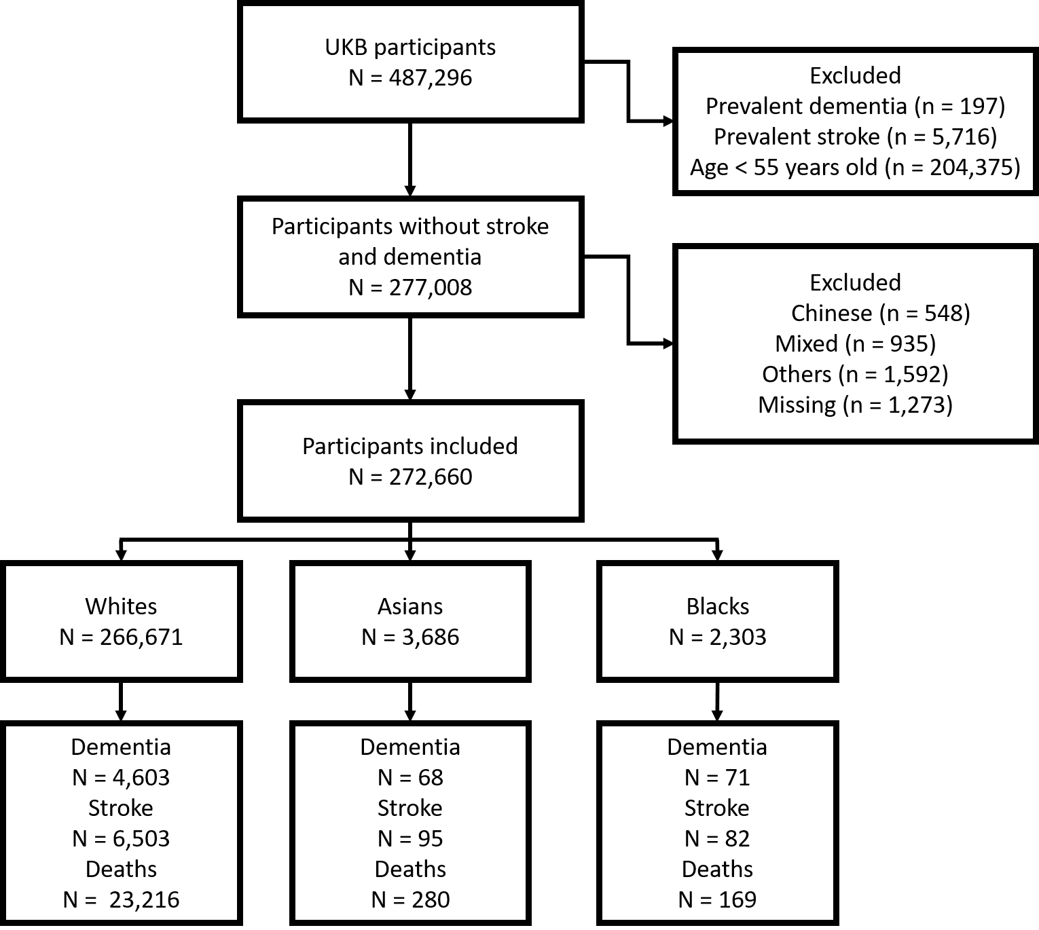
Supplementary Figure 1: Flow of the study participants

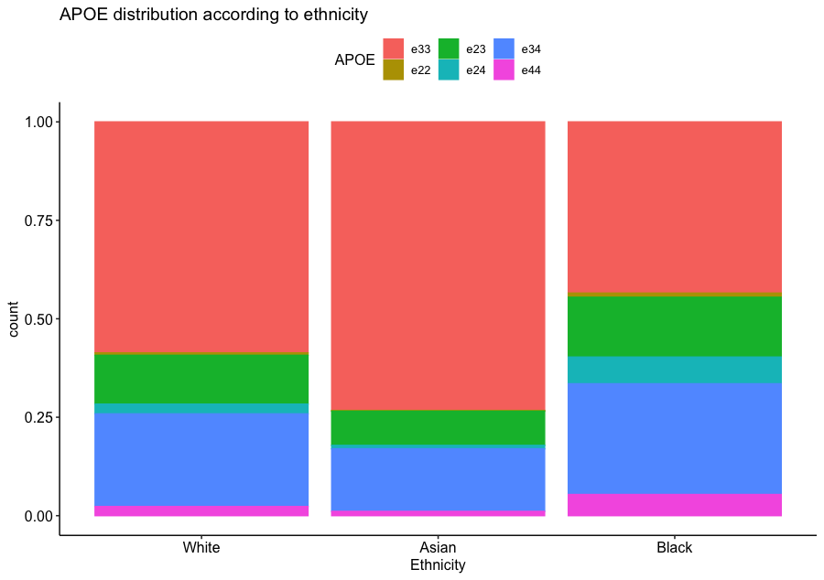
Supplementary Figure 2: Breakdown of APOE genotype by ethnicity.

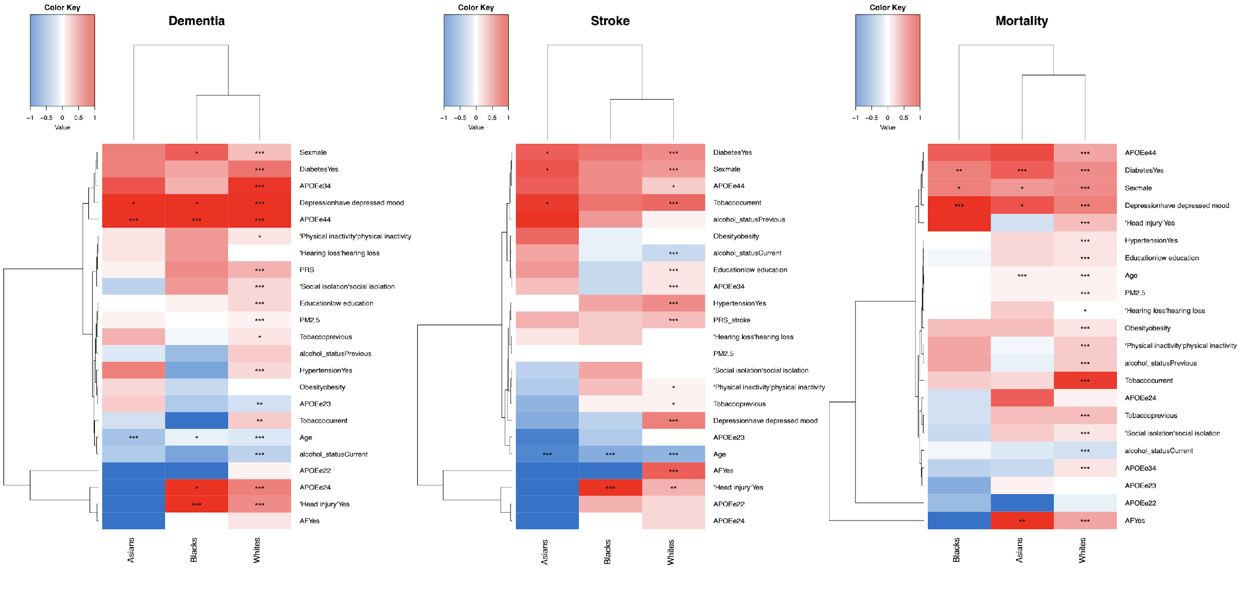
Supplementary Figure 3: Heatmaps of risk factors by ethnicity for dementia, stroke and mortality

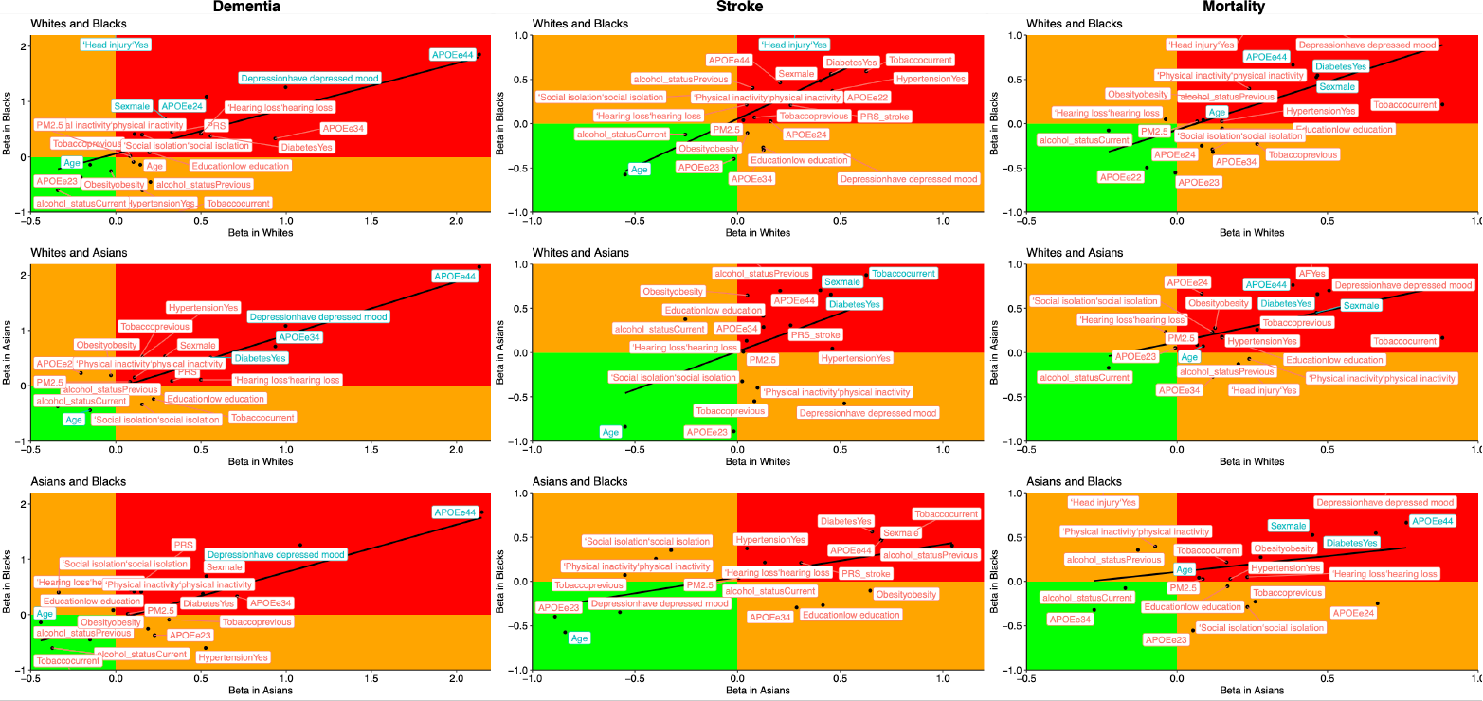
Supplementary Figure 4: Correlations between risk factors of dementia, stroke and mortality by ethnicity, blue color indicates the variables found to be significantly different between the two ethnicities.

