Graphical abstract:

Molecular Docking
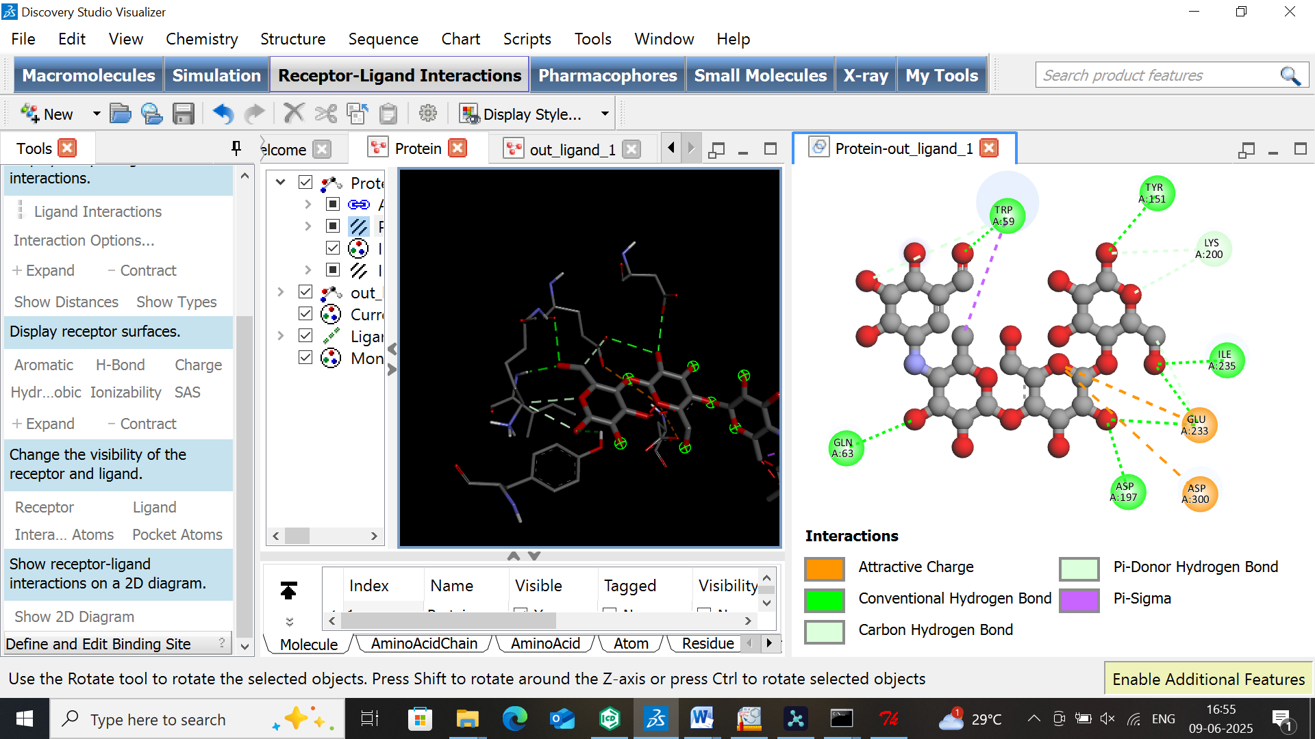
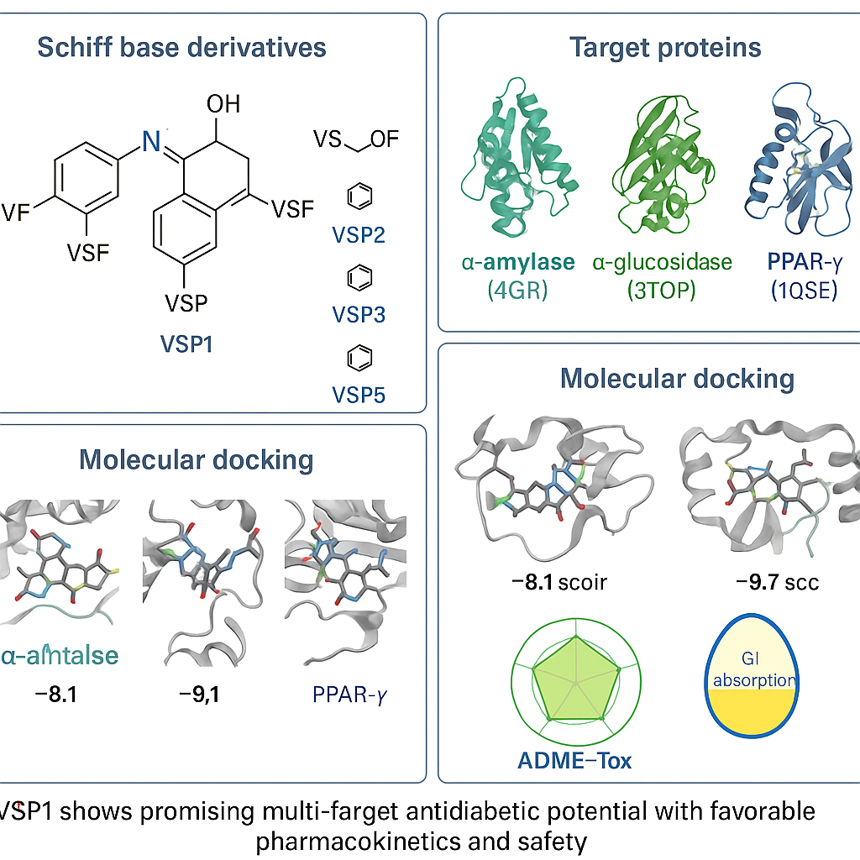

Ligand

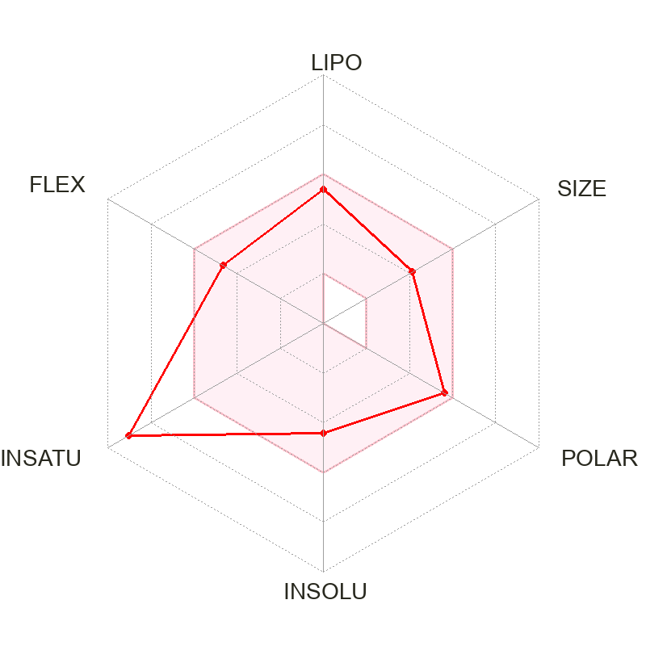

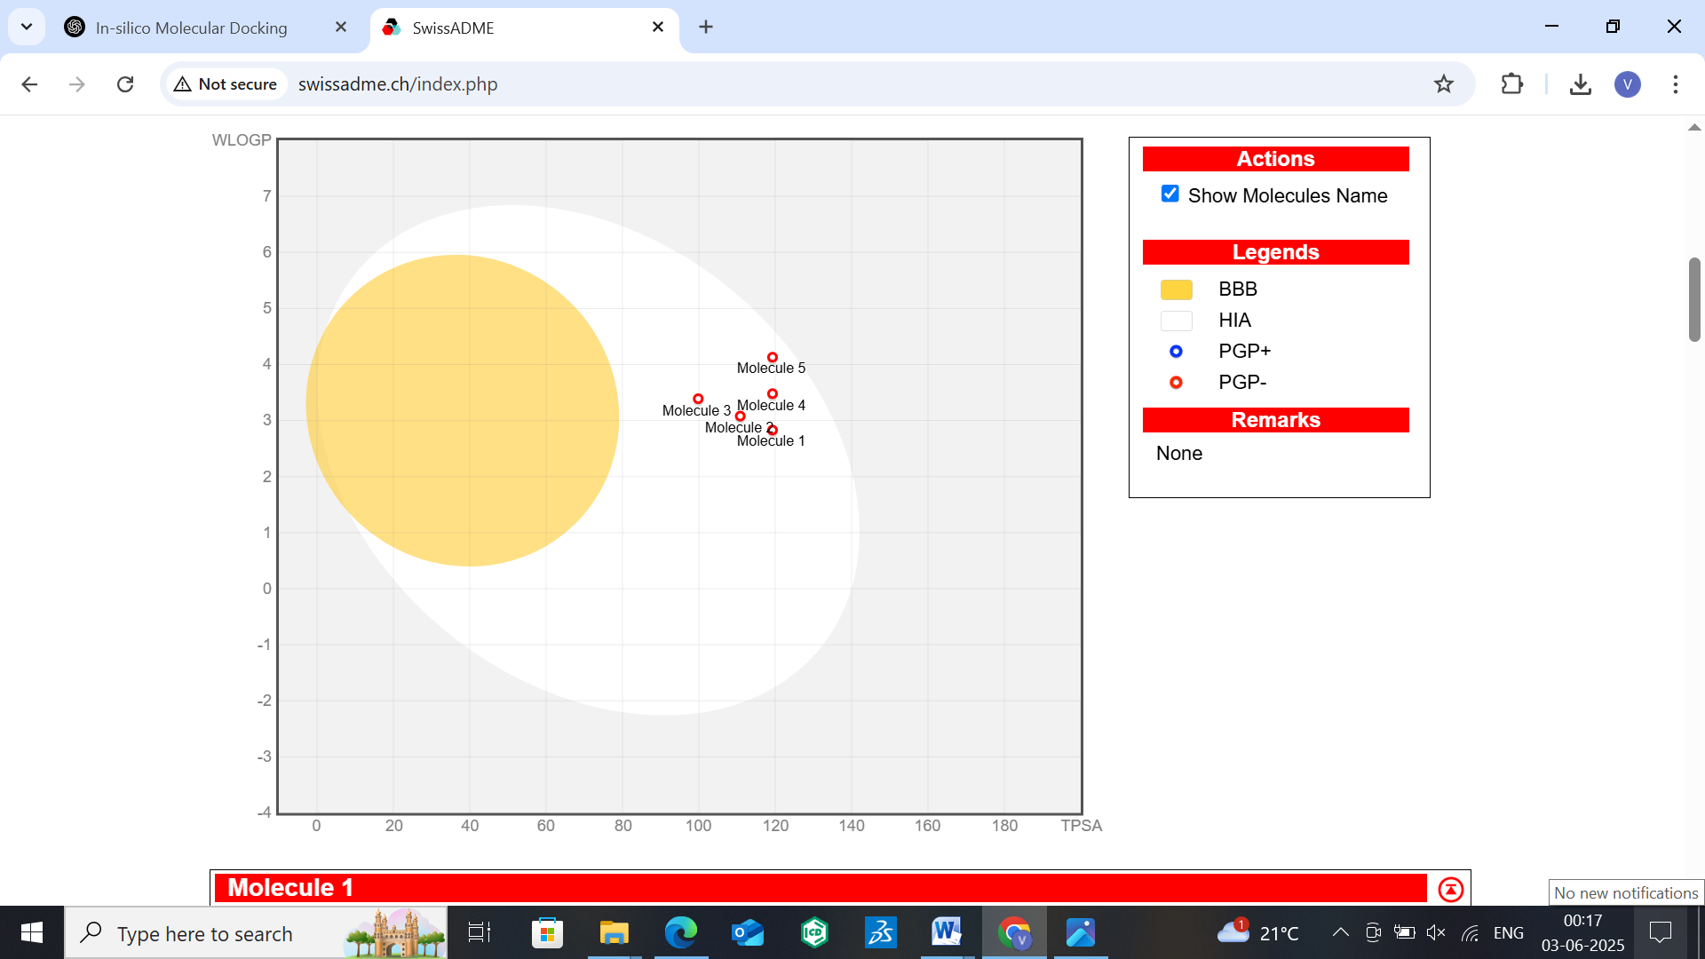
Designed 2-Mercaptobenzimidazole
Schiff base derivatives

ADMET Analysis
Boiled egg plot

Lipinski Analysis

