Supplementary Figure 1. Predicted proteins structures stability by the ERRAT2 and ProSA. The first column provided the Z-scores and the seconf column provided the plot of residue scores. Part A, C for Human metapneumovirus fusion (hMPV-F) protein and Part B, D Human metapneumovirus nucleoprotein (hMPV-N).
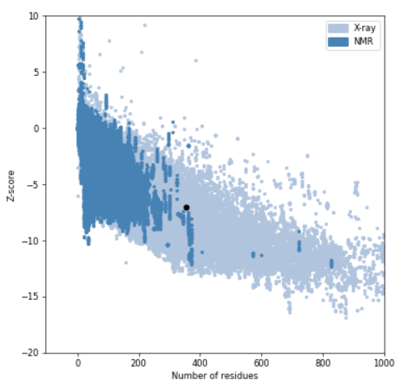
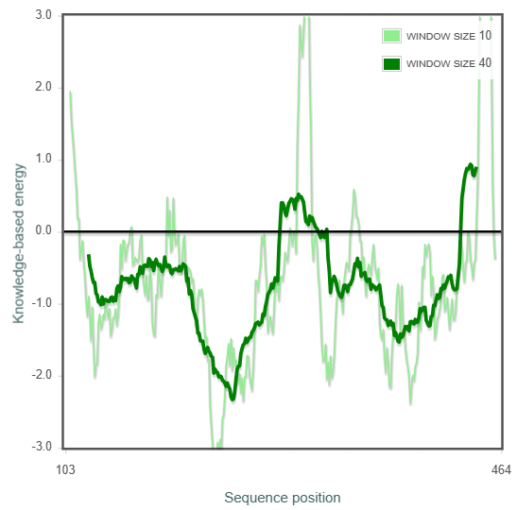
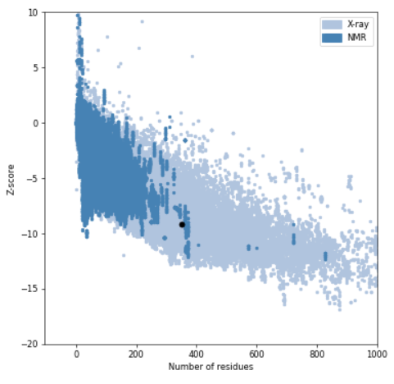
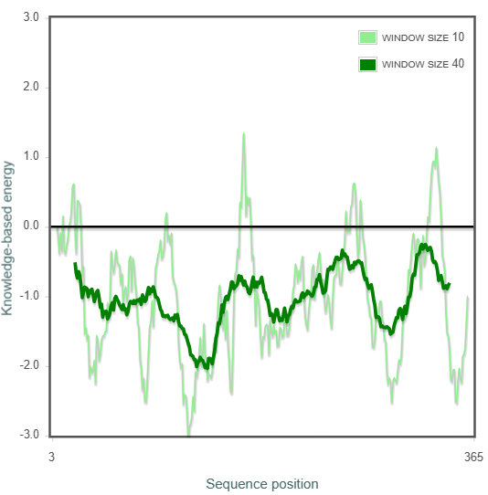
A.
B.
C.
D.
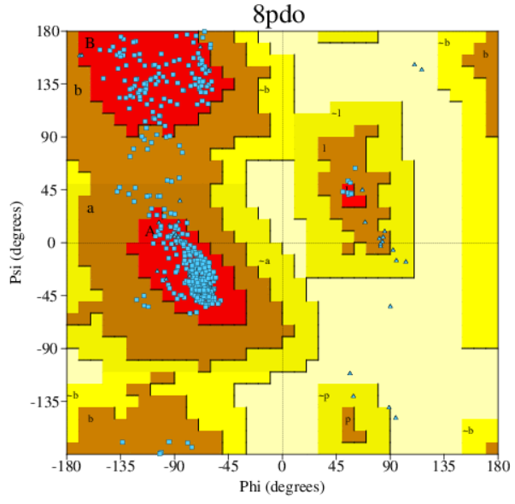
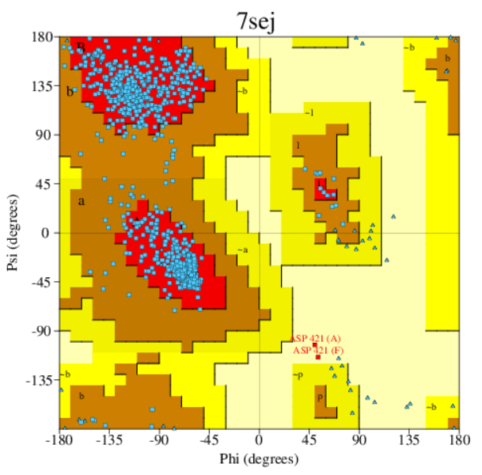
Supplementary Figure 2. Ramachandran plot for A. hMPV-F protein and B. hMPV-N.
B.
A.

