Electronic Supplementary Material
Bifunctionality of enhanced stability and synergistic catalysis for natural enzyme based on bimetallic zeolitic imidazolate framework
Zhongjie Zhu^{a,b,c}, Lulu Wu^{a,b}, Li Tang^{a,b}, Hongwei Yuan^{d}, Fei Yang^{a,b}, Wenwen Wang^{d}, Hui Ouyang^{d}, Hongmei Liu^{a,b}, Zhifeng Fu^{d, **}, Yong He^{a,b *}
ª Department of Pharmacy, The Second Affiliated Hospital of Zunyi Medical University, Zunyi, Guizhou 563003, China
^{b} College of Pharmacy, Zunyi Medical University, Zunyi, Guizhou 563003, China
^{c} Department of Pharmacy, The 958th Hospital of Chinese People’s Liberation Army, Chongqing 400715, China
^{d} College of Pharmaceutical Sciences, Southwest University, Chongqing 400715, China

* Corresponding author.
E-mail address: fuzf@swu.edu.cn (Z.F. Fu), heyongzmu@163.com (Y. He)

Table of content
1 Instrumentations S3
2 Materials S3
3 Preparation of ZIF-67, Fe (III) Zn-ZIF and MIL-88-NH₂ (Fe) S4
4 Preparation of HRP-on-FeZn-ZIF and HRP-on-ZIF-8 S5
5 Examination of the HRP activity within FeZn-ZIF and ZIF-8 S5
6 Measurement of the catalytic kinetic parameters S6
7 Measurement of the HRP loading contents by FeZn-ZIF and ZIF-8 S7
8 Enzymatic activity assay of GOx@FeZn-ZIF and GOx@ZIF-8 S7
9 Enzymatic activity assay of ALP@FeZn-ZIF and ALP@ZIF-8 S7
Supplementary Figures S8
Supplementary References S22

1 Instrumentations
Absorbance was determined with an Infinite M200 PRO multifunctional microplate reader from TECAN (Switzerland). Scanning transmission electron microscope photographs were obtained by a Merlin Compact field emission scanning electron microscope from Zeiss (Germany). Transmission electron microscopy and energy-dispersive X-ray spectroscopy mapping were conducted with a Tecnai G2 F30 S-TWIN transmission electron microscope from FEI (USA). High-resolution transmission electron microscopy photograph was carried out using Tecnai G2 F30 S-Twin high-resolution transmission electron microscope from FEI (USA). X-ray photoelectron spectroscopy was measured with a K-alpha spectrometer from Thermo Fisher (USA). Element contents were measured with a 730 ICP-emission spectrometer from Agilent (USA). Fourier-transform infrared resonance spectroscopy was conducted using a Shimadzu 010409 spectrometer (Japan). Specific surface area and pore diameter of nanomaterials were estimated using an analyser from Quantachrome (USA) based on the Brunauer-Emmett-Teller method. Ultrapure water (18.2 MΩ/cm) was produced by a Milli-Q system from Merck Millipore (USA).

2 Materials
Zinc Nitrate Hexahydrate (Zn(NO₃)₂·H₂O) were purchased from Shanghai Titan (China). Digoxin (DGX), 2-Methylimidazole (2-MeIm), Horseradish Peroxidase (HRP), Glucose oxidase (GOX), Alkaline phosphatase (ALP), cetyltrimethylammonium bromide (CTAB), Ferrous sulfate heptahydrate (FeSO₄·7H₂O), hydrogen peroxide (H₂O₂) and lidocaine were supplied by Aladdin (China). Bovine serum albumin (BSA) was supplied by Shanghai Yuanye (China). Monoclonal antibody(mAb) against DGX and DGX-BSA were both purchased from Wuxi Determine (China). Glucose, estramusting, digitoxin, ouabain, phenytoin sodium, atropine, amiodarone, sodium acetate, pluronic F127, polyvinyl pyrrolidone (PVP), 2-aminoterephthalic acid, 4,4'-diamino-3,3',5,5'-tetramethylbiphenyl (TMB), 2,2′-azino-bis (3-ethylbenzothiazoline-6-sulfonic acid (ABTS) and 4-Methylumbelliferyl phosphate, 4-Methylumbelliferyl phosphate (4-MUP) were supplied by Macklin (China). Ferric chloride hexahydrate (FeCl₃·6H₂O) was obtained from Merck (Germany). A Bradford protein concentration determination kit was obtained from Beyotime (China). Human serum samples were provided by Abbkine Bio-Tech (China). Human urine and saliva were obtained from a healthy volunteer in the laboratory. Phosphate buffered saline (10.0 mM, pH 7.4) (PBS) was used as a washing buffer and a dilution buffer. Phosphate buffered saline with Tween 20 (PBST) was prepared through dissolving 0.05% (v/v) Tween-20 in phosphate buffered PBS to dilute sample solutions. Carbonate buffer solution (50.0 mM, pH 9.6) was adopted as electrolyte for absorbance measurements. Blocking buffer was provided by Thermo Fisher (USA).

3 Preparation of ZIF-67, Fe (III) Zn-ZIF and MIL-88-NH₂ (Fe)
ZIF-67 were prepared according to the reported study ^{[S1]} with minor modifications.
Equal volume of Co(NO₃)₂·6H₂O (0.4 M) and 2-MeIm (1.6 M), both prepared in ethanol, were mixed together at room temperature for 24 h. Finally, the resulted nanoparticles were centrifuged at 14000 rpm, and washed with ethanol for three times.
Fe (III) Zn-ZIF precursor was synthesized to analyze and identify the main factors for ZIF cage. Briefly, 2.5 mg of CTAB was mixed with 5.0 mL of Zn(CH₃COO)₂·2H₂O (90 mg), before being saturated with N₂. Next, sufficient Fe(NO3)3∙9H2O was added to achieve a Fe-to-Zn mass ratio of 1:2 in the final solution that was then stirred for 2 min. Finally, 5.0 mL of 2-methylimidazole (2-MeIm) solution (330 mg) was added into the obtained solution and stirred continuously for 30 min. The product was then collected by centrifugation at 9000 rpm and washed three times with deionized water. The collected product was freeze-dried in a vacuum.
The preparation of MIL-88-NH₂ (Fe) was based on the previous study ^{[S2]}. Briefly, 0.16 g of pluronic F127 surfactant was dissolved in 13.34 mL of deionized water, and then 1.66 mL of FeCl₃·6H₂O solution (0.4 M) was added to the above solution.After stirring this solution at room temperature for 1 h, 0.3 mL of acetic acid was added. After a 1-h stirring, 60 mg of 2-aminobenzene-1,4-dicarboxylic acid was added. The obtained solution was stirred for another 2 h before transferring into a teflon-lined autoclave. Then the reactants were heated at 110 ºC for 24 h. After reaction, the raw products were collected by centrifugation at 10000 rpm and washed with ethanol.

4 Preparation of HRP-on-FeZn-ZIF and HRP-on-ZIF-8
The HRP-on-FeZn-ZIF and HRP-on-ZIF-8 was also prepared as followed: 5 mg FeZn-ZIF and 5 mg ZIF-8 were ultrasonically dispersed in 1 mL HRP solution (1 mg/mL), respectively, before they were mixed tother and agitated on an oscillator for 30 min. Finally, the precipitate was collected by centrifugation at 9000 rpm, and washed by deionized water three times.

5 Examination of the HRP activity within FeZn-ZIF and ZIF-8
The oxidase catalytic activities of HRP@ZIF-8 and HRP@FeZn-ZIF were evaluated based on a TMB-H₂O₂-HRP colorimetric reaction. The concentration of nanometer catalyst (HRP@ZIF-8 and HRP@FeZn-ZIF) used for individual experiment were set at 0.157 mg/mL and 0.1 mg/mL, respectively. Nanometer catalyst solution (10 μL) was added to the cuvette, which was diluted using 100 μL of NaAC (0.2 M, pH 4.0). Then, 50 μL of TMB were successively added. Immediately, 200 μL H₂O₂ at different concentration was correspondingly added to cuvettes containing the same concentration of catalyst solution and TMB to trigger the catalytic reaction. The generation of oxTMB production of H₂O₂ was monitored by monitoring at 650 nm using a time-scanning mode. The signal intensity was corrected by subtraction of the background.

6 Measurement of the catalytic kinetic parameters
The enzyme kinetic parameters were obtained according to the Michaelis-Menten equation S1
V₀ = (V_{max}·[S]) / (K_{m} + [S]) Equation . (S1)
Where, V₀ is the initial catalytic rate estimated by the slope in the initial phase of a V versus [S] plot, V_{max} the maximum catalytic rate obtained when the enzyme catalytic sites are saturated with substrates, [S] the initial substrate concentration determined at 0 s, and K_{m} the Michaelis-Menten constant. The kinetic parameters V_{max} and K_{m} were then simply estimated from the ordinate intercept and slope of a linear 1/V₀ versus 1/[S] plot. Additionally, the catalyst rate constant (k_{cat}) is equal to the quotient of Vmax and the concentration of the enzyme.

7 Measurement of the HRP loading contents by FeZn-ZIF and ZIF-8
The loading content of HRP within mesoporous FeZn-ZIF and ZIF-8 were measured by detecting the HRP concentration in the supernatant before and after encapsulation via Bradford protein assays ^{[S3]}. Typically, 20 μL of the supernatant was added into 96-well plates, followed by adding 200 μL of Coomassie Brilliant Blue G-250 reagent. After incubation for 5 min, the UV-vis absorbance spectrum of the solution was recorded. The concentration of HRP is proportional to the absorbance intensity at 595 nm.

8 Enzymatic activity assay of GOx@FeZn-ZIF and GOx@ZIF-8
The activity of GOx in aqueous solution were measured by using glucose as the substrate in PBS. In a typical measurement, 50 μL of GOx@FeZn-ZIF and GOx@ZIF-8 or free GOx with the same amount of protein was added in PBS containing glucose (100 mM), ABTS (0.28 mg/mL) and horseradish peroxidase (0.05 mg/mL). The absorbance increase at 415 nm was measured using an UV-Vis spectrophotometer.

9 Enzymatic activity assay of ALP@FeZn-ZIF and ALP@ZIF-8
The hydrolytic activity of ALP@FeZn-ZIF and ALP@ZIF-8 were determined using 4-MUP as the substrate. First, 4-MUP was dissolved in H₂O and then diluted with CBS with a final concentration of 10 mM. The reaction was initiated by adding 50 µL of ALP aqueous solution to 150 µL of the substrate solution. The fluorescence intensity at 448 nm was recorded using a microplate reader.

Supplementary Figures
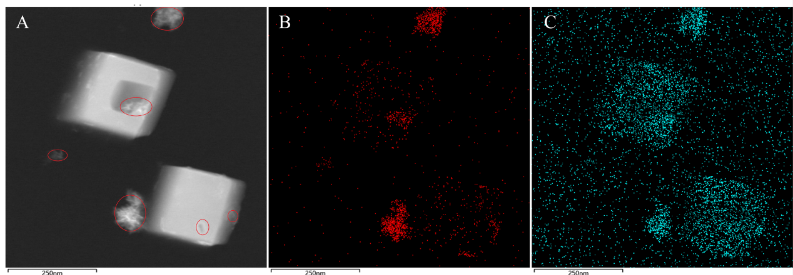
Fig. S1 (A-C) HADDF and EDS maps of Fe and O elements in FeZn-ZIF. Red circles indicated the substance of iron oxides.

Fig. S2 TEM of (A) ZIF-8 and (B) Fe (Ⅲ) Zn-ZIF.

Fig. S3 XPS patterns for (A) Zn 2p and (B) N 1s of FeZn-ZIF, ZIF-8 and Fe(Ⅲ)Zn-ZIF.

Fig. S4 FTIR patterns of ZIF-8, FeZn-ZIF, HRP@ZIF-8, HRP@FeZn-ZIF and HRP.

Fig. S5 PVP-surface-adsorbent exchange experiment for HRP @ or on different ZIFs using in situ encapsulation method and pore entrapment method. (@: indicate that HRP was encapsulated in the cage of ZIF; on: indicated that HRP was on the surface of ZIF). The difference of absorbance around 340 nm and 380 nm can be inferred as the release of HRP indicated by FeZn-ZIF and ZIF-8 under the treatment of PVP.

Fig. S6 Relative activity of HRP@FeZnZIF and free HRP by oxidized TMB under (A) Stability freeze-thawing cycles, (B) Physical and chemical stability, (C) Anti-trypsin digestion stability and (D) Recycle performance (n = 3).

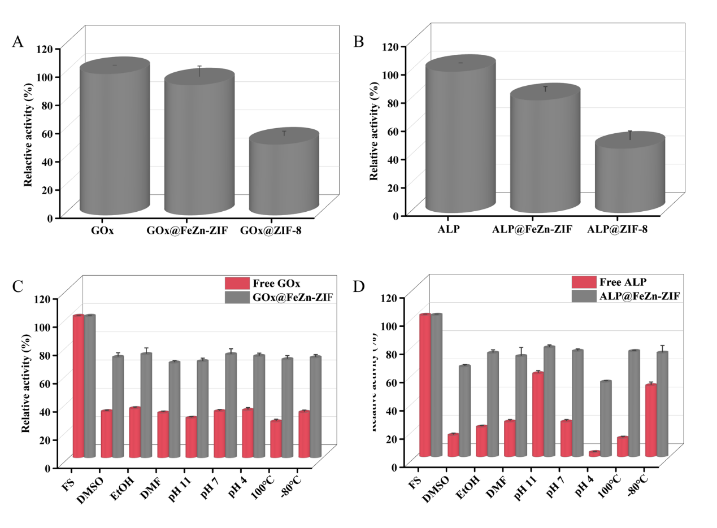
Fig. S7 Relative activity and encapsulation rate of (A) Free GOx, GOx@FeZn-ZIF, GOx@ZIF-8, (B) Free ALP, ALP@FeZn-ZIF, ALP@ZIF-8; Relative activity of (C) Free GOx, GOx@FeZn-ZIF, GOx@ZIF-8, (D) Free ALP, ALP@FeZn-ZIF, ALP@ZIF-8 under physicochemical treatments (n = 3).

Fig. S8 Michaelis-Menten plots of (A) FeZn-ZIF and (C) HRP@FeZn-ZIF. Lineweaver-Burk plots of (B) FeZn-ZIF and (D) HRP@FeZn-ZIF (n = 3).

Fig. S9 Optimization condition of (A) Concentration of coated DGX-BSA, (B) Quantity of DGX mAb, (C) Dilution time and (D) Volume of DGX mAb - HRP@FeZn-ZIF (n = 3).
Table S1 The BET surface area and average pore size of different nano material.
Sample | Specific surface area (BET) (m²·g⁻¹) | Average pore size (nm)
ZIF-8 | 1568 | 1.43
HRP@ZIF-8 | 1466 | 1.40
FeZn-ZIF | 1361 | 2.10
HRP@FeZn-ZIF | 1242 | 1.81

Supplementary References
[S1] Wu RB, Wang DP, Han JY, et al (2015) A general approach towards multi-faceted hollow oxide composites using zeolitic imidazolate frameworks. Nanoscale 7: 965 - 974.
[S2] Kurisingal JF, Rachuri Y, Gu YJ, et al (2019) Fabrication of hierarchically porous MIL-88-NH₂(Fe): a highly efficient catalyst for the chemical fixation of CO₂ under ambient pressure. Inorg Chem Front 6: 3613 - 3620.
[S3] Chen GS, Huang SM, Kou XX, et al (2020) Embedding functional biomacromolecules within peptide-directed metal-organic framework (MOF) nanoarchitectures enables activity enhancement. Angew Chem Int Ed Engl 59: 13947 - 13954.

