Supporting Information
Age and sex differences in gBOLD-CSF coupling alteration 1
Quality Control 1
Figure S1. 2
Figure S2. 3
References 3

Age and sex differences in gBOLD-CSF coupling alteration
To investigate the age and sex differences in gBOLD-CSF coupling alteration, the gBOLD-CSF coupling strength at this lag was correlated with age and compared between sexes. The gBOLD-CSF coupling strength showed a positive correlation with subjects’ age (r = 0.33, p = 0.01), i.e., the coupling strength was stronger (more negative) with decreasing age (Figure S2A). This gBOLD-CSF coupling relationship for our subjects aged between 24 to 68 years had the same pattern from the previous report with elderly subjects ^{[1, 2]}. However, there was no significant difference between males and females for the gBOLD-CSF coupling strength in the whole sample (t₍₆₀₎ = 1.013, p = 0.315; Figure S2B).

Quality Control
To ensure the quality of imaging data, T1-weighted sMRI, rs-fMRI and DTI data exhibiting excessive motion, artifacts or poor brain coverage were excluded. Moreover, rigorous quality control (QC) was performed for individual sMRI scans following CAT12 preprocessing. Several parameter-specific ratings were provided as well as a handy overall rating for quantifying image qualities such as noise, intensity inhomogeneities, image resolution, and weighted average (IQR) ^{[3]}. Subjects with poor MRI quality, as indicated by any of the QC parameters being lower than B, were also excluded. For the rs-fMRI data, outlier detection was performed for each subject, in which framewise displacement (FD) and root-mean-square of voxel-wise differentiated signal (DVARS) were estimated using fsl_motion_outliers implemented in the FSL software (version 6.0.5; https://fsl.fmrib.ox.ac.uk/fsl/fslwiki). FD was derived as the cumulative sum of the absolute values of all six translational and rotational realignment parameters^{[4]}. Simultaneously, DVARS was computed as the root mean square (RMS) value, calculated at each volume, representing the first derivatives of all voxel time series across the entire brain^{[4, 5]}. Volumes with mean FD values exceeding 0.3 mm or DVARS values surpassing 50 were marked as outliers (censored frames). One frame before and two frames after these outliner volumes were also flagged as censored frames, together with those lasting fewer than five contiguous volumes. Subjects who had more than half the volumes labeled as censored frames were rejected from further analysis. In addition to these automated quality control measures, all preprocessed rs-fMRI time series underwent visual inspection for artifacts, especially motion artifacts that might affect the bottom slice of rs-fMRI data. DTI quantitative identification of slices with signal loss was performed using the eddy implemented in the FSL software (version 6.0.5; https://fsl.fmrib.ox.ac.uk/fsl/fslwiki). Outlier volumes were replaced by non-parametric predictions using the Gaussian process^{[6]}. Finally, 36 HCs and 34 SCA3 patients with structural MRI were used to obtain the CP and CSF volumes. 1 HC and 7 SCA3 patients with rs-fMRI as well as 1 HC and 6 SCA3 patients with DTI were excluded for further BOLD-CSF coupling and DTI-ALPS analysis.

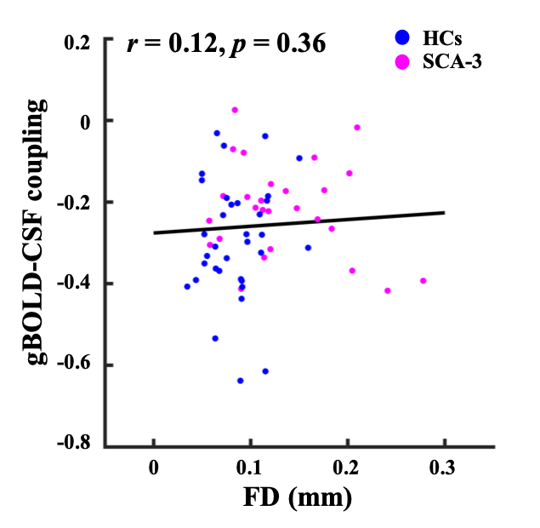

Figure S1.
The head motion did not affect the BOLD-CSF coupling strength. The head motion of subjects, quantified by mean FD, was not correlated with the BOLD-CSF coupling strength (r = 0.12, p = 0.36).

Figure S2. The BOLD-CSF coupling strength is associated with age, and differed between HC and SCA3 groups, as well as across brain regions. (A) The strength of gBOLD-CSF coupling, quantified as the cross-correlation at +3s, presented significantly positive correlation (Spearman’s correlation, r = 0.33, p = 0.01) with age across all subjects (N = 62). Blue and magenta dots indicate HCs (N = 35) and SCA3 patients (N = 27). (B) Male and female subjects showed no different gBOLD-CSF coupling in the whole cohort (t₍₆₀₎ = 1.013, p = 0.315; Independent-samples t test). Blue and magenta bars indicate males (N = 36) and females (N = 26). Error bars represent the standard deviation (SD).

References
1. Wang, Z., et al., Reduced coupling of global brain function and cerebrospinal fluid dynamics in Parkinson’s disease. Journal of Cerebral Blood Flow & Metabolism, 2023. 43(8): p. 1328-1339.
2. Han, F., et al., Reduced coupling between cerebrospinal fluid flow and global brain activity is linked to Alzheimer disease–related pathology. PLoS biology, 2021. 19(6): p. e3001233.
3. Gaser, C., et al., CAT-a computational anatomy toolbox for the analysis of structural MRI data. BioRxiv, 2022: p. 2022.06. 11.495736.
4. Power, J.D., et al., Spurious but systematic correlations in functional connectivity MRI networks arise from subject motion. Neuroimage, 2012. 59(3): p. 2142-2154.
5. Smyser, C.D., et al., Longitudinal analysis of neural network development in preterm infants. Cerebral cortex, 2010. 20(12): p. 2852-2862.
6. Andersson, J.L., et al., Incorporating outlier detection and replacement into a non-parametric framework for movement and distortion correction of diffusion MR images. Neuroimage, 2016. 141: p. 556-572.

