Pre- Assessment Questions
Prior to today, how much experience do you have with Bedside Ultrasound?
None, 1-4 hours of training, 4-20 hours of training, 20 or more hours of training
and/or significant clinical ultrasound experience, other
Pre- and Post-Assessment Questions
How important do you perceive bedside ultrasound will be in your career?
Rate your comfort with ultrasound in general
Rate your comfort with cardiac ultrasound exams
Rate your comfort with abdominal ultrasound exams
Rate your comfort with eFAST/Trauma ultrasound exams
Rate your comfort with vascular ultrasound exams
Rate your comfort performing ultrasound-guided procedures
Post-Assessment Questions
How does this course compare to your prior ultrasound training?
Far beyond, better, similar, not as good, terrible
Would you recommend this program to your colleagues?
Strongly yes, yes, neutral, no, strongly no
What was your favorite station
Cardiac, abdomen, eFAST (Trauma), Vascular, Procedure, Ocular
How can we improve this course in the future?

Supplemental Table 1. Pre- and Post-Survey Questions were denoted on a 10-point Likert Scale.

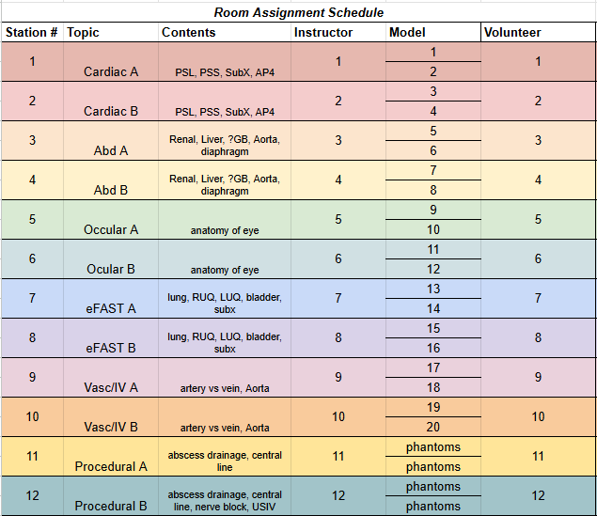
Supplemental Table 2. Room Rotation Assignments. Demonstration of room instructor, model, and volunteer staffing for each station.

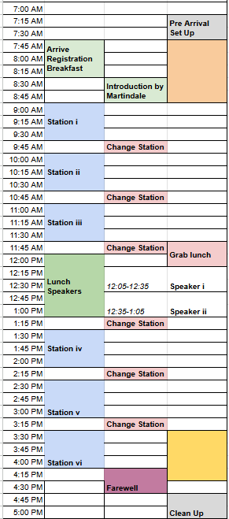
Supplemental Table 3. Day of Event Rotation Schedule.

Participant Identifier | Perceived Importance of US |  |  | General Ultrasound |  |  | Cardiac Comfort |  |  | Abdominal |  |  | eFAST/Trauma |  |  | Vascular |  |  | US-guided procedures
Participant Identifier | Pre | Post | Δ | Pre | Post | Δ | Pre | Post | Δ | Pre | Post | Δ | Pre | Post | Δ | Pre | Post | Δ | Pre | Post | Δ
1 | 9 | 10 | 1 | 2 | 7 | 5 | 3 | 9 | 6 | 2 | 6 | 4 | 1 | 6 | 5 | 2 | 9 | 7 | 1 | 8 | 7
4 | 10 | 10 | 0 | 5 | 10 | 5 | 3 | 8 | 5 | 3 | 9 | 6 | 3 | 9 | 6 | 3 | 9 | 6 | 2 | 8 | 6
6 | 10 | 10 | 0 | 5 | 8 | 3 | 3 | 8 | 5 | 2 | 8 | 6 | 3 | 8 | 5 | 8 | 9 | 1 | 3 | 9 | 6
7 | 10 | 10 | 0 | 6 | 8 | 2 | 6 | 7 | 1 | 3 | 8 | 5 | 5 | 8 | 3 | 6 | 10 | 4 | 3 | 9 | 6
11 | 10 | 10 | 0 | 5 | 7 | 2 | 6 | 8 | 2 | 2 | 6 | 4 | 2 | 7 | 5 | 3 | 7 | 4 | 3 | 7 | 4
12 | 8 | 8 | 0 | 3 | 7 | 4 | 3 | 6 | 3 | 2 | 8 | 6 | 3 | 8 | 5 | 3 | 8 | 5 | 2 | 6 | 4
15 | 5 | 4 | -1 | 2 | 3 | 1 | 3 | 4 | 1 | 3 | 3 | 0 | 1 | 5 | 4 | 1 | 2 | 1 | 1 | 2 | 1
18 | 5 | 5 | 0 | 3 | 5 | 2 | 1 | 4 | 3 | 3 | 7 | 4 | 1 | 7 | 6 | 3 | 8 | 5 | 3 | 8 | 5
22 | 7 | 6 | -1 | 4 | 7 | 3 | 5 | 6 | 1 | 4 | 7 | 3 | 5 | 7 | 2 | 5 | 6 | 1 | 5 | 6 | 1
25 | 7 | 7 | 0 | 3 | 6 | 3 | 1 | 5 | 4 | 1 | 7 | 6 | 1 | 8 | 7 | 1 | 7 | 6 | 5 | 5 | 0
26 | 10 | 10 | 0 | 1 | 7 | 6 | 1 | 8 | 7 | 1 | 6 | 5 | 1 | 6 | 5 | 1 | 9 | 8 | 1 | 7 | 6
27 | 4 | 4 | 0 | 3 | 8 | 5 | 2 | 8 | 6 | 3 | 8 | 5 | 2 | 8 | 6 | 2 | 8 | 6 | 2 | 8 | 6
31 | 8 | 10 | 2 | 3 | 7 | 4 | 2 | 6 | 4 | 3 | 7 | 4 | 3 | 6 | 3 | 4 | 7 | 3 | 3 | 6 | 3
33 | 10 | 10 | 0 | 4 | 9 | 5 | 4 | 9 | 5 | 2 | 9 | 7 | 2 | 9 | 7 | 10 | 10 | 0 | 6 | 9 | 3
36 | 10 | 10 | 0 | 3 | 6 | 3 | 2 | 5 | 3 | 2 | 5 | 3 | 3 | 5 | 2 | 2 | 5 | 3 | 2 | 5 | 3
39 | 8 | 9 | 1 | 5 | 8 | 3 | 4 | 6 | 2 | 2 | 6 | 4 | 2 | 8 | 6 | 7 | 8 | 1 | 5 | 7 | 2
42 | 5 | 7 | 2 | 1 | 4 | 3 | 1 | 4 | 3 | 1 | 4 | 3 | 1 | 4 | 3 | 1 | 4 | 3 | 1 | 4 | 3
44 | 10 | 10 | 0 | 3 | 5 | 2 | 2 | 5 | 3 | 3 | 5 | 2 | 4 | 5 | 1 | 3 | 4 | 1 | 5 | 4 | -1
47 | 8 | 5 | -3 | 2 | 6 | 4 | 2 | 8 | 6 | 2 | 6 | 4 | 2 | 8 | 6 | 2 | 5 | 3 | 2 | 5 | 3
51 | 10 | 10 | 0 | 6 | 8 | 2 | 3 | 8 | 5 | 3 | 8 | 5 | 6 | 8 | 2 | 6 | 8 | 2 | 5 | 8 | 3
52 | 8 | 8 | 0 | 3 | 7 | 4 | 3 | 7 | 4 | 2 | 6 | 4 | 2 | 6 | 4 | 2 | 6 | 4 | 2 | 5 | 3
53 | 10 | 10 | 0 | 8 | 8 | 0 | 6 | 7 | 1 | 5 | 8 | 3 | 6 | 9 | 3 | 6 | 7 | 1 | 7 | 8 | 1
64 | 8 | 9 | 1 | 4 | 9 | 5 | 3 | 9 | 6 | 3 | 9 | 6 | 4 | 9 | 5 | 3 | 9 | 6 | 2 | 9 | 7
66 | 10 | 8 | -2 | 5 | 8 | 3 | 1 | 7 | 6 | 2 | 8 | 6 | 1 | 8 | 7 | 3 | 10 | 7 | 1 | 6 | 5
72 | 2 | 5 | 3 | 4 | 6 | 2 | 2 | 5 | 3 | 4 | 8 | 4 | 7 | 9 | 2 | 4 | 6 | 2 | 4 | 6 | 2
73 | 10 | 9 | -1 | 4 | 6 | 2 | 4 | 6 | 2 | 1 | 6 | 5 | 1 | 6 | 5 | 3 | 6 | 3 | 3 | 5 | 2
76 | 10 | 10 | 0 | 3 | 6 | 3 | 2 | 5 | 3 | 3 | 6 | 3 | 3 | 6 | 3 | 3 | 6 | 3 | 3 | 5 | 2
81 | 10 | 10 | 0 | 2 | 10 | 8 | 1 | 10 | 9 | 1 | 10 | 9 | 1 | 10 | 9 | 1 | 10 | 9 | 1 | 10 | 9
82 | 10 | 10 | 0 | 3 | 5 | 2 | 1 | 5 | 4 | 3 | 6 | 3 | 2 | 5 | 3 | 1 | 5 | 4 | 4 | 4 | 0
83 | 8 | 10 | 2 | 6 | 9 | 3 | 5 | 9 | 4 | 4 | 9 | 5 | 5 | 9 | 4 | 7 | 8 | 1 | 6 | 7 | 1
86 | 10 | 10 | 0 | 1 | 8 | 7 | 1 | 8 | 7 | 1 | 7 | 6 | 1 | 7 | 6 | 1 | 8 | 7 | 1 | 8 | 7
91 | 10 | 10 | 0 | 8 | 9 | 1 | 6 | 8 | 2 | 5 | 8 | 3 | 8 | 9 | 1 | 1 | 6 | 5 | 3 | 5 | 2
93 | 9 | 9 | 0 | 2 | 8 | 6 | 2 | 8 | 6 | 2 | 7 | 5 | 2 | 9 | 7 | 3 | 8 | 5 | 2 | 8 | 6
94 | 8 | 10 | 2 | 7 | 8 | 1 | 6 | 8 | 2 | 3 | 8 | 5 | 4 | 8 | 4 | 7 | 8 | 1 | 5 | 8 | 3
96 | 10 | 10 | 0 | 5 | 6 | 1 | 3 | 5 | 2 | 3 | 5 | 2 | 5 | 5 | 0 | 7 | 6 | -1 | 5 | 6 | 1
101 | 10 | 10 | 0 | 6 | 8 | 2 | 4 | 8 | 4 | 4 | 8 | 4 | 9 | 9 | 0 | 4 | 7 | 3 | 4 | 7 | 3
103 | 10 | 10 | 0 | 6 | 9 | 3 | 7 | 9 | 2 | 3 | 9 | 6 | 10 | 9 | -1 | 8 | 7 | -1 | 6 | 8 | 2
105 | 8 | 9 | 1 | 3 | 5 | 2 | 6 | 7 | 1 | 1 | 4 | 3 | 1 | 4 | 3 | 2 | 4 | 2 | 2 | 6 | 4
111 | 7 | 3 | -4 | 4 | 8 | 4 | 3 | 7 | 4 | 2 | 6 | 4 | 3 | 8 | 5 | 3 | 7 | 4 | 2 | 7 | 5
113 | 9 | 9 | 0 | 6 | 8 | 2 | 1 | 7 | 6 | 1 | 7 | 6 | 1 | 7 | 6 | 6 | 8 | 2 | 2 | 8 | 6
115 | 10 | 10 | 0 | 3 | 6 | 3 | 1 | 6 | 5 | 1 | 7 | 6 | 3 | 8 | 5 | 4 | 7 | 3 | 2 | 5 | 3
116 | 8 | 9 | 1 | 2 | 5 | 3 | 1 | 5 | 4 | 2 | 2 | 0 | 2 | 3 | 1 | 2 | 5 | 3 | 1 | 2 | 1
117 | 7 | 7 | 0 | 4 | 4 | 0 | 4 | 5 | 1 | 2 | 5 | 3 | 3 | 4 | 1 | 7 | 4 | -3 | 4 | 4 | 0
avg | 8.51 | 8.60 | 0.09 | 3.91 | 7.02 | 3.12 | 3.02 | 6.81 | 3.79 | 2.44 | 6.79 | 4.35 | 3.14 | 7.14 | 4.00 | 3.74 | 7.00 | 3.26 | 3.07 | 6.47 | 3.40
st dev | 1.97 | 2.05 | 1.22 | 1.78 | 1.66 | 1.74 | 1.81 | 1.59 | 1.96 | 1.09 | 1.73 | 1.75 | 2.29 | 1.77 | 2.28 | 2.39 | 1.89 | 2.53 | 1.67 | 1.89 | 2.29
avg+stdev | 10.48 | 10.65 | 1.31 | 5.69 | 8.68 | 4.86 | 4.84 | 8.40 | 5.75 | 3.53 | 8.52 | 6.10 | 5.43 | 8.91 | 6.28 | 6.14 | 8.89 | 5.78 | 4.74 | 8.35 | 5.69
avg-stdev | 6.55 | 6.55 | -1.12 | 2.13 | 5.36 | 1.37 | 1.21 | 5.22 | 1.83 | 1.36 | 5.06 | 2.60 | 0.85 | 5.37 | 1.72 | 1.35 | 5.11 | 0.73 | 1.40 | 4.58 | 1.11

Supplemental Table 4. Paired and Matched Participant responses pre- and post-event. Survey responses regarding the comfort of each scan pre- and post-course completion. Responses were matched by deidentified participant numbers assigned at registration. Each response by surveyed Likert scale 1-10.

Instructor Guide (Supplemental Content) —> https://docs.google.com/document/d/1gOuHN3RZ8k6v1DlllMD4_bcZHxYvaXzFMSDjrRWkWQ8/edit?usp=sharing
Volunteer Recruitment Powerpoint (Supplemental Content)

