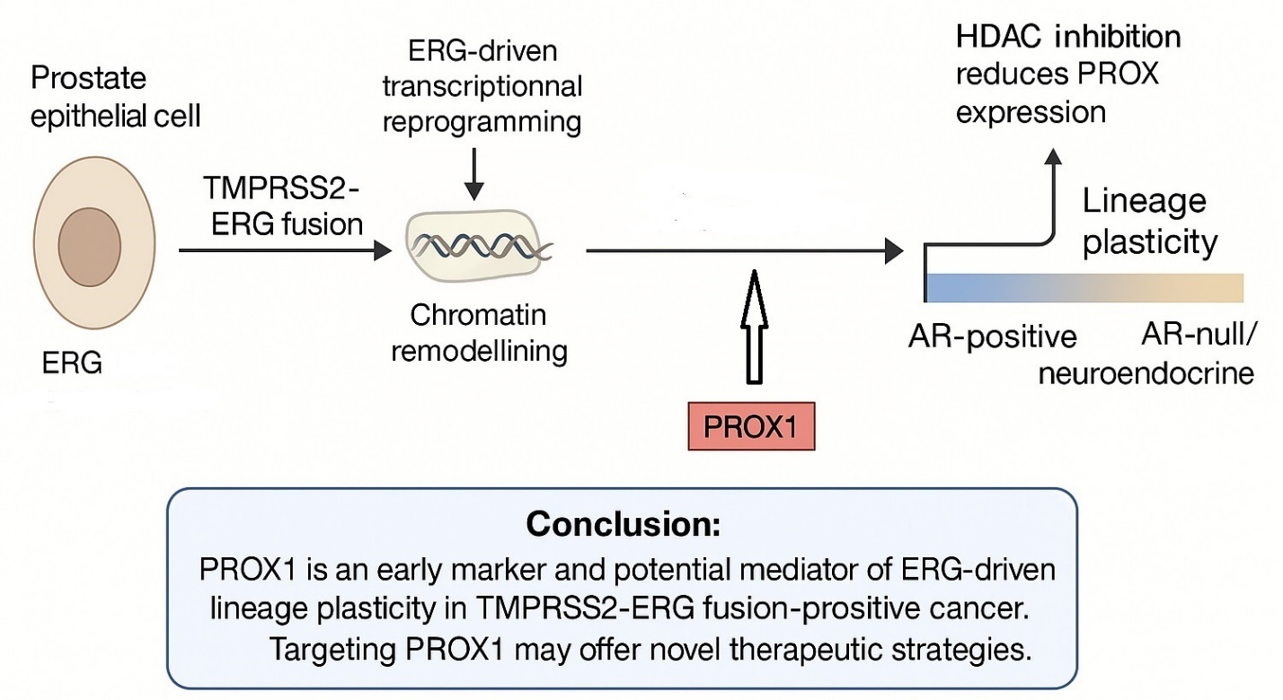
Graphical abstract: TMPRSS2-ERG fusion leads to ERG overexpression and transcriptional reprogramming in prostate cancer. PROX1 expression is induced in fusion-positive tumors and correlates strongly with ERG expression. PROX1 promotes lineage plasticity and may be targetable via histone deacetylase (HDAC) inhibition. Our findings support PROX1 as an early marker and potential driver of plasticity-linked treatment resistance in TMPRSS2-ERG fusion-positive disease.

