Table I. Gene Ontogeny Categories
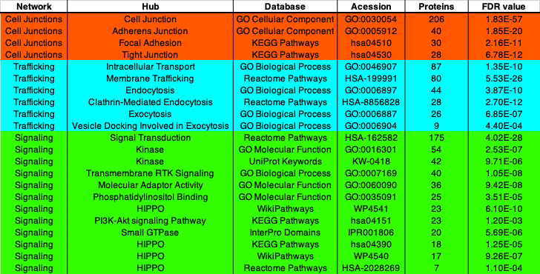
Table I. Gene Ontogeny Categories. Merlin proximal proteins mapped to each gene ontogeny term, the specific GO databases, including their description, specific accession number and the p-value associated with the analysis.

Table II. Selected Merlin Proximal Proteins.
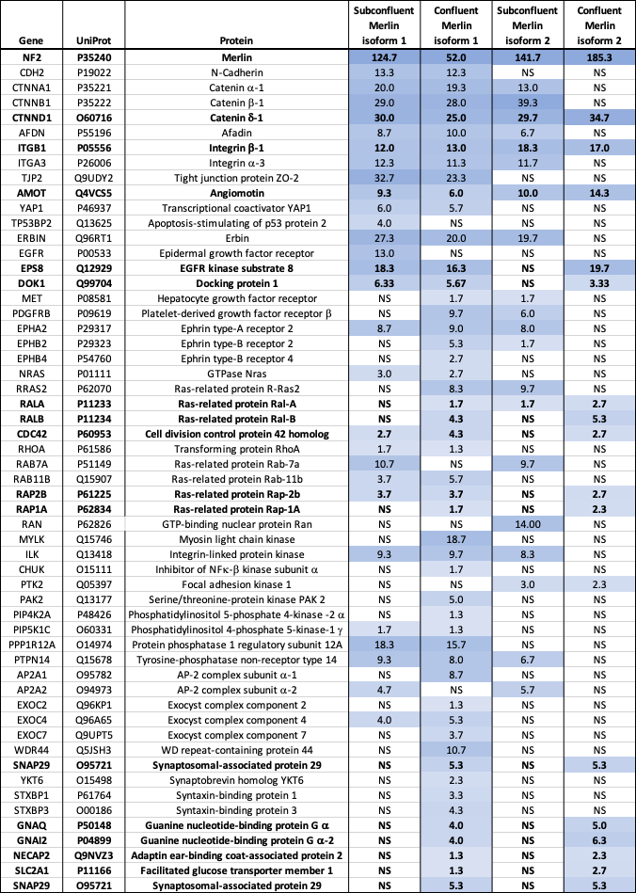
Table II. Selected Merlin Proximal Proteins. Merlin proximal proteins that were mentioned in the text, showing the mean normalized peptide count per 10,000 in each experimental condition, the intensity of the blue background is proportional the peptide count. NS indicates no significant difference in mean peptide number relative to the APEX only control. Proteins highlighted in bold are proximal to both isoform 1 and isoform 2 in confluent cells.

