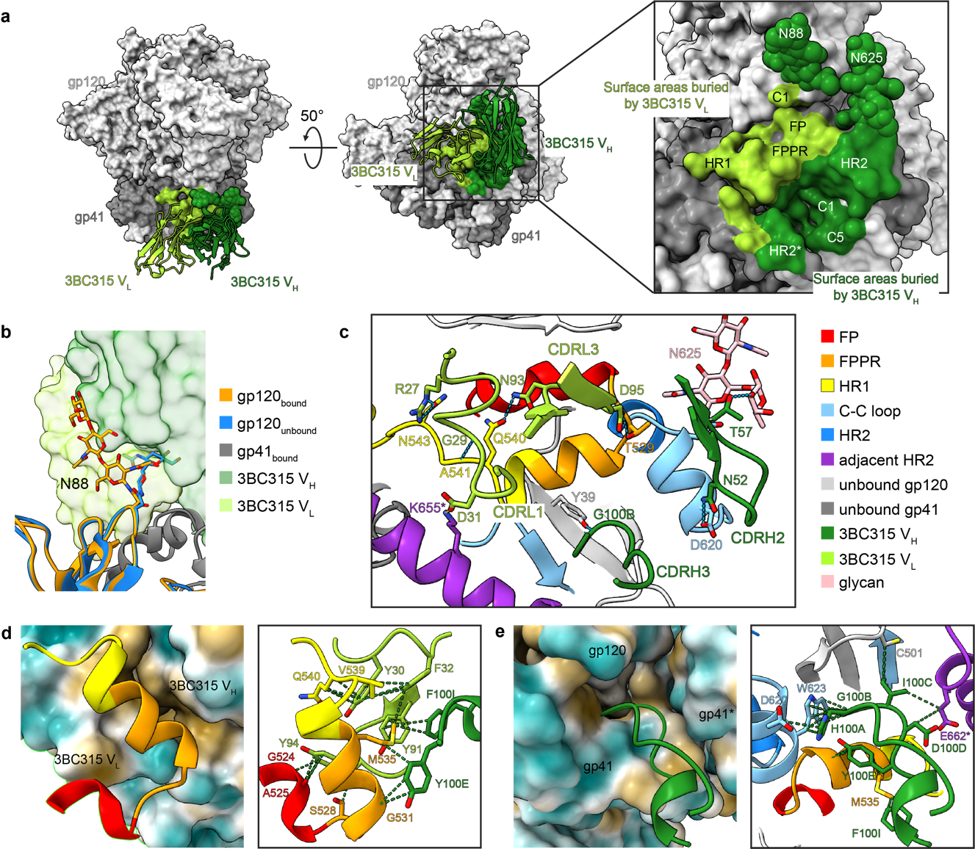
Extended Data Fig. 1 | Epitope analysis of 3BC315 in AMC008-PGT121-VRC01-3BC315. a Left and middle: surface areas of AMC008 buried by 3BC315 Fab. Right: close-up view of the 3BC315 binding epitope. b Glycan N88 is flipped to accommodate 3BC315. c Hydrophilic interactions at the AMC008-3BC315 epitope-paratope interface. d Left: G524-G540 of AMC008 interact with a highly hydrophobic groove at the interface of 3BC315 heavy chain and light chain formed by six aromatic amino acid residues. The surfaces of 3BC315 are colored by hydrophobicity. Right: hydrophobic contacts at the interface. e Left: 3BC315 CDRH3 is inserted into a hydrophobic hole on the AMC008 gp120-gp41-gp41* interface. The surfaces of AMC008 are colored by hydrophobicity. Right: hydrophobic contacts at the interface. Hydrogen bonds are indicated by blue dashed lines; salt bridges are indicated by orange dashed lines; hydrophobic contacts are indicated by green dashed lines. Amino acids from the adjacent protomer are labeled by * marks. PGT121 and VRC01 Fabs are hidden for better visualization in b-f. Coloring schemes of ribbon representation in e and f are same as d.

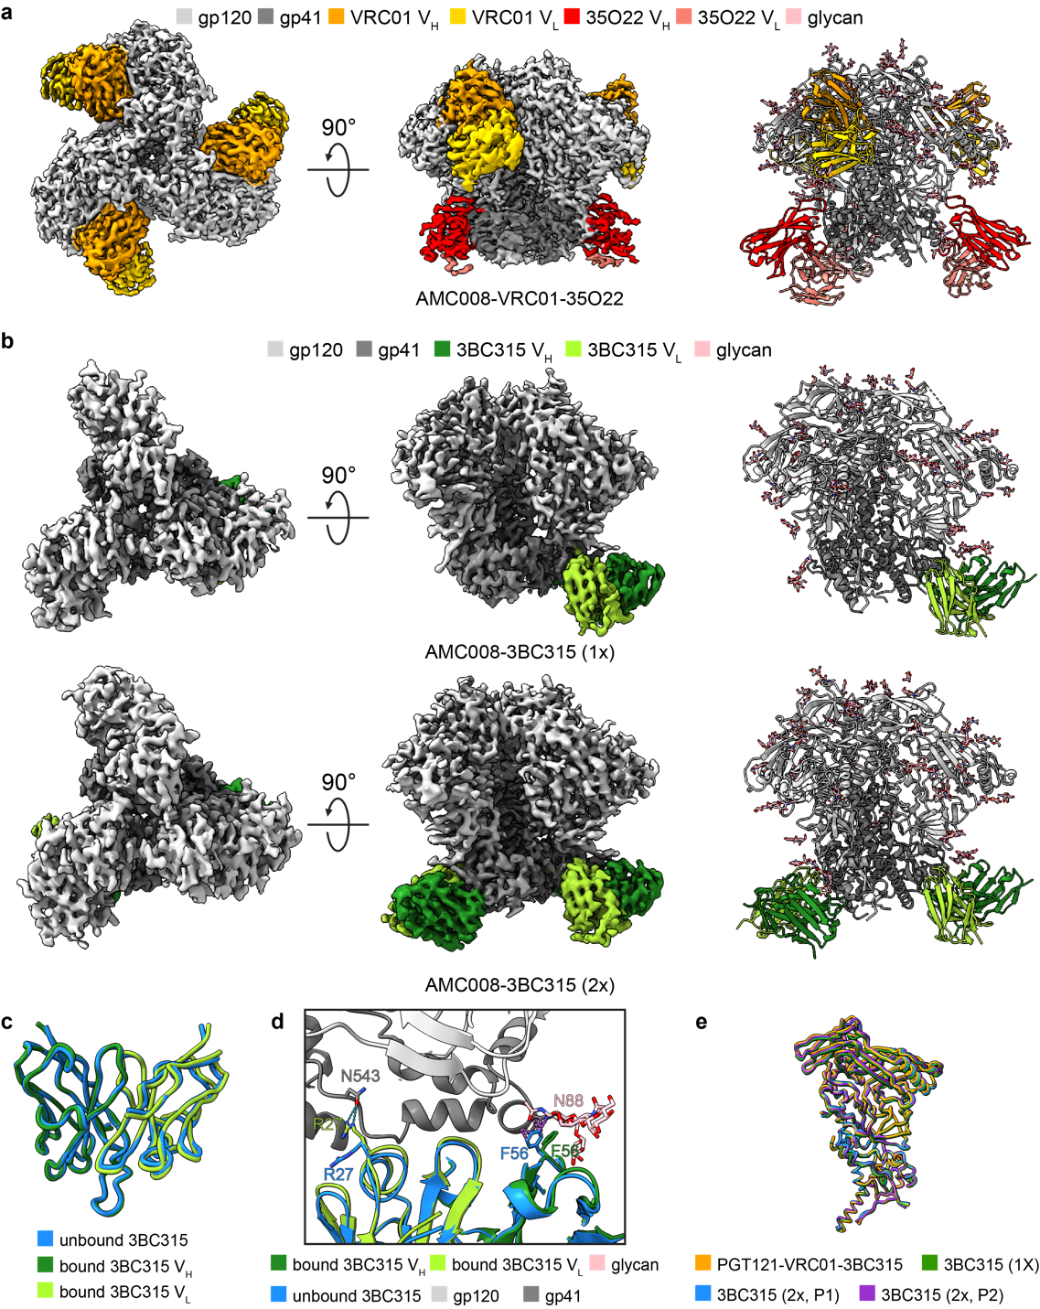
Extended Data Fig. 2 | Supplementary data of 3BC315-bound AMC008 SOSIP. a 2.9 Å cryo-EM density map (left and middle, top and side views) and atomic model (right) of AMC008 in complex with VRC01 and 35O22 Fabs. b 3.6 Å and 3.5 Å cryo-EM density maps (left and middle, top and side views) and atomic models (right) of AMC008 in complex with one 3BC315 Fab (top) and two 3BC315 Fabs (bottom). c Comparison of AMC008 bound 3BC315 to unliganded 3BC315 crystal structure (5CCK). d Conformational changes of 3BC315 after binding to AMC008. e Comparison of 3BC315 liganded AMC008 protomers in AMC008-PGT121-VRC01-3BC315, AMC008-3BC315 (1x), and AMC008-3BC315 (2x). P1, 3BC315-liganded Protomer 1, P2, 3BC315-liganded Protomer 2.

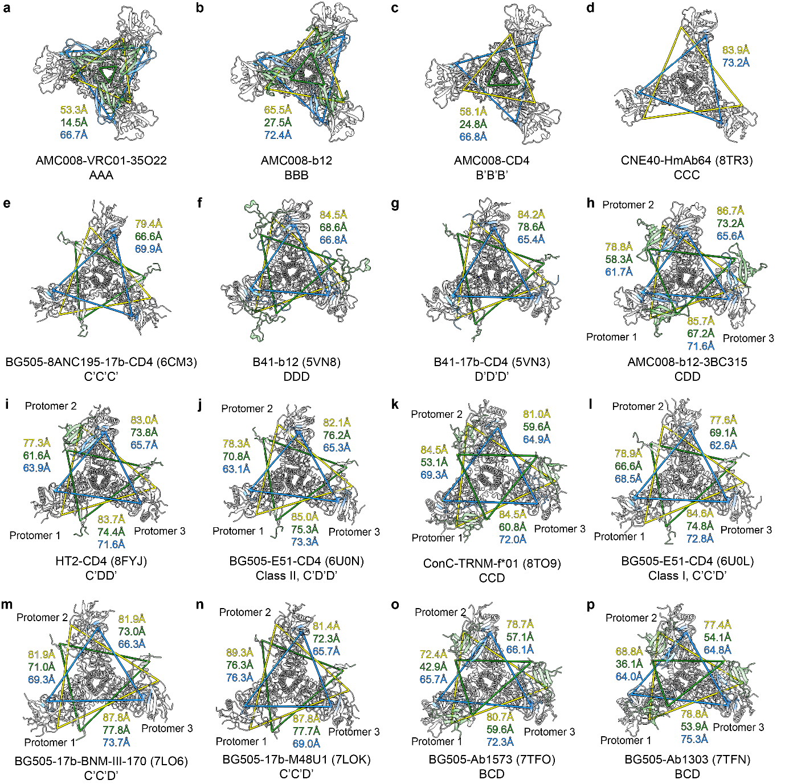
Extended Data Fig. 3 | Measurement of interprotomer distances. a-p Measurement of interprotomer distances of V1V2 apex (Pro124, green), V3 (Cys296, blue) and, CD4bs (Asp368, yellow) in closed (AMC008-VRC01-35O22, a), b12-bound moderately open (AMC008-b12, b), CD4-bound moderately open (AMC008-b12, c), HmAb64-bound partially open (CNE40-HmAb64, d), CD4-bound partially open (BG505-8ANC195-17b-CD4, e), b12-bound fully open (B41-b12 ,f), CD4-bound fully open (B41-17b-CD4, g), b12 and 3BC315-bound asymmetric open (AMC008-b12-3BC315, h), two CD4 bound asymmetric open (HT2-CD4, i), three CD4-bound asymmetric open (BG505-E51-CD4, Class I and II, l and j), TRNM-f*01-bound asymmetric open (Conc-TRNM-f*01, k), BNM-III-170-bound asymmetric open (BG505-17b-BNM-III-170, m), M48U1-bound asymmetric open (BG505-17b-M48U1, n), Ab1303-bound asymmetric open (BG505-Ab1303, o), and Ab1573-bound asymmetric open (BG505-Ab1573, p) Env models. V1 and V2 loops are colored in green; V3 loop is colored in blue; gp120 is colored in light gray; gp41s is colored in gray. Fabs and CD4s are hidden for better visualization. Closed states are denoted with A, moderately open states are denoted with B, partially open states are denoted with C, fully open states are denoted with D, CD4-bound states are denoted with ’. Pro124 residues are not ordered in c.

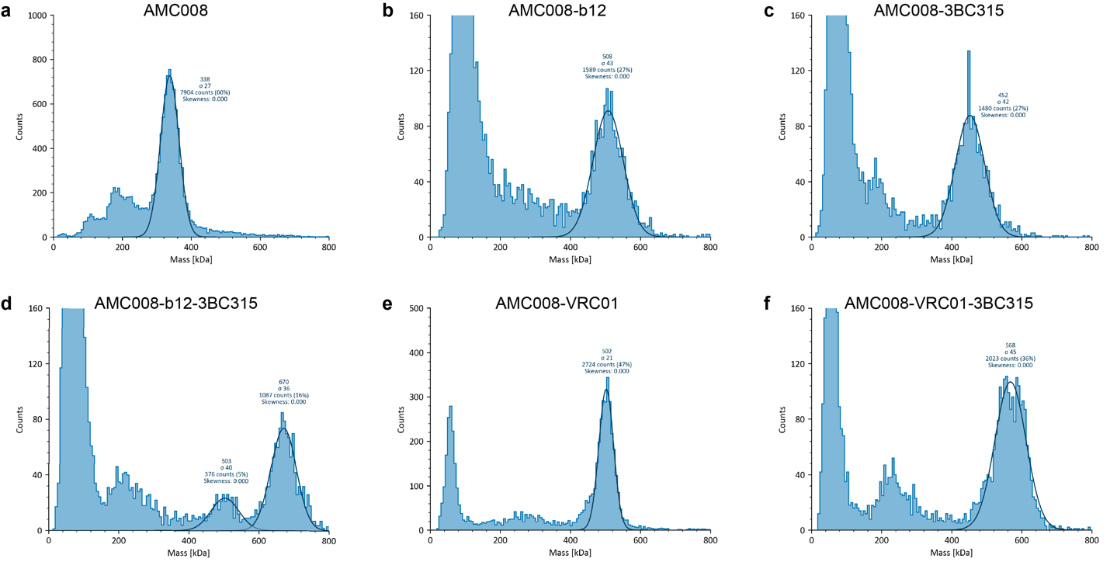Extended Data Fig. 4 | Raw data of mass photometry experiments. a-f Mass histograms of AMC008 SOSIP.v4.2 (a) and AMC008 in complex with excess b12 (b), 3BC315 (c), b12 and 3BC315 (d), VRC01 (e), VRC01 and 3BC315 (f).

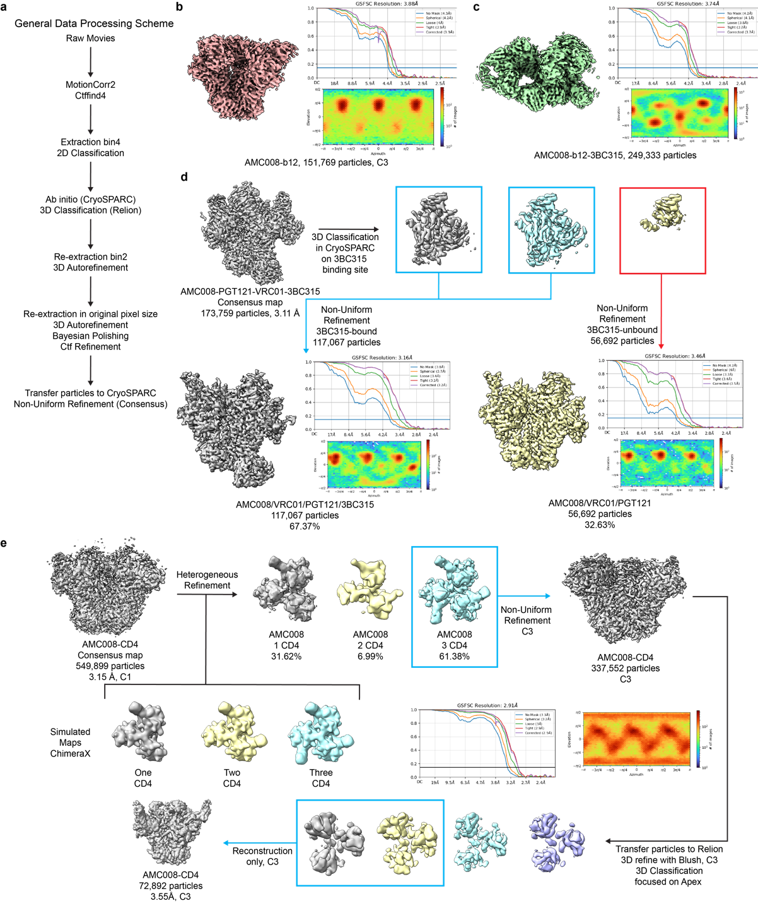
Extended Data Fig. 5 | Cryo-EM data processing scheme Ι. a General cryo-EM data processing scheme to generate consensus maps in this study. Final cryo-EM density maps AMC008 in complex with (b) b12, and (c) b12 and 3BC315 along with their GS-FSC curve, resolution and particle distribution plot. d Additional Cryo-EM data processing for AMC008 in complex with PGT121, VRC01, and 3BC315. Particles used for the reconstruction of the consensus map were 3D classified focused on the 3BC315 binding site. Classes that have 3BC315 binding were combined and used for Non-Uniform Refinement. e Additional Cryo-EM data processing for AMC008 in complex with CD4.

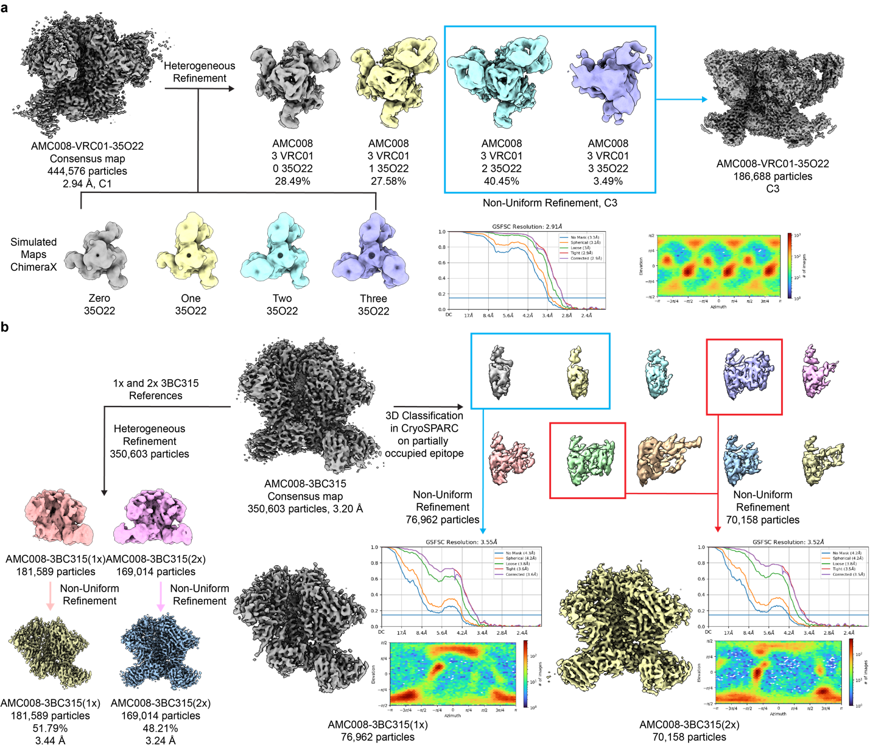Extended Data Fig. 6 | Cryo-EM data processing scheme ΙI. a Additional Cryo-EM data processing for AMC008 in complex with VRC01 and 35O22. Simulated maps generated using ChimeraX were used as templates for Heterogeneous refinement using particles from the consensus map of AMC008/VRC01/35O22. Classes with two and three 35O22 occupancy were combined and used for Non-Uniform Refinement with C3 symmetry. b Additional Cryo-EM data processing for AMC008 in complex with 3BC315. Particles used for the reconstruction of the consensus map were 3D classified followed by Non-Uniform Refinement to generate AMC008 Envs occupied with one 3BC315 and two 3BC315.

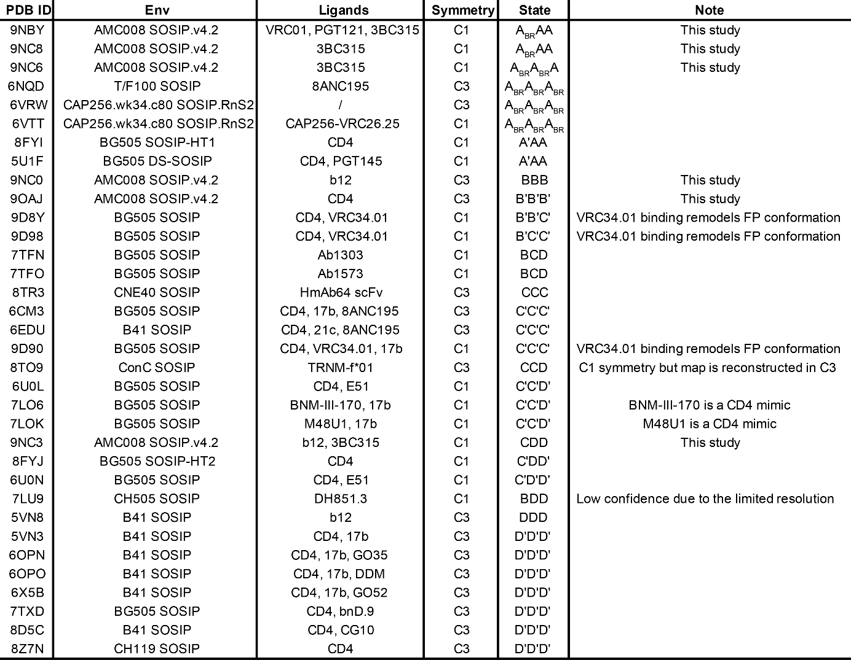
Extended Data Table 1 | Summary of non-AAA Env structures classified by protomeric states in the PDB database. A, B, C, and D denote closed, moderately open, partially open, and fully open states. CD4-bound states are denoted with ’, base-relaxed states are denoted with BR. Fusion peptide conformations in BG505-CD4-VRC34.01 (states B’B’C’ and B’C’C’) and BG505-CD4-VRC34.01-17b (state C’C’C’) are remodeled by the binding of fusion peptide targeting antibody VRC34.01. Thus, the gp41 conformation of these complexes does not align with our model, but the gp120 openness, V1V2 displacement, formation of 4-stranded bridging sheet and α0 helix agree with states B’B’C’, B’C’C’, and C’C’C’.

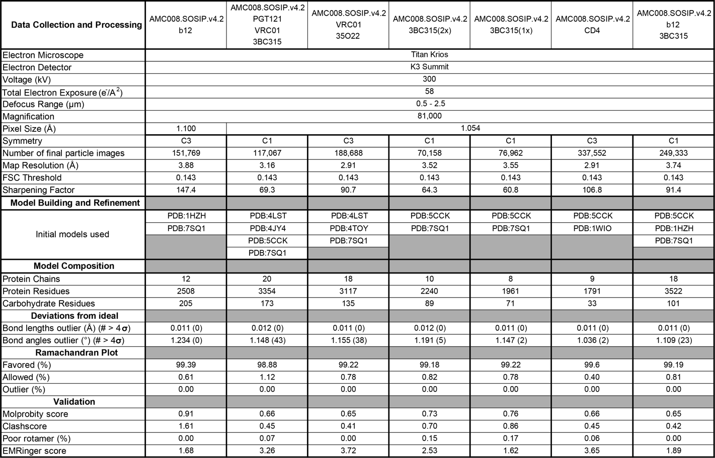
Extended Data Table 2 | Cryo-EM data collection, model refinement and validation statistics.

Movie 1 | Direct Conformational Change from Occluded Closed to Occluded Open Env leads to V2 clashes. Linear conformational interpolation from our closed state AAA Env (AMC008-VRC01-35O22) to our open state CDD Env (AMC008-b12-3BC315) reveals massive steric clashes between amino acid positions 163-168 (chartreuse) of the V2 region (otherwise red). gp120 is shown in light gray and gp41 in slate gray.

Movie 2 | Conformational Change from Occluded Closed over Moderately Open to Occluded Open Env. Conformational interpolation from our closed state AAA Env (AMC008-VRC01-35O22) over our moderately open state BBB Env (AMC008-b12) to our open state CDD Env (AMC008-b12-3BC315) relieves the V2 clashes observed in Movie 1. Thus, moderately open state BBB Env is instrumental to understanding the Env conformational path from closed to open conformations. Coloration as in Movie 1.

