Supplementary Materials

Drug abbreviations

Abbreviation | Name
AMK | Amikacin
BDQ | Bedaquiline
BDQ-M2 | Bedaquiline M2 metabolite
BTZ-043 | -
CFZ | Clofazimine
DLM | Delamanid
EMB | Ethambutol
GFB | Ganfeborole
GSK-286 | -
GTX | Gatifloxacin
INH | Isoniazid
KAN | Kanamycin
LZD | Linezolid
MXF | Moxifloxacin
PMD | Pretomanid
PZA | Pyrazinamide
QBD | Quabodepistat
RBT | Rifabutin
RIF | Rifampin
RPT | Rifapentine
SZD | Sutezolid
SZD-M1 | Sutezolid M1 metabolite
TBAJ-587 | -
TBAJ-587-M3 | TBAJ-587 M3 metabolite
TBAJ-876 | -
TBAJ-876-M3 | TBAJ-876 M3 metabolite
TBD-11 | -
TBI-223 | -

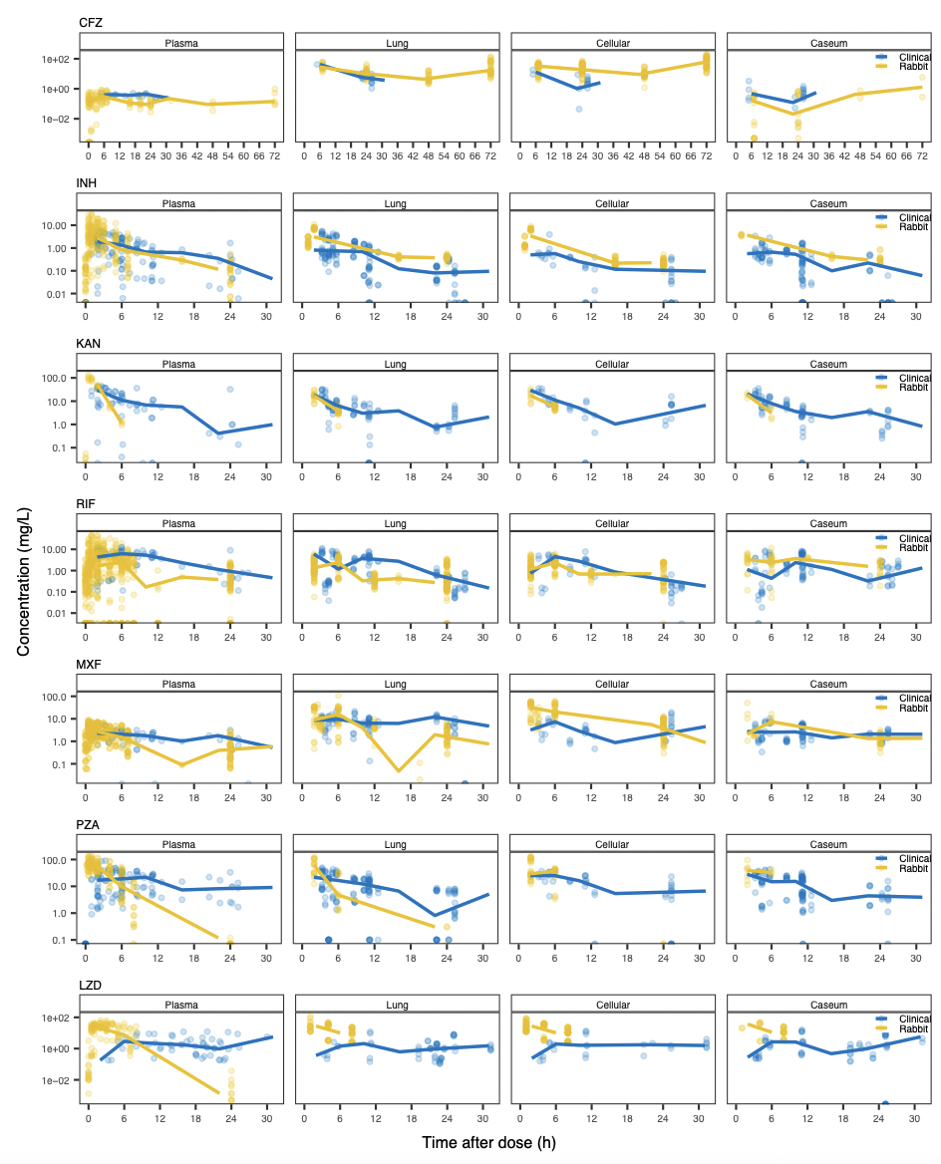

Supplementary Figure 1. Detailed focus on clinical (yellow) and rabbit (blue) plasma and tissue pharmacokinetic data for seven approved drugs.
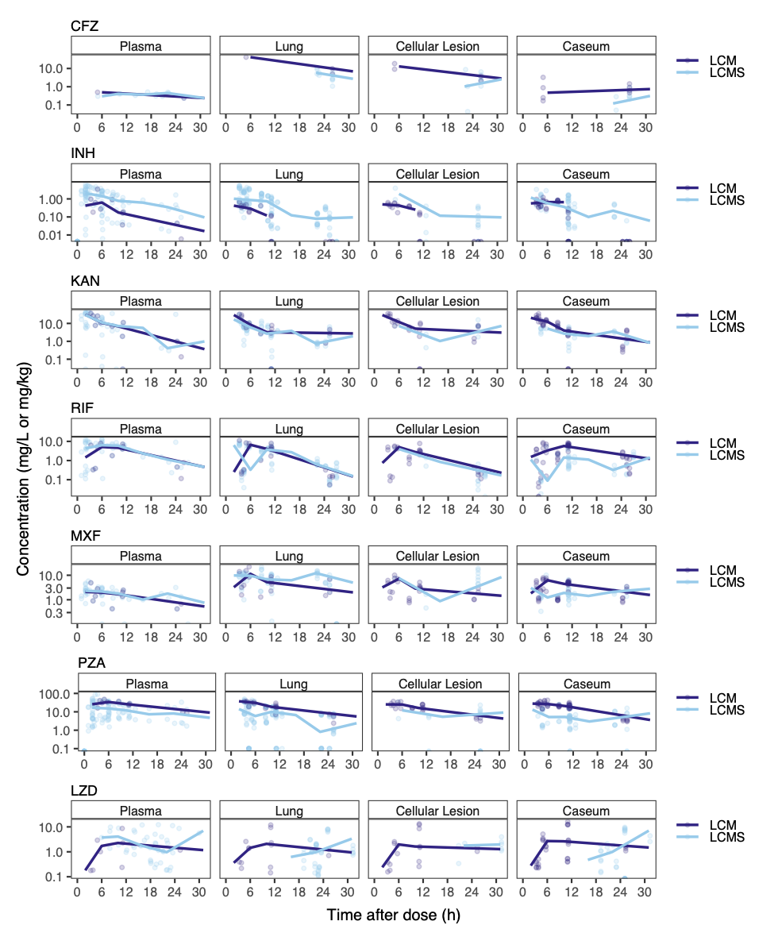

Supplementary Figure 2. Clinical plasma and tissue data using tissue homogenates and laser-capture microdissection (LCM) samples, both analyzed by liquid chromatography-tandem mass spectrometry (LC-MS/MS).
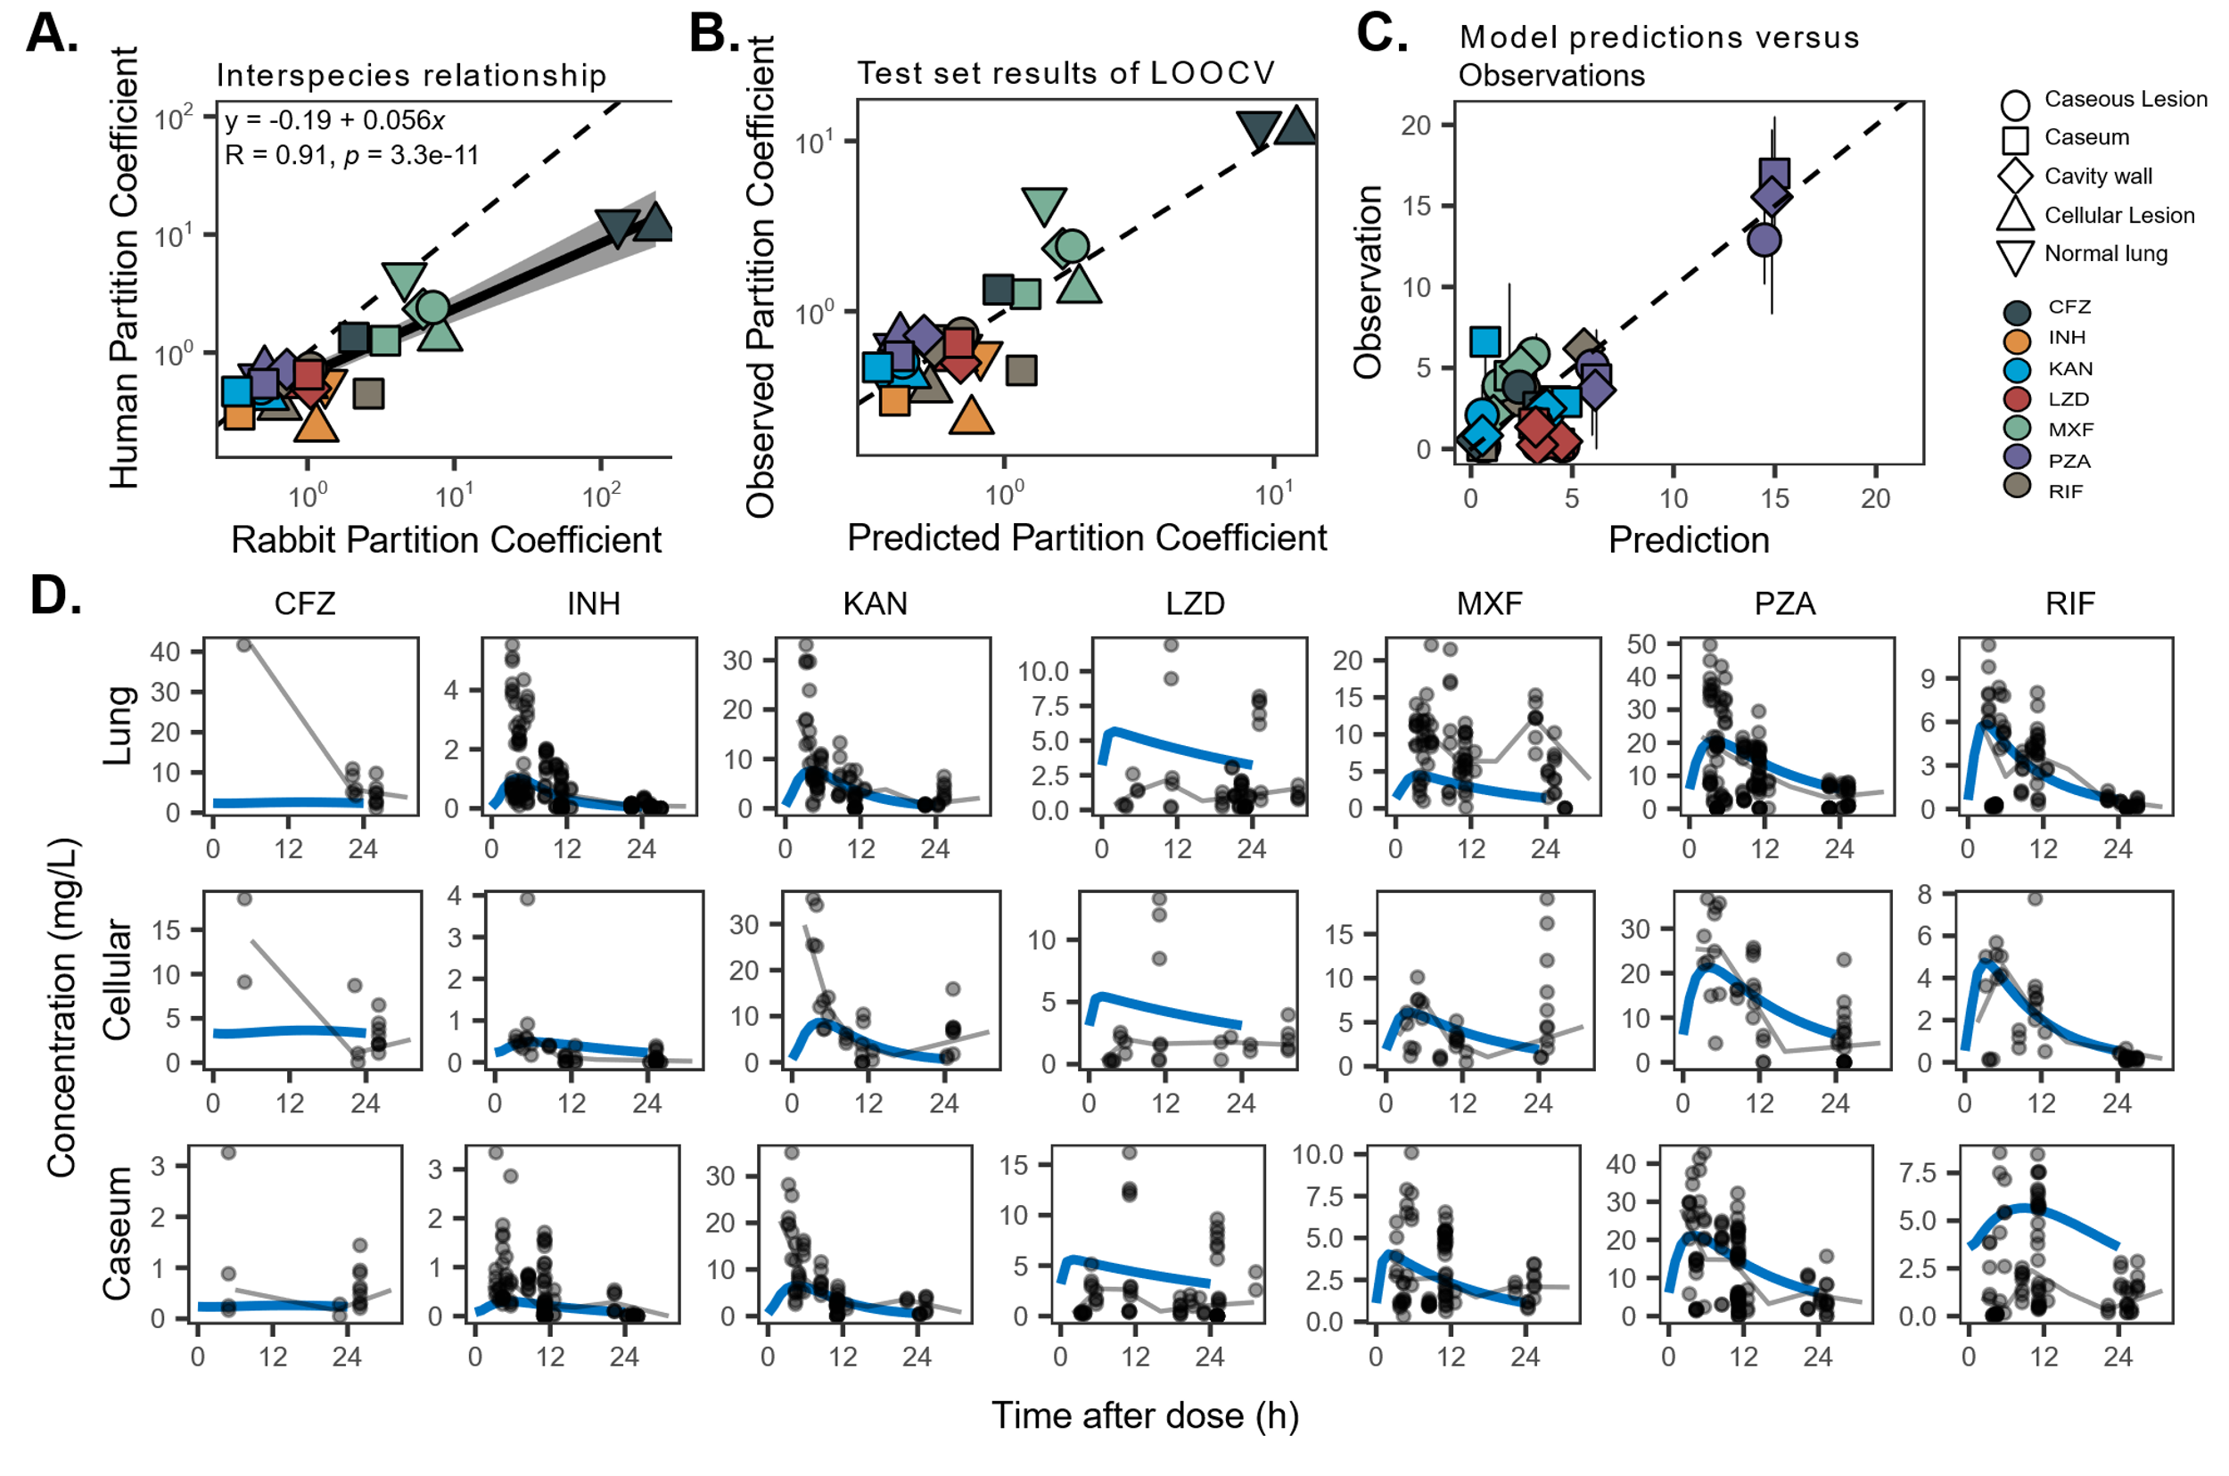
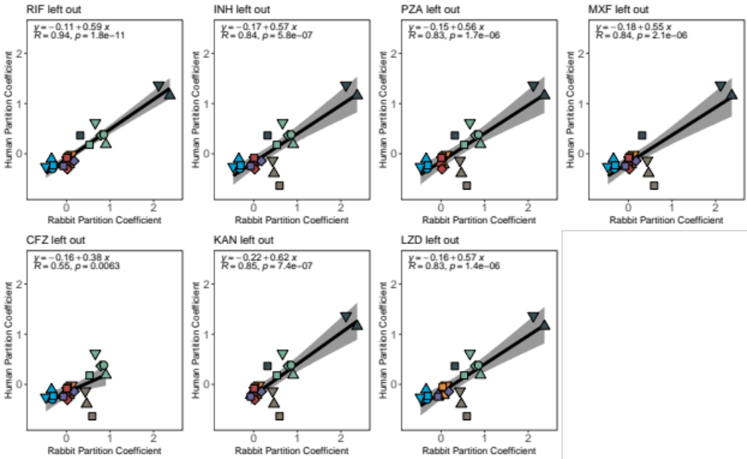

Supplementary Figure 3. Sensitivity analysis of the leave-one-out cross validation.
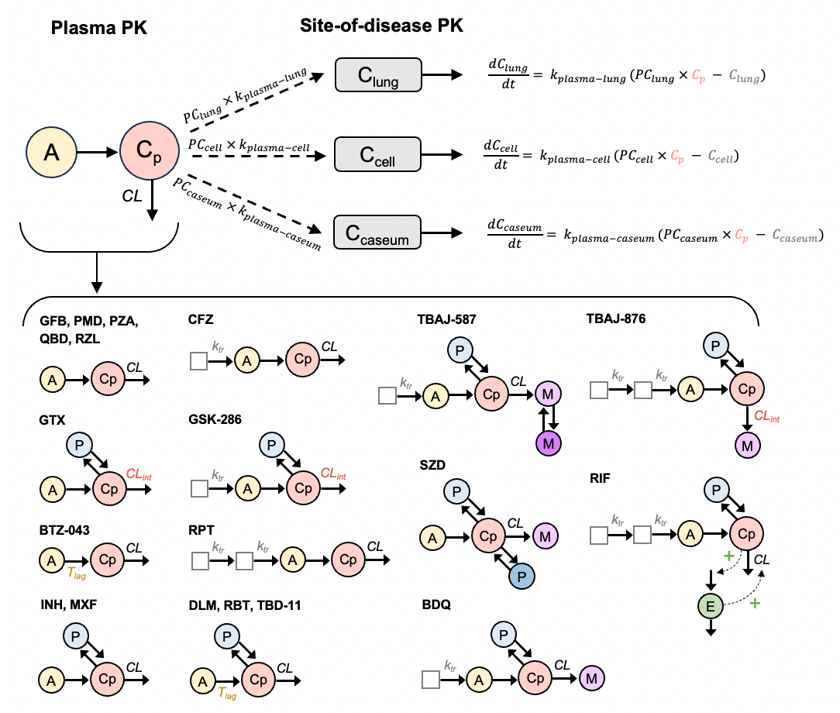

Supplementary Figure 4. Workflow of rabbit PK modeling. Plasma PK was modeled first, and each model structure was drug dependent. Plasma concentrations were then linked to site-of-disease concentrations via estimation of a partition coefficient (PC) and rate of delay (k) from plasma to each tissue type--uninvolved lung, cellular lesion, and caseum. Top half describes the site-of-disease PK model. Bottom half describes plasma PK structures for each drug.

Key: White square: transit absorption compartment, Yellow circle: absorption compartment, Pink circle: central compartment, Blue circle(s): peripheral compartment(s), Purple circle(s): metabolite compartment(s), Green circle: enzyme compartment.

Abbreviations: A: absorption compartment, C_{p}: plasma concentration, C_{lung}: lung concentration, C_{cell}: cellular lesion concentration, C_{caseum}: caseum concentration, CL: clearance, CL_{int}: intrinsic clearance, E: enzyme compartment, k_{tr}: transit compartment rate constant, M: metabolite compartment, P: peripheral compartment, T_{lag}: absorption time lag.
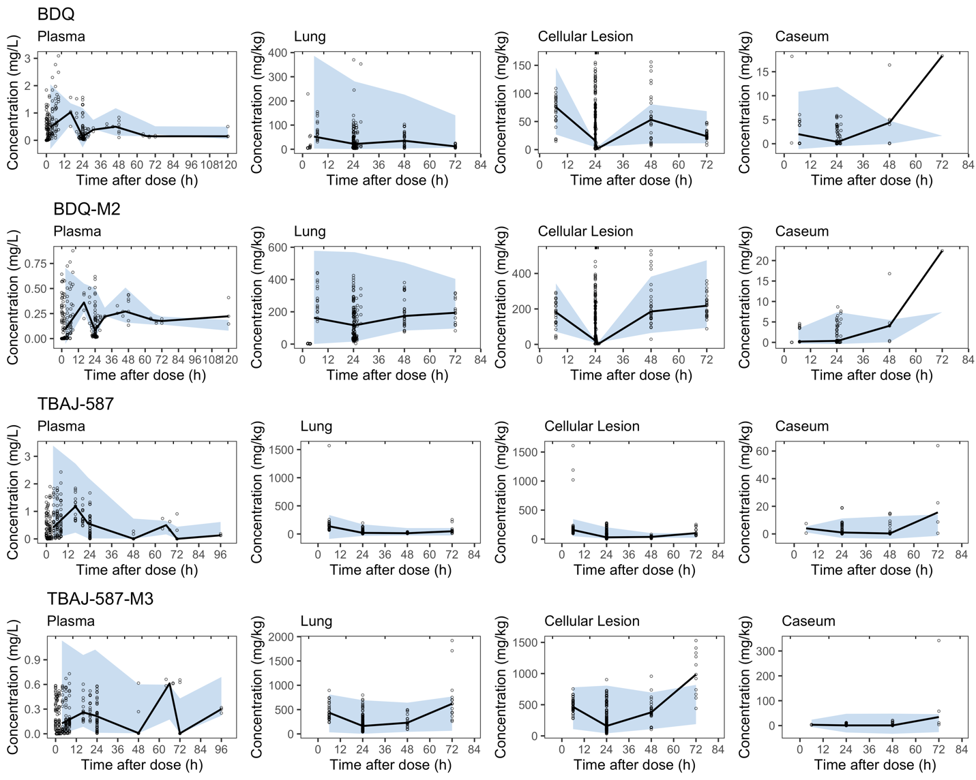
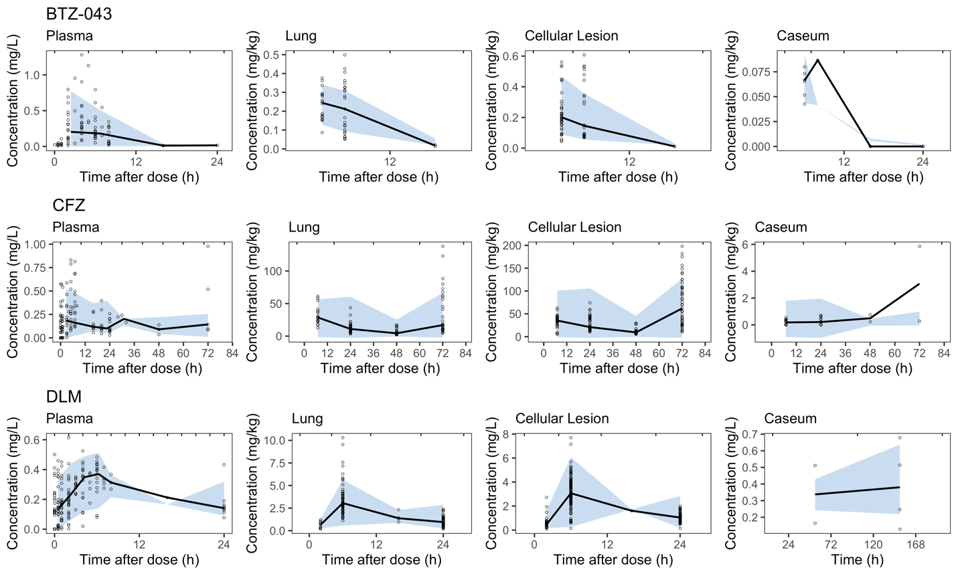
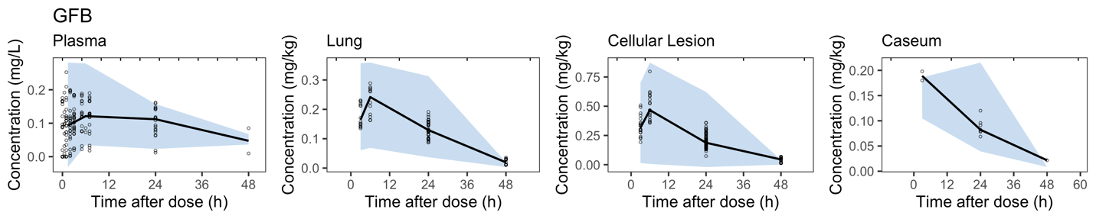
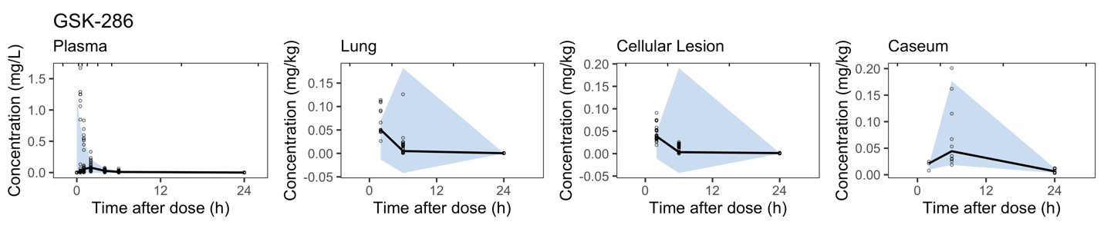
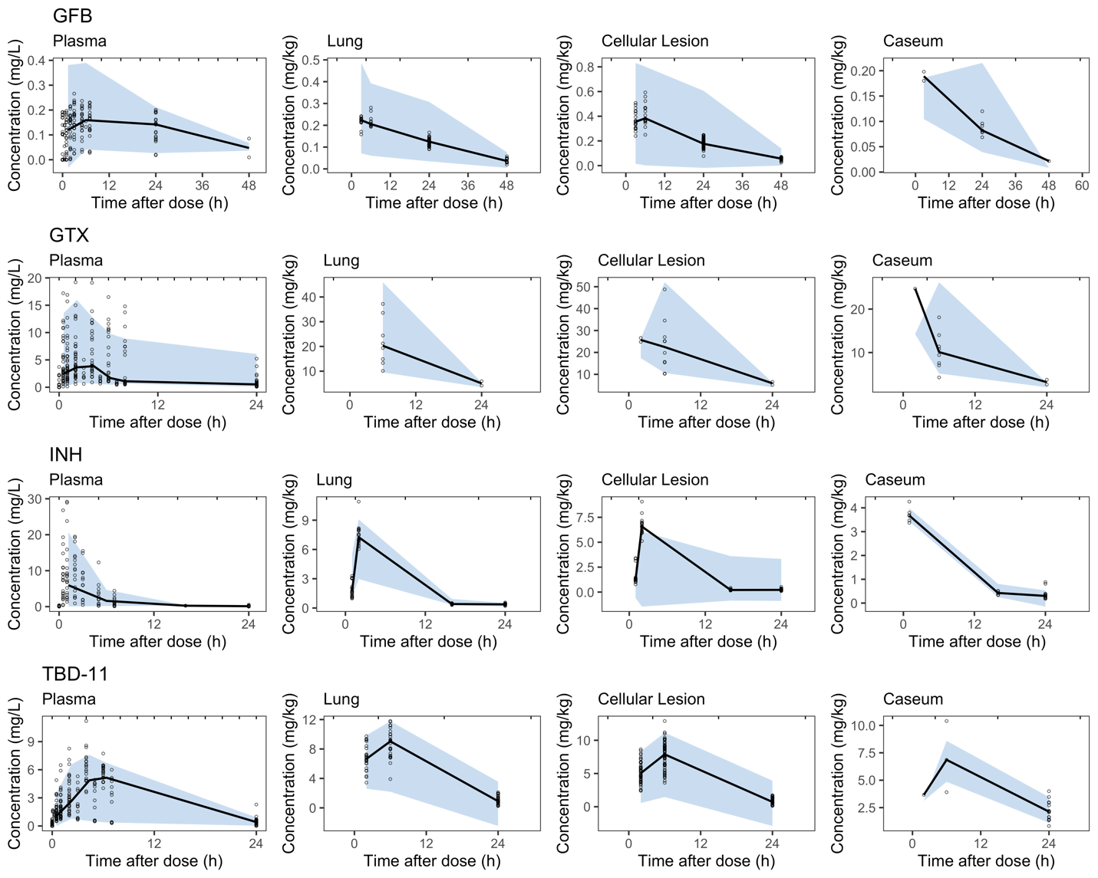
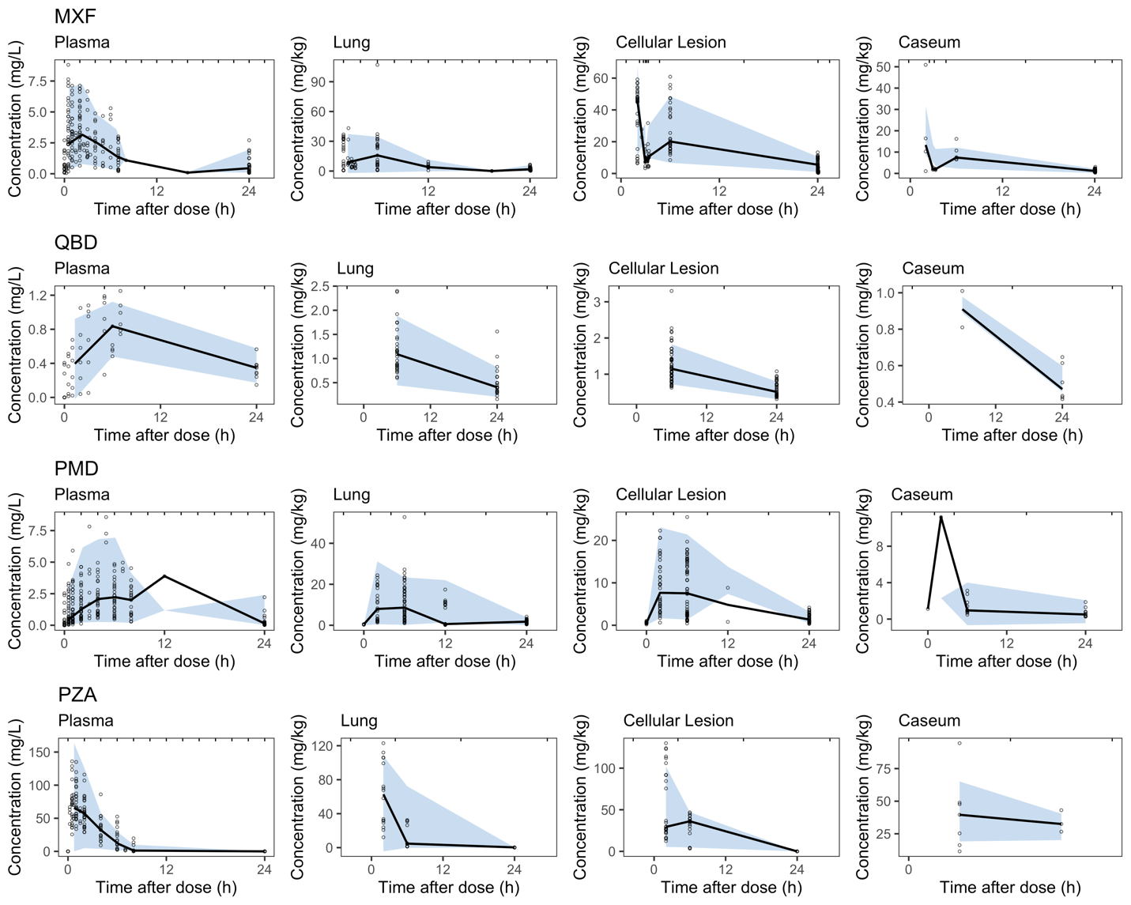
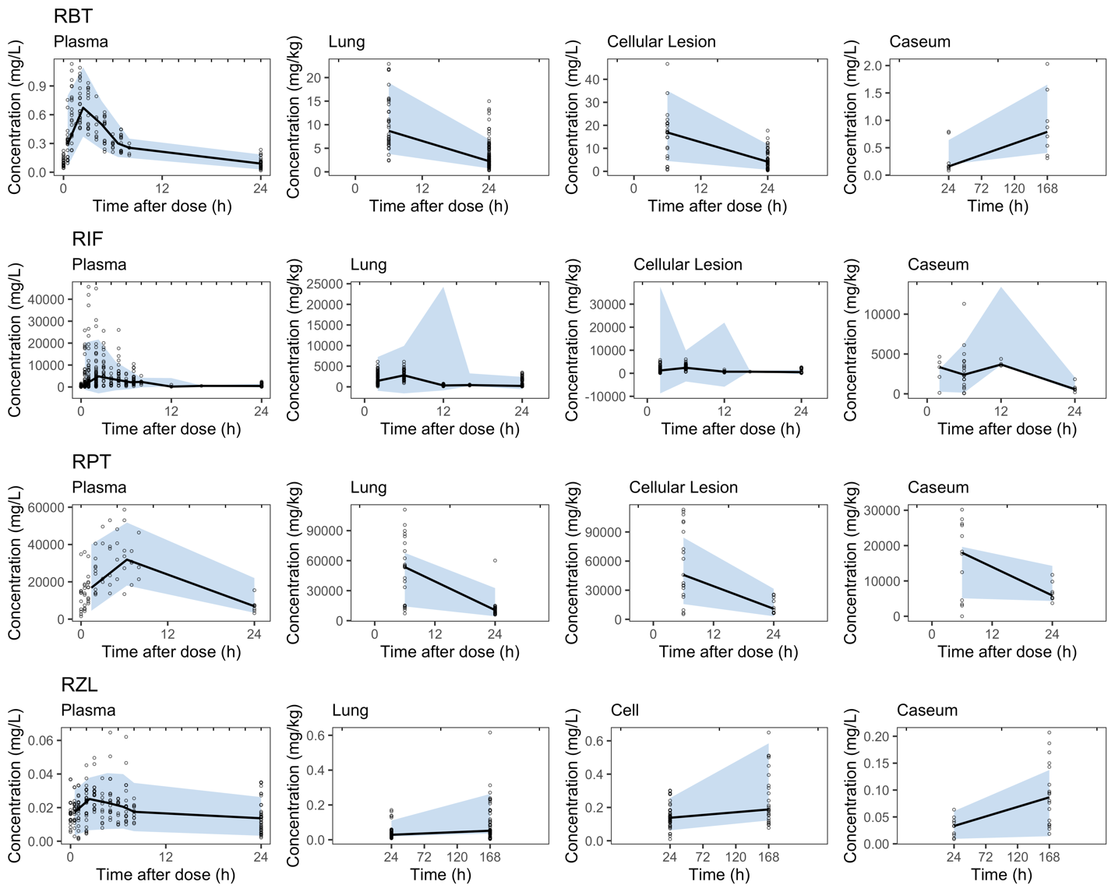
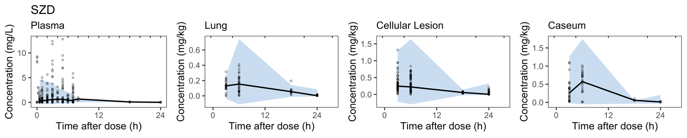
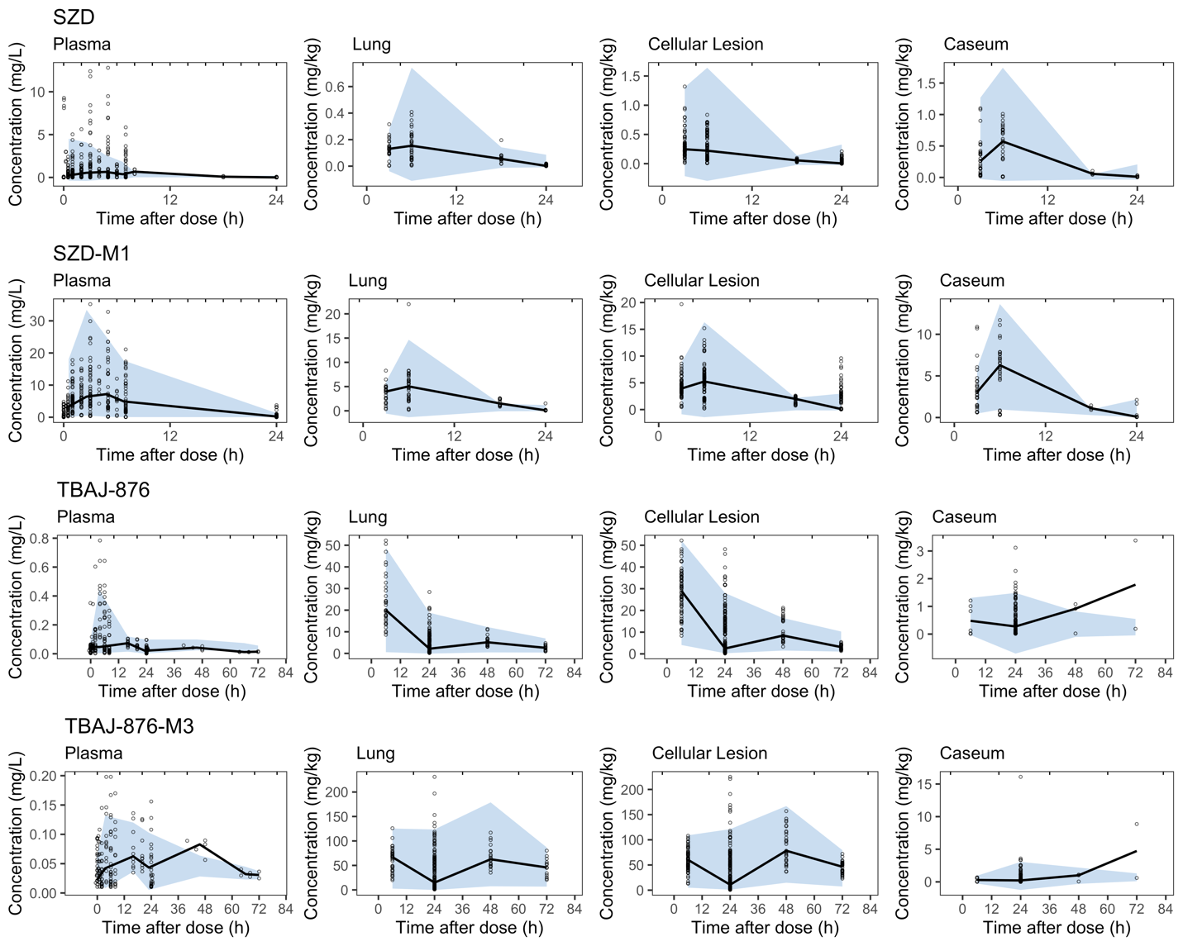

Supplementary Figure 5. Visual predictive checks for rabbit models of all drugs and metabolites in plasma, uninvolved lung, cellular lesion, and caseum. Points are individual observations, solid lines are data medians, and shaded areas are 90% prediction intervals of 500 simulations. Prediction correction (i.e., normalization of observed and simulation concentrations) was done to adjust for differences in dose levels and to yield a more consistent evaluation of model performance.
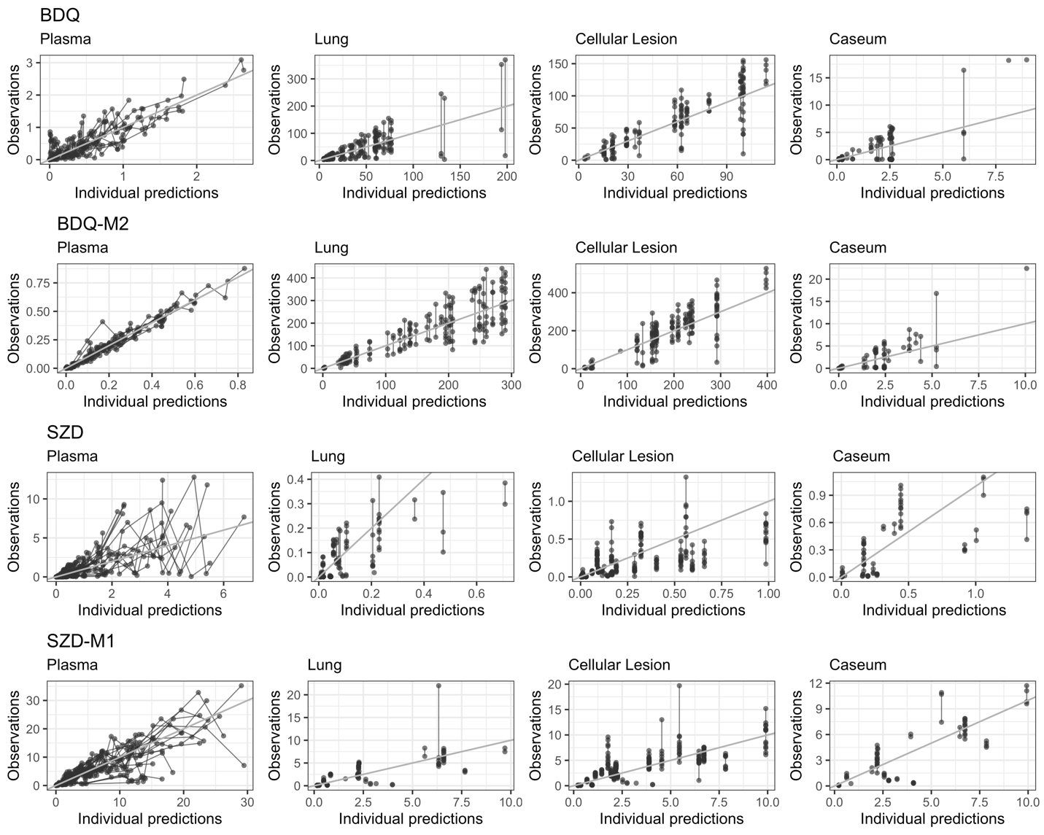
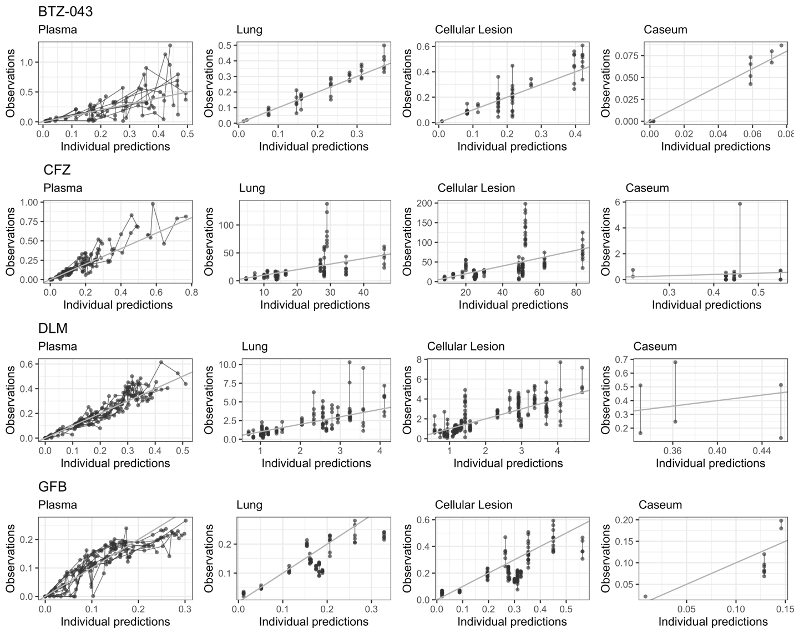
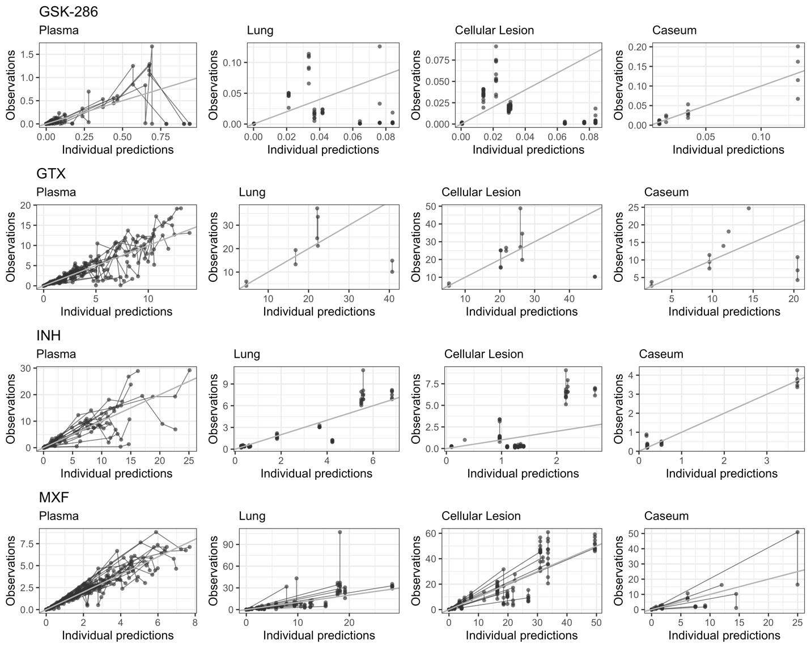
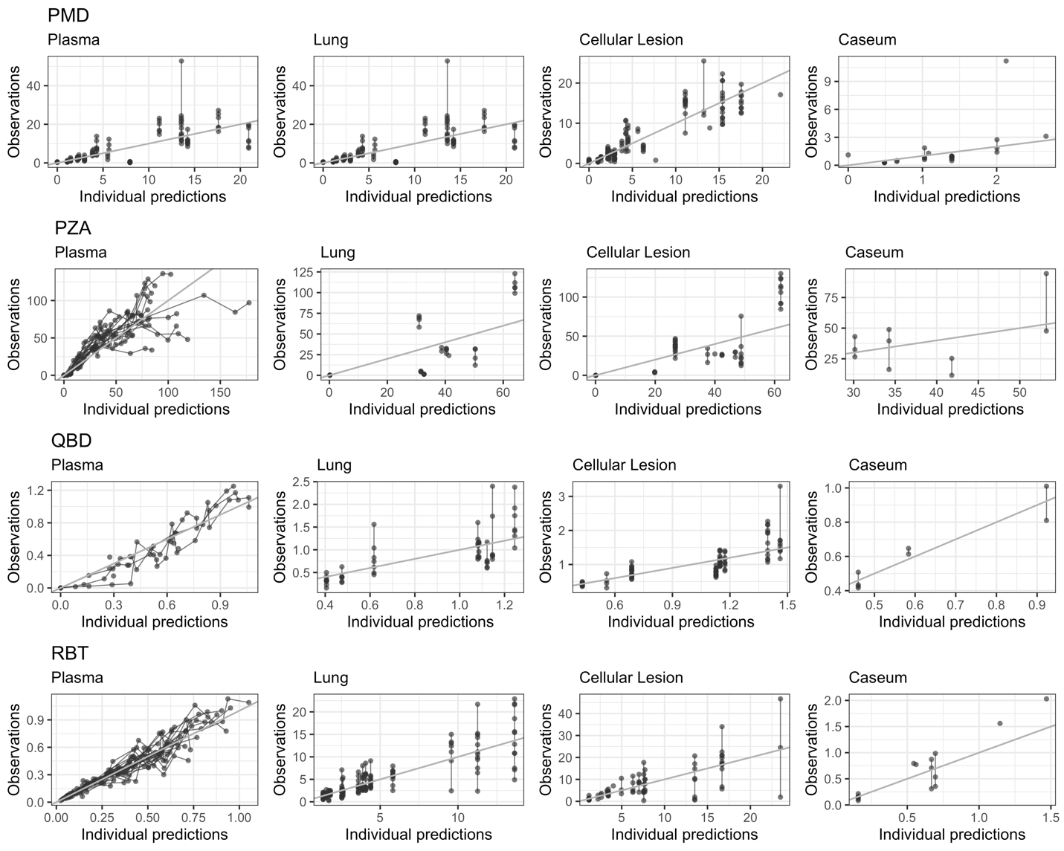
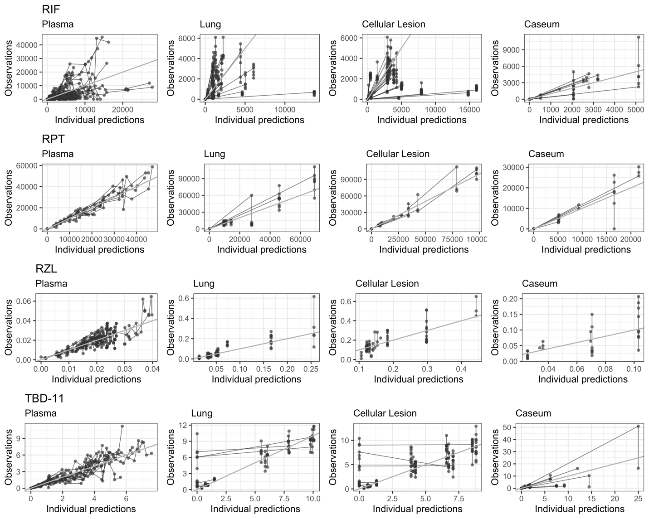
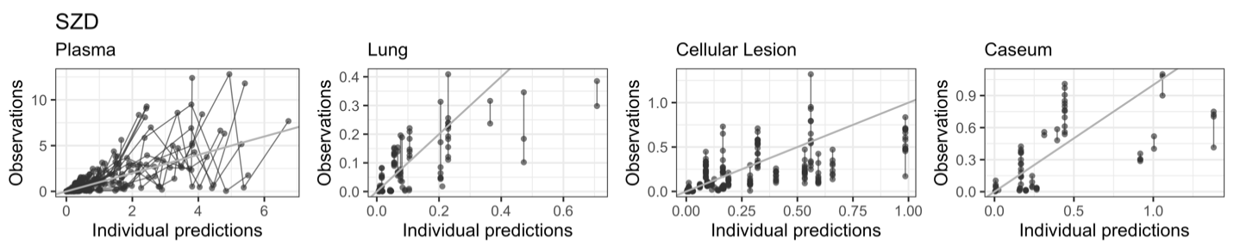
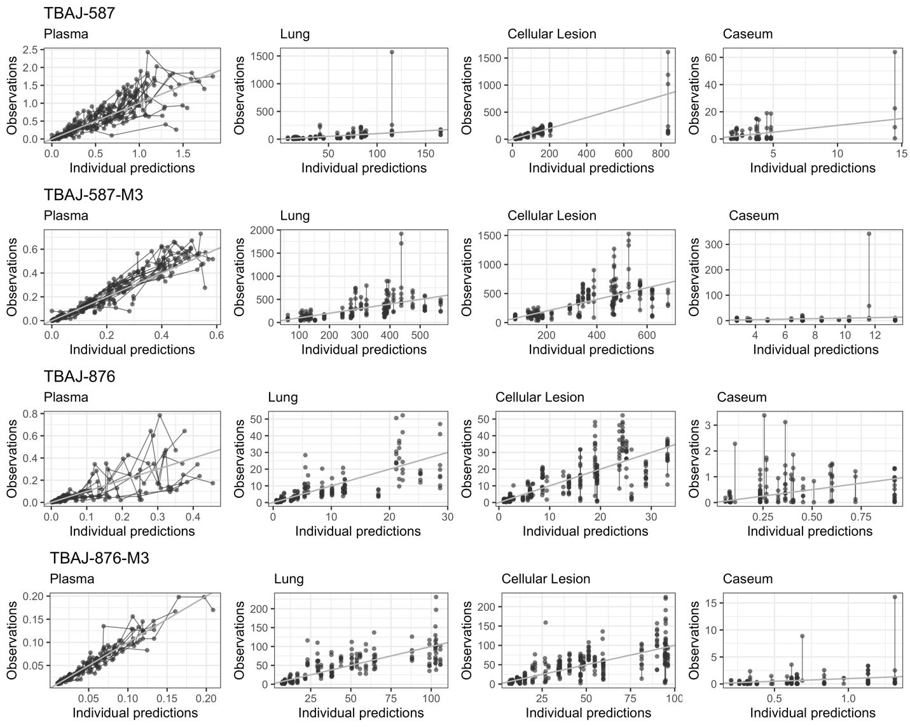

Supplementary Figure 6. Goodness-of-fit plots for rabbit models of all drugs and metabolites in plasma, uninvolved lung, cellular lesion, and caseum. Grey line represents a line of unity of perfect alignment between individual concentration predictions on the x-axis and measured concentrations on the y-axis.
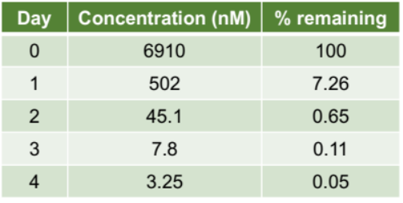
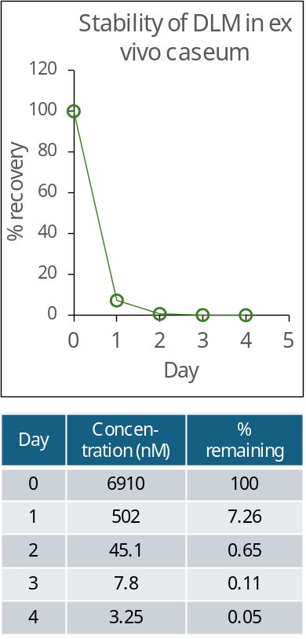

Supplementary Figure 7. Instability of DLM in caseum. The duration of the caseum bactericidal assay is 7 days. To accurately measure the caseum MBC, a resupply scheme was developed to compensate for the daily loss, as described in the methods.

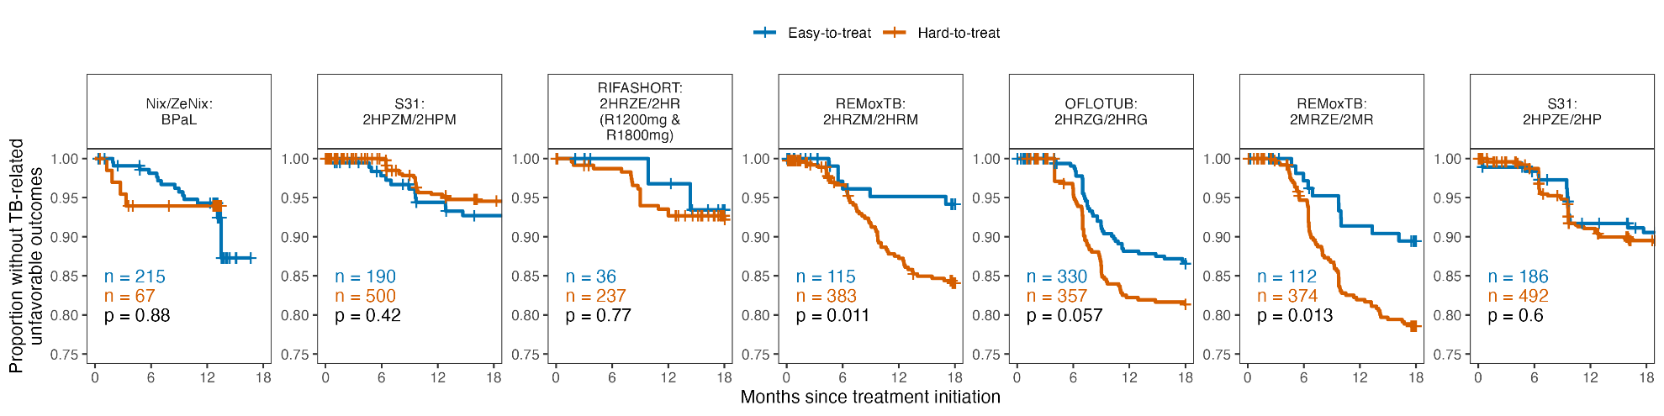

Supplementary Figure 8. Patients across Phase 3 trials stratified based on cavitary status.
Abbreviations: B: bedaquiline, C: clofazimine, E: ethambutol, G: gatifloxacin, H: isoniazid, L: linezolid, M: moxifloxacin, P: rifapentine, Pa: pretomanid, R: rifampicin, Z: pyrazinamide, S31: Study 31.

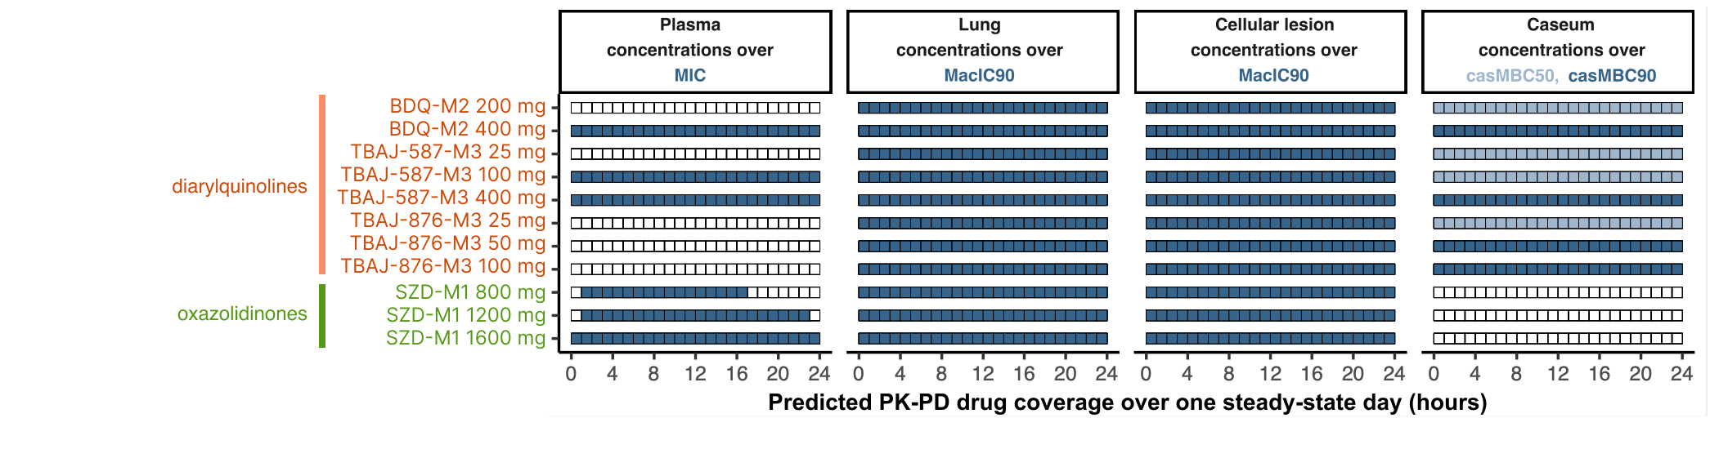

Supplementary Figure 9. Coverage by dose for diarylquinoline and oxazolidinone metabolites.

Supplementary Table 1. Clinical and rabbit PK database.
 | Drug | Subjects (n) | Plasma  observations  (n) | Lesion  observations  (n) | Doses tested in dose-finding plasma PK experiments  (n total doses) | Doses tested in lesion PK experiments  (n total doses)
Clinical | CFZ | 3 | 14 | 60 | - | -
Clinical | INH | 16 | 127 | 543 | - | -
Clinical | KAN | 15 | 60 | 275 | - | -
Clinical | LZD | 13 | 52 | 216 | - | -
Clinical | MXF | 16 | 64 | 315 | - | -
Clinical | PZA | 16 | 129 | 538 | - | -
Clinical | RIF | 16 | 66 | 346 | - | -
Rabbit | AMK | 9 | 48 | 106 | 60 mg/kg (3) | 25 mg/kg IM (3)
Rabbit | BDQ | 55 | 232 | 568 | 20 mg/kg (1, 11, 17)  160 mg/kg (3) | 20 mg/kg (1, 29)  400 mg flat (3)
Rabbit | BDQ-M2* | 55 | 232 | 568 | - | -
Rabbit | BTZ-043 | 15 | 142 | 131 | 50 mg/kg (1)  200 mg/kg (8) | 125 mg/kg (3)
Rabbit | CFZ | 14 | 123 | 305 | 5 mg/kg (1)  20 mg/kg (1) | 120 mg flat (3)
Rabbit | DLM | 26 | 302 | 890 | 5 mg/kg (1) | 5 mg/kg (1, 3, 7)
Rabbit | GFB | 15 | 215 | 223 | 0.3 mg/kg (1, 4) | 1 mg flat (3, 4)
Rabbit | GSK-286 | 13 | 165 | 311 | 50 mg/kg (1) | 2.5 mg/kg IV (1, 2)  100 mg/kg (1, 2, 3, 4)
Rabbit | GTX | 28 | 261 | 35 | 30 mg/kg (1)  60 mg/kg (1)  90 mg/kg (1) | 40 mg/kg (1, 15)  100 mg/kg (1, 7)
Rabbit | INH | 20 | 246 | 229 | 10 mg/kg (3)  50 mg/kg (1) | 30 mg/kg (2, 3)
Rabbit | KAN | 5 | 26 | 98 | AMK PK used to infer dose for lesion PK | 25 mg/kg IM (3)
Rabbit | LZD | 18 | 120 | 205 | 50 mg/kg (1) | 100 mg/kg (5)  90 mg/kg (5)
Rabbit | MXF | 43 | 402 | 371 | 50 mg/kg (1)  100 mg/kg (1) | 20 mg/kg (1)  25 mg/kg (56)  60 mg/kg (21)
Rabbit | PMD | 30 | 250 | 514 | 50 mg/kg (1)  5 mg/kg (1, 14)  10 mg/kg (1, 14)  20 mg/kg (1, 13 doses) | 20 mg/kg (1, 3, 16)
Rabbit | PZA | 19 | 177 | 95 | 150 mg/kg (1)  175 mg/kg (21)  300 mg/kg (1) | 125 mg/kg (1)  250 mg/kg (1)
Rabbit | QBD | 11 | 56 | 154 | 3 mg/kg (3) | 2 mg/kg (4)
Rabbit | RBT | 31 | 178 | 355 | 15 mg/kg (42) | 15 mg/kg (1, 7)
Rabbit | RIF | 69 | 560 | 804 | 25 mg/kg (5) | 30 mg/kg (1, 3, 7, 10)
Rabbit | RPT | 17 | 130 | 131 | 4 mg/kg (1)  100 mg/kg (42) | 100 mg/kg (7)
Rabbit | RZL | 31 | 243 | 281 | 10 mg/kg (42) | 10 mg/kg (1, 7)
Rabbit | SZD | 43 | 427 | 509 | 5 mg/kg IV (1)  50 mg/kg (3, 5)  65 mg/kg (3, 5)  100 mg flat (2, 3)  500 mg flat (3, 4) | 65 mg/kg (3, 5)  100 mg flat (2, 3)  500 mg flat (3, 4)
Rabbit | SZD-M1* | 43 | 343 | 516 | - | -
Rabbit | TBAJ-587 | 23 | 201 | 256 | 5 mg/kg (1)  10 mg/kg (3)  500 mg flat (1, 3) | 300 mg flat (2, 3)  30 mg flat (14, 28)
Rabbit | TBAJ-587-M3* | 23 | 201 | 255 | - | -
Rabbit | TBAJ-876 | 42 | 401 | 746 | 5 mg/kg (1)  10 mg/kg (3)  100 mg/kg (1, 3)  150 mg/kg (1, 3) | 125 mg flat (2, 3)  12.5 mg flat (14, 28)
Rabbit | TBAJ-876-M3* | 36 | 293 | 746 | - | -
Rabbit | TBD-11 | 32 | 248 | 247 | 1 mg/kg IV (1)  10 mg/kg (4) | 10 mg/kg (3)
Rabbit | TBI-223 | 9 | 39 | 193 | 50 mg/kg (1)  150 mg/kg (3) | 200 mg/kg (3)
*Quantification of metabolite after dosing with parent drug.
All dosing is oral unless otherwise specified.

Supplementary Table 2. Rabbit model parameter estimates.
Drug | Plasma PK structural model | Plasma PK parameters (%RSE) | Lesion PK parameters (%RSE)
BDQ | 2 compartment,  linear elimination,  1 transit compartment,  metabolite (M2) compartment | CL (L/h): 11.19 (9.8)  VC (L): 257.3 (21)  KTR (1/h): 0.41 (18)  Q (L/h): 26.03 (62)  VP (L): 301.5 (34)  Parent Prop Error (%CV): 27.6 (7.8)  F IIV (%CV): 31.8 (25)  VP IIV (%CV): 57.2 (16)  M2 CL (L/h): 27.22 (11)  M2 VC (L): Fixed to Parent VC  M2 Prop Error (%CV): 3.88 (16) | Parent Lung Kpl (1/h): 10 FIX  Parent Lung PC: 133 (14)  Parent Lung Prop Error (%CV): 57.7 (5.9)  Parent Lung PC IIV (%CV): 107.2 (11.4)  Parent Cellular Kpl (1/h): 0.141 (31)  Parent Cellular PC: 81.3 (11)  Parent Cellular Prop Error (%CV): 40.2 (11)  Parent Cellular PC IIV (%CV): 51.19 (16.7)  Parent Caseum Kpl (1/h): 10 FIX  Parent Caseum PC: 4.95 (28)  Parent Caseum Prop Error (%CV): 94.2 (6.9)  Parent Caseum PC IIV (%CV): 101 (17.3)  M2 Lung Kpl (1/h): 0.108 (35)  M2 Lung PC: 1067 (5.8)  M2 Lung Prop Error (%CV): 38.3 (5.6)  M2 Lung PC IIV (%CV): 38.6 (19.7)  M2 Cellular Kpl (1/h): 0.034 (87)  M2 Cellular PC: 834 (19)  M2 Cellular Prop Error (%CV): 38.4 (14)  M2 Cellular PC IIV (%CV): 36.88 (71.0)  M2 Caseum Kpl (1/h): 0.005 (23)  M2 Caseum PC: 31.2 (15)  M2 Caseum Prop Error (%CV): 90.6 (6.9)  M2 Caseum PC IIV (%CV): 35.92 (22.3)
BTZ-043 | 1 compartment,  linear elimination,  absorption lag | CL (L/h): 163.9 (9.3)  VC (L): 386 (14)  KA (1/h): 0.365 (21)  ALAG (h): 0.458 (3.3)  Prop Error (%CV): 64.5 (9.4)  CL IIV (%CV): 34.6 (19)  KA IIV (%CV): 72.3 (2.8) | Lung Kpl (1/h): 0.620 (26)  Lung PC: 0.831 (0.9)  Lung Prop Error (%CV): 22.7 (7.7)  Cellular Kpl (1/h): 10.8 (<0.1)  Cellular PC: 1.12 (0.2)  Cellular Prop Error (%CV): 37.4 (0.5)  Caseum Kpl (1/h): 10 FIX  Caseum PC: 0.296 (5)  Caseum Add Error (mg/kg): 0.00143 (11)  Caseum Prop Error (%CV): 20.3 (12)
CFZ | 1 compartment,  linear elimination,  1 transit compartment | CL (L/h): 15.4 (26)  VC (L): 647 (11)  KA (1/h): 0.37 (24)  KTR (1/h): 0.37 (25)  Prop Error (%CV): 42.3 (13)  CL IIV (%CV): 74.3 (25)  VC IIV (%CV): 37.3 (21) | Lung Kpl (1/h): 10 FIX  Lung PC: 130.4 (18)  Lung Prop Error (%CV): 76.2 (17)  Cellular Kpl (1/h): 10 FIX  Cellular PC: 235.6 (19)  Cellular Prop Error (%CV): 69.5 (11)  Caseum Kpl (1/h): 10 FIX  Caseum PC: 2.07 (48)  Caseum Prop Error (%CV): 226 (12)
DLM | 2 compartment,  linear elimination,  absorption lag | CL (L/h): 1.68 (12)  VC (L): 31.0 (13)  KA (1/h): 0.10 (20)  Q (L/h): 2.06 (28)  VP (L): 183.6 (5.5)  ALAG (h): 0.34 (15)  Add Error (mg/L): 0.0011 (8.9)  Prop Error (%CV): 27.3 (13)  CL IIV (%CV): 41.4 (18)  VC IIV (%CV): 61.4 (25)  ALAG IIV (%CV): 31.4 (31) | Lung Kpl (1/h): 2.63 (79)  Lung PC: 8.11 (7.9)  Lung Prop Error (%CV): 51.2 (9.6)  Cellular Kpl (1/h): 10 FIX  Cellular PC: 9.18 (8.6)  Cellular Prop Error (%CV): 54.0 (14)  Caseum Kpl (1/h): 10 FIX  Caseum PC: 1.14 (14)  Caseum Prop Error (%CV): 57.0 (8.5)
GFB | 1 compartment,  linear elimination | CL (L/h): 0.24 (17)  VC (L): 7.22 (16)  KA (1/h): 0.41 (31)  Prop Error (%CV): 36.7 (9.5)  F IIV (%CV): 54.8 (35) | Lung Kpl (1/h): 10 FIX  Lung PC: 1.10 (15)  Lung Prop Error (%CV): 52.3 (23)  Cellular Kpl (1/h): 10 FIX  Cellular PC: 1.88 (22)  Cellular Prop Error (%CV): 68.0 (16)  Caseum Kpl (1/h): 10 FIX  Caseum PC: 0.77 (28)  Caseum Prop Error (%CV): 60.0 (20)
GSK-286 | 2 compartment,  saturated elimination,  1 transit compartment | CL (L/h): 76.9 (35)  VC (L): 16.6 (42)  KA (1/h): 6.38 (89)  KM (mg/L): 0.05 (45)  MTT (h): 2.81 (19)  Q (L/h): 1.64 (18)  VP (L): 1.05E5 (37)  F: 0.12 (19)  Prop Error (%CV): 74.0 (6.4)  F IIV (%CV): 16.6 (36)  VC IIV (%CV): 154 (32)  MTT IIV (%CV): 15.9 (34) | Lung Kpl (1/h): 0.39 (6.2)  Lung PC: 1.62 (15)  Lung Prop Error (%CV): 114 (10)  Cellular Kpl (1/h): 0.30 (3.6)  Cellular PC: 1.31 (11)  Cellular Prop Error (%CV): 114 (7.2)  Caseum Kpl (1/h): 0.11 (11)  Caseum PC: 1.99 (9.8)  Caseum Prop Error (%CV): 44.5 (11)
GTX | 2 compartment,  saturated elimination | CLINT (L/h): 25.1 (8.7)  KM (mg/L): 0.26 (114)  VC (L): 7.65 (37)  KA (1/h): 0.22 (22)  Q (L/h): 8.78 (19)  VP (L): 333 (15)  Prop Error (%CV): 37.3 (8.3)  Add Error (mg/L): 0.000447 (26)  F IIV (%CV): 20.4 (29)  KA IIV (%CV): 54.6 (12) | Lung Kpl (1/h): 0.70 (63)  Lung PC: 7.22 (16)  Lung Prop Error (%CV): 43.2 (34)  Cellular Kpl (1/h): 1.02 (29)  Cellular PC: 8.70 (14)  Cellular Prop Error (%CV): 42.3 (33)  Caseum Kpl (1/h): 10 FIX  Caseum PC: 4.35 (20)  Caseum Prop Error (%CV): 46.7 (34)
INH | 2 compartment,  linear elimination | CL (L/h): 2.42 (9.9)  VC (L): 6.75 (17)  KA (1/h): 2.40 (32)  Q (L/h): 0.48 (35)  VP (L): 4.25 (29)  Prop Error (%CV): 50.8 (8.7)  F IIV (%CV): 35.2 (31) | Lung Kpl (1/h): 0.29 (10)  Lung PC: 1.32 (9.1)  Lung Prop Error (%CV): 35.5 (20)  Cellular Kpl (1/h): 0.06 (11)  Cellular PC: 1.15 (34)  Cellular Prop Error (%CV): 117 (23)  Caseum Kpl (1/h): 0.470 (14)  Caseum PC: 1.09 (11)  Caseum Add Error (mg/kg): 0.25 (29)
MXF | 2 compartment,  linear elimination | CL (L/h): 4.13 (15)  VC (L): 37.8 (8.3)  KA (1/h): 1.61 (17)  Q (L/h): 6.09 (15)  VP (L): 287 (31)  Prop Error (%CV): 29.3 (10)  CL IIV (%CV): 53.6 (16)  VC IIV (%CV): 30.8 (23) | Lung Kpl (1/h): 1.00 (49)  Lung PC: 4.58 (12)  Lung Prop Error (%CV): 77.1 (13)  Cellular Kpl (1/h): 1.00 (37)  Cellular PC: 8.01 (8.9)  Cellular Prop Error (%CV): 44.7 (15)  Caseum Kpl (1/h): 10 FIX  Caseum PC: 3.39 (13)  Caseum Prop Error (%CV): 58.5 (18)
PMD | 1 compartment,  linear elimination | CL (L/h): 2.16 (16)  VC (L): 19.4 (17)  KA (1/h): 0.265 (14)  Prop Error (%CV): 43.0 (8.5)  F IIV (%CV): 64.7 (12)  CL IIV (%CV): 68.4 (9.7) | Lung Kpl (1/h): 2.44 (68)  Lung PC: 4.59 (14)  Lung Prop Error (%CV): 61.8 (19)  Cellular Kpl (1/h): 10 FIX  Cellular PC: 4.56 (8.4)  Cellular Prop Error (%CV): 43.6 (7.1)  Caseum Kpl (1/h): 10 FIX  Caseum PC: 2.16 (25)  Caseum Prop Error (%CV): 96.9 (24)  Caseum Add Error (mg/kg): 0.511 (35)
PZA | 1 compartment,  linear elimination | CL (L/h): 3 (5.3)  VC (L): 1.07 (0.5)  KA (1/h): 0.363 (12)  Prop Error (%CV): 59.6 (7.9)  F IIV (%CV): 28.5 (28) | Lung Kpl (1/h): 0.54 (8.5)  Lung PC: 1.10 (9.8)  Lung Prop Error (%CV): 78.7 (22)  Cellular Kpl (1/h): 0.88 (0.01)  Cellular PC: 0.859 (0.26)  Cellular Prop Error (%CV): 60.5 (11)  Caseum Kpl (1/h): 0.61 (19)  Caseum PC: 0.852 (11)  Caseum Prop Error (%CV): 44.5 (25)
QBD | 1 compartment,  linear elimination | CL (L/h): 0.581 (3.0)  VC (L): 3.368 (37)  KA (1/h): 0.10 (22)  Add Error (mg/L): 0.143 (19)  VC IIV (%CV): 33.6 (29) | Lung Kpl (1/h): 10 FIX  Lung PC: 1.75 (10)  Lung Prop Error (%CV): 41.4 (13)  Cellular Kpl (1/h): 10 FIX  Cellular PC: 1.94 (9.4)  Cellular Prop Error (%CV): 27.2 (17)  Caseum Kpl (1/h): 0.393 (32)  Caseum PC: 1.60 (5.2)  Caseum Prop Error (%CV): 10.2 (10)
RBT | 2 compartment,  linear elimination,  absorption lag | CL (L/h): 8.355 (8.1)  VC (L): 13.48 (39.2)  KA (1/h): 0.3392 (20.0)  Q (L/h): 8.436 (14.9)  VP (L): 194.4 (24.5)  ALAG (h): 0.3279 (10.7)  Prop Error (%CV): 22.01 (9.5)  CL IIV (%CV): 23.0 (20.5)  ALAG IIV (%CV): 29.5 (33.3)  F IIV (%CV): 21.1 (23.4) | Lung Kpl (1/h): 0.1536 (37)  Lung PC: 29.04 (18)  Lung Prop error (%CV): 40.31 (7.5)  Cellular Kpl (1/h): 0.2088 (45)  Cellular PC: 47.28 (16)  Cellular Prop error (%CV): 51.56 (11)  Caseum Kpl (1/h): 10 FIX  Caseum PC: 8.939 (25)  Caseum Prop error (%CV): 39.16 (5.8)
RIF | 2 compartment,  linear elimination,  2 transit compartments,  enzyme autoinduction | CL (L/h): 0.153 (20)  VC (L): 12.5 (16)  KA (1/h): 6.67 (49)  Q (L/h): 0.791 (25)  VP (L): 13.67 (25)  MTT (h): 0.30 (21)  KENZ: 0.019 (49)  EMAX: 88.46 (64)  C50: 1129 (68)  Prop Error (%CV): 92.6 (5.1) | Lung Kpl (1/h): 0.155 (21)  Lung PC: 2.706 (20)  Lung Prop error (%CV): 105 (12)  Cellular Kpl (1/h): 10 FIX  Cellular PC: 2.907 (22)  Cellular Prop error (%CV): 138 (11)  Caseum Kpl (1/h): 0.036 (52)  Caseum PC: 3.897 (30)  Caseum Prop error (%CV): 57.1 (15)
RPT | 1 compartment,  linear elimination,  2 transit compartments | CL (L/h): 0.69 (13)  VC (L): 10.1 (34)  KA (1/h): 0.33 (92)  MTT (h): 0.699 (56)  Prop Error (%CV): 23.6 (11)  CL IIV (%CV): 33.2 (20)  VC IIV (%CV): 44.3 (71) | Lung Kpl (1/h): 0.53 (27)  Lung PC: 1.33 (2.9)  Lung Prop error (%CV): 41.1 (28)  Cellular Kpl (1/h): 0.82 (188)  Cellular PC: 1.99 (16)  Cellular Prop error (%CV): 21.4 (16)  Caseum Kpl (1/h): 0.13 (354)  Caseum PC: 0.536 (49)  Caseum Prop error (%CV): 37.7 (47)
RZL | 1 compartment,  linear elimination  absorption lag | CL (L/h): 69.5 (9.0)  VC (L): 3330 (10.3)*  KA (1/h): 1.15 (15.0)*  ALAG (h): 0.729 (10.1)  Prop Error (%CV): 28.0 (13.3)  Add Error (mg/L): 0.00142 (18.7)  CL IIV (%CV): 32.56 (33.6)  KA IIV (%CV): 99.55 (32.5) | Lung Kpl (1/h): 10 FIX  Lung PC: 9.38 (32.4)  Lung Prop error (%CV): 43.4 (10.7)  Cellular Kpl (1/h): 10 FIX  Cellular PC: 23.1 (14.1)  Cellular Prop error (%CV): 38.2 (19.6)  Caseum Kpl (1/h): 10 FIX  Caseum PC: 4.99 (20.24)  Caseum Prop error (%CV): 55.2 (15.3)
SZD | 3 compartment,  linear elimination,  metabolite (M1) compartment | CL (L/h): 15.35 (24)  VC (L): 1.61 (35)  KA (1/h): 0.24 (8.3)  Q1 (L/h): 26.5 (40)  VP1 (L): 3.63 (51)  Q2 (L/h): 4.13 (30)  VP2 (L): 272.3 (65)  F: 0.52 (25)  Parent Prop Error (%CV): 97.8 (4.7)  CL IIV (%CV): 56.0 (14)  F IOV (%CV): 45.6 (39)  M1 CL (L/h): 1.43 (21)  M1 VC (L): 1.74 (34)  M1 Prop Error (%CV): 51.0 (4.9) | Parent Lung Kpl (1/h): 0.13 (31)  Parent Lung PC: 0.44 (21)  Parent Lung Prop Error (%CV): 103 (16)  Parent Cellular Kpl (1/h): 0.24 (20)  Parent Cellular PC: 0.51 (22)  Parent Cellular Prop Error (%CV): 112 (12)  Parent Caseum Kpl (1/h): 0.53 (53)  Parent Caseum PC: 0.66 (26)  Parent Caseum Prop Error (%CV): 73.4 (21)  Parent Caseum Add Error (mg/kg): 0.0463 (34)  M1 Lung Kpl (1/h): 0.30 (17)  M1 Lung PC: 0.90 (16)  M1 Lung Add Error (mg/kg): 0.833 (12)  M1 Cellular Kpl (1/h): 0.23 (33)  M1 Cellular PC: 1.01 (14)  M1 Cellular Add Error (mg/kg): 0.811 (16)  M1 Caseum Kpl (1/h): 0.25 (21)  M1 Caseum PC: 0.99 (16)  M1 Caseum Prop Error (%CV): 12.5 (87)  M1 Caseum Add Error (mg/kg): 0.555 (25)
TBAJ-587 | 2 compartment,  linear elimination,  1 transit compartment,  metabolite (M3) central compartment and metabolite (M3) peripheral compartment | CL (L/h): 7.12 (13)  VC (L): 89.4 (12)  KTR (1/h): 0.283 (18)  Q (L/h): 13.46 (31)  VP (L): 182.3 (30)  Parent Prop Error (%CV): 47.3 (6.5)  F IIV (%CV): 63.7 (22)  M3 CL (L/h): 12.79 (12)  M3 VC (L): 38.86 (54)  M3 VP (L): 352.8 (20)  M3 Q (L/h): 41.31 (25)  M3 Prop Error (%CV): 38.7 (10) | Parent Lung Kpl (1/h): 10.4 (<0.1)  Parent Lung PC: 89.8 (13)  Parent Lung Prop Error (%CV): 123 (21)  Parent Cellular Kpl (1/h): 13.2 (0.1)  Parent Cellular PC: 129 (10)  Parent Cellular Prop Error (%CV): 34.9 (12)  Parent Caseum Kpl (1/h): 0.0156 (30)  Parent Caseum PC: 7.58 (19)  Parent Caseum Prop Error (%CV): 133.4 (6.3)  M3 Lung Kpl (1/h): 10 FIX  M3 Lung PC: 974 (7.8)  M3 Lung Prop Error (%CV): 62.1 (9.9)  M3 Cellular Kpl (1/h): 10 FIX  M3 Cellular PC: 1170 (6.9)  M3 Cellular Prop Error (%CV): 47.4 (9.2)  M3 Caseum Kpl (1/h): 0.645 (<0.1)  M3 Caseum PC: 25.3 (44)  M3 Caseum Prop Error (%CV): 345 (7.9)
TBAJ-876 | 2 compartment,  saturated elimination,  2 transit compartments,  metabolite (M3) compartment | CLINT (L/h): 37.26 (11)  VC (L): 207.2 (18)  KA (1/h): 1.39 (21)  Q (L/h): 40.43 (10)  VP (L): 1324 (22)  KM (mg/L): 0.195 (39)  MTT (h): 1.43 (10)  Parent Prop Error (%CV): 51.5 (10)  CLINT IIV (%CV): 29.9 (15)  M3 CL (L/h): 60.29 (12)  M3 VC (L): 607.9 (12)  M3 Prop Error (%CV): 20.1 (7.9)  M3 CL IIV (%CV): 35.1 (14) | Parent Lung Kpl (1/h): 0.15 (16)  Parent Lung PC: 106.7 (4.9)  Parent Lung Prop Error (%CV): 64.8 (8.6)  Parent Cellular Kpl (1/h): 0.08 (9.6)  Parent Cellular PC: 145.8 (2.8)  Parent Cellular Prop Error (%CV): 53.5 (3.9)  Parent Caseum Kpl (1/h): 0.03 (28)  Parent Caseum PC: 4.82 (19)  Parent Caseum Add Error (mg/kg): 0.628 (13)  M3 Lung Kpl (1/h): 0.04 (43)  M3 Lung PC: 950.9 (7.2)  M3 Lung Prop Error (%CV): 62.6 (8.5)  M3 Cellular Kpl (1/h): 0.04 (17)  M3 Cellular PC: 867 (3.7)  M3 Cellular Prop Error (%CV): 57.1 (9.2)  M3 Caseum Kpl (1/h): 0.002 (112)  M3 Caseum PC: 55.47 (88)  M3 Caseum Prop Error (%CV): 178 (11)
TBD-11 | 2 compartment,  linear elimination,  absorption lag | CL (L/h): 0.29 (12)*  VC (L): 1.66 (7.3)  KA (1/h): 0.29 (14)  Q (L/h): 0.03 (40)  VP (L): 5.45 (38)  F: 0.54 (9.7)*  ALAG (h): 0.12 (25)  Prop Error (%CV): 31.9 (12)  CL IIV (%CV): 18.3 (23)  KA IIV (%CV): 43.6 (18)  ALAG IIV (%CV): 56.1 (30) | Lung Kpl (1/h): 11.2 (261)  Lung PC: 1.86 (2.9)  Lung Add Error (mg/kg): 2.14 (23)  Cellular Kpl (1/h): 2.05 (61)  Cellular PC: 1.55 (3.7)  Cellular Add Error (mg/kg): 2.33 (19)  Caseum Kpl (1/h): 0.19 (8.8)  Caseum PC: 2.08 (6.5)  Caseum Prop Error (%CV): 36.5 (8.4)
*Denotes parameter estimates for infected rabbits only.
Rabbit plasma and lesion PK estimates for AMK, KAN, LZD, and TBI-223 can be found in their respective publications [25, 27].
Unless otherwise stated, bioavailability (F) was fixed to 1.
Abbreviations: Add: additive, ALAG: absorption lag, CL: clearance, CLINT: intrinsic clearance, CV: coefficient of variation, C50: concentration at half maximum effect, EMAX: maximum effect on enzyme production, F: bioavailability, IIV: interindividual variability, IOV: interoccassional variability, KA: absorption rate constant, KENZ: enzyme production rate constant, KM: concentration to reach half maximum velocity, Kpl: plasma to tissue delay rate constant, KTR: transit compartment rate constant, MTT: mean transit time, PC: partition coefficient, Prop: proportional, Q: intercompartmental clearance, RSE: relative standard error, VC: central volume of distribution, VP: peripheral volume of distribution.

Supplementary Table 3. Clinical population PK models used.
Drug | Dose (mg) | C_{max} (mg/L) | t_{max} (h) | AUCss_{0-24h} (mg⋅h/L) | Reference
AMK | 1000 | 56.8 | 1 | 326.8 | [72]
BDQ | 200 | 2.28 | 5 | 45.2 | In-house
BDQ | 400 | 4.55 | 5 | 90.3 | In-house
BDQ-M2 | 200 | 0.45 | 13 | 10.88 | In-house
BDQ-M2 | 400 | 0.91 | 14 | 21.7 | In-house
BTZ-043 | 1250 | 0.92 | 1 | 3.12 | [73]
CFZ | 100 | 0.29 | 8 | 6.13 | [4]
DLM | 100* | 0.25 | 16 | 5.38 | [74]
EMB | 1200 | 1.91 | 4 | 20.98 | In-house
GFB | 1 | 0.02 | 1 | 0.27 | [75]
GFB | 5 | 0.09 | 1 | 1.35 | [75]
GFB | 10 | 0.18 | 1 | 2.7 | [75]
GFB | 20 | 0.36 | 1 | 5.41 | [75]
GTX | 400 | 3.84 | 2 | 37.99 | [76]
INH† | 300 | 4.08 | 2 | 31.16 | In-house
KAN | 1000 | 26.02 | 2 | 216.9 | [4]
LZD | 600 | 5.2 | 2 | 72.79 | [4]
MXF | 400 | 2.23 | 4 | 23.63 | In-house
PMD | 200 | 3.09 | 5 | 60.23 | Shared by TB Alliance
PZA | 1500 | 30.56 | 3 | 339.9 | [77]
QBD | 30 | 0.14 | 3 | 2.12 | [78]
QBD | 90 | 0.28 | 3 | 4.21 | [78]
RBT | 300 | 0.4 | 3 | 4.56 | [79]
RIF | 600 | 6.56 | 3 | 30.61 | [80]
RIF | 1200 | 13.13 | 3 | 61.22 | [80]
RPT | 1200 | 29.97 | 7 | 535.7 | In-house
SZD | 800 | 0.88 | 2 | 6.2 | In-house
SZD | 1200 | 1.38 | 2 | 10.43 | In-house
SZD | 1600 | 1.92 | 2 | 15.5 | In-house
SZD-M1 | 800 | 3.36 | 2 | 28.68 | In-house
SZD-M1 | 1200 | 4.39 | 2 | 43.03 | In-house
SZD-M1 | 1600 | 5.15 | 2 | 57.37 | In-house
TBAJ-587 | 25 | 0.12 | 3 | 2.66 | [81]
TBAJ-587 | 100 | 0.45 | 3 | 9.53 | [81]
TBAJ-587 | 400 | 1.56 | 3 | 32.7 | [81]
TBAJ-587-M3 | 25 | 0.04 | 9 | 0.901 | [81]
TBAJ-587-M3 | 100 | 0.12 | 9 | 2.75 | [81]
TBAJ-587-M3 | 400 | 0.34 | 9 | 8.05 | [81]
TBAJ-876 | 25 | 0.1 | 3 | 1.65 | In-house
TBAJ-876 | 50 | 0.2 | 3 | 3.3 | In-house
TBAJ-876 | 100 | 0.4 | 3 | 6.61 | In-house
TBAJ-876-M3 | 25 | 0.02 | 7 | 0.486 | In-house
TBAJ-876-M3 | 50 | 0.04 | 7 | 0.974 | In-house
TBAJ-876-M3 | 100 | 0.08 | 7 | 1.95 | In-house
TBD-11 | 50 | 6.36 | 5 | 127.83 | Allometrically-  scaled (in-house)
TBD-11 | 100 | 12.72 | 5 | 255.66 | Allometrically-  scaled (in-house)
TBD-11 | 200 | 25.44 | 5 | 511.33 | Allometrically-  scaled (in-house)
TBD-11 | 400 | 50.87 | 5 | 1022.65 | Allometrically-  scaled (in-house)
TBI-223 | 1200 | 3.98 | 9 | 43.5 | [69]
TBI-223 | 2400 | 8.81 | 9 | 100.26 | [69]
*DLM was dosed twice daily.
†INH PK measures reflect those of slow metabolizers.
Abbreviations: AUCss_{0-24h}: area under the curve over 24 hours at steady-state, C_{max}: maximum concentration, t_{max}: time at Cmax.

Supplementary Table 4. In vitro data available.
Drug | MIC (mg/L) | macIC₉₀ (mg/L) | casMBC₅₀ (mg/L) | casMBC₉₀ (mg/L)
AMK | 1 | 8 | 2.05 | >299.83
BDQ | 0.06 | 0.05 | 1.17 | 2.61
BDQ-M2 | 0.47 | - | 0.6 | 2.17
BTZ-043 | 0.001 | 0.0016 | >220.9 | >220.9
CFZ | 0.12 | 9.47 | 9.47 | >60.6
DLM | 0.002 | 0.01 | 1.07 | 4.28
EMB | 0.6 | 4.09 | >104.4 | >104.4
GFB | 0.02 | 0.01 | >150.5 | >150.5
GTX | - | - | 0.19 | 0.56
INH | 0.06 | 0.04 | 0.56 | 70.22
KAN | 2 | 20 | >248.06 | >248.06
LZD | 0.5 | 6.75 | >172.72 | >172.72
MXF | 0.12 | 1 | 0.05 | 0.24
PMD | 0.04 | 1.4 | 1.08 | 25.15
PZA | 12.5 | 2.4 | 98.5 | 1009.09
QBD | 0.0005 | 0.0001 | >238.49 | >238.49
RBT | 0.01 | 0.12 | 0.13 | 0.85
RIF | 0.02 | 0.25 | 2.24 | 8.23
RPT | 0.01 | 0.02 | 0.79 | 8.77
SZD | 0.1 | 0.01 | 0.49 | 5.65
SZD-M1 | 0.5 | - | 4.4 | 16.3
TBAJ-587 | 0.004 | 0.01 | 0.17 | 0.86
TBAJ-587-M3 | 0.07 | - | 0.08 | 1.38
TBAJ-876 | 0.001 | 0.01 | 0.03 | 0.13
TBAJ-876-M3 | 0.004 | - | 0.08 | 0.13
TBD-11 | 0.08 - 0.13 | 0.0756 | >215.1 | >512.1
TBI-223 | 2 | 4.2 | >46.77 | >46.77
MIC and macIC₉₀ values were gathered from literature. MIC was assessed in cholesterol broth.
Values for casMBC₅₀ and casMBC₉₀ are based on the 7-day ex vivo caseum assay, except for BDQ, BDQ-M2, TBAJ-587, TBAJ-587-M3, TBAJ-876, TBAJ-876-M3, which are based on the 14-day ex vivo caseum assay.
Abbreviations: casMBC_{50,90}: concentration that kills 50 or 90% of non-replicating persisters in ex vivo rabbit caseum, macIC₉₀: concentration at which 90% of bacterial growth is inhibited in the macrophage, MIC: minimum inhibitory concentration.
Supplementary Table 5. Details of late-phase clinical trials testing novel, shortened anti-TB regimens.
Trial Number | Shorthand Trial Name | Experimental Regimen(s) | Primary Efficacy Endpoint | Success Definition | Reference
NCT02410772 | Study 31/A5349 | HPZM  HPZE | Survival free of TB at 12 months after randomization | Noninferiority margin compared to standard-of-care (6-month HRZE) of 6.6% | [82]
NCT02333799, NCT03086486 | Nix, ZeNix | BPaL | Incidence of an unfavorable outcome, defined as treatment failure or disease relapse (bacteriologic or clinical) | Lower bound of the 95% confidence interval of the percentage of patients with a favorable outcome of greater than 50% | [83, 84]
NCT02589782 | TB-PRACTECAL | BPaLM | Stage 1: Culture conversion in MGIT liquid medium at 8 weeks after randomization  Stage 2: Unfavorable status ( composite of death, treatment failure, treatment discontinuation, loss to follow-up, or recurrence of TB) at 72 weeks after randomization | Noninferiority margin compared to standard-of-care (site-specific) of 12% | [85]
NCT03338621 | SimpliciTB | BPaMZ | Time to sputum culture-negative status by 8 weeks | Significant hazard ratio compared to standard-of-care (6-month HRZE) based on two-sided alpha level of 5% | [86]
NCT02342886 | STAND | PaMZ | Treatment failure or relapse at 12 months post-randomization | Noninferiority margin compared to standard-of-care (6-month HRZE) of 12% | [87]
NCT02581527 | RIFASHORT | R₁₂₀₀HZE  R₁₈₀₀HZE | Composite of treatment failure and relapse in participants who were sputum smear positive at baseline | Noninferiority margin compared to standard-of-care (6-month HRZE) of 8% | [88]
NCT00864383 | REMoxTB | HRZM  RZME | Proportion of patients with bacteriologically or clinically defined failure or relapse within 18 months after randomization | Noninferiority margin compared to standard-of-care (6-month HRZE) of 6% | [89]
NCT04311502 | CLO-FAST | HPZEC | Time to stable culture conversion in liquid media | Efficacy compared to 6-month standard-of-care | [90]
NCT00216385 | OFLOTUB | HRZG | Unfavorable outcome (treatment failure, recurrence, or death or study dropout during treatment) measured 24 months after the end of treatment | Noninferiority margin compared to standard-of-care (6-month HRZE) of 6% | [91]
Abbreviations: B: bedaquiline, C: clofazimine, E: ethambutol, G, gatifloxacin, H: isoniazid, L: linezolid, M: moxifloxacin, MGIT: mycobacteria growth indicator tube, P: rifapentine, Pa: pretomanid, R: rifampicin, Z: pyrazinamide.

