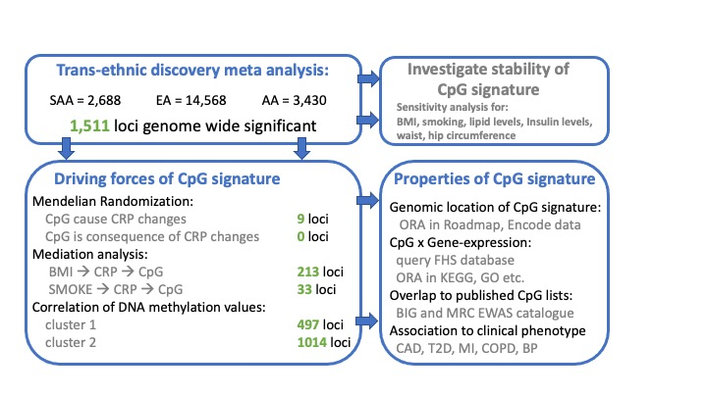
Supplementary Results:

Supplementary figure 1: Study overview. Flow of analysis starts with trans-ethnic discovery. Followed by analysis presented in the manuscript. ORA is short for over representation analysis (see online method section Overrepresentation analysis). Description of the Roadmap project incl. their publicly available data sets are available on their project homepage (http://www.roadmapepigenomics.org/data/ )FHS database indicates results from CpG x Gene expression analysis in Framingham heart study relevant for this study. BIG EWAS catalogue is supplied by National Genomics Datacenter China (https://bigd.big.ac.cn/databasecommons/database/id/6285 ) MRC EWAS catalogue is provided by the University of Bristol (http://www.ewascatalog.org)

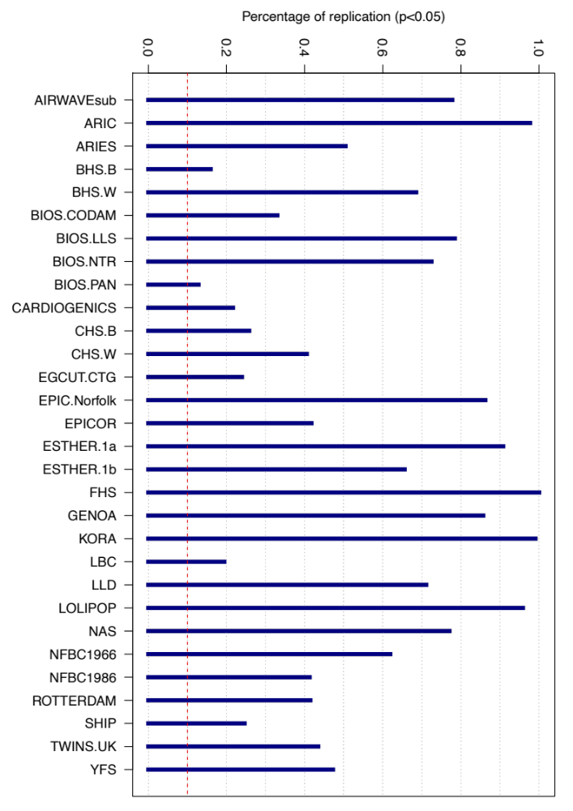

Supplementary Figure 2: Proportion of replicated CpGs. 218 CpG sites identified in Ligthart et al. Genome Biology (2016) were measured in each of the participating cohorts in the present study. Successful replication for any of the 218 markers in each cohort was defined as P value below 0.05 for the association between CpG methylation and serum CRP levels.

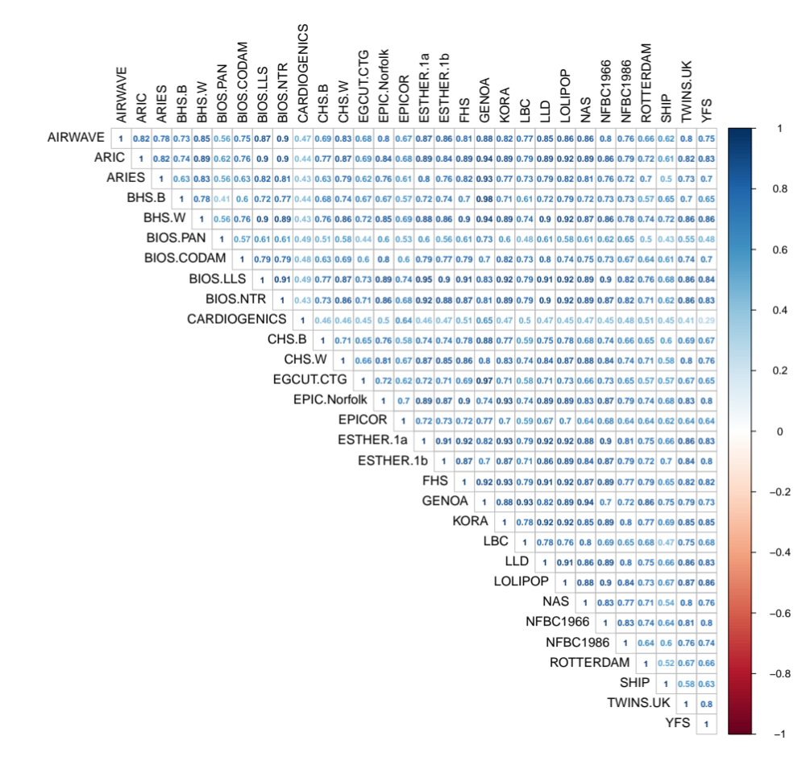

Supplementary Figure 3: Correlation of effect estimates for CRP association. As with Supplemental Figure 2 we restricted the analysis to 218 CpG sites reported as associated with blood CRP levels in Ligthart et al. We calculated Pearson correlation coefficients of pairwise complete observation between the cohorts.

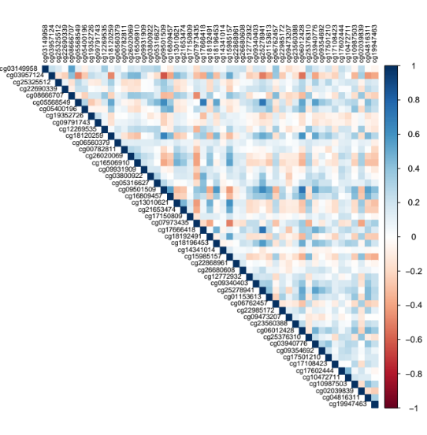
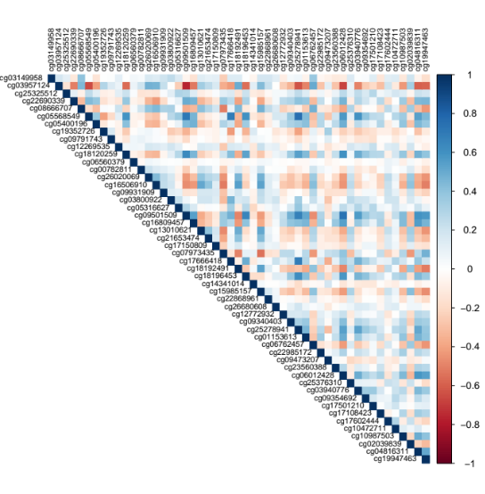
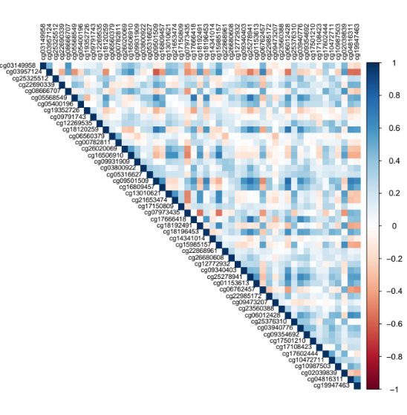
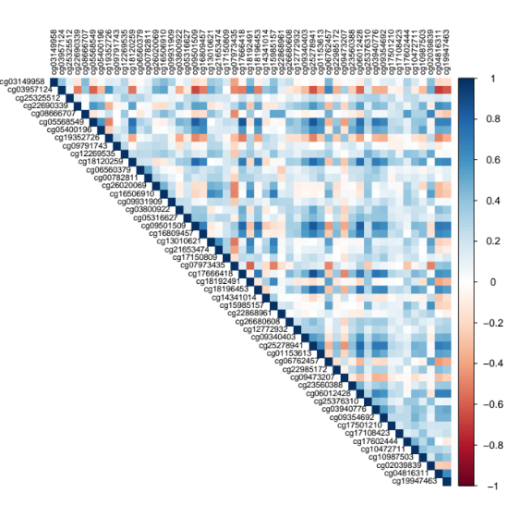
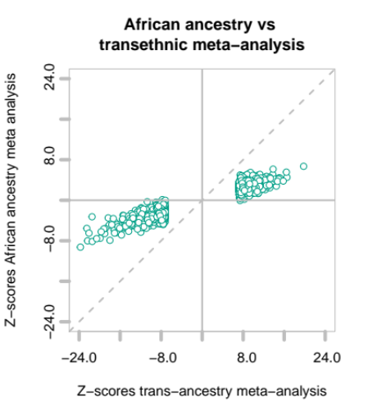
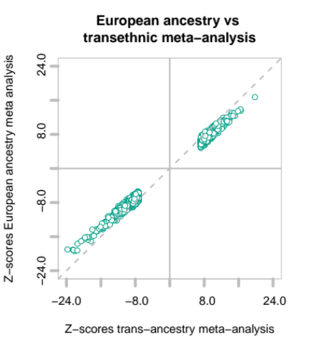
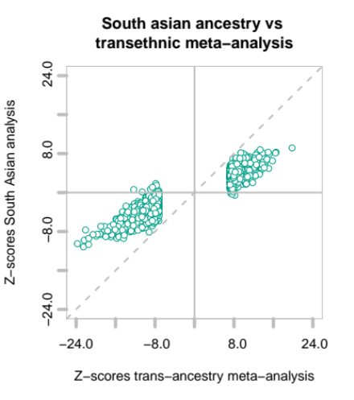
Supplementary Figure 4: Transethnic meta-analysis. For the 1,765 Bonferroni significant marker we compared Z-scores of each ancestry to transethnic discovery meta-analysis. Z-scores were calculated dividing effect sizes through standard errors.
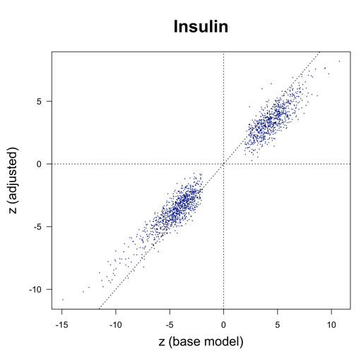
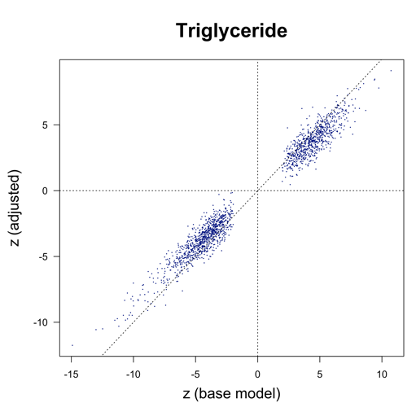
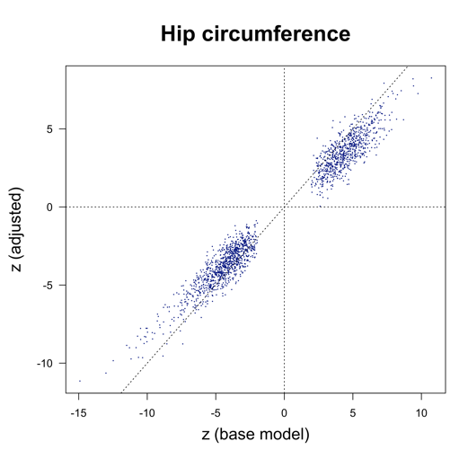
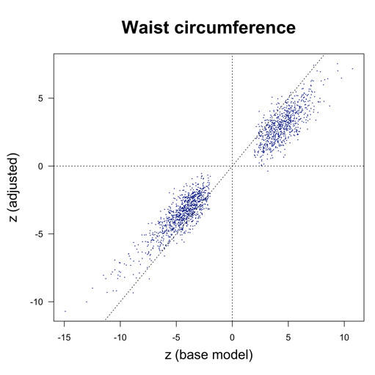
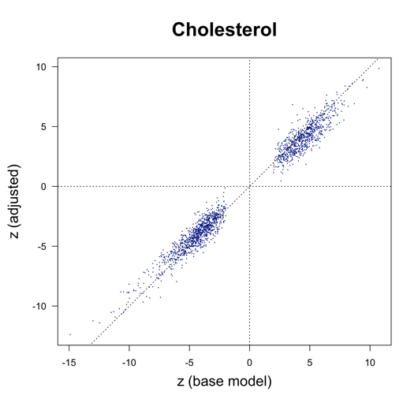
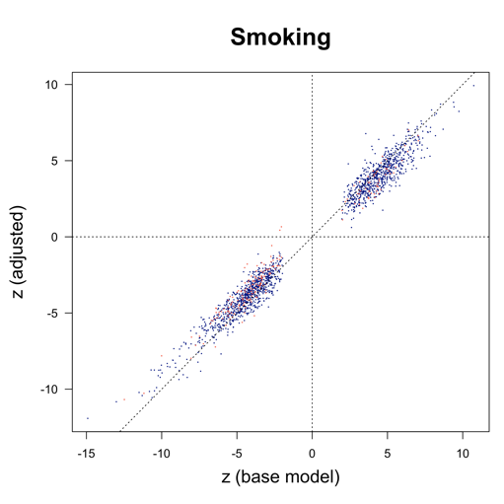
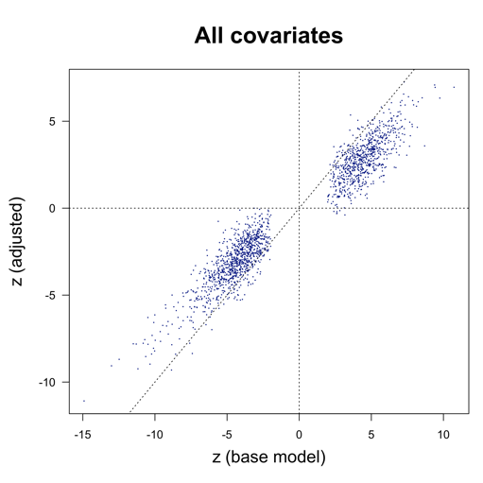
Supplementary Figure 5: Correlation of coefficients for DNA methylation values. From top left to bottom right cohorts are AIRWAVE, KORA, NFBC1966 and NFBC1986. Pearson correlation coefficients of random genomic region including 50 CRP-associated CpGs. The 50 CpGs are the same in all 4 datasets. All CpGs are sorted according their chromosomal position. Airwave data were generated on EPIC arrays whereas all other data was derived from Illumina 450k arrays.
Supplementary Figure 6: Z-score comparison from sensitivity analysis. From top left to bottom: smoking, waist circumference, hip circumference, total cholesterol, triglycerides, insulin, all tested covariates in one per regression model. For example the two models compared in the top left plot were: log(CRP) ~ DNAmeth + age + sex + estimated blood cell count + technical covariates as the base model plotted on the x axis versus Z scores from the model log(CRP) ~ DNAmeth + age + sex + estimated blood cell count + technical covariates + smoking on the y axis.

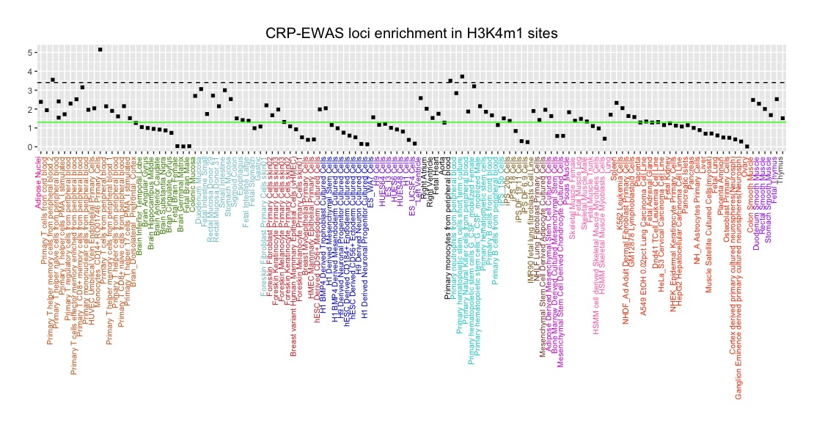
Supplementary Figure 7: Result of overrepresentation analysis for H3K4me1 across roadmap tissues. On the x axis datasets are given. Each entry represents one H3K4me1 data set for one specific tissue. The tissues are grouped by color. Y axis gives the negative log10 value of the P values derived from permutation test. Green line is P = 0.05; dotted line is Bonferroni significance level for all tested tissues. P value of overlap is derived from complete 1511 loci list.

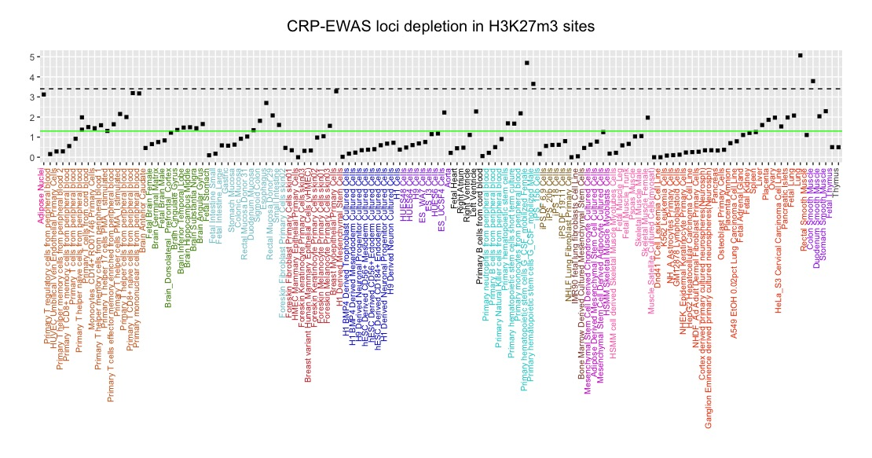
Supplementary Figure 8: Result of overrepresentation analysis for H3K27me3 across roadmap tissues. On the x axis datasets are given. Each entry represents one H3K27me3 data set for one specific tissue. The tissues are grouped by color. Y axis gives the negative log10 value of the P values derived from permutation tests. Green line is P = 0.05; dotted line is the Bonferroni significance level for all tested tissues. P value of overlap is derived from the complete 1511 loci list.

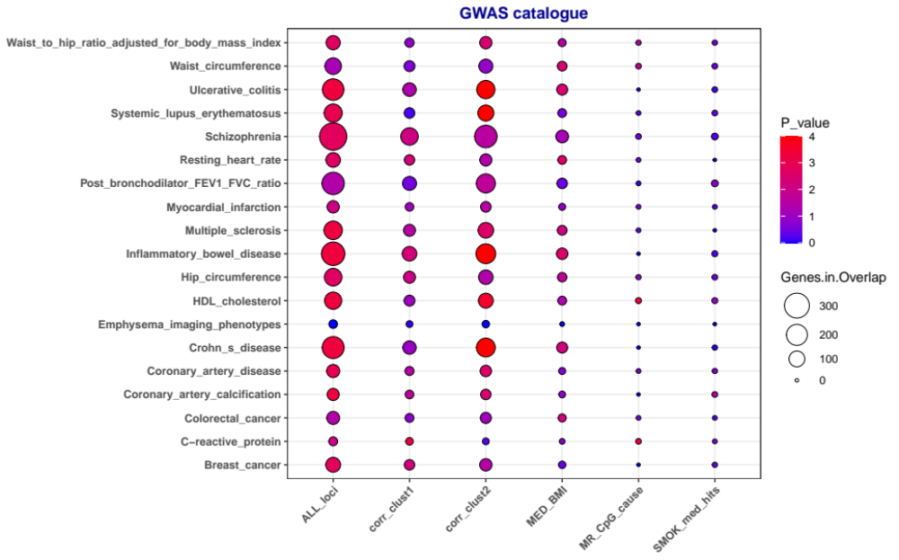

Supplementary Figure 9: Result of overrepresentation analysis. Selected traits from overlap between GWAS catalogue and CRP associated CpG signatures. Detailed explanation of overlap calculation and included trait is given in online methods.

