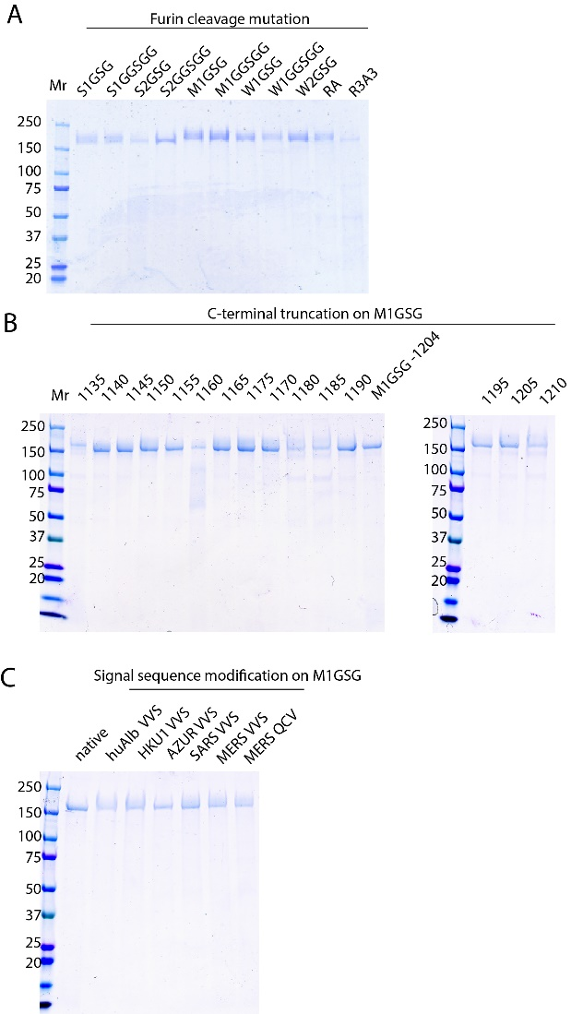

Supplementary Figure 1. SDS-PAGE analysis of Sclamp vaccine candidates (A) Furin cleavage mutation (B) C-terminal truncation on M1GSG backbone (C) Signal sequence modification on M1GSG backbone. Two micrograms of proteins were prepared in reduced condition, boiled and loaded onto 4-15% SDS-PAGE gel. The proteins were visualised by Coomassie staining.

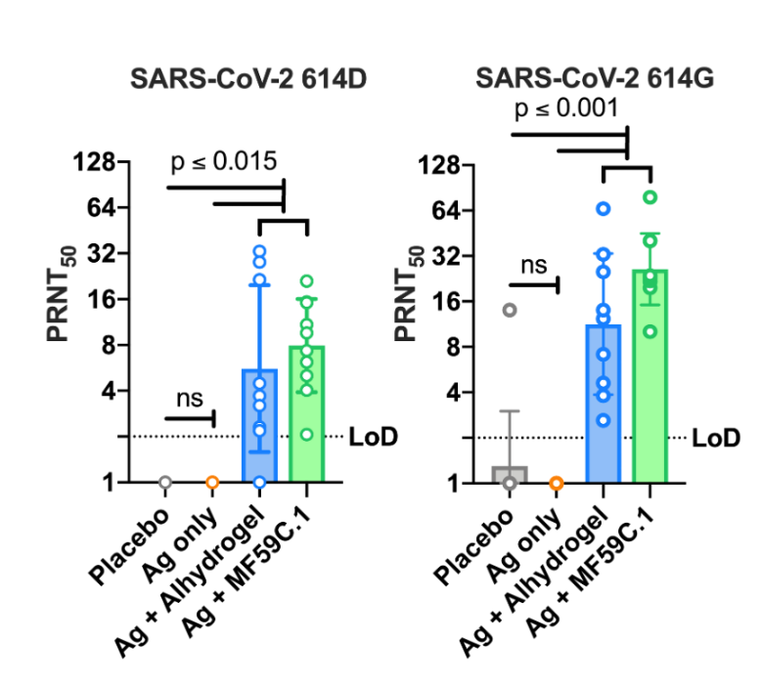
Supplementary Figure 2. Virus neutralisation in BAL. Day 42 BAL sample from placebo or SARS-CoV-2 Sclamp vaccinated BALB/c mice assessed by PRNT₅₀ assay against live SARS-CoV-2 614D and 614G isolates. P values were calculated as described in Figure 2.

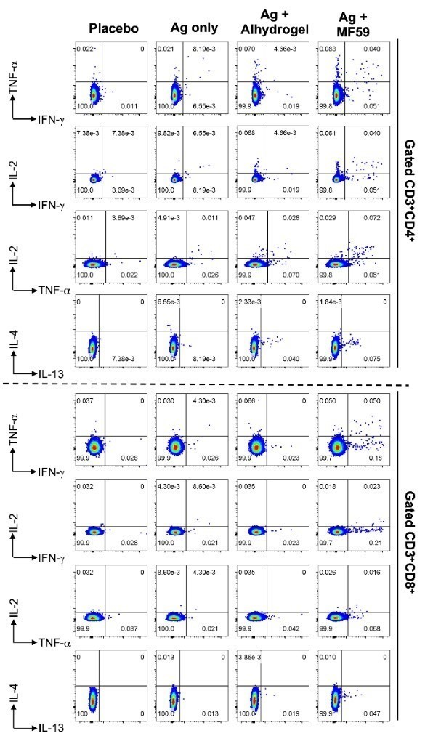
Supplementary Figure 3. Representative plots showing the expression of IFN-y, TNF-α, IL-2, IL-4 and/or IL-13 on gated CD3⁺CD4⁺ (top panel) or CD3⁺CD8⁺ (bottom panel) in placebo or SARS-CoV-2 Sclamp vaccinated mice analysed in the ICS analysis.

