Extended Data for Manuscript Entitled
Accelerated development of molecular clamp stabilized recombinant Spike protein subunit vaccine for COVID-19

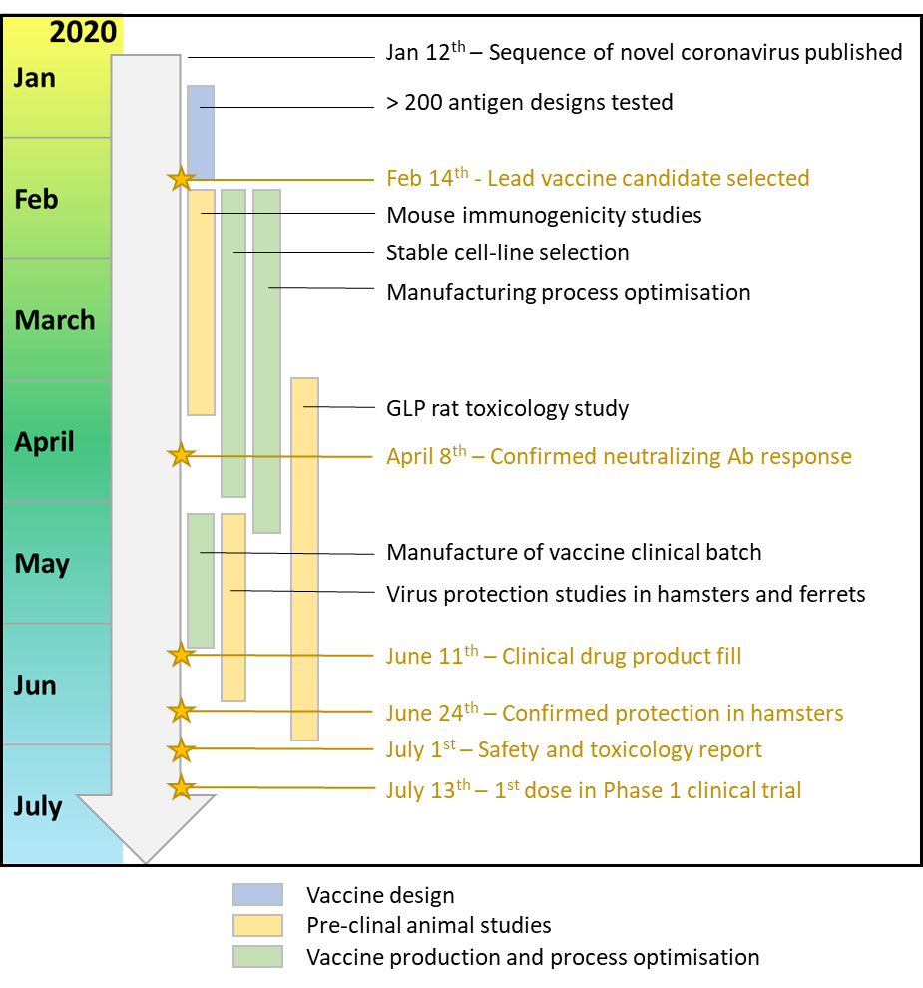
Extended Data Figure 1. Timeline summarising the preclinical development of the SARS-CoV-2 Sclamp vaccine.

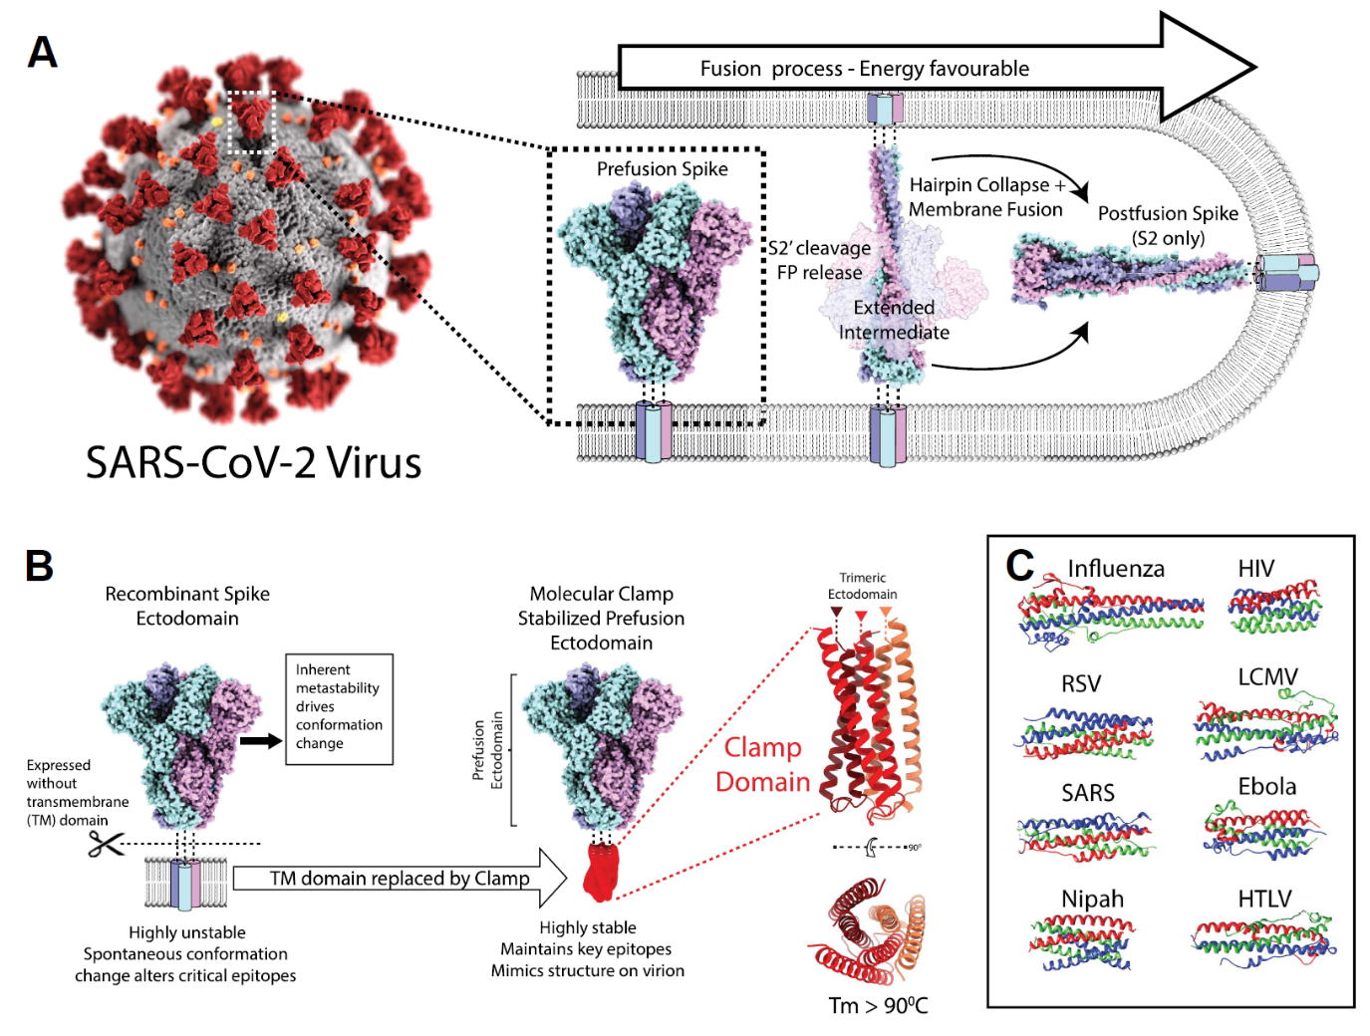
Extended Data Figure 2 Overview of the molecular clamp platform. A) Schematic representing the SARS-CoV-2 virion, spike protein and the transition process from the pre-fusion conformation to the post-fusion conformation. B) Schematic representation of how the molecular clamp six helical bundle is inserted in place of the spike protein transmembrane domain to produce a soluble protein that is stabilized in the pre-fusion conformation. C) Representative image showing the conserved architecture of the six-helical bundles from viral fusion protein that can be used as molecular clamps to achieve pre-fusion stabilization.

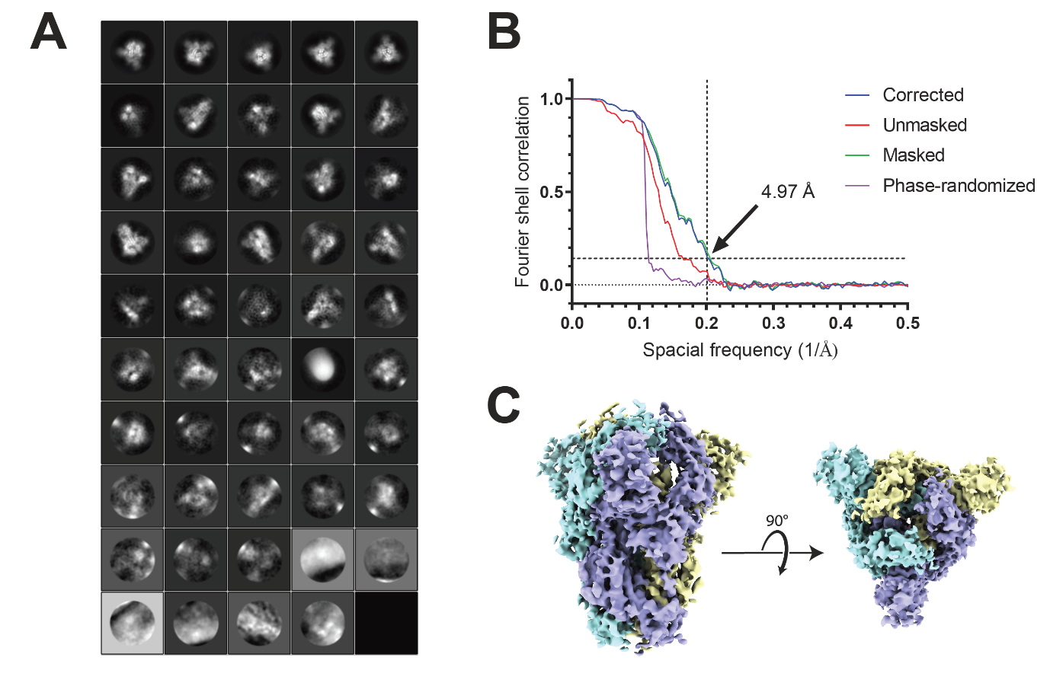
Extended Data Figure 3 Cryo-EM single particle analysis of Sclamp. Purified SARS-CoV-2 Sclamp was plunge frozen on TEM grids and imaged by cryo-EM. Data was acquired on a CryoARM-300 equipped with a K3 camera. A) 2D class averages of the Sclamp particles with an imposed spherical mask of 250 Å were generated by RELION 3.1. B) Fourier shell correlation (FSC) analysis of single particle analysis 3D refinement with C3 symmetry, indicating a final resolution of 4.97 Å at a FSC cut-off of 0.143. C) Side-on and top down representations of the Sclamp cryo-EM map with the 3 S protein monomers coloured individually for clarity.

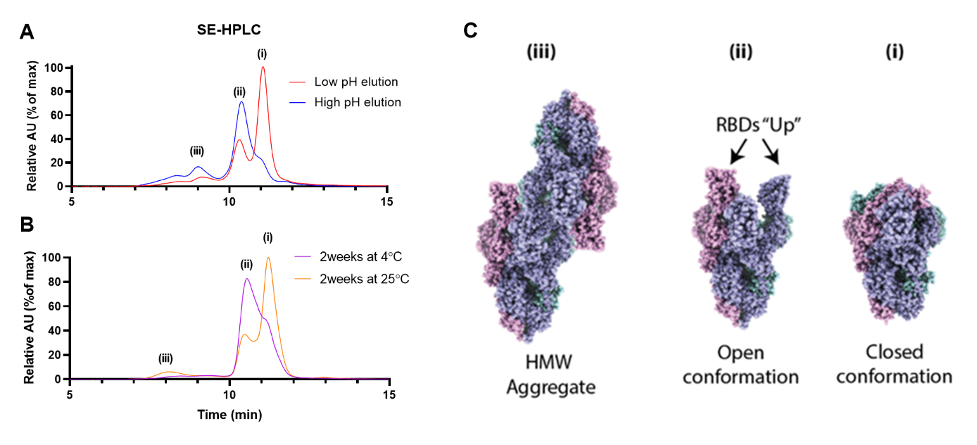
Extended Data Figure 4. Separation of SARS-Cov-2 Sclamp conformations by analytical SE-HPLC. A) Analytical SE-HPLC separation of low and high pH eluted SARS-CoV-2 Sclamp showing the presence of three peaks designate i, ii, and iii.For the purification, supernatant from the Sclamp encoding DNA (M1 GSG) was added to anti-clamp protein affinity column that was pre-equilibrated with high salt PBS (PBS with 400 mM NaCl, pH 7.4). Bound resin was washed with 15 column volumes (CV) of high salt PBS before elution with either high pH buffer (100 mM glycine, 137 mM NaCl, 5 mM EDTA, pH 11.5) or low pH buffer (100 mM Sodium Acetate, 100 mM NaCl, pH 3.5). B) Analytical SE-HPLC separation of SARS-CoV-2 Sclamp following 2-week incubation at 4º or 25ºC showing the presence of three peaks designated i, ii, and iii. C) Hypothesis describing the structure of SARS-CoV-2 Sclamp present at each peak present on the HPLC trace and how the antigen may transition between the two previously described Spike conformations, termed ‘open’ and ‘closed’, and a high molecular weight aggregated product.

Extended Data Figure 5. Thermal stability and separation of SARS-CoV-2 Sclamp conformations by analytical SE-HPLC. Purified SARS-CoV-2 Sclamp was incubated for either 1 (A), 2 (B), 4 (C) or 8 (D) weeks at 4°C, 25°C or 40°C before separation by SE-HPLC. (E) Negative stain images of SARS-CoV Sclamp stored for 4 weeksat 4°C, 25°C or 40°C, and imaged using a Hitachi HT7700 microscope operated at 120 kV, at the magnification of 25,000X using high contrast mode. Pre-fusion conformation of Sclamp was observed across the different thermal stress conditions.

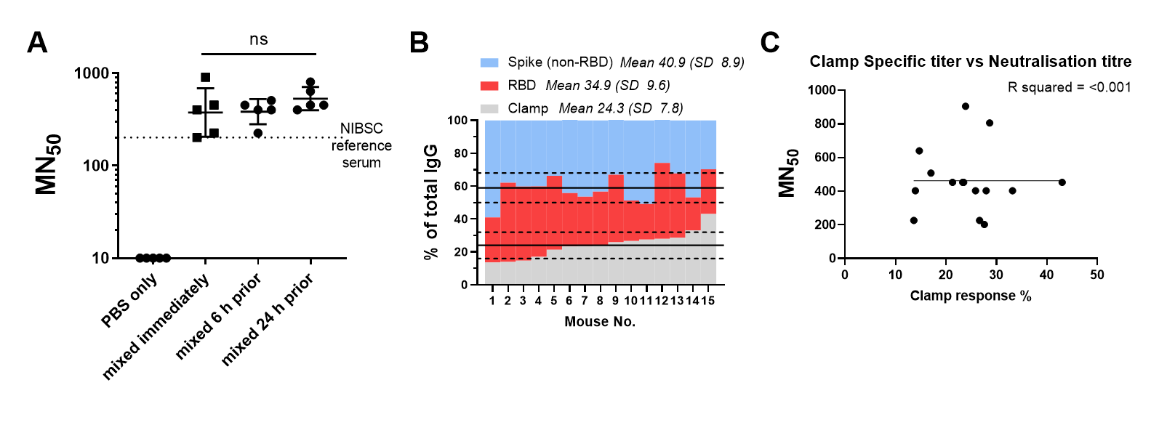
Extended Data Figure 6. Immunogenicity and post-formulation stability of SARS-CoV-2 Sclamp. Immunogenicity in mice was assessed by MN assay and ELISA as per methods. The SARS-CoV-2 Sclamp and MF59C.1 adjuvant were mixed either immediately (mouse 11-15), 6 hours (mouse 16-20) or 24 hours prior to dosing (mouse 21-25). Mixed formulations were incubated at 25°C for the specified time. A) Virus neutralisation assessed by TCID₅₀ using the indicated mouse serum isolated at week 5 following two doses given 3 weeks apart. Convalescent patient reference serum (NIBSC code 20:130) was included in the same neutralisation assay to allow benchmarking to other vaccine approaches. GMT = 426 (95%CI = 336-539) for Sclamp + MF59C.1 compared to 202 for the reference serum B) Analysis of clamp-specific, RBD-specific and non-RBD Spike specific IgG EC₅₀ titre assessed by ELISA. C) Scatter plot comparison of the percentage of clamp specific response against virus neutralisation.

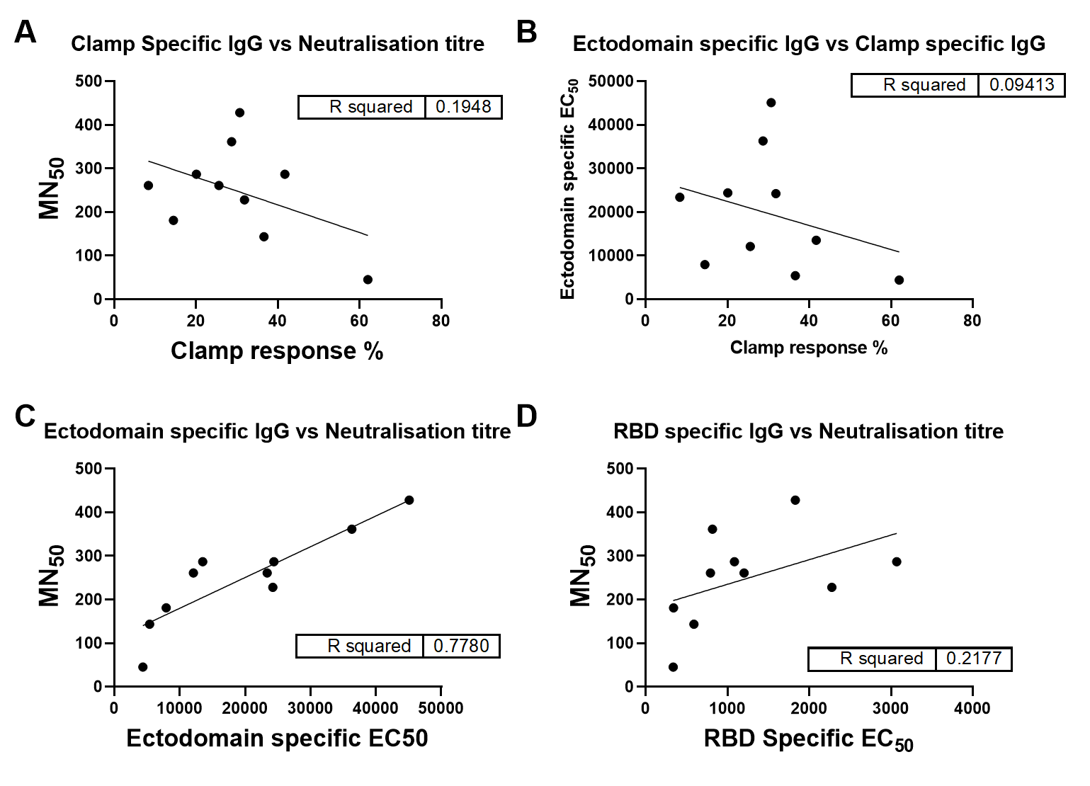
Extended Data Figure 7. Scatter plot comparison of humoral immune response (IgG) specificity and MN titre in mice. A) Percentage of clamp specific response compared against ectodomain specific ELISA EC₅₀. B) Percentage of clamp specific response compared against antigen and MN titre. C) Ectodomain specific ELISA EC₅₀ compared against antigen and MN titre. D) RBD specific ELISA EC₅₀ compared against antigen and MN titre.

Extended Data Figure 8. Hamster single dose protection study. A) Single dose study schedule. B) SARS-CoV-2 MN titre was measured for hamster serum collected at day 21 and 28 and the average MN₁₀₀ titre graphed. B) SARS-CoV-2 MN₁₀₀ titre was measured for hamster serum collected at day 21 and 28 and the average graphed. C) Virus quantification in daily throat swabs taken post-infection. D) Viral loads in nasal turbinates and lung tissue at day 4 post-infection. E) Severity score of inflammatory response based on histology at day 4 post-infection; 0 = no inflammatory cells, 1= few inflammatory cells, 2 = moderate number of inflammatory cells and 3 = many inflammatory cells. P values were calculated using a Kruskal-Wallis ANOVA with Dunn’s multiple comparison tests or a Two-Way ANOVA with Dunnett’s multiple comparison tests.

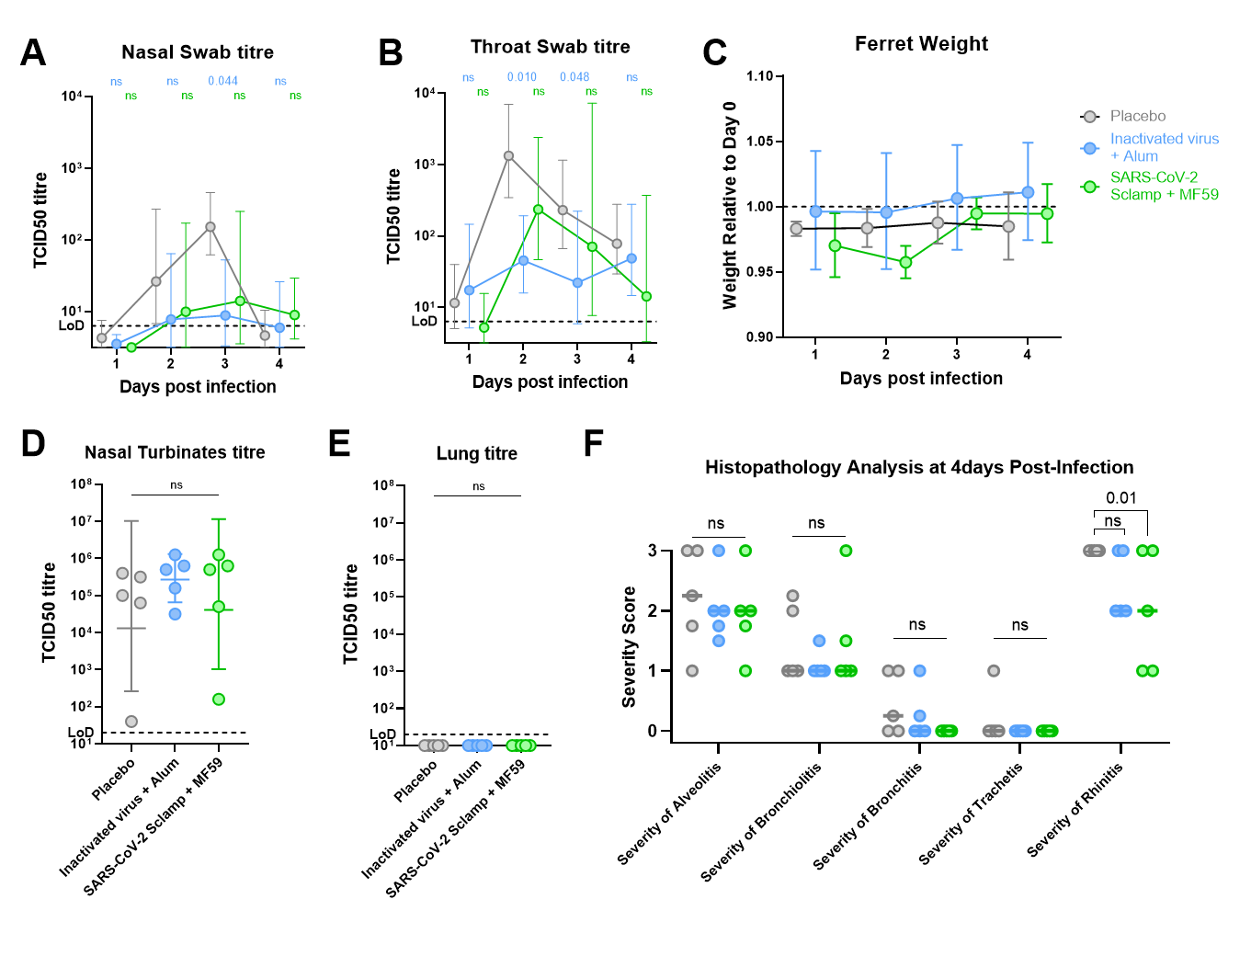 Extended Data Figure 9. Ferret Challenge Model. A) Daily nasal swab virus titre. B) Daily throat swab virus titre. C) Ferret weight relative to pre-challenge. D) Nasal turbinate tissue viral titre from animals sacrificed at day 4 post-challenge. E) Lung tissue viral titre from animals sacrificed at day 4 post-challenge. F) Histopathology scoring based on severity scoring at day 4 post-infection; 0 = no inflammatory cells, 1= few inflammatory cells, 2 = moderate number of inflammatory cells and 3 = many inflammatory cells. P values were calculated using a Kruskal-Wallis ANOVA with Dunn’s multiple comparison tests or a Two-Way ANOVA with Dunnett’s multiple comparison tests.

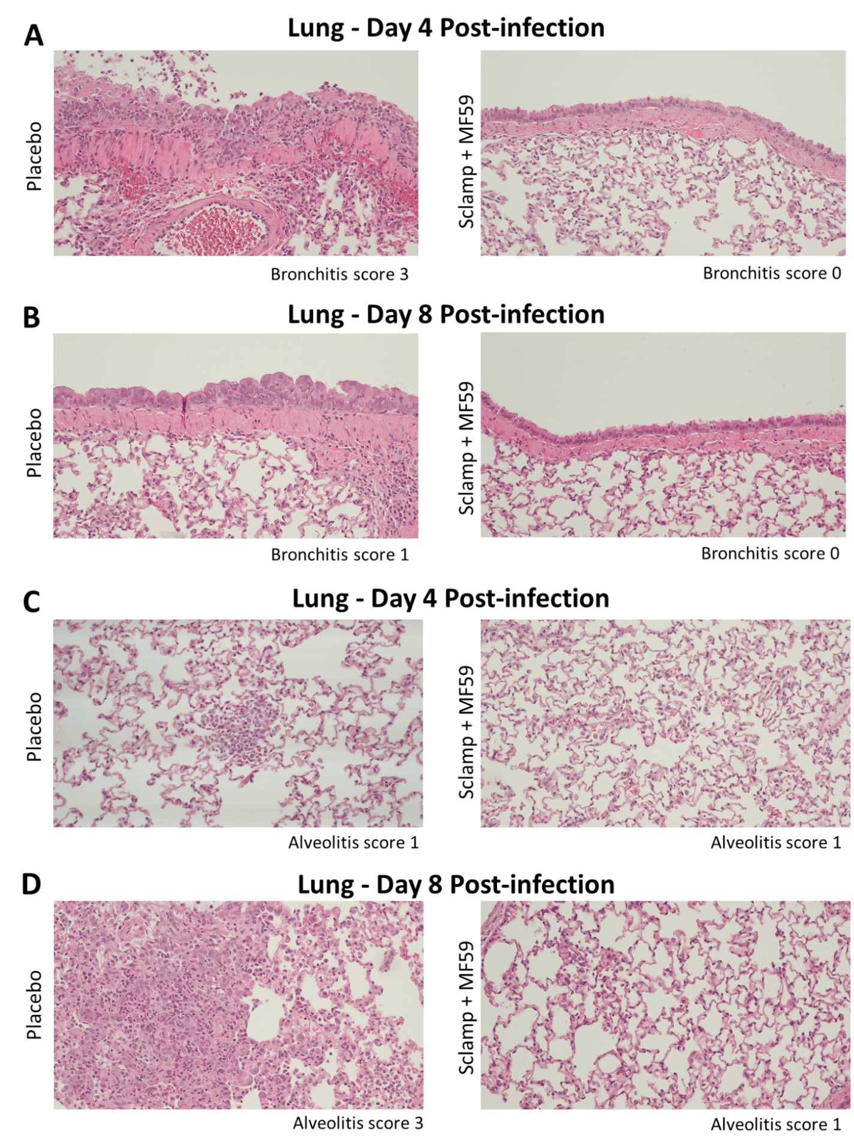

Extended Data Figure 10. Representative histopathology images. (10x objective) from hamster lungs. A/C) Placebo and Sclamp + MF59C.1 vaccinated animals at day 4 post-infection. B/D) Placebo and Sclamp + MF59C.1 vaccinated animals at day 8 post-infection.

