Development of Machine Learning Models for Precise Prediction of Bioactive Supramolecular Nucleoside Hydrogels

Weiqi Li et al.

*Corresponding author Email: zhaohangahy@scu.edu.cn

This PDF file includes:

Supplementary Methods
Supplementary Figure 1 to 11
Supplementary Table 1 to 11
References (1 to 3)

Other Supplementary Materials for this manuscript include the following:
Supplementary Data 1 to 10

Table of Contents
1. Supplementary Methods............................................................................3
2. Supplementary Figures............................................................................10
3. Supplementary Tables..............................................................................23
4. References.................................................................................................34

Supplementary Methods
- Data Collection and Preprocessing
1.1. Biological toxicology
In the Tox21 program (https://tripod.nih.gov/tox21/challenge/), activation of stress response effects (NR) and nuclear receptor effects (SR) was used to predict potential toxic effects of compounds¹. Data from 12 NR and SR toxicity assays were used, excluding compounds with excessive missing information (less than 10 assays available). Any activity in the assays was considered toxic, while no activity was considered non-toxic. After processing, 2,034 toxic (Activity=1) and 4,279 non-toxic (Activity=0) compounds were obtained.
1.2. Antibacterial
In PubChem², TAXONOMY project 837 was used as the database for inhibitors of Porphyromonas gingivalis. Compounds described as "Active" were considered inhibitors, while those described as "Inactive" were considered non-inhibitors. After processing, 30 inhibitors (Activity=1) and 122 non-inhibitors (Activity=0) were obtained.
1.3. Anti-viviral
1.3.1. Human alphaherpesvirus 1
In PubChem, TAXONOMY project 10298 was used as the database for inhibitors of Human alphaherpesvirus 1 (HSV-1). Compounds described as "Active" were considered inhibitors, while those described as "Unspecified/Inactive" were considered non-inhibitors. After processing, 1,807 inhibitors (Activity=1) and 3,699 non-inhibitors (Activity=0) were obtained.
1.3.2. Varicella-zoster virus
In PubChem, TAXONOMY project 10335 was used as the database for inhibitors of varicella-zoster virus (VZV). Compounds described as "Active" were considered inhibitors, while those described as "Unspecified/Inactive" were considered non-inhibitors. After processing, 408 inhibitors (Activity=1) and 1,247 non-inhibitors (Activity=0) were obtained.
1.3.3. Epstein-Barr virus
In PubChem, TAXONOMY project 10376 was used as the database for inhibitors of Epstein-Barr virus (EBV). Compounds described as "Active" were considered inhibitors, while those described as "Unspecified/Inactive" were considered non-inhibitors. For data with a class imbalance ratio greater than 1:5, downsampling was performed using propensity score matching by MACCSkeys fingerprint. After downsampling, 573 inhibitors (Activity=1) and 573 non-inhibitors (Activity=0) were obtained.
1.3.4. Human immunodeficiency virus
In PubChem, TAXONOMY project 12721 was used as the database for inhibitors of Human immunodeficiency virus (HIV). Compounds described as "Active" were considered inhibitors, while those described as "Unspecified/Inactive" were considered non-inhibitors. After processing, 984 inhibitors (Activity=1) and 935 non-inhibitors (Activity=0) were obtained.
1.4. Anti-inflammatory
1.4.1. Interleukin-1β
In PubChem, Protein project P01584 was used as the database for inhibitors of the Interleukin-1β (IL-1β). Compounds described as "Active" were considered inhibitors, while those described as "Unspecified/Inactive" were considered non-inhibitors.For data with a class imbalance ratio greater than 1:5, downsampling was performed using propensity score matching by MACCSkeys fingerprint. After downsampling, 567 inhibitors (Activity=1) and 567 non-inhibitors (Activity=0) were obtained.
1.4.2. Tumor necrosis factor-α
In PubChem, Protein project P01375 was used as the database for inhibitors of the Tumor necrosis factor-α (TNF-α). Compounds described as "Active" were considered inhibitors, while those described as "Unspecified/Inactive" were considered non-inhibitors. After processing, 3,405 inhibitors (Activity=1) and 2,770 non-inhibitors (Activity=0) were obtained.
1.5. Anti-tumor
In PubChem, Cell Lines project Centre Antoine Lacassagne-27 (CAL-27) was used as the database for inhibitors of oral cancer cell lines. Compounds described as "Active" were considered inhibitors, while those described as "Unspecified/Inactive" were considered non-inhibitors. After processing, 159 inhibitors (Activity=1) and 101 non-inhibitors (Activity=0) were obtained.
- Detailed methods for building the model
  - Feature selection based on descriptors
A total of 5566 molecular descriptors were calculated for each nucleoside derivative by alvaDesc (Supplementary Data 3)³. After removing the descriptors with missing values that were not suitable for this study, a three-step feature selection was utilized based on the descriptors that passed the missing values to avoid overfitting and improve the model accuracy. The flow chart of the feature selection was illustrated in Fig. 2a. Firstly, the rank-sum test was used to find the descriptors have significant differences (P<0.05) between inhibitors and non-inhibitors group of nine bioactivity datasets. Secondly, exclude one of the pairs of descriptors with correlation coefficient higher than 0.8 (Rho > 0.8) with Spearman correlation to avoid the collinearity. After this step, remaining descriptors were kept for subsequent model training. Finally, ML algorithm-based recursive feature elimination (RFE) was used to obtain the optimal combination of descriptors that maximizes model performance. Four commonly used ML algorithms were utilized to construct prediction models: LR, decision tree (DT), RF, and extreme gradient boosting (XGBoost).
  - Determination of the Predictive Model
To construct the prediction models comprehensively from the four stages of feature selection, different mathematical representations of molecules based on descriptors were used to build prediction models with four ML algorithms (Supplementary Table 1). The performances of all these models were assessed by five evaluation indexes, including test accuracy, area under the curve (AUC), precision, recall and F1 score (Supplementary Methods 2.3). And in this study, test accuracy and AUC were mainly focused on, and the results of precision, recall, and F1 score were used as auxiliary indicators. Fivefold stratified cross-validation which was performed 10 times independently was applied in hyperparameter optimization, recursive feature elimination (RFE), and calculation for evaluation indexes.
  - Details of model parameters
The optimal model was determined with reference to the results of accuracy and AUC, and with attention to parameters including recall, F1 score and precision.
A true positive (TP) is an outcome where the model correctly predicts the positive class. Similarly, a true negative (TN) is an outcome where the model correctly predicts the negative class. A false positive (FP) is an outcome where the model incorrectly predicts the positive class. And a false negative (FN) is an outcome where the model incorrectly predicts the negative class.
Precision: Denotes the percentage of samples with positive predictions that are truly positive. In our study, it means the proportion for the true inhibitors of we predicted inhibitors of the nine bioactivities.
$Precision=\frac{TP}{TP+FP}$(1)
Recall: Denotes the percentage of samples that are truly positive and the number of samples that are predicted to be positive. In our study, it means the proportion for accurately predicted inhibitors of all inhibitors of the nine bioactivities.
$Recall=\frac{TP}{TP+FN}$ (2)
F1 score: It can be interpreted as a harmonic mean of the precision and recall. The higher the summed average of precision and recall is, the better the model performance is.
$F1 score=\frac{2TP}{2TP+FP+FN}$ (3)
Accuracy: The percentage of total predictions that were correct. In our study, it means the proportion of accurately predicted inhibitors and non-inhibitors of the nine bioactivities in nucleoside derivatives.
$Accuracy=\frac{TP+TN}{TP+TN+FP+FN}$ (4)
AUC: Denotes the area under the ROC curve. When inhibitors and non-inhibitors is randomly picked, the probability of the inhibitors ranking in front of the non-inhibitors according to the calculated score is the AUC value. The larger the AUC value is, the better the predicted model performs.

Micro-CT Analysis
Samples (alveolar bone from the mouse maxilla) were fixed in 4% paraformaldehyde for micro-CT scanning (SCANCO) with a resolution of 15 μm, an energy of 70 kVp, and a power of 114 μA. Using Skyscan software, bone volume fraction (BV/TV), trabecular separation (Tb. Sp), and trabecular number (Tb. N) were assessed within a three-dimensional region of interest (ROI). Additionally, the linear dimension of alveolar bone loss was measured at three locations of the first molar (mesial buccal, middle buccal, and distal buccal), and the average value was calculated. Representative sagittal 3D and 2D images of the maxillary molars were captured at each time point.
H&E, and IHC Staining
For complete decalcification, specimens were treated with 10% ethylenediaminetetraacetic acid (EDTA) at room temperature for one month. The samples were then embedded in paraffin and sectioned along the mesiodistal direction of the teeth to obtain 5-μm thick slices. Sagittal sections were stained with hematoxylin and eosin (H&E) to evaluate the normal and pathological status of periodontal tissues. High-power microscopy was used to observe and compare the number of inflammatory cells and collagen fibers in H&E sections.
For immunohistochemical (IHC) staining, cytokines were detected using primary antibodies for TNF-α and IL-1β, and images were captured under a light microscope. Average optical density (AOD) and the number of protein-positive cells in each group were quantified using ImageJ under high-power magnification.

Supplementary Figures
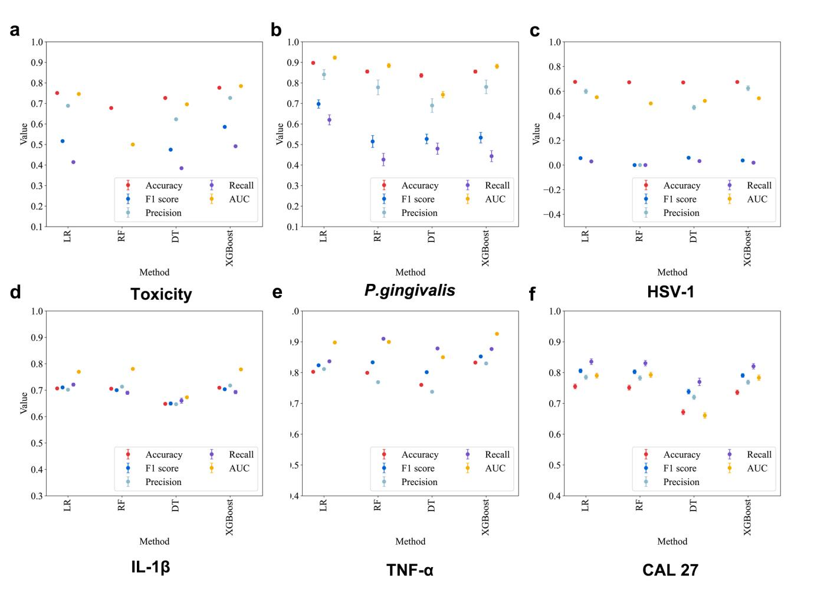
Supplementary Fig. 1. a-f Scatterplots illustrates the performance of the four algorithms ML models after recursive feature elimination for six bioactivity datasets. Metrics including test accuracy, F1 score, recall, precision, and AUC (Area under the curve).

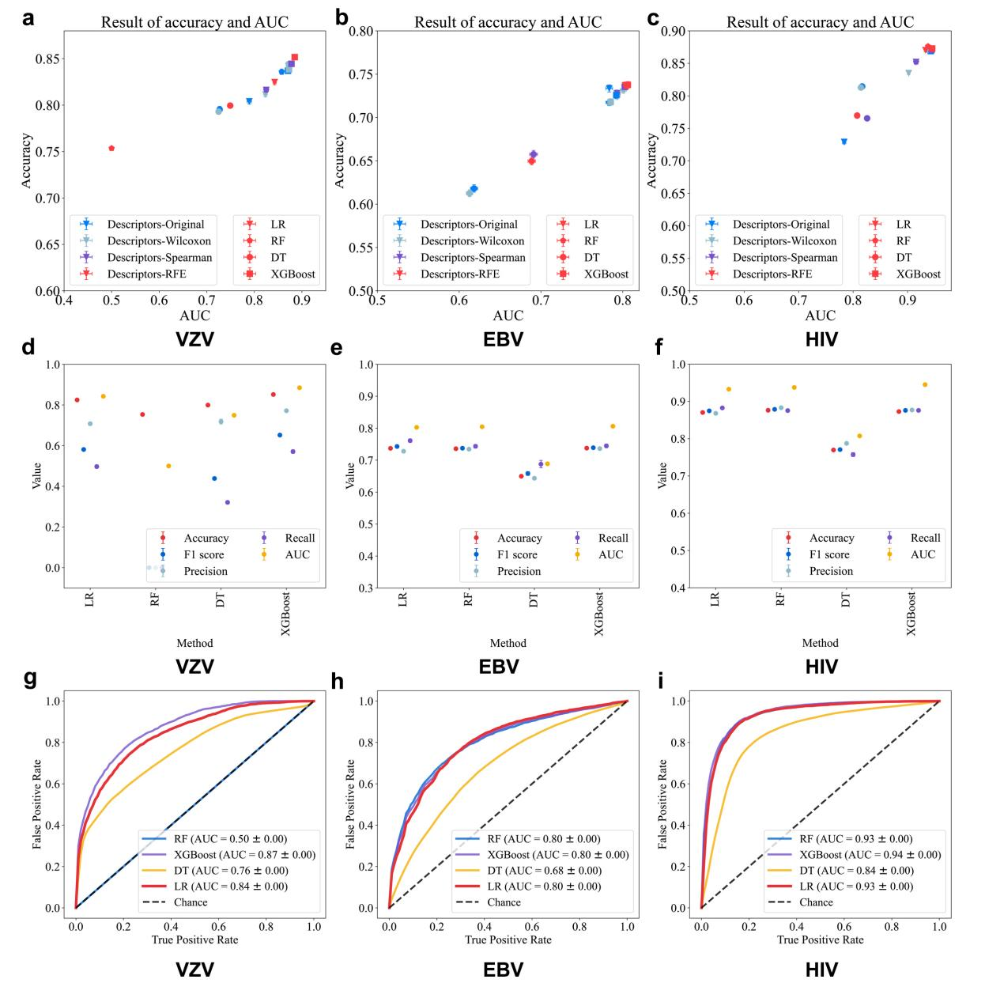

Supplementary Fig. 2. Scatterplots illustrates the performance of the ML models for three bioactivity datasets. a - c Scatterplots showed the distribution of AUC (area under the curve) and test accuracy for all models. The 4-point shapes represent different ML algorithms: extreme gradient boosting (XGBoost), logistic regression (LR), decision tree (DT), and random forest (RF). Descriptor’s part: Initially obtained descriptors,descriptors after rank sum test, descriptors after correlation coefficient selection, and descriptors after recursive feature elimination (RFE); b - e Scatterplots illustrates the performance of the four algorithms ML models after recursive feature elimination for six bioactivity datasets. Metrics including test accuracy, F1 score, recall, precision, and AUC (Area under the curve). g - i AUC (Area under the curve) for the four algorithms (LR, DT, RF, and XGBoost) using descriptors after RFE.

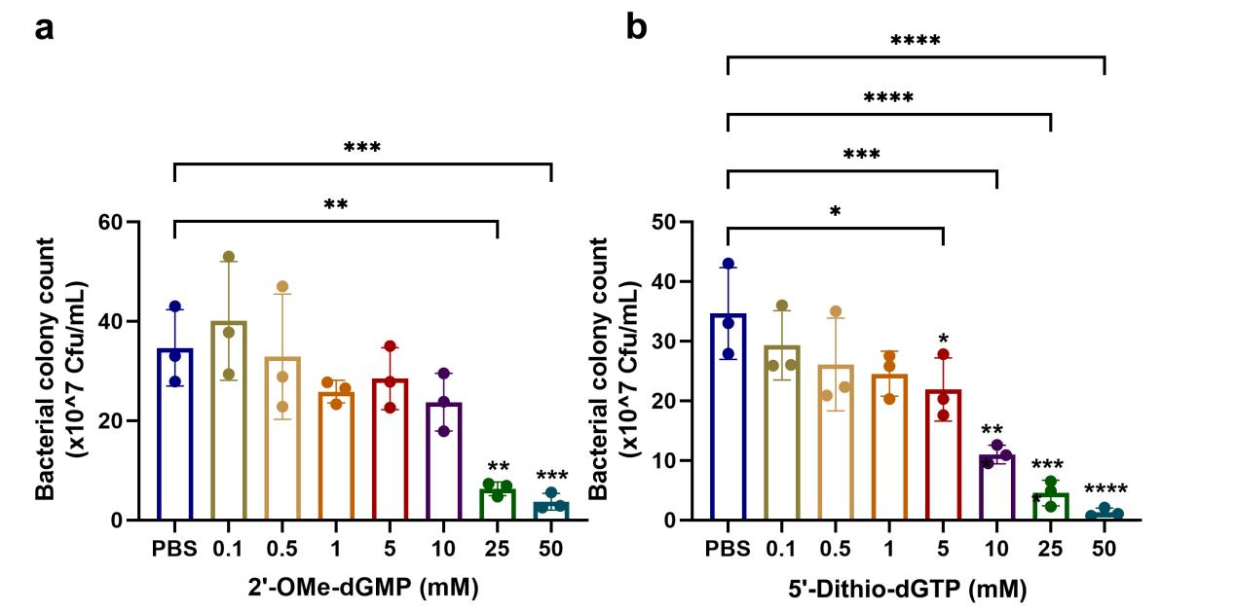

Supplementary Fig. 3. Colony counting calculated results a Colony counting calculated of 2'-OMe-dGMP monomers b Colony counting calculated of 5'-Dithio-dGTP monomers
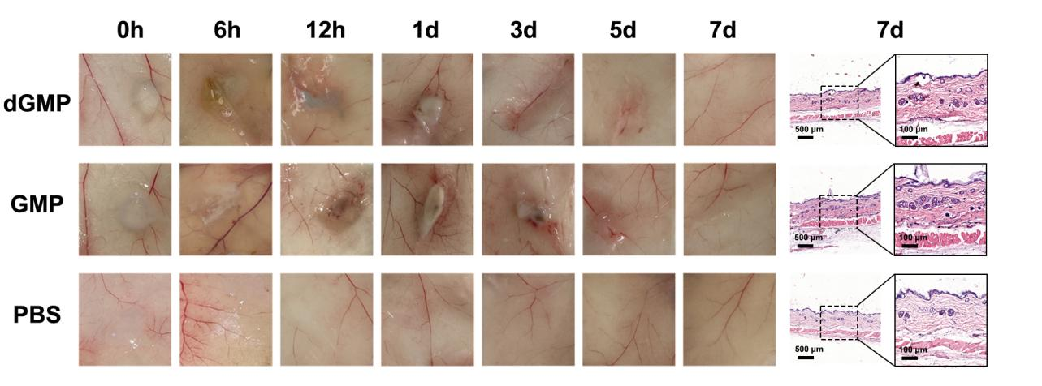
Supplementary Fig. 4. In Vivo Biocompatibility of Hydrogels. The in vivo biocompatibility test of GMP, dGMP, and PBS control hydrogels following subcutaneous injection. The left panels represent images at different time points post-injection, ranging from 0 hours (0 h) to 7 days (7 d), to observe inflammation and healing at the injection sites. The right panels display hematoxylin and eosin (H&E) stained histological sections obtained on day 7 to evaluate the effect of hydrogels on subcutaneous tissue.
Supplementary Fig 5. Biocompatibility evaluation of GMP and dGMP gels in major organs. Histological sections of major organs (heart, spleen, liver, lung, kidney) sampled 14 days after injection of Ag+, GMP, dGMP, and their hydrogels in periodontitis-induced mice. The control group included injections of Ag+, GMP, and dGMP solutions, while the gel group included GMP and dGMP hydrogels. Hematoxylin and eosin (H&E) staining was performed to assess the biocompatibility of hydrogels in various organs.
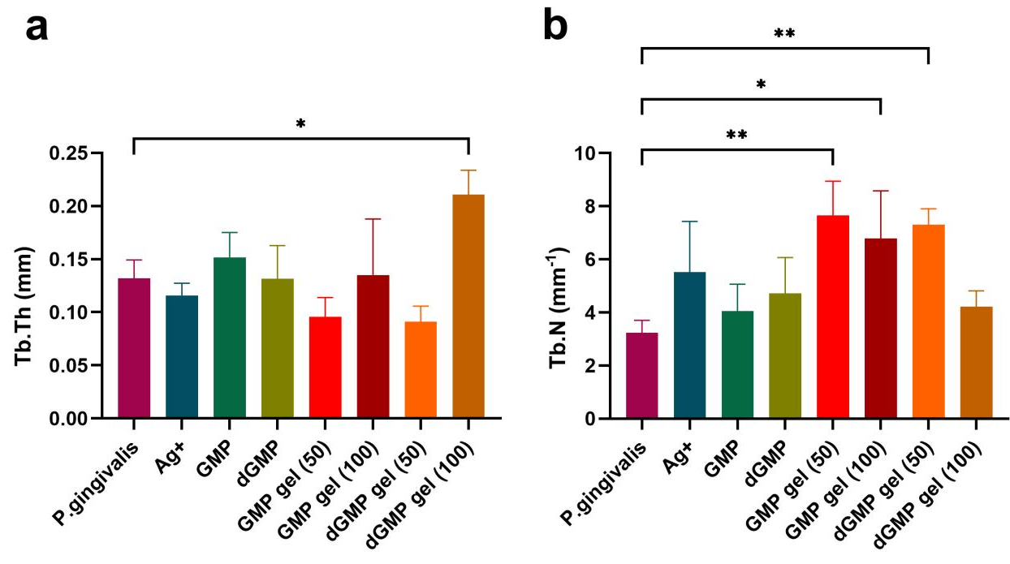
Supplementary Fig 6. Trabecular bone analysis after hydrogel treatment. Trabecular bone thickness (a, Tb.Th) and trabecular number (b, Tb.N) after hydrogel treatment.

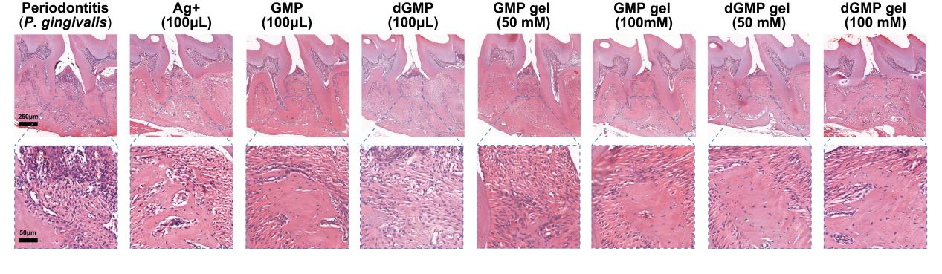
Supplementary Fig 7. Hematoxylin and eosin (H&E) staining showing inflammation levels after treatment with different gels. H&E staining of gingival tissue
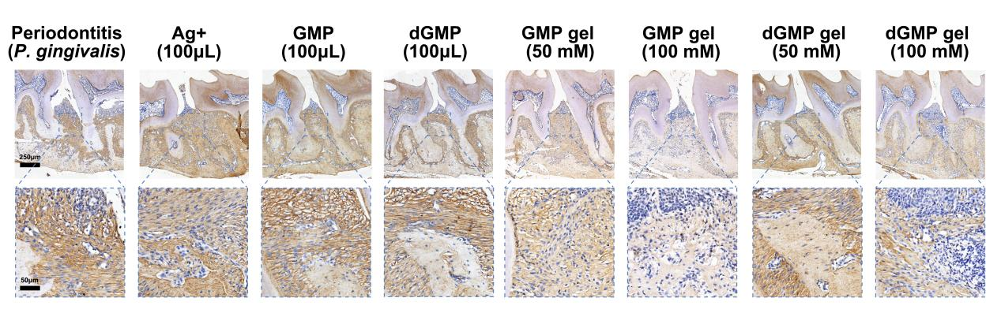
Supplementary Fig 8. Immunohistochemical (IHC) analysis of TNF-α expression in gingival tissue, indicating inflammation status across various groups.
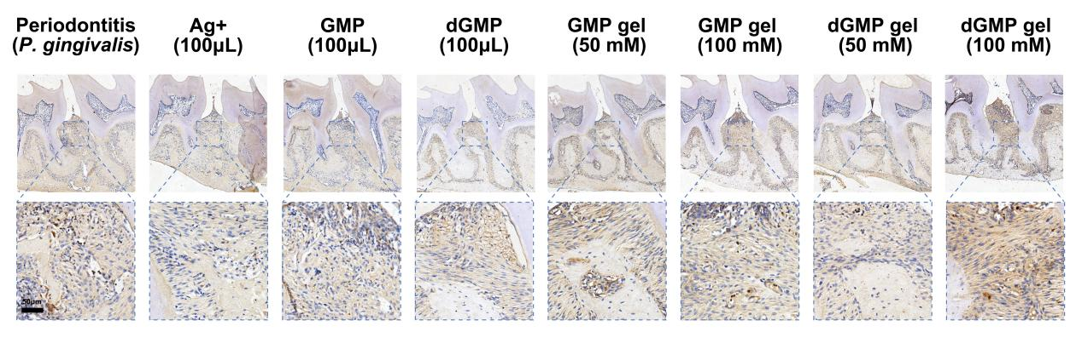
Supplementary Fig 9. Immunohistochemical (IHC) analysis of and TGF-β expression in gingival tissue, indicating inflammation status across various groups.

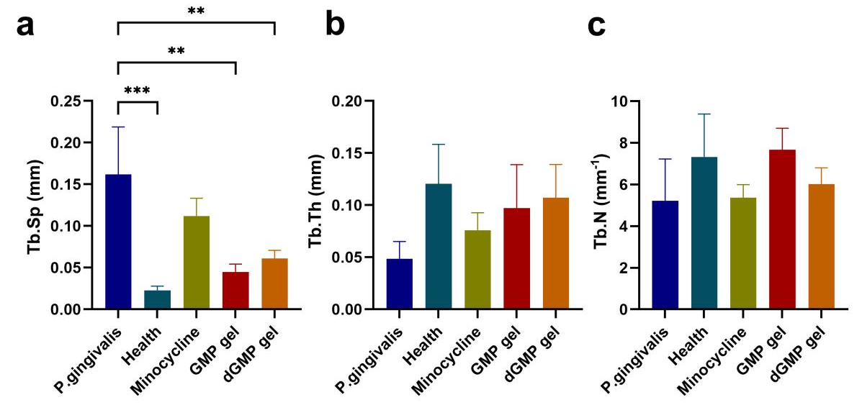
Supplementary Fig 10. Trabecular bone analysis. Trabecular separation (a, Tb.Sp), trabecular thickness (b, Tb.Th), and trabecular number (c, Tb.N) in different treatment groups.

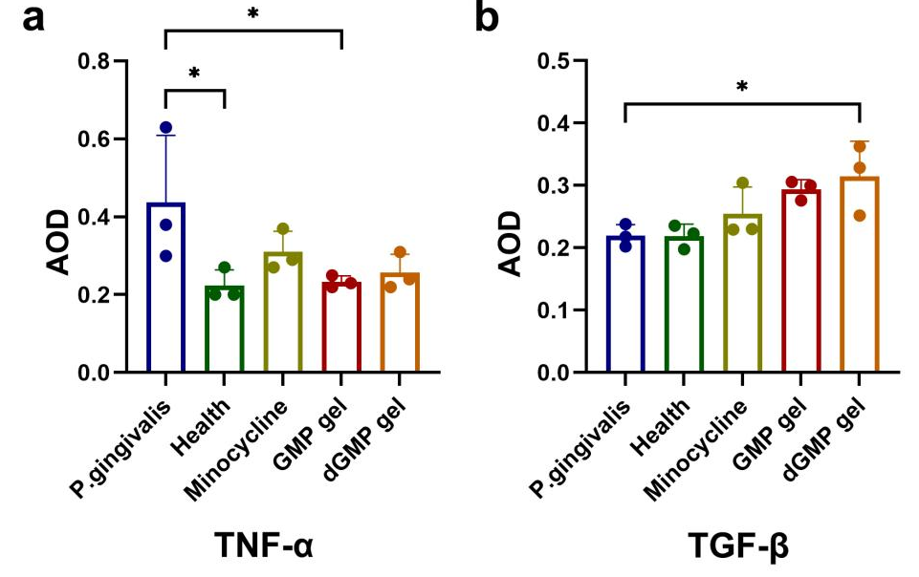
Supplementary Fig 11. Quantitative analysis of TNF-α and TGF-β expression. Average optical density (AOD) values for TNF-α (a) and TGF-β (b) in different treatment groups.

Supplementary Tables
Supplementary Table 1. Characteristics of the prediction models
Features | Algorithms | Rows | Columns
Descriptors- | LR, DT, RF, XGBoost# | N of datasets | N of descriptors
Descriptors- | LR, DT, RF, XGBoost | N of datasets | N of descriptors
Descriptors- | LR, DT, RF, XGBoost | N of datasets | N of descriptors
Descriptors-REF& | LR, DT, RF, XGBoost | N of datasets | N of descriptors
Notes: * Rows: Whether the nucleoside derivatives have the hydrogel-forming ability.
#Algorithms: Logistic regression (LR), decision tree (DT), random forest (RF), and extreme gradient boosting (XGBoost);
&Descriptors-REF: Recursive feature elimination (REF) has different optimal descriptors for different Algorithms.

Supplementary Table 2. The model performance result of different models of toxicology
Features | Descriptprs-  Original |  | Descriptprs-  Wilcoxon |  | Descriptprs-  Spearman |  | Descriptors-  REF
Values | Mean | SE | Mean | SE | Mean | SE | Mean | SE
Accuracy (test set) | 0.759 | 0.002 | 0.757 | 0.002 | 0.771 | 0.001 | 0.777 | 0.001
Accuracy (train set) | 0.996 | 0.000 | 0.995 | 0.000 | 0.928 | 0.000 | 0.891 | 0.000
F1 Score | 0.574 | 0.003 | 0.570 | 0.003 | 0.571 | 0.003 | 0.586 | 0.003
Precision | 0.666 | 0.003 | 0.665 | 0.003 | 0.718 | 0.003 | 0.727 | 0.003
Recall | 0.506 | 0.004 | 0.499 | 0.004 | 0.475 | 0.004 | 0.492 | 0.004
AUC* | 0.760 | 0.002 | 0.756 | 0.002 | 0.781 | 0.002 | 0.785 | 0.002
Notes: * AUC：Area under Curve
REF: Recursive feature elimination used extreme gradient boosting.
Supplementary Table 3. The model performance result of different models of anti - P. gingivalis
Features | Descriptprs-  Original |  | Descriptprs-  Wilcoxon |  | Descriptprs-  Spearman |  | Descriptors-  REF
Values | Mean | SE | Mean | SE | Mean | SE | Mean | SE
Accuracy (test set) | 0.806 | 0.009 | 0.835 | 0.008 | 0.869 | 0.008 | 0.897 | 0.007
Accuracy (train set) | 0.857 | 0.003 | 0.918 | 0.002 | 0.947 | 0.002 | 0.944 | 0.002
F1 Score | 0.426 | 0.025 | 0.464 | 0.024 | 0.614 | 0.022 | 0.697 | 0.020
Precision | 0.544 | 0.035 | 0.710 | 0.041 | 0.778 | 0.031 | 0.841 | 0.024
Recall | 0.377 | 0.025 | 0.373 | 0.023 | 0.540 | 0.024 | 0.620 | 0.025
AUC* | 0.762 | 0.017 | 0.861 | 0.011 | 0.872 | 0.011 | 0.923 | 0.008
Notes: * AUC：Area under Curve
REF: Recursive feature elimination used logistic regression.

Supplementary Table 4. The model performance result of different models of anti - HSV-1
Features | Descriptprs-  Original |  | Descriptprs-  Wilcoxon |  | Descriptprs-  Spearman |  | Descriptors-  REF
Values | Mean | SE | Mean | SE | Mean | SE | Mean | SE
Accuracy (test set) | 0.658 | 0.001 | 0.674 | 0.001 | 0.675 | 0.001 | 0.675 | 0.001
Accuracy (train set) | 0.693 | 0.000 | 0.678 | 0.000 | 0.677 | 0.000 | 0.677 | 0.000
F1 Score | 0.124 | 0.003 | 0.077 | 0.002 | 0.057 | 0.002 | 0.056 | 0.002
Precision | 0.391 | 0.008 | 0.551 | 0.015 | 0.593 | 0.017 | 0.598 | 0.018
Recall | 0.074 | 0.002 | 0.041 | 0.001 | 0.030 | 0.001 | 0.029 | 0.001
AUC* | 0.504 | 0.002 | 0.546 | 0.002 | 0.547 | 0.002 | 0.551 | 0.002
Notes: * AUC：Area under Curve
REF: Recursive feature elimination used logistic regression.

Supplementary Table 5. The model performance result of different models of anti - VZV
Features | Descriptprs-  Original |  | Descriptprs-  Wilcoxon |  | Descriptprs-  Spearman |  | Descriptors-  REF
Values | Mean | SE | Mean | SE | Mean | SE | Mean | SE
Accuracy (test set) | 0.837 | 0.003 | 0.838 | 0.003 | 0.844 | 0.003 | 0.852 | 0.002
Accuracy (train set) | 0.985 | 0.000 | 0.985 | 0.000 | 0.982 | 0.000 | 0.968 | 0.000
F1 Score | 0.632 | 0.007 | 0.634 | 0.006 | 0.631 | 0.007 | 0.652 | 0.007
Precision | 0.715 | 0.007 | 0.721 | 0.008 | 0.760 | 0.008 | 0.772 | 0.007
Recall | 0.571 | 0.008 | 0.571 | 0.008 | 0.545 | 0.008 | 0.571 | 0.009
AUC* | 0.871 | 0.003 | 0.873 | 0.003 | 0.878 | 0.003 | 0.885 | 0.003
Notes: * AUC：Area under Curve
REF: Recursive feature elimination used extreme gradient boosting.

Supplementary Table 6. The model performance result of different models of anti - EBV
Features | Descriptprs-  Original |  | Descriptprs-  Wilcoxon |  | Descriptprs-  Spearman |  | Descriptors-  REF
Values | Mean | SE | Mean | SE | Mean | SE | Mean | SE
Accuracy (test set) | 0.726 | 0.004 | 0.718 | 0.004 | 0.735 | 0.004 | 0.738 | 0.004
Accuracy (train set) | 1.000 | 0.000 | 1.000 | 0.000 | 0.965 | 0.000 | 0.962 | 0.000
F1 Score | 0.728 | 0.004 | 0.720 | 0.004 | 0.738 | 0.004 | 0.739 | 0.004
Precision | 0.724 | 0.004 | 0.716 | 0.004 | 0.732 | 0.004 | 0.736 | 0.004
Recall | 0.733 | 0.005 | 0.726 | 0.006 | 0.746 | 0.006 | 0.745 | 0.006
AUC* | 0.792 | 0.004 | 0.785 | 0.004 | 0.803 | 0.004 | 0.806 | 0.004
Notes: * AUC：Area under Curve
REF: Recursive feature elimination used extreme gradient boosting.

Supplementary Table 7. The model performance result of different models of anti - HIV
Features | Descriptprs-  Original |  | Descriptprs-  Wilcoxon |  | Descriptprs-  Spearman |  | Descriptors-  REF
Values | Mean | SE | Mean | SE | Mean | SE | Mean | SE
Accuracy (test set) | 0.869 | 0.002 | 0.871 | 0.002 | 0.871 | 0.002 | 0.873 | 0.002
Accuracy (train set) | 0.993 | 0.000 | 0.993 | 0.000 | 0.993 | 0.000 | 0.993 | 0.000
F1 Score | 0.872 | 0.002 | 0.874 | 0.002 | 0.874 | 0.002 | 0.876 | 0.002
Precision | 0.874 | 0.003 | 0.878 | 0.003 | 0.875 | 0.003 | 0.877 | 0.003
Recall | 0.871 | 0.003 | 0.870 | 0.003 | 0.873 | 0.003 | 0.876 | 0.003
AUC* | 0.942 | 0.001 | 0.942 | 0.001 | 0.944 | 0.001 | 0.945 | 0.001
Notes: * AUC：Area under Curve
REF: Recursive feature elimination used extreme gradient boosting.

Supplementary Table 8. The model performance result of different models of anti - IL-1β
Features | Descriptprs-  Original |  | Descriptprs-  Wilcoxon |  | Descriptprs-  Spearman |  | Descriptors-  REF
Values | Mean | SE | Mean | SE | Mean | SE | Mean | SE
Accuracy (test set) | 0.693 | 0.005 | 0.691 | 0.004 | 0.710 | 0.004 | 0.709 | 0.004
Accuracy (train set) | 0.999 | 0.000 | 0.999 | 0.000 | 0.999 | 0.000 | 0.999 | 0.000
F1 Score | 0.689 | 0.005 | 0.686 | 0.005 | 0.703 | 0.005 | 0.704 | 0.005
Precision | 0.697 | 0.005 | 0.698 | 0.005 | 0.719 | 0.004 | 0.718 | 0.005
Recall | 0.684 | 0.007 | 0.677 | 0.006 | 0.690 | 0.006 | 0.693 | 0.006
AUC* | 0.758 | 0.005 | 0.756 | 0.004 | 0.778 | 0.004 | 0.779 | 0.004
Notes: * AUC：Area under Curve
REF: Recursive feature elimination used extreme gradient boosting.

Supplementary Table 9. The model performance result of different models of anti - TNF-α
Features | Descriptprs-  Original |  | Descriptprs-  Wilcoxon |  | Descriptprs-  Spearman |  | Descriptors-  REF
Values | Mean | SE | Mean | SE | Mean | SE | Mean | SE
Accuracy (test set) | 0.826 | 0.001 | 0.817 | 0.001 | 0.827 | 0.001 | 0.833 | 0.001
Accuracy (train set) | 0.998 | 0.000 | 0.998 | 0.000 | 0.998 | 0.000 | 0.998 | 0.000
F1 Score | 0.846 | 0.001 | 0.838 | 0.001 | 0.847 | 0.001 | 0.852 | 0.001
Precision | 0.827 | 0.001 | 0.820 | 0.002 | 0.824 | 0.002 | 0.830 | 0.001
Recall | 0.867 | 0.002 | 0.857 | 0.002 | 0.872 | 0.002 | 0.877 | 0.002
AUC* | 0.919 | 0.001 | 0.914 | 0.001 | 0.922 | 0.001 | 0.926 | 0.001
Notes: * AUC：Area under Curve
REF: Recursive feature elimination used extreme gradient boosting.

Supplementary Table 10. The model performance result of different models of anti - CAL-27
Features | Descriptprs-  Original |  | Descriptprs-  Wilcoxon |  | Descriptprs-  Spearman |  | Descriptors-  REF
Values | Mean | SE | Mean | SE | Mean | SE | Mean | SE
Accuracy (test set) | 0.687 | 0.008 | 0.692 | 0.009 | 0.704 | 0.008 | 0.755 | 0.008
Accuracy (train set) | 0.901 | 0.002 | 0.798 | 0.001 | 0.772 | 0.001 | 0.777 | 0.001
F1 Score | 0.751 | 0.007 | 0.755 | 0.007 | 0.768 | 0.006 | 0.806 | 0.006
Precision | 0.732 | 0.007 | 0.737 | 0.008 | 0.742 | 0.007 | 0.785 | 0.007
Recall | 0.778 | 0.010 | 0.782 | 0.011 | 0.803 | 0.009 | 0.835 | 0.009
AUC* | 0.692 | 0.010 | 0.740 | 0.009 | 0.747 | 0.009 | 0.790 | 0.008
Notes: * AUC：Area under Curve
REF: Recursive feature elimination used logistic regression.

Supplementary Table 11. The optimal model for nine bioactivity
Bioactivity | Model* | Accuracy  (test set)# | Accuracy  (train set) | F1 Score | Precision | Recall | AUC&
Toxicity | XGBoost | 0.777 ± 0.001 | 0.891 ± 0.000 | 0.586 ± 0.003 | 0.727 ± 0.003 | 0.492 ± 0.004 | 0.785 ± 0.002
Anti-  P. g. | LR | 0.897 ± 0.007 | 0.944 ± 0.002 | 0.697 ± 0.02 | 0.841 ± 0.024 | 0.62 ± 0.025 | 0.923 ± 0.008
Anti- HSV-1 | LR | 0.675 ± 0.001 | 0.677 ± 0.000 | 0.056 ± 0.002 | 0.598 ± 0.018 | 0.029 ± 0.001 | 0.551 ± 0.002
Anti- VZV | XGBoost | 0.852 ± 0.002 | 0.968 ± 0.000 | 0.652 ± 0.007 | 0.772 ± 0.007 | 0.571 ± 0.009 | 0.885 ± 0.003
Anti- EBV | XGBoost | 0.738 ± 0.004 | 0.962 ± 0.000 | 0.739 ± 0.004 | 0.736 ± 0.004 | 0.745 ± 0.006 | 0.806 ± 0.004
Anti- HIV | XGBoost | 0.873 ± 0.002 | 0.993 ± 0.000 | 0.876 ± 0.002 | 0.877 ± 0.003 | 0.876 ± 0.003 | 0.945 ± 0.001
Anti- IL-1β | XGBoost | 0.709 ± 0.004 | 0.999 ± 0 | 0.704 ± 0.005 | 0.718 ± 0.005 | 0.693 ± 0.006 | 0.779 ± 0.004
Anti-  TNF-α | XGBoost | 0.833 ± 0.001 | 0.998 ± 0 | 0.852 ± 0.001 | 0.83 ± 0.001 | 0.877 ± 0.002 | 0.926 ± 0.001
Anti-  CAL 27 | LR | 0.755 ± 0.008 | 0.777 ± 0.001 | 0.806 ± 0.006 | 0.785 ± 0.007 | 0.835 ± 0.009 | 0.79 ± 0.008
Notes: *Algorithms, Logistic regression (LR), decision tree (DT), random forest (RF), and extreme gradient boosting (XGBoost);
# Data was shown as mean ± se;
& AUC, Area under Curve;
P. g. , P. gingivalis.

References
1. Huang, R., et al., Nature Communications (2016) 7 (1), 10425
2. Wang, Y., et al., Nucleic Acids Research (2009) 37 (suppl_2), W623
3. Li, W., et al., Nature Communications (2024) 15 (1), 2603

