Supplementary sheet:
Supplementary Table S1
Table S1: Showing variables considered for occupancy analysis with source(s).
Variables | Covariates | Resolution | Source(s)
Topographical | Digital Elevation Model (DEM) | 30 m | NASA Shuttle Radar Topography Mission (SRTM) (2013). Shuttle Radar Topography Mission (SRTM) Global. Distributed by Open Topography. https://doi. org/10.5069/G9445JDF.
Topographical | Terrain Ruggedness Index | 30 m | Derived from DEM data
Topographical | Slope | 30m | Derived from DEM data
Geomorphological/ Hydrological | Drainage Density | 1km | Hydroshed Atlas, WWF, and calculate line density toolbox through ArcGIS
Geomorphological/ Hydrological | Distance to water | 1km | Derived from Pekel, J.F., Cottam, A., Gorelick, N. and Belward, A.S., 2016. High-resolution mapping of global surface water and its long-term changes. Nature, 540(7633), pp.418-422. and transformed through euclidean distance toolbox in ArcGIS
Geomorphological/ Hydrological | Snow/Ice | 10m | Permanent, Derived from Karra, Kontgis, et al. “Global land use/land cover with Sentinel-2 and deep learning.” IGARSS 2021-2021 IEEE International Geoscience and Remote Sensing Symposium. IEEE, 2021 data
Landscape | Rangelands | 10m | Derived from Karra, Kontgis, et al. “Global land use/land cover with Sentinel-2 and deep learning.” IGARSS 2021-2021 IEEE International Geoscience and Remote Sensing Symposium. IEEE, 2021
Landscape | Agriculture Lands | 10m | Derived from Karra, Kontgis, et al. “Global land use/land cover with Sentinel-2 and deep learning.”  IGARSS 2021-2021 IEEE International Geoscience and Remote Sensing Symposium. IEEE, 2021 data
Bioclimatic | Land Surface Temperature | 30m | Derived from Landsat-8 data for the April to October 2021 considering the active period of the brown bear in the region.
Anthropogenic | Distance to Settlement | 1km² | Distance to Settlement (Derived from Karra, Kontgis, et al. “Global land use/land cover with Sentinel-2 and deep learning.” IGARSS 2021-2021 IEEE International Geoscience and Remote Sensing Symposium. IEEE, 2021 data. Built Area was extracted and transformed through euclidean distance toolbox in ArcGIS
Anthropogenic | Distance to Road | 1km² | HDXHOTOSM, accessed on 1st July 2023 data was transformed through euclidean distance toolbox in ArcGIS

Supplementary Table S2
On the basis of our study design, we propose several hypotheses to investigate the habitat ecology of the Himalayan brown bear in the resource-limited Trans-Himalayan region of Ladakh.
S. No. | Ecological Factor | Hypothesis | Null Hypothesis
a | Habitat Type Preference | Brown bears in the Ladakh region exhibit a preference for specific habitat types (Rathore 2008). | Brown bears in the Ladakh region do not exhibit a preference for specific habitat types.
b | Slope and Terrain Ruggedness Preference | Brown bears in Ladakh prefer specific slope angles and rugged terrain. | Brown bears in Ladakh do not exhibit a preference for slope angle or terrain ruggedness.
c | Food Resource Availability | Food resource availability significantly impacts brown bear occupancy in Ladakh. | Food resource availability does not significantly impact brown bear occupancy in Ladakh.
d | Elevation Range Influence | Elevation influences brown bear occupancy in the Trans-Himalayan region. High-altitude permafrost and glaciers are inhospitable terrain with no food. | Elevation is not a primary determinant of brown bear occupancy in Ladakh.
e | Seasonal Variation in Habitat Preference | Brown bears in Ladakh exhibit seasonal variation in habitat preference. | Brown bears in Ladakh do not exhibit seasonal variation in terrain preference.
f | Effects of Temperature on Habitat Selection | Temperature variation affects brown bear habitat selection in Ladakh. | Temperature does not influence brown bear habitat selection in Ladakh.

Supplementary Table S3
Table S3: Correlation matrix for the 14 environmental covariates selected for Occupancy modelling.
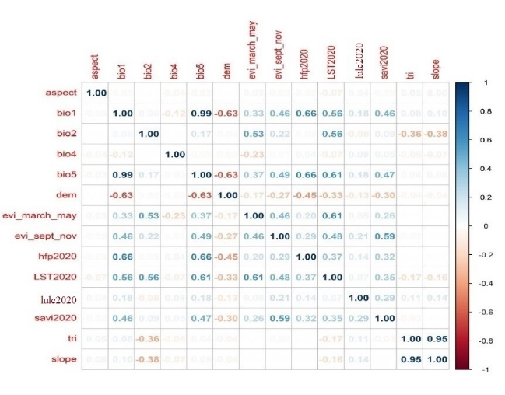

Supplementary Table S4
Table S4: Correlation matrix of the 11 eco-geographical covariates selected for MaxEnt modelling
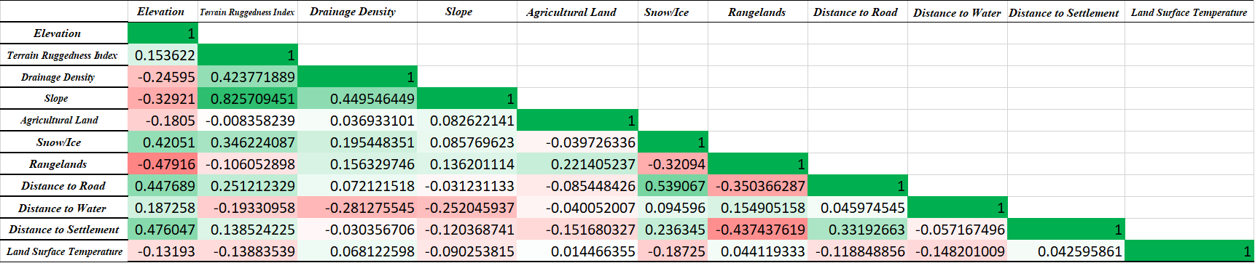

Supplementary Table S5
Table S5: The PRESENCE software was exercised to run 36 combinations of occupancy models.
Sr.no. | Models | AIC | deltaAIC | AIC wgt | Model Likelihood | No.of parameters | -2*LogLike | C-hat Value
1 | psi(R+RL+DW+LST), p(.) | 719.23 | 0.00 | 0.9717 | 1.0000 | 6 | 707.23 | 1.2430
2 | psi(R+DS+DW+LST+E), p(.) | 727.80 | 8.57 | 0.0134 | 0.0138 | 7 | 713.80 | 1.2461
3 | psi(S+RL+DW+LST), p(.) | 728.47 | 9.24 | 0.0096 | 0.0099 | 6 | 716.47 | 1.2274
4 | psi(E+RL+DW+S).p(.) | 731.2 | 11.97 | 0.0024 | 0.0025 | 6 | 719.2 | 1.3126
5 | psi(DW+R+RL).p(.) | 731.43 | 12.2 | 0.0022 | 0.0022 | 5 | 721.43 | 1.2771
6 | psi(DW+LST).p(.) | 734.98 | 15.75 | 0.0004 | 0.0004 | 4 | 726.98 | 1.1597
7 | psi(DW+R).p(.) | 737.19 | 17.96 | 0.0001 | 0.0001 | 4 | 729.19 | 1.3293
8 | psi(E+DS+DW+LST).p(.) | 737.57 | 18.34 | 0.0001 | 0.0001 | 6 | 725.57 | 1.2762
9 | psi(S+RL+DW).p(.) | 739.47 | 20.24 | 0.0000 | 0.0000 | 5 | 729.47 | 1.2773
10 | psi(DW+DD).p(.) | 740.63 | 21.4 | 0.0000 | 0.0000 | 4 | 732.63 | 1.2553
11 | psi(E+DW+S).p(.) | 742.36 | 23.13 | 0.0000 | 0.0000 | 5 | 732.36 | 1.3358
12 | psi(DW).p(.) | 743.48 | 24.25 | 0.0000 | 0.0000 | 3 | 737.48 | 1.2804
13 | psi(S+DS+DW).p(.) | 743.87 | 24.64 | 0.0000 | 0.0000 | 5 | 733.87 | 1.2766
14 | psi(E+DW).p(.) | 744.25 | 25.02 | 0.0000 | 0.0000 | 4 | 736.25 | 1.3454
15 | psi(DW+DS).p(.) | 745.27 | 26.04 | 0.0000 | 0.0000 | 4 | 737.27 | 1.2341
16 | psi(R+RL+DD+LST).p(.) | 753.16 | 33.93 | 0.0000 | 0.0000 | 6 | 741.16 | 1.3736
17 | psi(DD+R+RL).p(.) | 773.11 | 53.88 | 0.0000 | 0.0000 | 5 | 763.11 | 1.3437
18 | psi(LST+R+RL).p(.) | 774.01 | 54.78 | 0.0000 | 0.0000 | 5 | 764.01 | 1.3637
19 | psi(R).p(.) | 774.91 | 55.68 | 0.0000 | 0.0000 | 3 | 768.91 | 1.4199
20 | psi(R+RL).p(.) | 775.76 | 56.53 | 0.0000 | 0.0000 | 4 | 767.76 | 1.3755
21 | psi(S).p(.) | 783.7 | 64.47 | 0.0000 | 0.0000 | 3 | 777.7 | 1.3757
22 | psi(SI+E).p(.) | 783.87 | 64.64 | 0.0000 | 0.0000 | 4 | 775.87 | 1.2694
23 | psi(DD).p(.) | 784.06 | 64.83 | 0.0000 | 0.0000 | 3 | 778.06 | 1.3005
24 | psi(S+E).p(.) | 785.55 | 66.32 | 0.0000 | 0.0000 | 4 | 777.55 | 1.3575
25 | psi(S+RL).p(.) | 785.7 | 66.47 | 0.0000 | 0.0000 | 4 | 777.7 | 1.3957
26 | psi(E+RL+S).p(.) | 787.52 | 68.29 | 0.0000 | 0.0000 | 5 | 777.52 | 1.3548
27 | psi(AL+DS).p(.) | 789.15 | 69.92 | 0.0000 | 0.0000 | 4 | 781.15 | 1.3072
28 | psi(SI).p(.) | 790.07 | 70.84 | 0.0000 | 0.0000 | 3 | 784.07 | 1.3405
29 | psi(AL).p(.) | 791.15 | 71.92 | 0.0000 | 0.0000 | 3 | 785.15 | 1.3024
30 | psi(LST).p(.) | 795.32 | 76.09 | 0.0000 | 0.0000 | 3 | 789.32 | 1.3620
31 | psi(LST+DS).p(.) | 796.24 | 77.01 | 0.0000 | 0.0000 | 4 | 788.24 | 1.4524
32 | psi(DR).p(.) | 800.65 | 81.42 | 0.0000 | 0.0000 | 3 | 794.65 | 1.3830
33 | psi(.).p(.) | 802.53 | 83.3 | 0.0000 | 0.0000 | 2 | 798.53 | 1.3966
34 | psi(E).p(.) | 803.85 | 84.62 | 0.0000 | 0.0000 | 3 | 797.85 | 1.2585
35 | psi(RL).p(.) | 803.89 | 84.66 | 0.0000 | 0.0000 | 3 | 797.89 | 1.3421
36 | psi(.).p(TL) | 804.17 | 84.94 | 0.0000 | 0.0000 | 3 | 798.17 | 1.3462
Abbreviations: LST=Land Surface Temperature, DW=Distance to Water, DS=Distance to Settlement, RL=Rangelands, R=Terrain Ruggedness Index, E= Digital Elevation Model , S=Slope, AL=Agricultural Land, TL=Trail Length, DD=Drainage Density, DR=Distance to Road, SI= Snow/Ice.
Supplementary Data S6
Model 2: psi(R+DS+DW+LST+E),p(.)
Parameter Models ß estimate SE
Ψ Intercept -2.09 0.33
Ψ Terrain Ruggedness Index 0.76 0.26
Ψ Distance to Settlement -0.05 0.20
Ψ Distance to Water -2.04 0.47
Ψ Land Surface Temperature 0.79 0.22
Ψ Elevation 0.06 0.25
P Detection-Intercept -0.07 0.11
Table 6: Himalayan brown bear occupancy model. Second model parameter estimates Himalayan brown bear occupancy (Ψ) and detection (P) in Ladakh.
With seven parameters the second model identified the lowest AIC value (727.80), delta-AIC (8.57), AIC weight (0.0138), and model likelihood (0.0138). With the detection covariate as a constant, we hypothesised that "ruggedness," "distance to settlement," "distance to water," "land surface temperature," and "elevation," all impact the likelihood of a brown bear occupying a place. The data below allow us to deduce from the beta estimations and accompanying standard errors what the occupancy model requires. Along with a standard error of 0.26, the beta estimate for ruggedness was 0.76, suggesting a preference of brown bears for places defined by rocky terrain. Brown bears will find rugged environments intriguing because they provide improved shelter, protection for young, and different foraging chances.
The distance to settlement showed a beta estimate of -0.05 together with a standard error of 0.20. This value shows how close brown bears live to human areas influences their occupancy. The projection of -0.05 shows a minor negative effect on occupancy as bears approach communities. This implies that bears could avoid areas near to human activity. This result is environmentally important as brown bears usually avoid areas close to human activities. Along with a standard error of 0.47, the distance to water generated a beta estimate of -2.04, suggesting a declining brown bear occupancy as distance from water bodies increased.
The land surface temperature provided a beta estimate of 0.79 with a standard error of 0.22, implying that it has a positive association with brown bear occupancy. This could be due to seasonally variable preferences; bears may prefer warmer areas during certain times of the year, such as foraging in higher elevation meadows during the spring and summer. The beta estimate for elevation was 0.06 with a standard error of 0.25 when it was used with other variables. This means that higher elevations are slightly more likely to have brown bears living in them. Ecologically, this could be linked to factors like less human disturbance and specific habitat preferences of brown bears in Ladakh's high-altitude regions. The C-hat value of the model psi(R+DS+DW+LST+E), p(.) is 1.25.
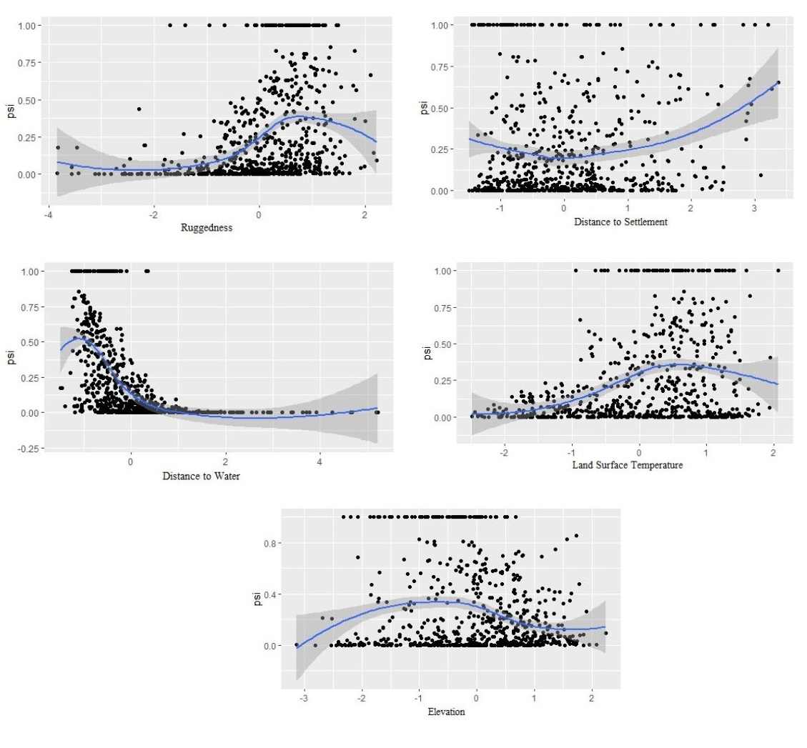

Graph 4: Relationships between Himalayan brown bear and environmental variables. Occupancy probability of brown bears in Ladakh in response to a) Terrain Ruggedness Index, b) Distance to settlement, c) average grid distance to perineal water source, and d) Land surface temperature between April - October season and e) Elevation.
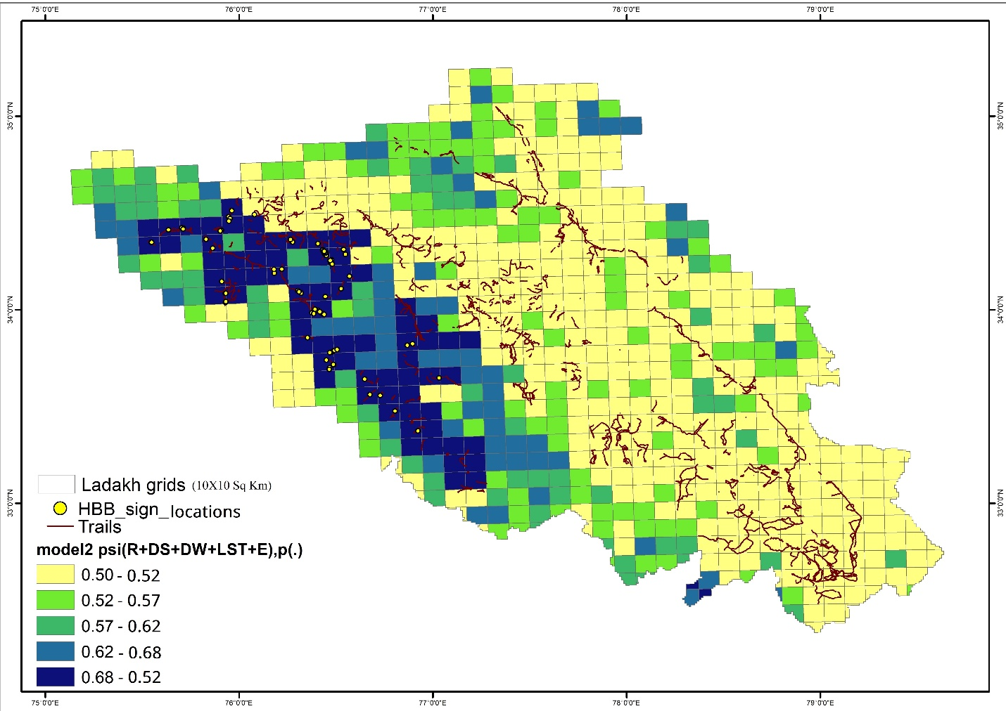Figure 4: Occupancy map of the second model with the lowest AIC value (Natural Breaks, Jenks). (Break values in percentages)

Model 3: psi(E+RL+DW+S),p(.)
Parameter Models ß estimate SE
Ψ Intercept -2.05 0.34
Ψ Elevation 0.76 0.25
Ψ Rangelands 0.75 0.22
Ψ Distance to Water -2.97 0.55
Ψ Slope 0.29 0.19
P Detection-Intercept -0.06 0.11
Table 7: Himalayan brown bear occupancy model. Third model parameter estimates Himalayan brown bear occupancy (Ψ) and detection (P) in Ladakh.
We identified the third model with the lowest AIC value (728.47), delta AIC (9.24), AIC weight (0.0099), and model likelihood (0.0099) with six parameters. With the detection covariate held constant, p(.), we thought that "Elevation," "Rangelands," "Distance to Water," and "Slope" would all affect the chance of a brown bear being at a site. The results shown below show what we can infer from the beta estimates and the standard errors that go with them for the occupancy model. A beta estimate of 0.76 with a standard error of 0.25 suggests that higher elevations are linked to a slightly higher brown bear population when other variables are considered. The rangelands had a beta value of 0.75 and a standard error of 0.22; this means that ecologically, places with rangelands are linked to having more brown bears. Distance to water gave a beta estimate of -2.97 with a standard error of 0.55, suggesting that as the distance to water sources increases, brown bear occupancy decreases. It means that as you move farther away from water sources, the likelihood of brown bear occupancy decreases. The slope generated a beta value of 0.29 together with a standard error of 0.19, implying that brown bear occupancy is favourably influenced by angle. Brown bears probably find more concealment and foraging chances from the presence of rocky terrain and mild slopes.
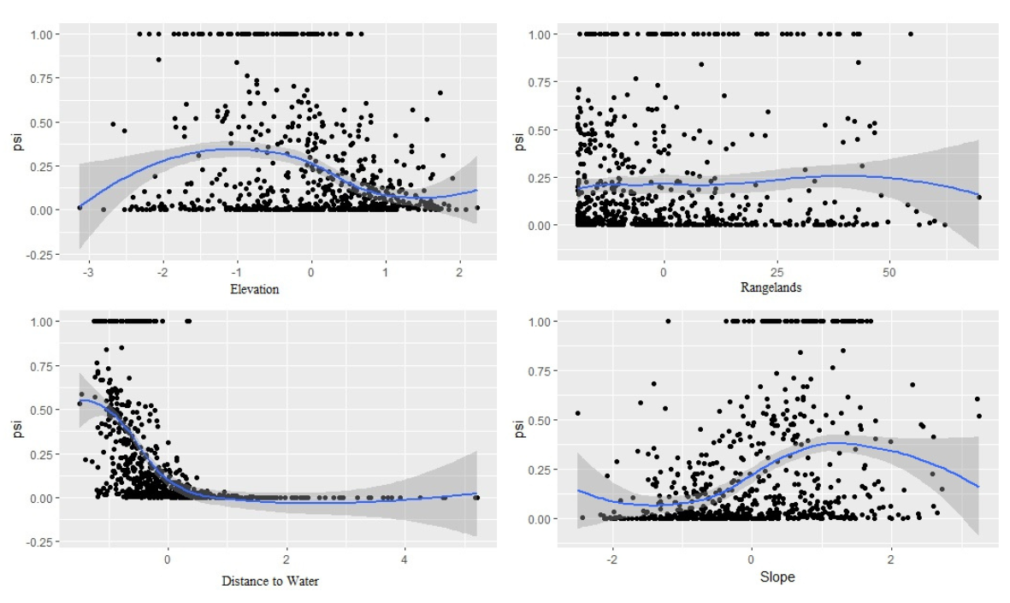

Graph 5: Relationships between Himalayan brown bear and environmental variables. Occupancy probability of brown bears in Ladakh in response to a) Elevation, b) ) proportion of Rangeland in a grid, c) average grid distance to perineal water source, and d) Slope.
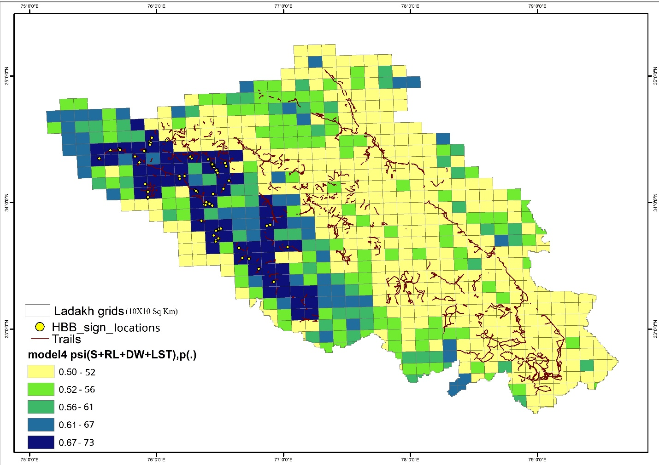
Figure 5: Occupancy map of the third model with the lowest AIC value (Natural Breaks, Jenks). The table displays the break values as a percentage.
Supplementary Graph S7
Graph 6: Jackknife of AUC for Himalayan brown bear resulted from MaxEnt SDM
