Supplementary Information
Mass-dependent Zn isotope measurements
The mass-dependent Zn isotope analyses of the Martian meteorites were performed with a double spike protocol and using a Nu Plasma HR MC-ICP-MS, as described in detail in previous studies^{36,39,40}. In brief, aliquots of the initial rock solutions were first equilibrated with a ⁶⁴Zn-⁶⁷Zn double spike, followed by separation of Zn from the rock matrix by ion exchange chromatography with AG MP-1 anion exchange resin. The purified Zn fractions were then introduced to the MC-ICP-MS using a Cetac autosampler and a Cetac Aridus II desolvation system fitted with glass concentric nebulisers with nominal uptake rates of 100 μL/min. The typical measurement sensitivity achieved for Zn was 100 V (µg ml⁻¹)⁻¹. Each run involved monitoring the ⁶⁴Zn, ⁶⁶Zn, ⁶⁷Zn, and ⁶⁸Zn ion beams using Faraday cups fitted with 10¹¹ Ω resistors for 60 data acquisition cycles of 5 s each. The ion beam intensities at mass numbers 62 (⁶²Ni⁺) and 68.5 (¹³⁷Ba²⁺) were also monitored for correction of isobaric interferences³⁶.
The mass dependent Zn isotope compositions are reported using the δ⁶⁶Zn notation, defined as:
$$δ^{66}{Zn}_{ }= \left(\frac{{({}_{}^{66}{Zn/{}_{}^{64}{Zn}})}_{sam}}{{({}_{}^{66}{Zn/{}_{}^{64}{Zn}})}_{std}}-1\right) x {10}^{3}$$

The sample measurements were initially performed, and the δ⁶⁶Zn values initially calculated, relative to bracketing analyses of the double-spiked AA-ETH Zn isotope reference material, using solutions with matching Zn concentrations and ratios of spike-derived to natural Zn⁴¹. To follow the convention of reporting δ⁶⁶Zn values relative to the JMC Lyon Zn isotope reference material, all reported values were corrected for a δ⁶⁶Zn offset of –0.28 between JMC Lyon Zn and AA-ETH Zn⁴¹. Due to the limited sample availability, this procedure was not applied to the Lunar samples. However, mass-dependent isotope results relative to the unspiked London Zn standard are reported in the main text.
The results for the Martian samples range from δ⁶⁶Zn = +0.32 ± 0.03 to δ⁶⁶Zn = +0.54 ± 0.02 relative to the JMC Lyon Zn isotope reference material (Table S1). The mean value (δ⁶⁶Zn = +0.42 ± 0.15) is consistent with previous findings^{6,42} in defining a significantly heavier Zn isotope compositio
n for bulk silicate Mars compared to that of the BSE (δ⁶⁶Zn = +0.16 ± 0.06 to +0.20 ± 0.05)⁴³⁻⁴⁶.

Table S1. Mass-dependent Zn isotope compositions of Martian samples.
Sample | δ⁶⁶Zn | 2SD | n | Zn (ppm)
MIL 03346 | 0.32 | 0.03 | 4 | 55.8
ALH 77005 | 0.54 | 0.02 | 4 | 51.5
EET 79001 | 0.40 | 0.06 | 4 | 57.8
LAR 12095 | 0.45 | 0.02 | 4 | 57.2
RBT 04262 | 0.38 | 0.04 | 5 | 51.2
ALH 84001 | … | … | … | …

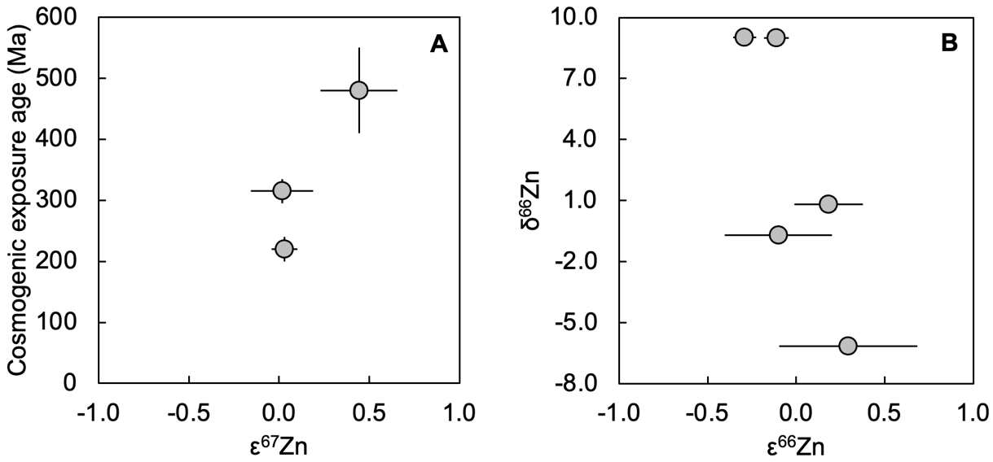
Figure S1. Cosmogenic exposure ages and mass-dependent Zn isotope compositions of Lunar samples. Panel (A) shows cosmogenic exposure ages relative to ε⁶⁷Zn. Panel (B) plots the mass-dependent Zn isotope compositions reported as δ⁶⁶Zn against mass-independent isotope composition (ε⁶⁶Zn) obtained for the same samples
Table S2. Mass-independent Zn isotope data for meteorite, Martian, Lunar and terrestrial samples employing the ⁶⁶Zn/⁶⁷Zn normalization.
Sample name | Type | ε⁶⁴Zn | 2sd | 2se | n | ε⁶⁸Zn | 2sd | 2se | n | ε⁷⁰Zn | 2sd | 2se | n
MIL 03346 | Nakhlite | 0.81 | 0.61 | 0.23 | 7 | -0.32 | 0.47 | 0.13 | 14 | -1.01 | 0.76 | 0.29 | 7
ALH 77005 | Shergottite | 0.44 | 0.30 | 0.11 | 8 | -0.28 | 0.57 | 0.15 | 14 | -0.89 | 0.30 | 0.12 | 6
EET 79001 | Shergottite | 0.57 | 0.40 | 0.16 | 6 | -0.27 | 0.55 | 0.18 | 9 | -1.30 | 0.44 | 0.25 | 3
LAR 12095 | Shergottite | 0.47 | 0.52 | 0.20 | 7 | -0.33 | 0.30 | 0.09 | 11 | -0.85 | 0.38 | 0.19 | 4
RBT 04262 | Shergottite | 0.51 | 0.43 | 0.14 | 10 | -0.28 | 0.45 | 0.12 | 15 | -1.15 | 0.55 | 0.28 | 4
ALH 84001 | SNC OPX | 0.56 | 0.60 | 0.17 | 12 | -0.29 | 0.56 | 0.16 | 12 | -0.44 | 0.99 | 0.29 | 12
Bulk silicate Mars |  | 0.56 | 0.24 | 0.10 | 6 | -0.30 | 0.04 | 0.02 | 6 | -0.94 | 0.55 | 0.22 | 6
70017-587 | High-Ti Mare Basalt | 0.43 | 0.51 | 0.17 | 9 | -0.15 | 0.31 | 0.10 | 9 | … | … | … | …
10017-423 | High-Ti Ilmenite Mare Basalt | -0.09 | 1.85 | 0.84 | 5 | -0.59 | 0.33 | 0.15 | 5 | … | … | … | …
15016-254 | Low-Ti Olivine Basalt | 0.44 | … | 0.84 | 2 | -0.32 | … | 0.40 | 2 | … | … | … | …
NWA 11182 | Feldspathic breccia | 0.19 | … | 0.54 | 2 | -0.63 | … | 0.26 | 2 | … | … | … | …
NWA 11898 | Feldspathic breccia | 0.30 | 0.53 | 0.26 | 4 | 0.08 | 0.52 | 0.26 | 4 | … | … | … | …
Lunar mean |  | 0.25 | 0.40 | 0.18 | 5 | -0.16 | 0.56 | 0.25 | 5 | … | … | … | …
Orgueil | CI | -1.09 | 0.60 | 0.14 | 18 | 0.45 | 0.29 | 0.07 | 18 | 1.59 | 1.02 | 0.24 | 18
BCR-2 | Terrestrial | 0.00 | 0.64 | 0.08 | 70 | -0.05 | 0.43 | 0.04 | 107 | -0.02 | 0.92 | 0.11 | 73
n is the total number of individual analytical runs for a given meteorite, for one or several powder/digest solution aliquots

Table S3. Compiled isotope data for Mars.
{Losno, 2022 #1860} | Value | 95% CI | Reference(s)
Δ¹⁷O | 0.25 | 0.06 | 47
ɛ⁴⁸Ca | -0.20 | 0.03 | 47, 48
ɛ⁵⁰Ti | -0.42 | 0.07 | 47, 48
ɛ⁵⁴Cr | -0.16 | 0.03 | 47, 48
ɛ⁶⁴Zn | 0.55 | 0.09 | This study
ɛ⁸⁴Sr | -0.25 | 0.15 | 47
ɛ⁹⁶Zr | 0.28 | 0.03 | 48
δ³⁰Si | -0.46 | 0.07 | 49
δ²⁵Mg | -0.13 | 0.03 | 50

Table S4. Compiled elemental concentration data for bulk silicate Mars.
 | Concentration range | Reference(s)
Na (%) | 0.37 – 0.87 | 10-12, 51, 52
Mg (%) | 16.46 – 19.90 | 10, 12, 51, 52
Al (%) | 1.53 – 1.90 | 10, 12, 51, 52
Si (%) | 20.50 – 22.20 | 10, 12, 51, 52
P (µg g⁻¹) | 675 – 740 | 10, 12, 51, 52
Ca (%) | 1.43 – 2.06 | 10, 12, 51, 52
K (µg g⁻¹) | 305 – 360 | 10, 12, 51, 52
Ti (µg g⁻¹) | 600 – 1010 | 10-12, 51, 52
Fe (%) | 11.40 – 14.10 | 10, 12, 51, 52
Mn (µg g⁻¹) | 2840 – 4800 | 10-12, 51, 52
O (%) | 43.2 | 10
Cr (µg g⁻¹) | 4640 – 6000 | 10, 12, 51, 52
Zn (µg g⁻¹) | 19 – 83 | 10, 12, 51, 52
Sr (µg g⁻¹) | 13.5 – 17.6 | 10, 12, 51
Zr (µg g⁻¹) | 7.5 – 8.3 | 10, 12, 51

