Supplementary Material (S1)
Heat plot of covariance matric of Data, Prior and Posterior, ALD-GP for different kernels at different lags using rainfall data.

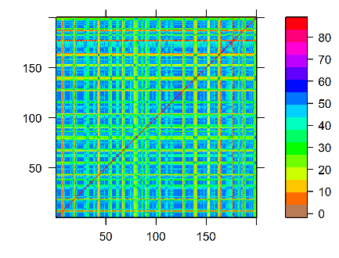 | 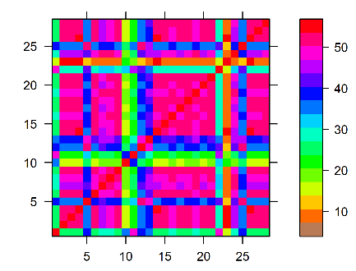 | 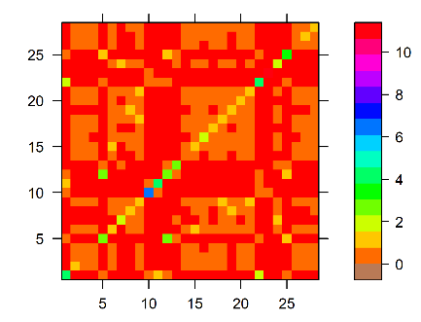
(a) | (b) | (c)
Figure S1 Covariance matrix of ALD-GP using SE kernel at One lag for rainfall data. (a) covariance matrix of train data. (b) covariance matrix of prior ALD-GP. (c) covariance matrix of posterior ALD-GP.

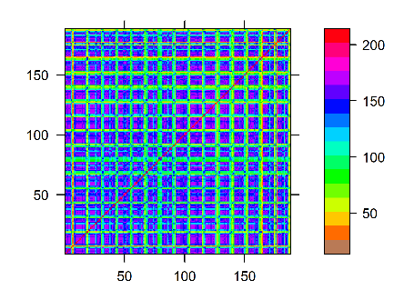 | 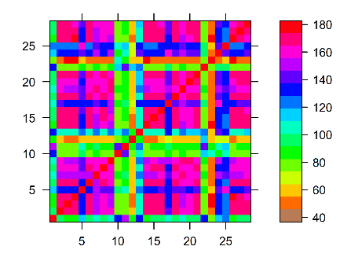 | 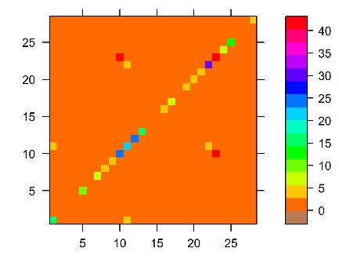
(a) | (b) | (c)
Figure S2 Covariance matrix of ALD-GP using SE kernel at Two lags for rainfall data. (a) covariance matrix of train data. (b) covariance matrix of prior ALD-GP. (c) covariance matrix of posterior ALD-GP.

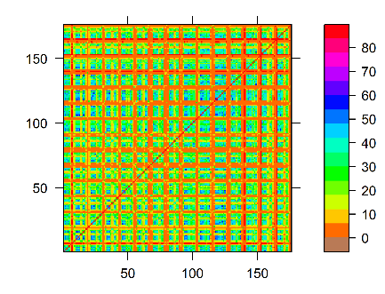 | 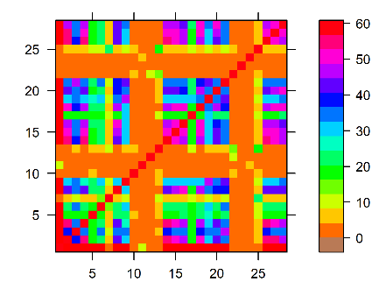 | 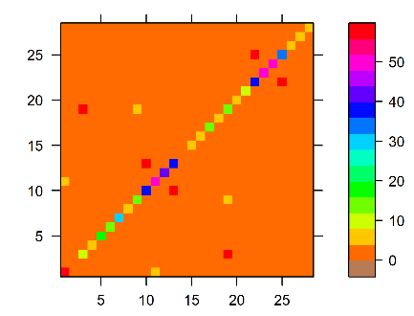
(a) | (b) | (c)
Figure S3 Covariance matrix of ALD-GP using SE kernel at Three lags for rainfall data. (a) covariance matrix of train data. (b) covariance matrix of prior ALD-GP. (c) covariance matrix of posterior ALD-GP.

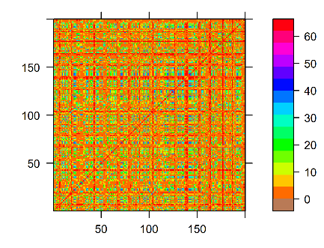 | 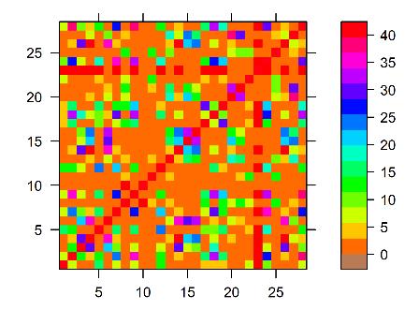 | 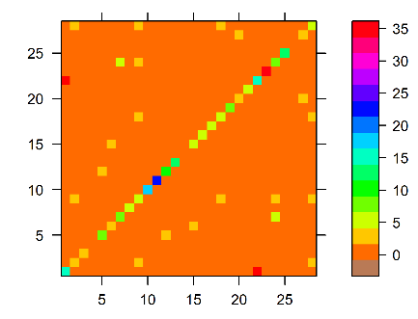
(a) | (b) | (c)
Figure S4 Covariance matrix of ALD-GP using SEP kernel at One lag for rainfall data. (a) covariance matrix of train data. (b) covariance matrix of prior ALD-GP. (c) covariance matrix of posterior ALD-GP.

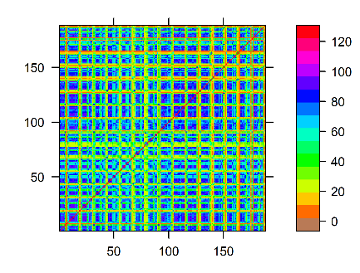 | 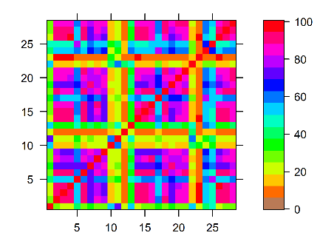 | 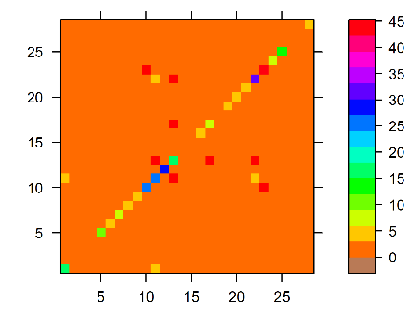
(a) | (b) | (c)
Figure S5 Covariance matrix of ALD-GP using SEP kernel at Two lags for rainfall data. (a) covariance matrix of train data. (b) covariance matrix of prior ALD-GP. (c) covariance matrix of posterior ALD-GP.

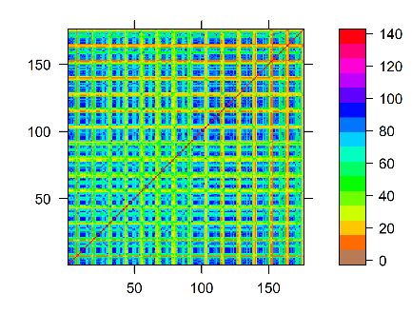 | 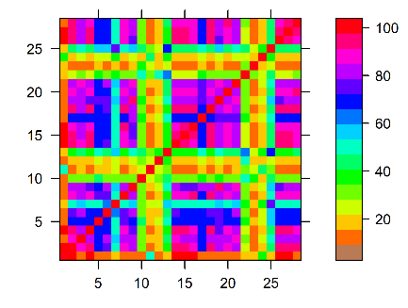 | 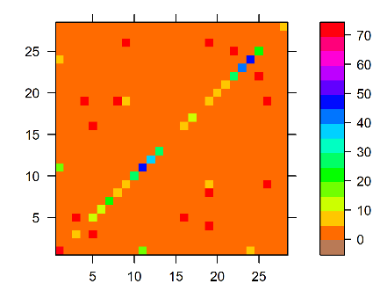
(a) | (b) | (c)
Figure S6 Covariance matrix of ALD-GP using SEP kernel at Three lags for rainfall data. (a) covariance matrix of train data. (b) covariance matrix of prior ALD-GP. (c) covariance matrix of posterior ALD-GP.

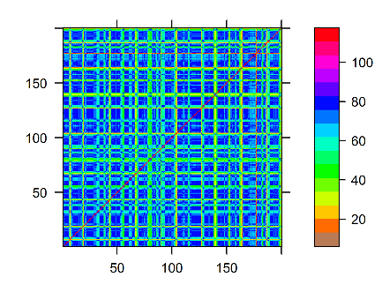 | 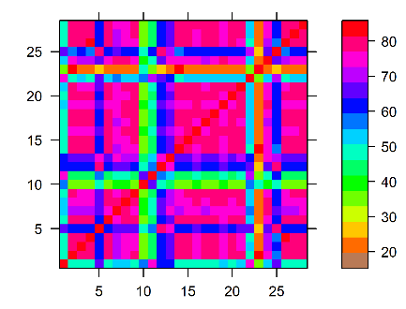 | 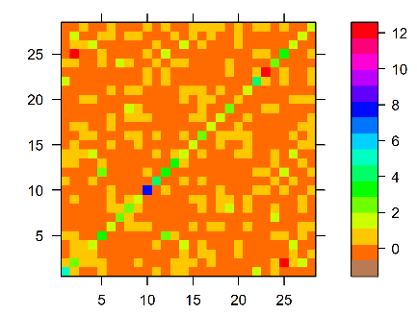
(a) | (b) | (c)
Figure S7 Covariance matrix of ALD-GP using SE+W kernel at One lag for rainfall data. (a) covariance matrix of train data. (b) covariance matrix of prior ALD-GP. (c) covariance matrix of posterior ALD-GP.

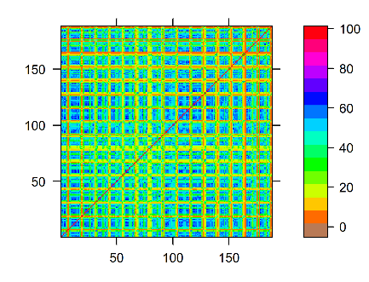 | 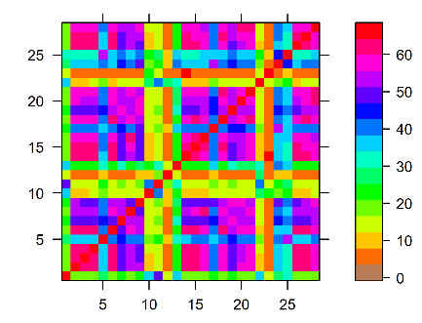 | 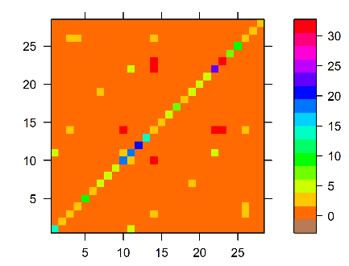
(a) | (b) | (c)
Figure S8 Covariance matrix of ALD-GP using SE+W kernel at Two lags for rainfall data. (a) covariance matrix of train data. (b) covariance matrix of prior ALD-GP. (c) covariance matrix of posterior ALD-GP.

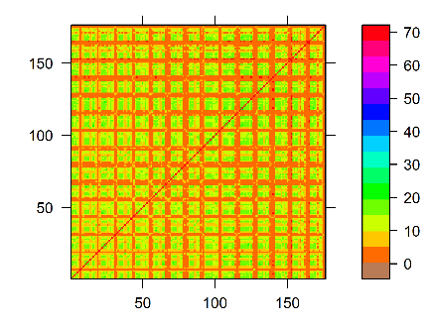 | 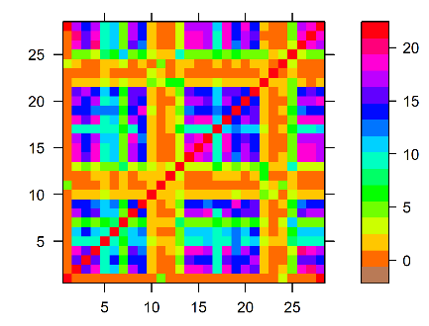 | 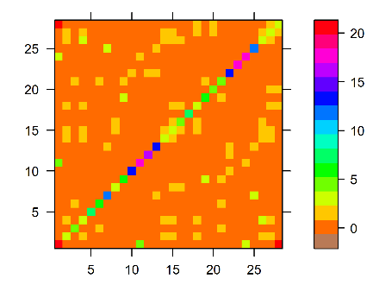
(a) | (b) | (c)
Figure S9 Covariance matrix of ALD-GP using SE+W kernel at Three lags for rainfall data. (a) covariance matrix of train data. (b) covariance matrix of prior ALD-GP. (c) covariance matrix of posterior ALD-GP.

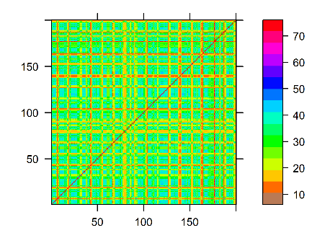 | 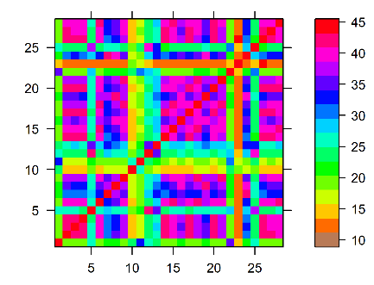 | 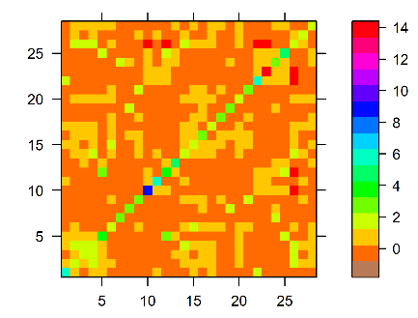
(a) | (b) | (c)
Figure S10 Covariance matrix of ALD-GP using RQ+W kernel at One lag for rainfall data. (a) covariance matrix of train data. (b) covariance matrix of prior ALD-GP. (c) covariance matrix of posterior ALD-GP.

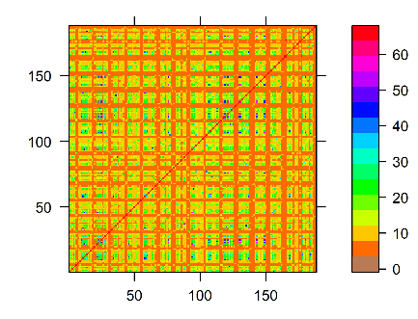 | 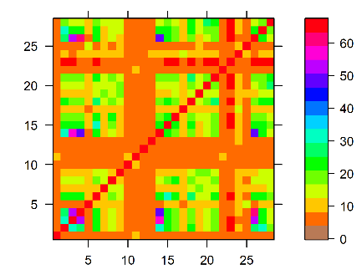 | 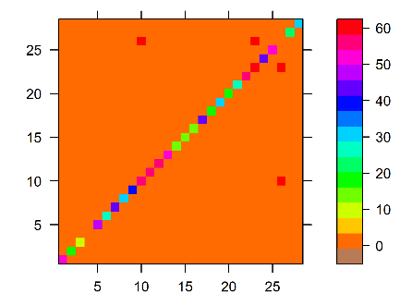
(a) | (b) | (c)
Figure S11 Covariance matrix of ALD-GP using RQ+W kernel at Two lags for rainfall data. (a) covariance matrix of train data. (b) covariance matrix of prior ALD-GP. (c) covariance matrix of posterior ALD-GP.

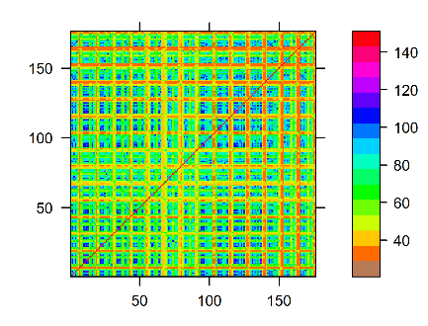 | 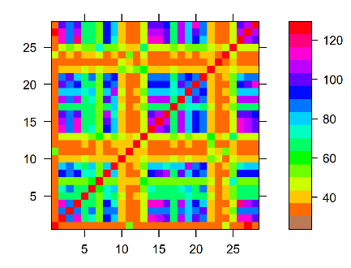 | 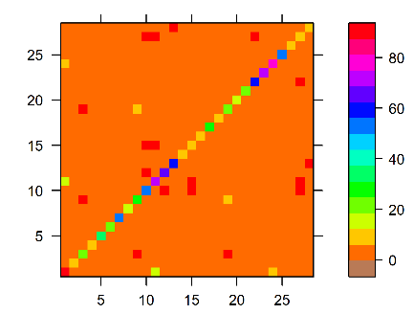
(a) | (b) | (c)
Figure S12 Covariance matrix of ALD-GP using RQ+W kernel at Three lags for rainfall data. (a) covariance matrix of train data. (b) covariance matrix of prior ALD-GP. (c) covariance matrix of posterior ALD-GP.

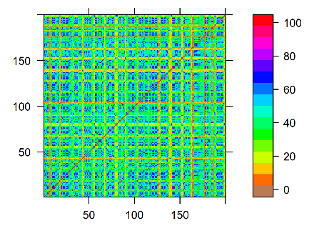 | 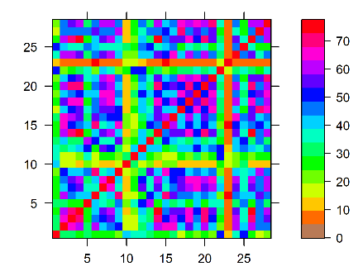 | 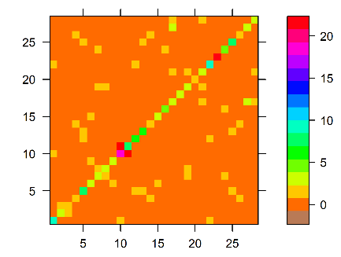
(a) | (b) | (c)
Figure S13 Covariance matrix of ALD-GP using P×SE+M₂ kernel at One lag for rainfall data. (a) covariance matrix of train data. (b) covariance matrix of prior ALD-GP. (c) covariance matrix of posterior ALD-GP.

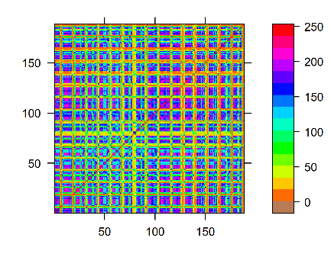 | 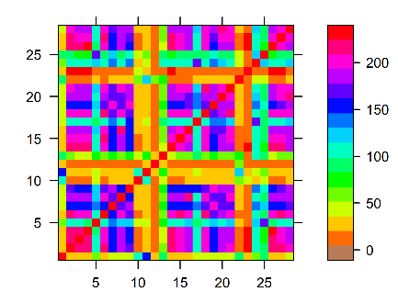 | 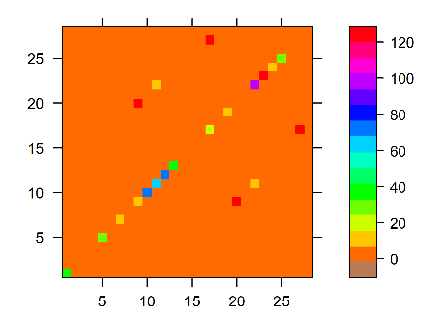
(a) | (b) | (c)
Figure S14 Covariance matrix of ALD-GP using P×SE+M₂ kernel at Two lags for rainfall data. (a) covariance matrix of train data. (b) covariance matrix of prior ALD-GP. (c) covariance matrix of posterior ALD-GP.

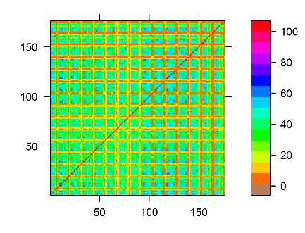 | 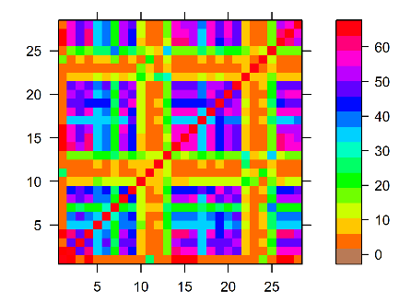 | 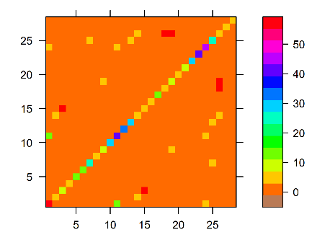
(a) | (b) | (c)
Figure S15 Covariance matrix of ALD-GP using P×SE+M₂ kernel at Three lags for rainfall data. (a) covariance matrix of train data. (b) covariance matrix of prior ALD-GP. (c) covariance matrix of posterior ALD-GP.

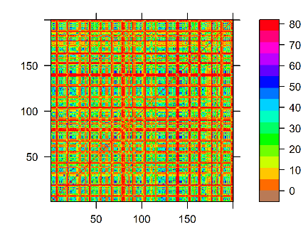 | 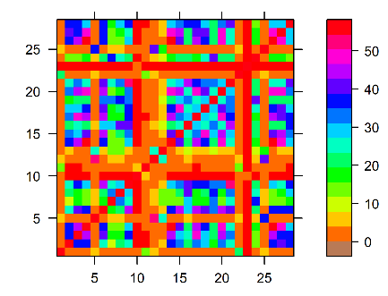 | 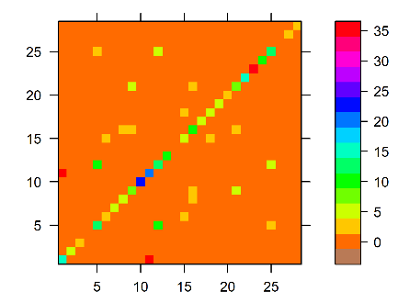
(a) | (b) | (c)
Figure S16 Covariance matrix of ALD-GP using SSEP kernel at One lag for rainfall data. (a) covariance matrix of train data. (b) covariance matrix of prior ALD-GP. (c) covariance matrix of posterior ALD-GP.

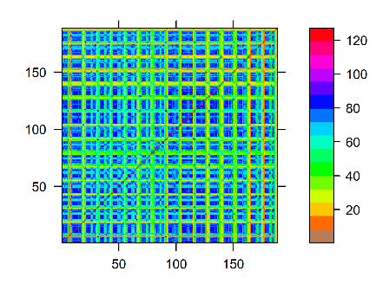 | 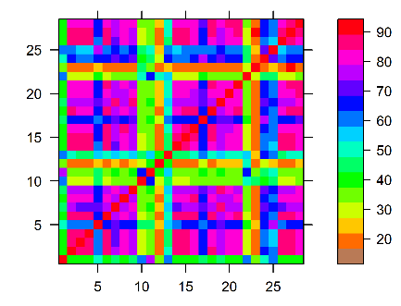 | 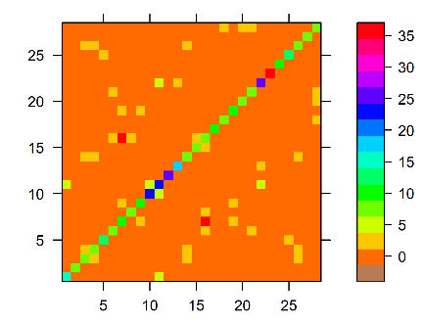
(a) | (b) | (c)
Figure S17 Covariance matrix of ALD-GP using SSEP kernel at Two lags for rainfall data. (a) covariance matrix of train data. (b) covariance matrix of prior ALD-GP. (c) covariance matrix of posterior ALD-GP.

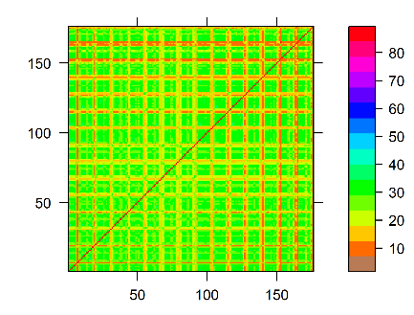 | 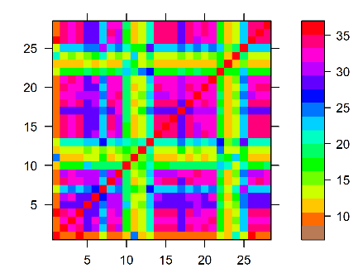 | 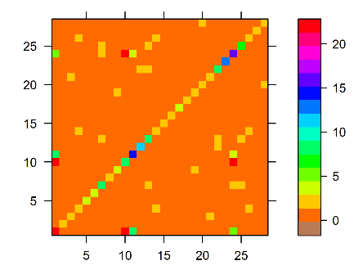
(a) | (b) | (c)
Figure S18 Covariance matrix of ALD-GP using SSEP kernel at Three lags for rainfall data. (a) covariance matrix of train data. (b) covariance matrix of prior ALD-GP. (c) covariance matrix of posterior ALD-GP.

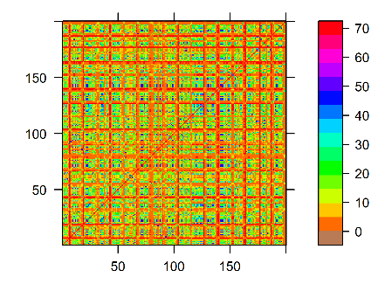 | 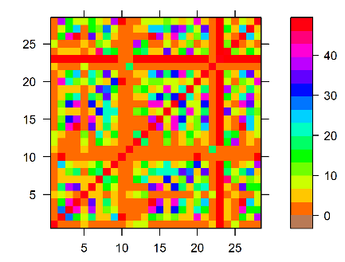 | 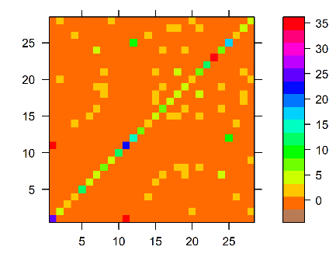
(a) | (b) | (c)
Figure S19 Covariance matrix of ALD-GP using SESP kernel at One lag for rainfall data. (a) covariance matrix of train data. (b) covariance matrix of prior ALD-GP. (c) covariance matrix of posterior ALD-GP.

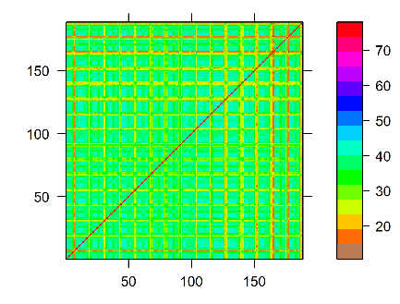 | 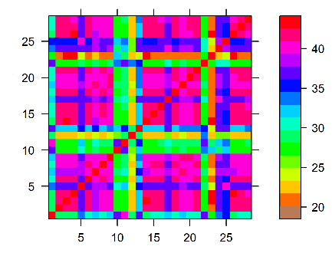 | 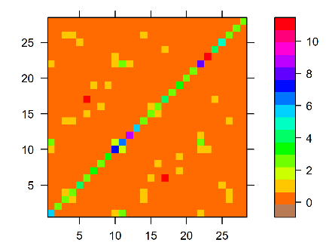
(a) | (b) | (c)
Figure S20 Covariance matrix of ALD-GP using SESP kernel at Two lags for rainfall data. (a) covariance matrix of train data. (b) covariance matrix of prior ALD-GP. (c) covariance matrix of posterior ALD-GP.

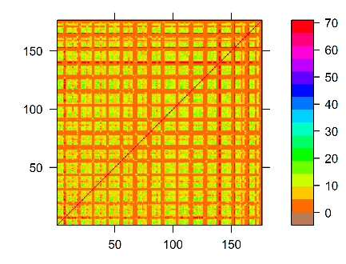 | 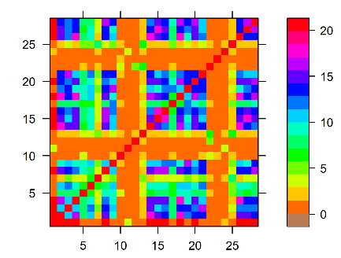 | 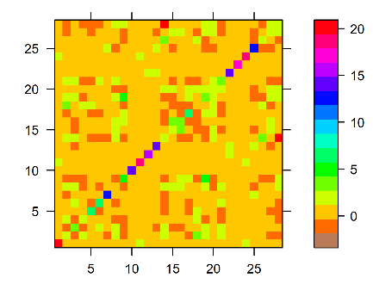
(a) | (b) | (c)
Figure S21 Covariance matrix of ALD-GP using SESP kernel at Three lags for rainfall data. (a) covariance matrix of train data. (b) covariance matrix of prior ALD-GP. (c) covariance matrix of posterior ALD-GP.

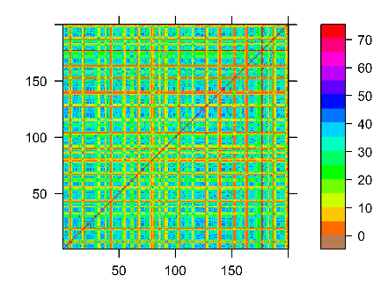 | 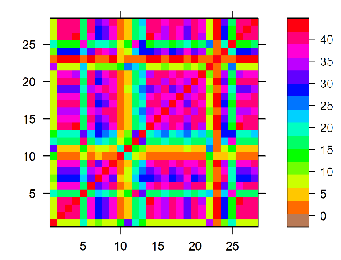 | 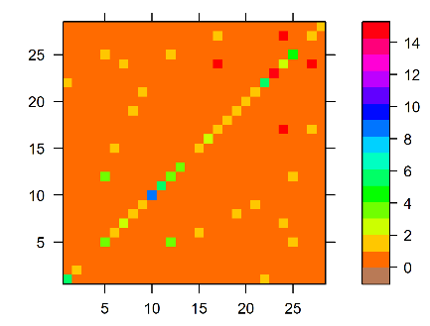
(a) | (b) | (c)
Figure S22 Covariance matrix of ALD-GP using 2SEP kernel at One lag for rainfall data. (a) covariance matrix of train data. (b) covariance matrix of prior ALD-GP. (c) covariance matrix of posterior ALD-GP.

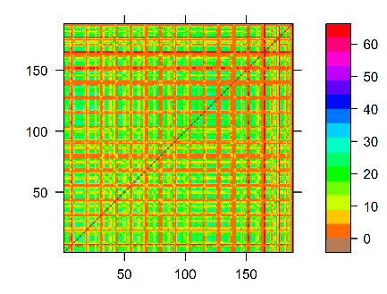 | 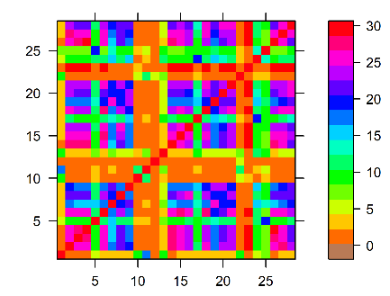 | 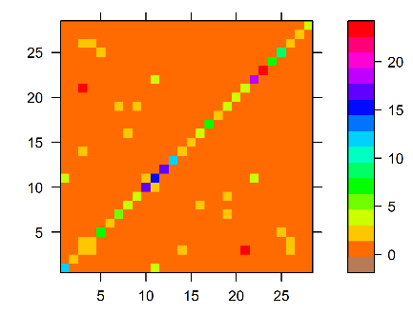
(a) | (b) | (c)
Figure S23 Covariance matrix of ALD-GP using 2SEP kernel at Two lags for rainfall data. (a) covariance matrix of train data. (b) covariance matrix of prior ALD-GP. (c) covariance matrix of posterior ALD-GP.

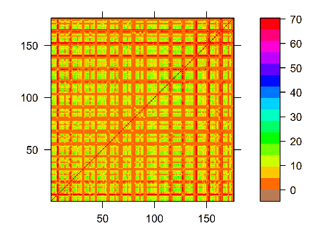 | 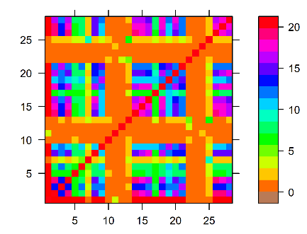 | 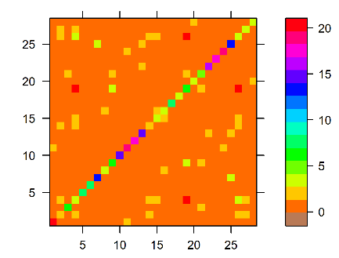
(a) | (b) | (c)
Figure S24 Covariance matrix of ALD-GP using 2SEP kernel at Three lags for rainfall data. (a) covariance matrix of train data. (b) covariance matrix of prior ALD-GP. (c) covariance matrix of posterior ALD-GP.

