Extended Data Figure 1 | Comparison of seismic images of Xline 2356 (see Supplementary Figure 1 for the location) using conventional method (a) showing Layer 2A reflections and magma domain magma sills, tomographic-derived velocities using full waveform of MCS data²⁶ (b), and 3-D PSDM (c) showing subsiding lava flows and melt sills. Note the absence of Layer 2A in the PSDM image, suggesting Layer 2A imaged in (a) is not the base of the lava flows.

Extended Data Figure 2 | Seismic image across caldera: A block diagram highlights Xline 2601 that crosses the southeast portion of the caldera. The dips of lava flow layers are marked.

Extended Data Figure 3 | Seismic images along the rift zones: Seismic images along the rift zones (SRZ, NRZ) (light blue lines in Supplementary Fig. 1). Yellow lines are lava flows, red lines show magma domain magma sills, and magenta lines denote upper crustal faults. Locations of hydrothermal fields are shown as small, magenta-filled triangles¹⁸. Outlines of the 1998 (blue), 2011 (cyan) and 2015 (green) eruption lava flows are overlain on the bathymetric map⁵⁶⁻⁵⁸. The non-interpreted seismic profiles are shown in Supplementary Fig. 6.

Extended Data Figure 4 | See next page for caption.
Extended Data Figure 4 | Criteria for the identification of seafloor, lava flows, and lithosphere-asthenosphere boundaries (LABs). (a), (b) and (c) show the local seismic profiles, waveforms, instantaneous amplitude, instantaneous phase and spectrogram at the reference traces Xline 2275, 2775 and 3350 in Inline 261 profile. The location of different events is emphasized using the blue (seafloor), yellow (lava flows) and red (melt sills). White dashed lines in the spectrogram indicate the wavenumber with the highest energy at different depth.

Extended Data Figure 5 | Seismic image along Xline profile 2801: Seismic image showing inflation (convex, red arrow) and deflation (concave, blue arrow) of melt sills leading to uplift and subsidence of lava flows. Note the merging of lava flows with melt sills around Inline 301 at ~3.5 km depth. Locations of hydrothermal fields are shown as small, magenta-filled triangles¹⁸. Outlines of the 1998 (blue) and 2015 (green) eruption lava flows is overlain on the bathymetric map⁵⁶⁻⁵⁸. The non-interpreted seismic profile is shown in Supplementary Fig. 7.

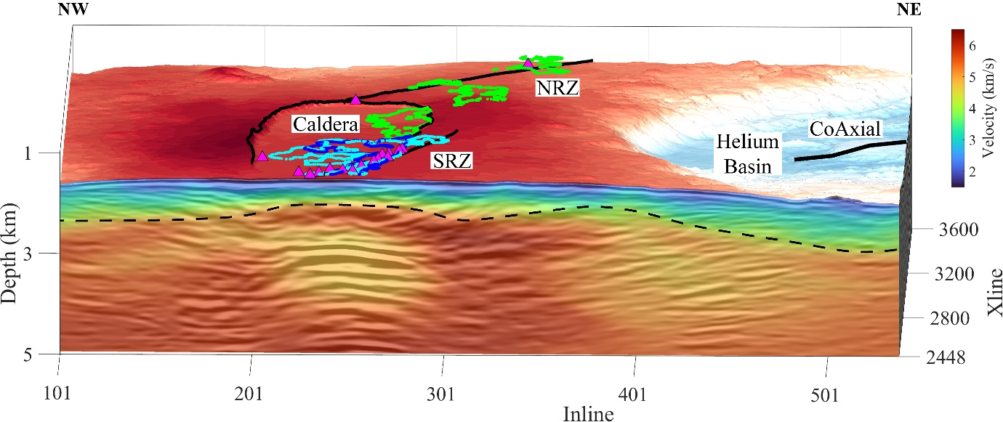
Extended Data Figure 6 | FWI result overlain on 3D PSDM result. The conventional Layer 2A/2B boundary is indicated by black dashed line. Locations of hydrothermal fields are shown as small, magenta-filled triangles¹⁸. Outlines of the 1998 (blue) and 2015 (green) eruption lava flows is overlain on the bathymetric map⁵⁶⁻⁵⁸.

Extended Data Figure 7 | Velocity-depth relationship from FWI and velocity-porosity relationship calculated by differential effective medium (DEM) approach. (a) 1D velocity curve with grey solid lines representing 1D velocity structure at various locations in the FWI profile, and the black solid line showing the average 1D velocity model. Black dash lines indicate the depth of conventional Layer 2A/B boundary and the corresponding P wave velocities. (b) Velocity-porosity relationships calculated by DEM, α in the inserted legend indicates the inverse aspect ratio. Black dashed lines indicate the velocities near the conventional Layer 2A/B boundary.

Extended Data Figure 8 | The Geometry of the 3D survey: (a) shot position, (b) receiver position, (c) fold number, (d) detailed map of a linear arrangement of receivers and sources of the seismic surveys’ distribution. The ideal distribution of midpoints includes the acquisition of two sources (75 m apart) and four streamers (150 m apart). The red asterisks and blue triangles represent the locations of the seismic sources and receivers, which are typically arrays of hydrophones towed behind survey vessels. The black crosses marked "midpoints" indicate the locations halfway between each source and receiver pair.

