Supporting Information
Stabilization of ZnO nanoparticles using water extract of waste coconut husk and photocatalytic activity

RiuRiuWary¹,SanjibBaglari¹, DuluBrahma²,Ujjal K Gautam³,Pranjal Kalita^{2 ,}*, ManasiBuzar Baruah^{1,}*

¹Department of Physics, Central Institute of Technology Kokrajhar (Deemed to be University, MHRD, Govt. of India), Kokrajhar-783370, Assam, India
²Department of Chemistry, Central Institute of Technology Kokrajhar (Deemed to be University, MHRD, Govt. of India), Kokrajhar-783370, Assam, India
³Indian Institute of Science Education and Research Mohali, Department of Chemical Sciences, Knowledge City, Sector 81, SAS Nagar, Manauli-140306.

*Corresponding author.

Email: mbbaruah@cit.ac.in, p.kalita@cit.ac.in

Supporting information “S1”

Williamson-Hall (W-H) plot
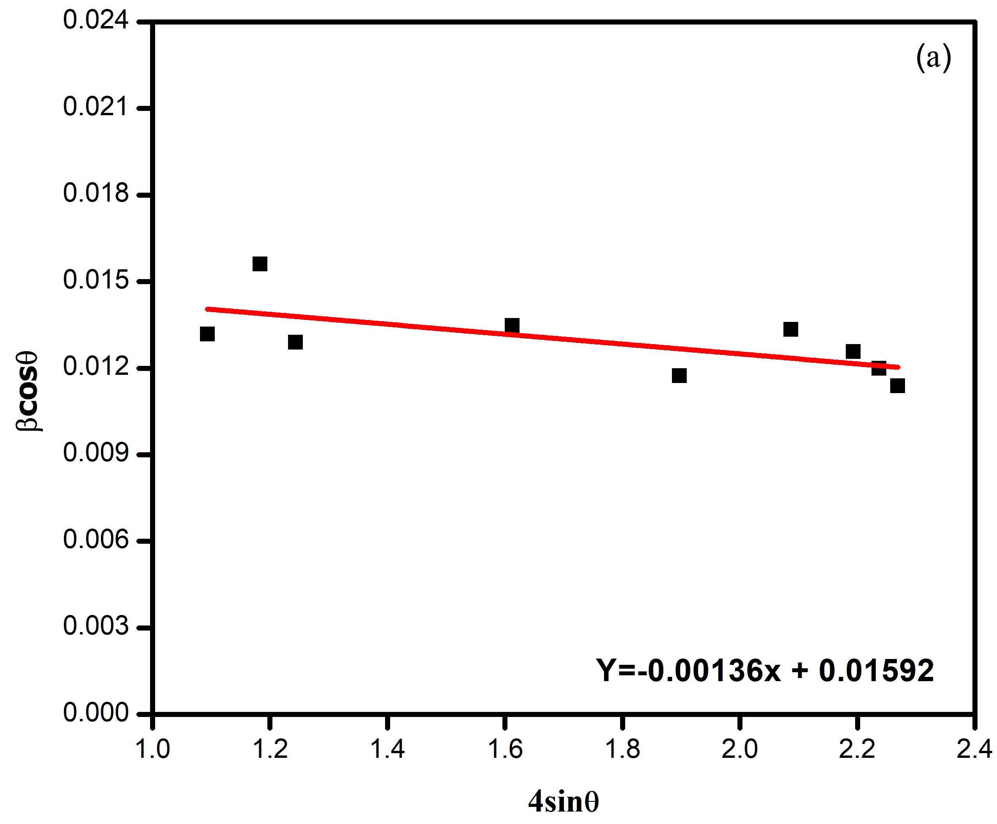

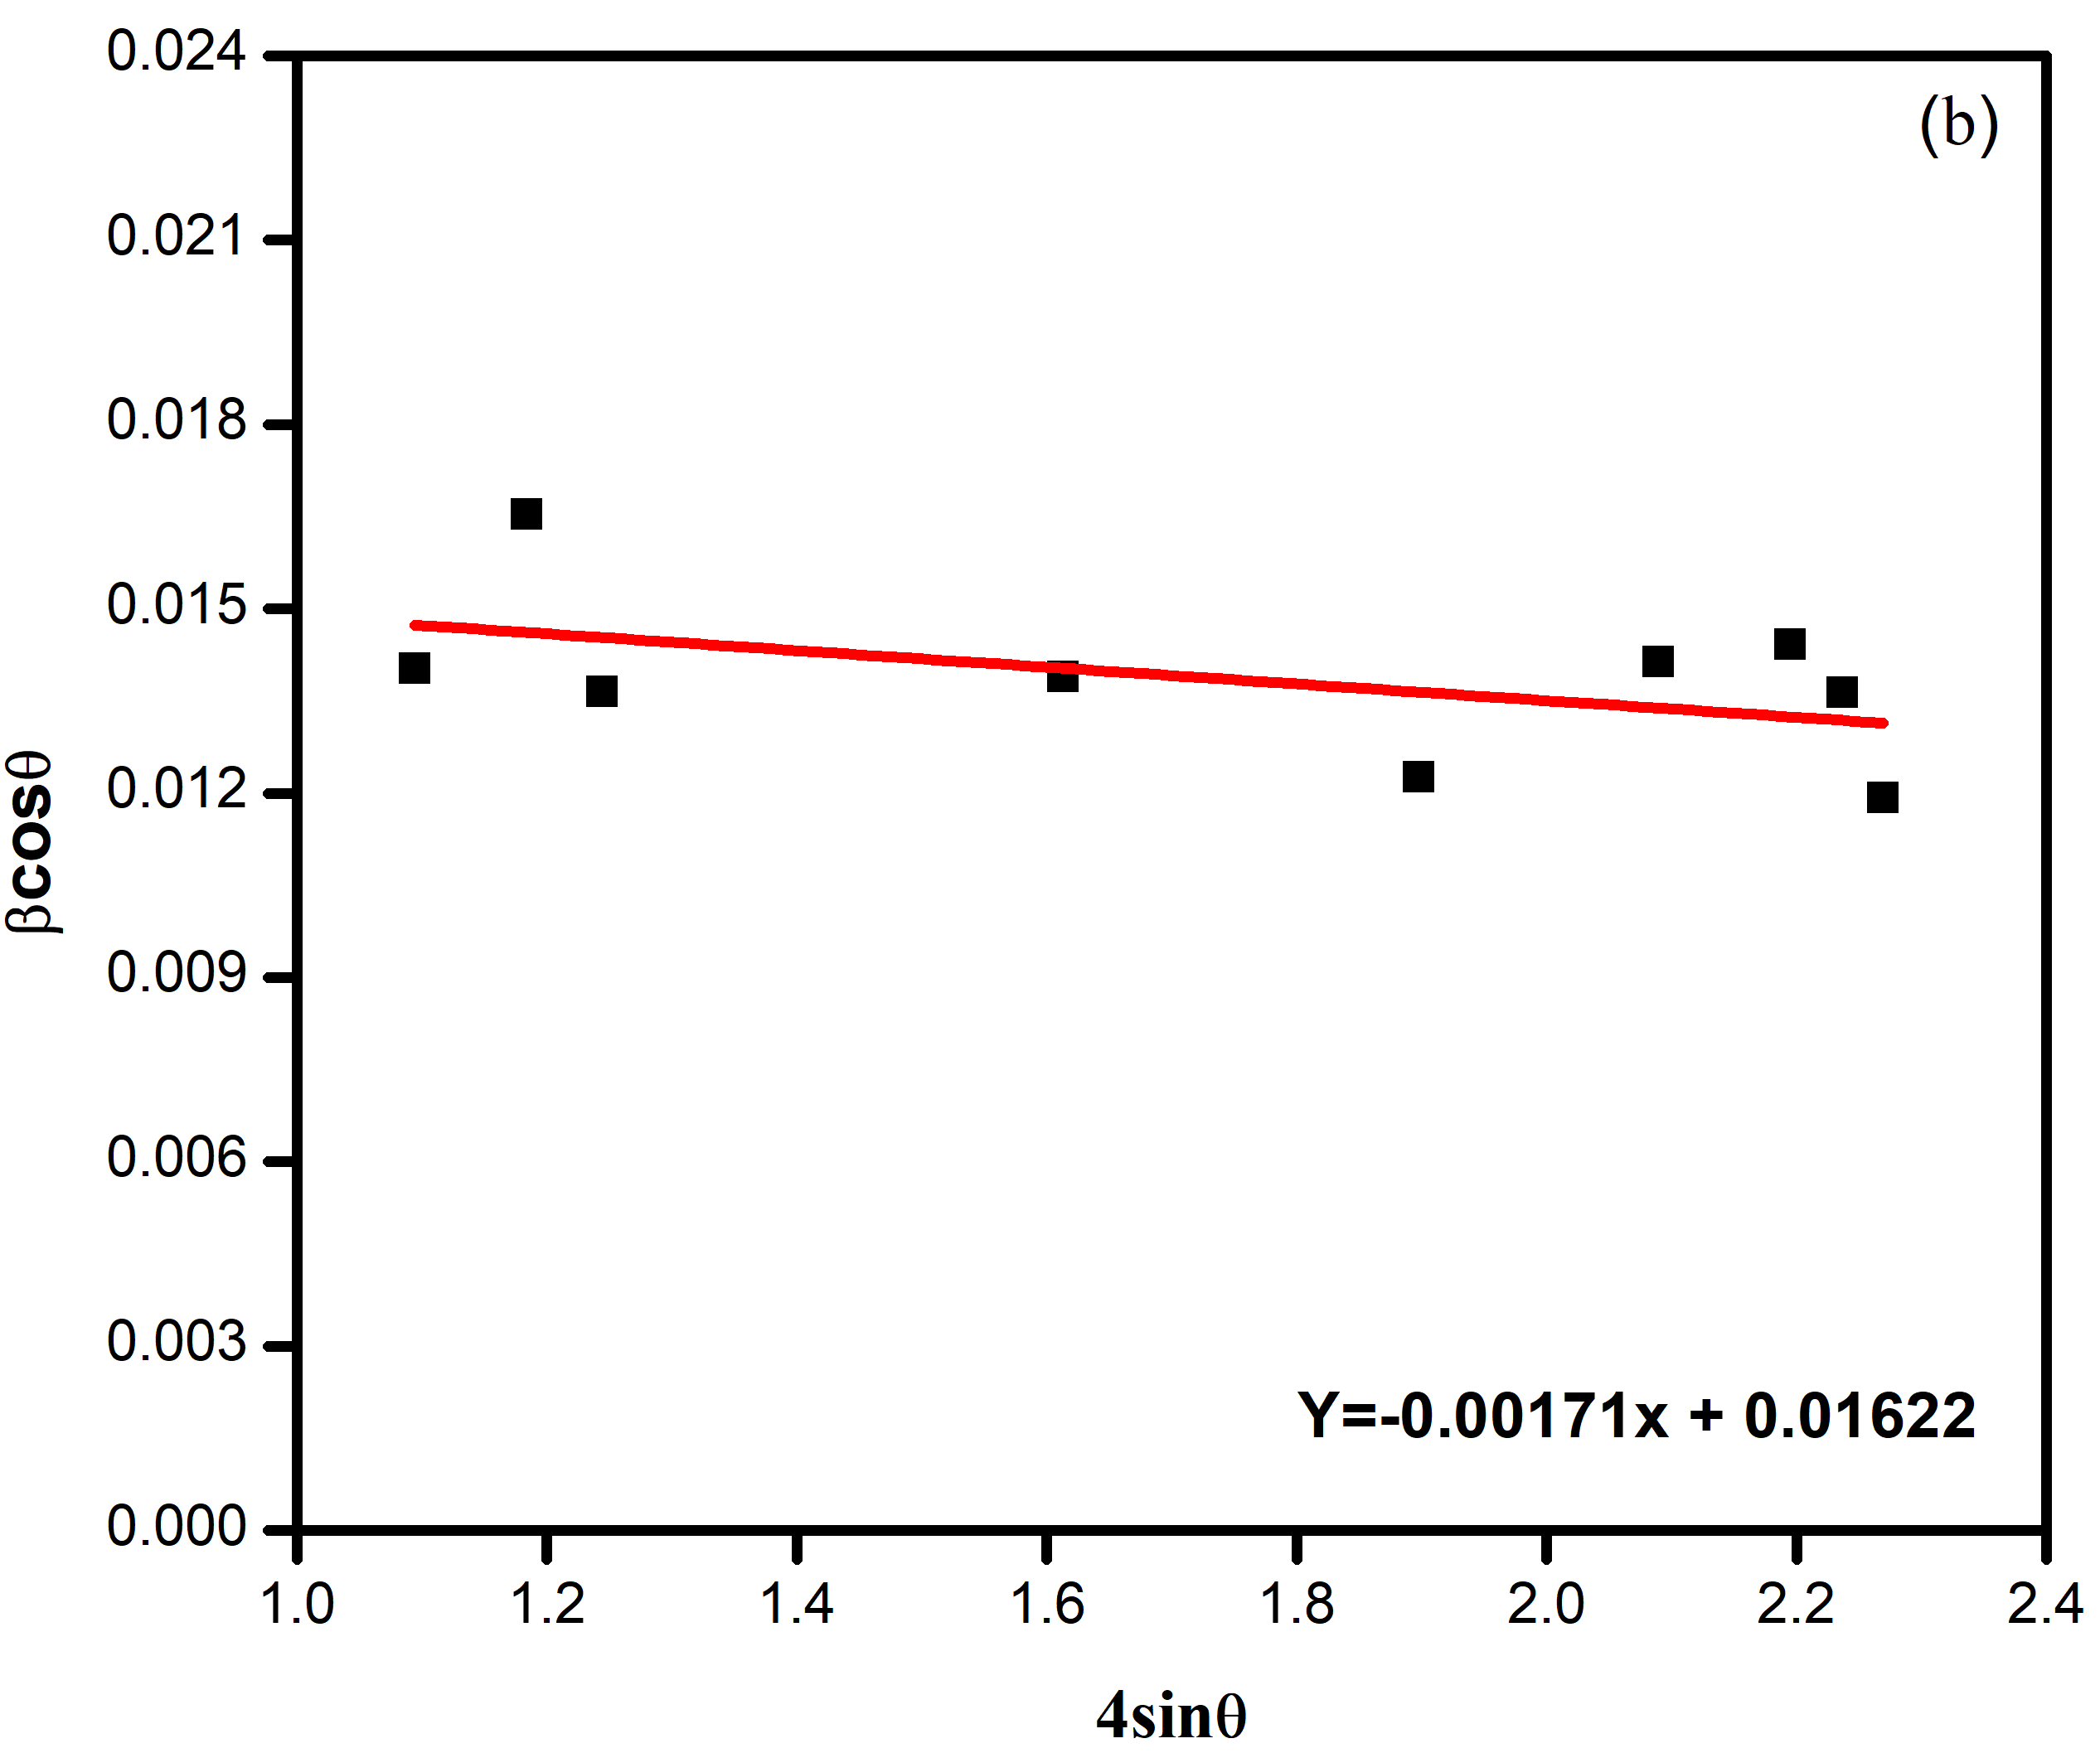
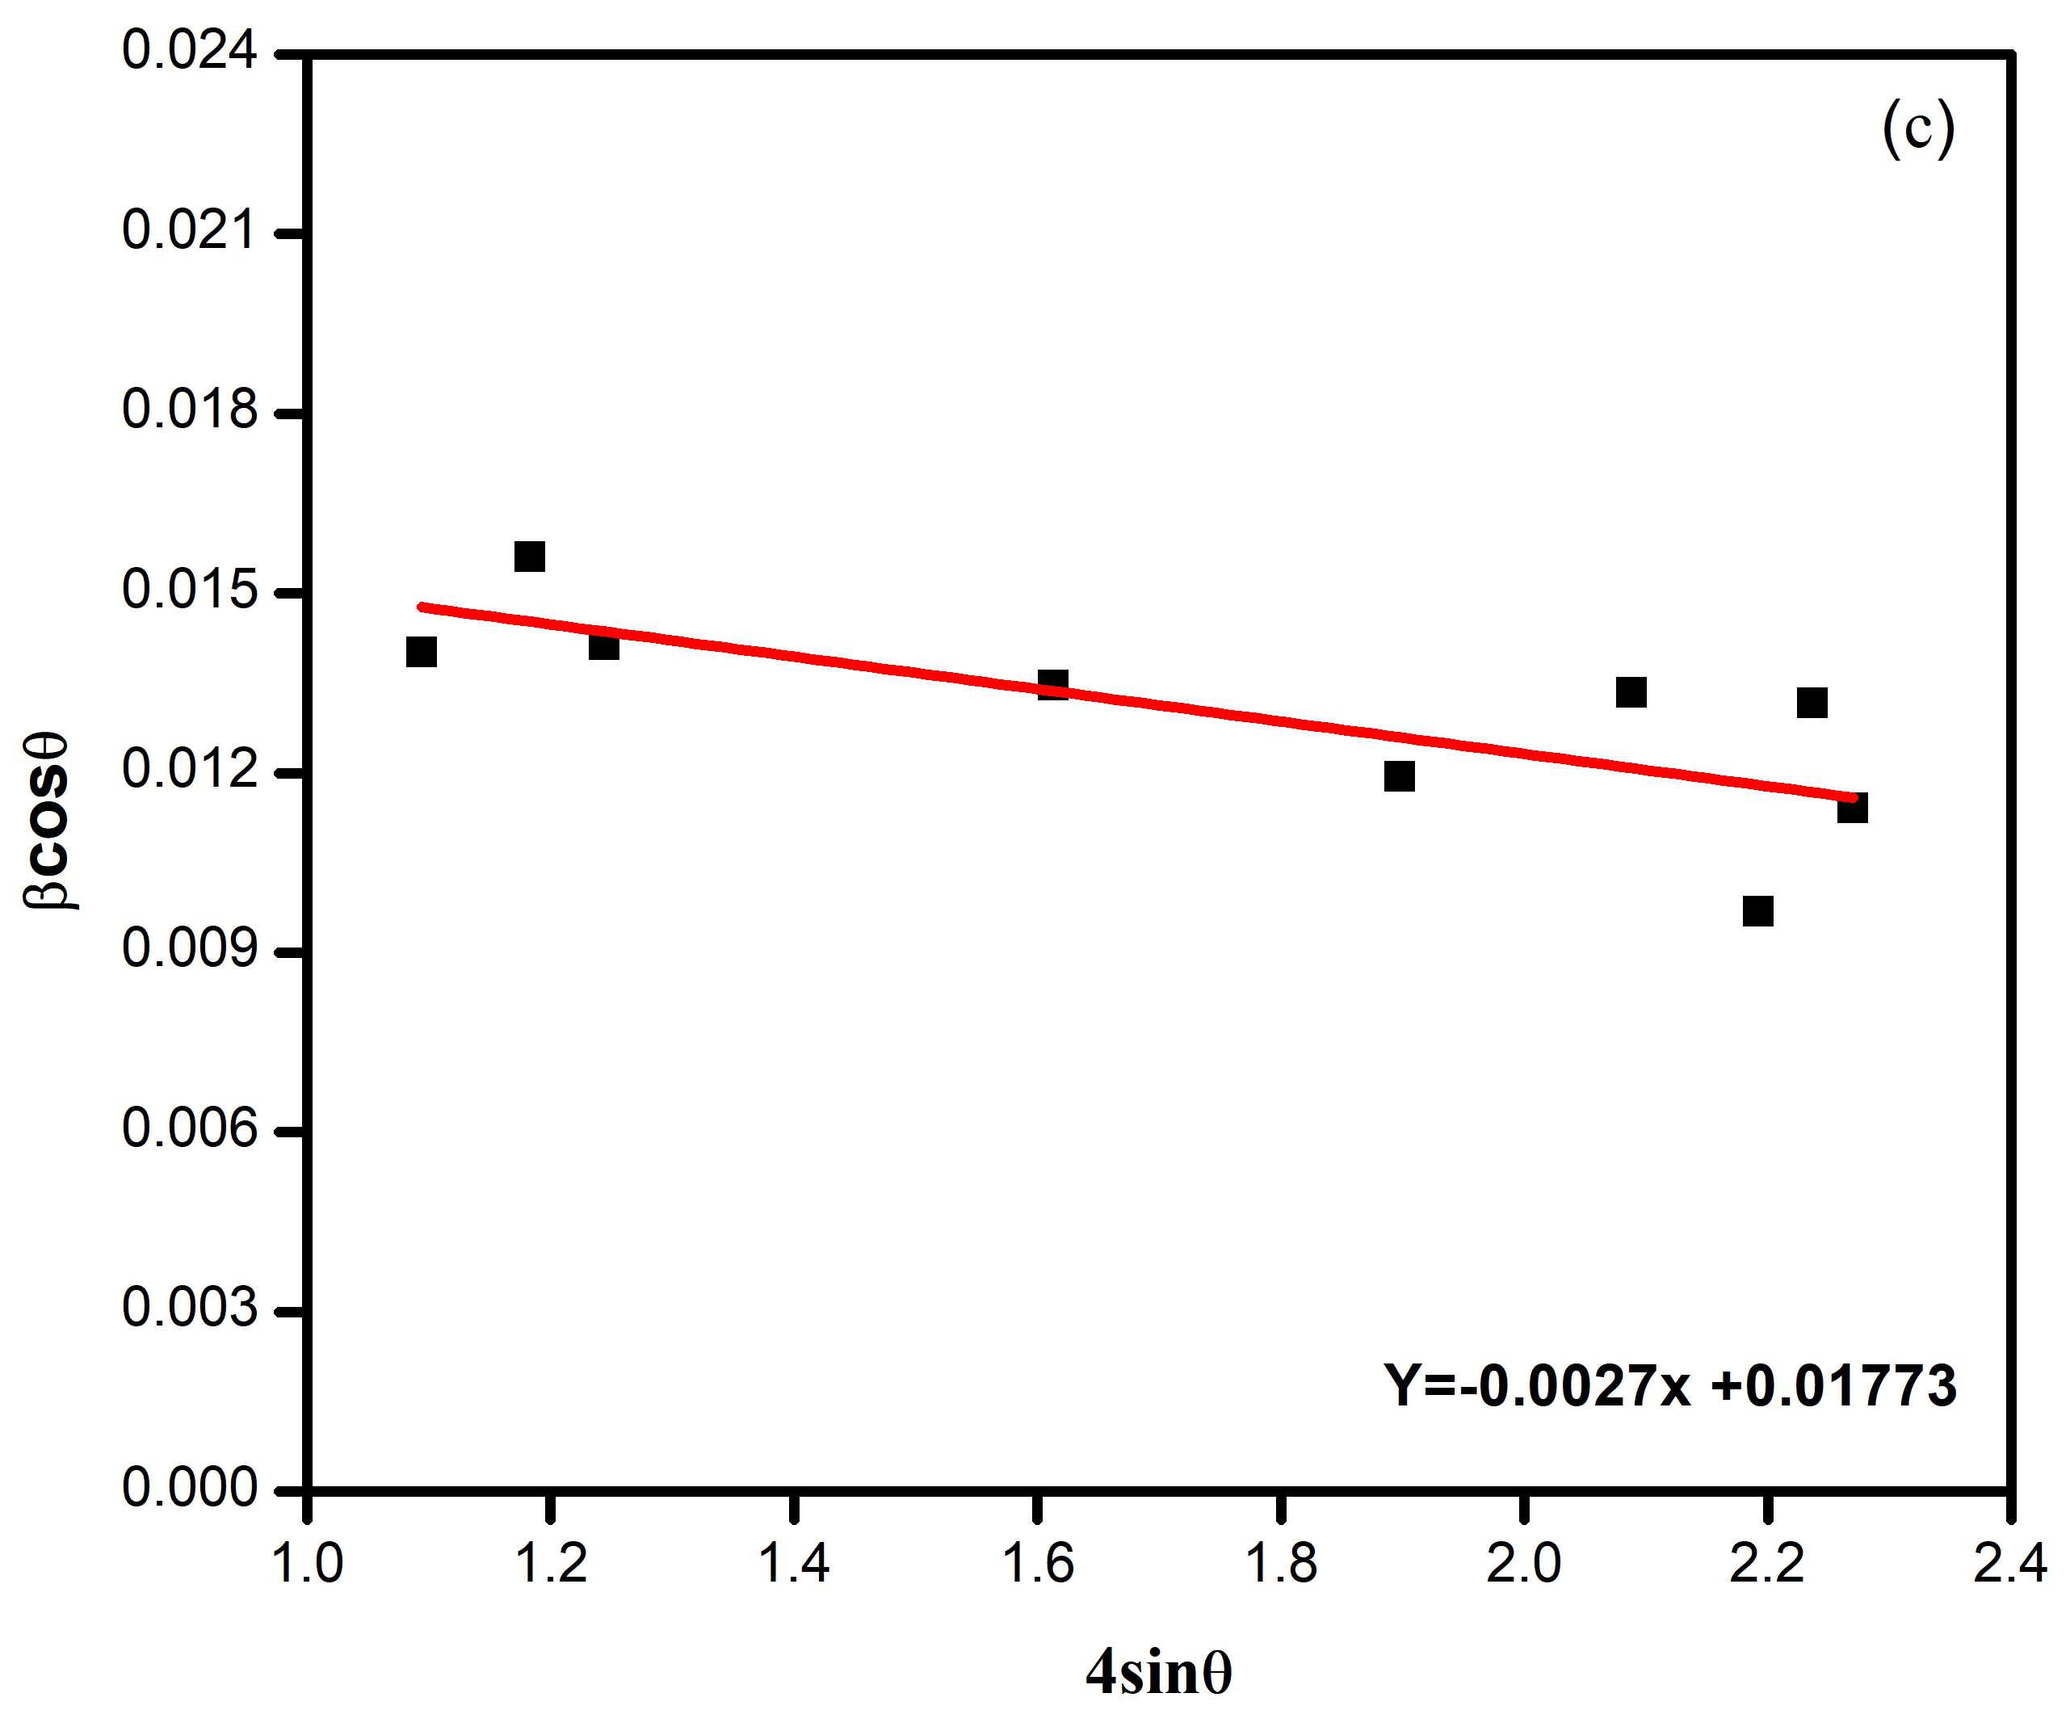

Fig. S1W-H plot of (a) ZnO NPs-pH 8.6, (b) ZnO NPs-pH 10.4 and (c) ZnO NPs-pH 12.7 prepared at different pH value.
The crystallite size (D) and lattice strain (Ɛ) were calculated from Williamson-Hall (W-H) method from the following relation [1]-

$β_{hkl}cosθ=\frac{Kλ}{D}+4εsinθ$

Where K, β and $λ$ represents shape factor,full width at half maximum (FWHM) and wavelength of the radiation (0.154 nm). The crystallite size (D) and lattice strain(Ɛ) were obatined from y-axis intercept and slop in$β_{hkl}cosθ$ vs 4$sinθ$ plot shown in Fig.S1(a-c)

Supporting information “S2”

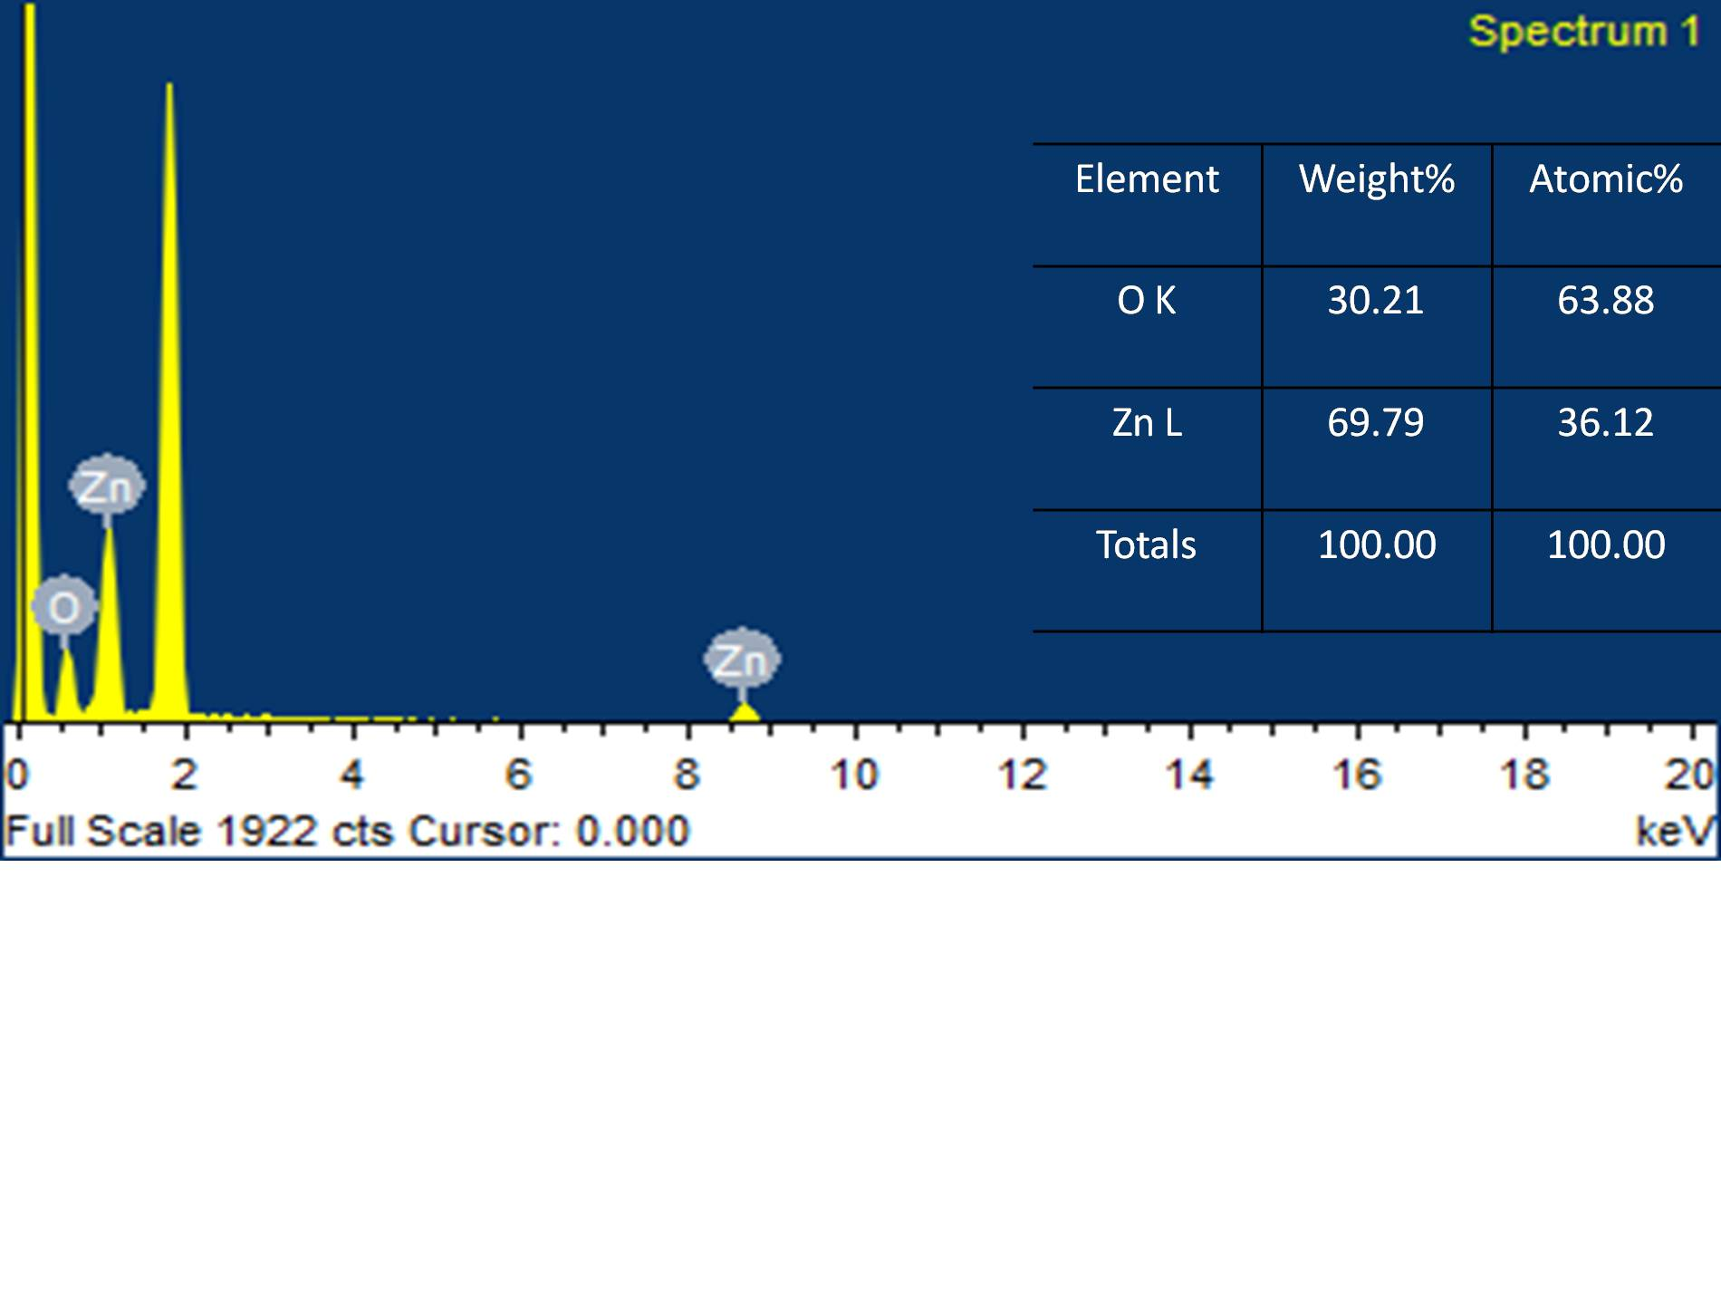
(a)

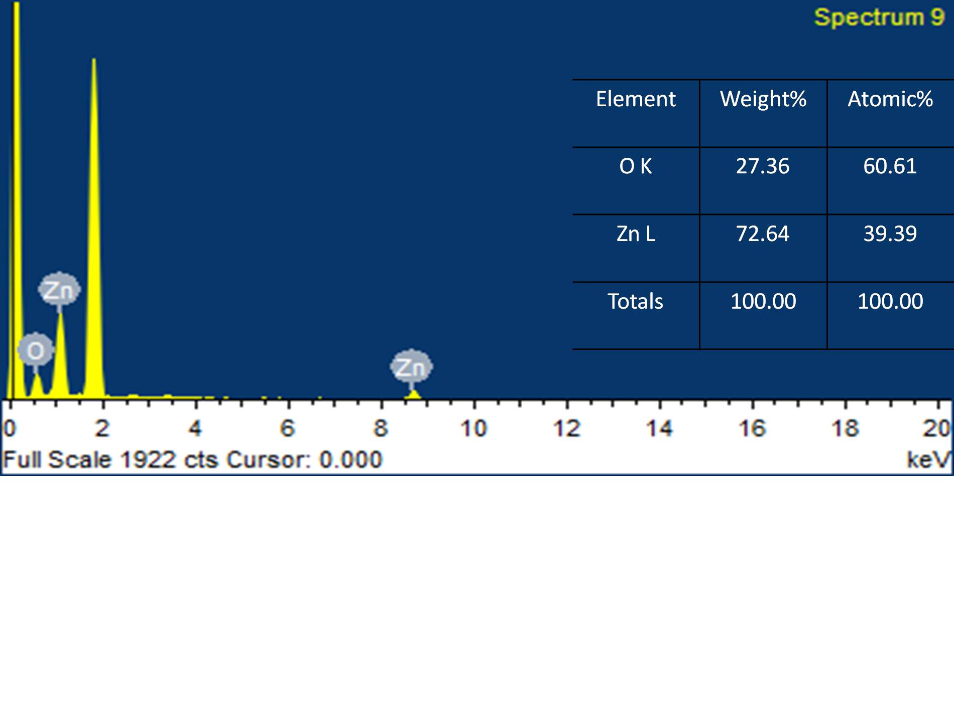
(c)
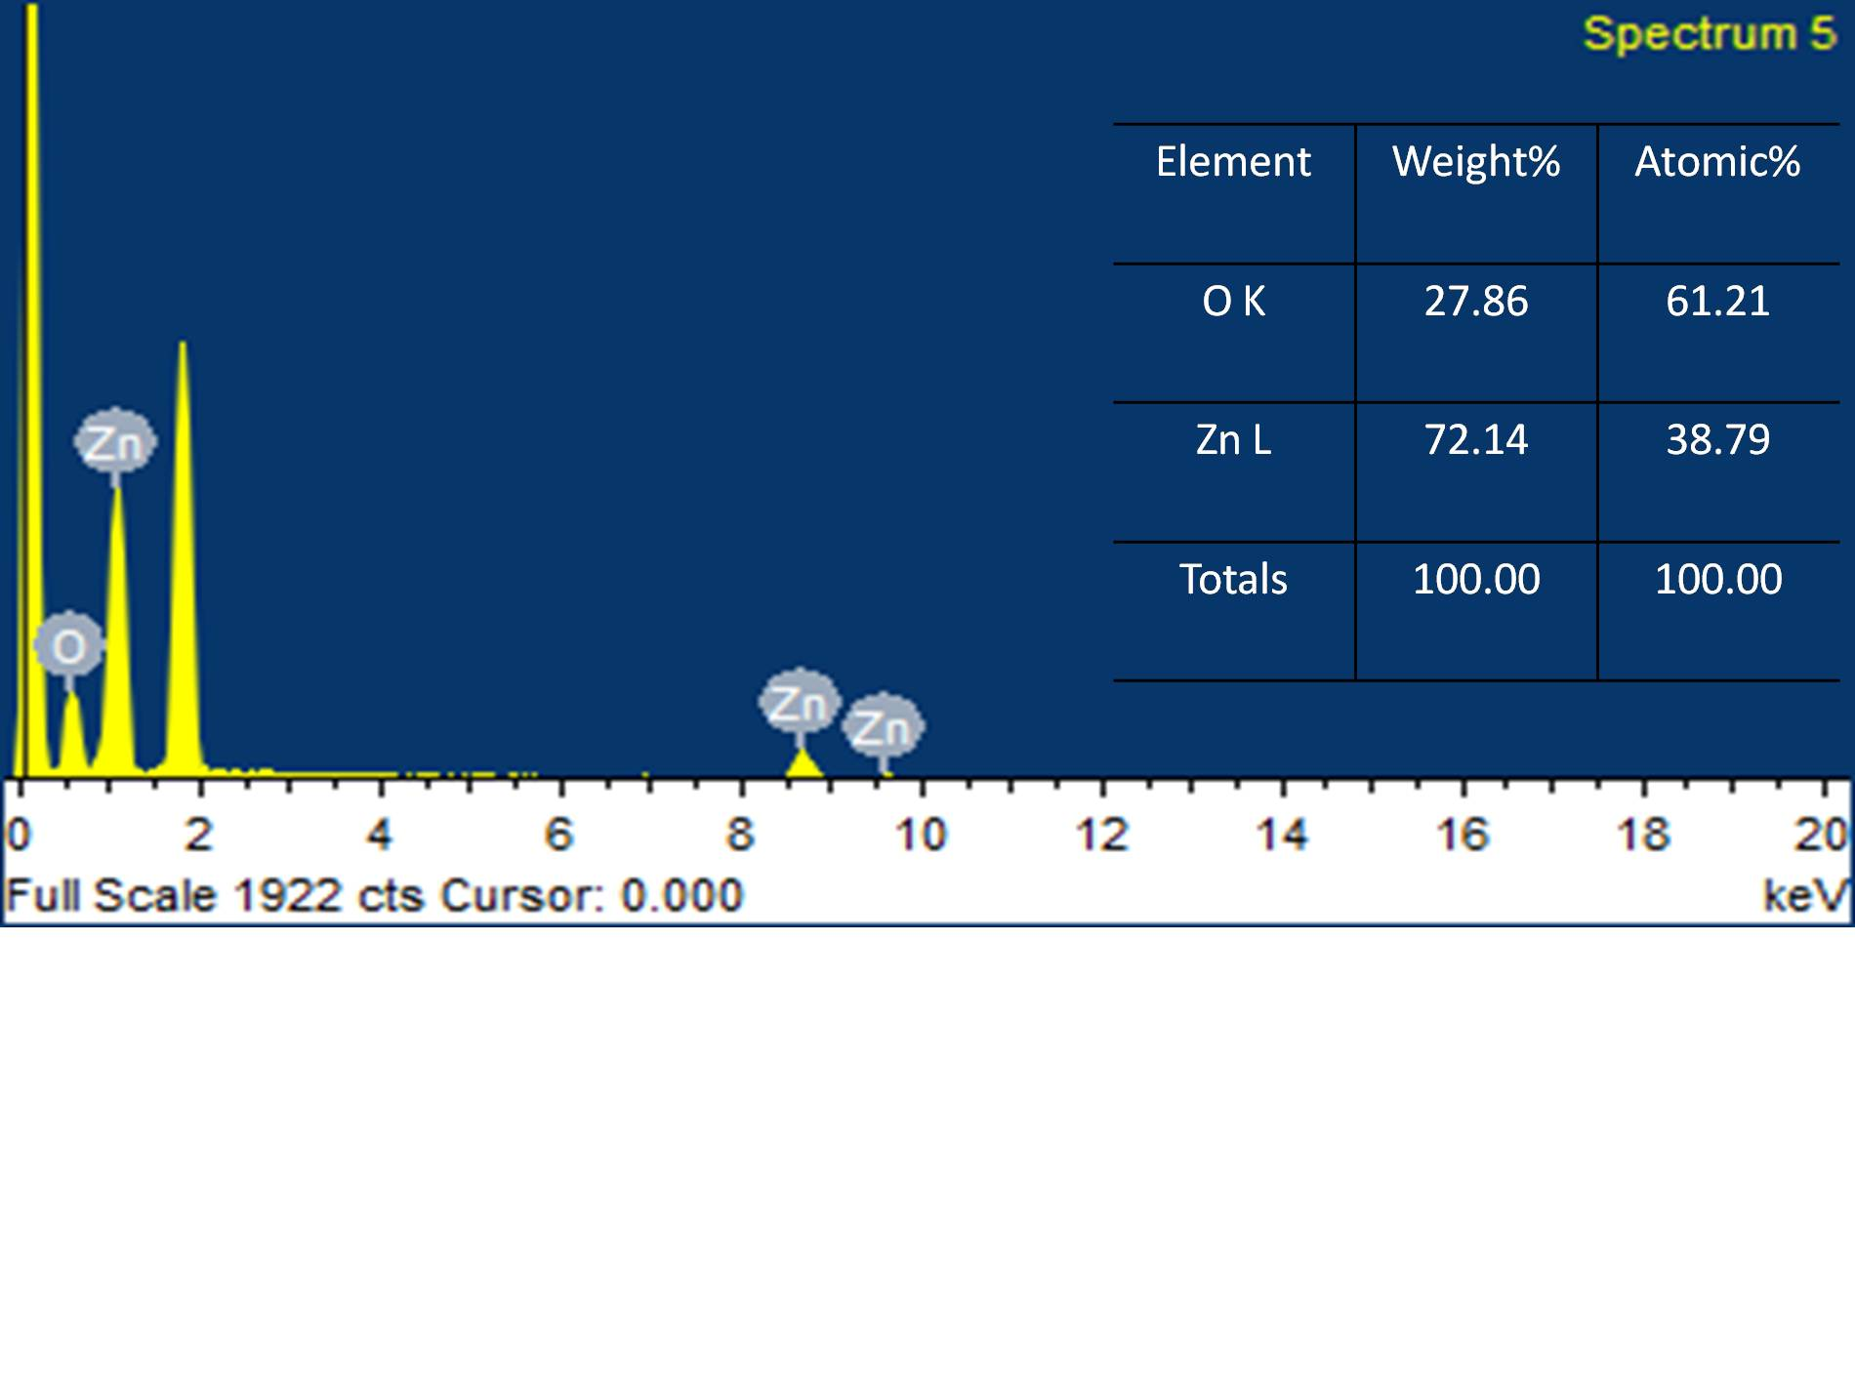
(b)
Fig. S2 EDX micrograph of (a) ZnO NPs-pH 8.6, (b) ZnO NPs-pH 10.4 and (c) ZnO NPs-pH 12.7samples with weight and atomic percentage.

Table S1. Comparison of photocatalytic activity of ZnO NPs synthesized with different precipitating or capping agent.

Material | Precipitating or Capping agent used | Pollutant used | Time of degradation  (min) | Degradation efficiency | Ref.
ZnO NPs | Leaves  extract | Methyl Orange | 100 | 93.4% | (Saraswathi et al. 2017)
ZnO | Leaves Extract | Methylene Blue | 120 | 92% | (Madan et al. 2016)
ZnO NPs | Peel Extract | Methylene Blue | 180 | 97% | (Nava et al. 2017)
ZnO NPs | Peel Extract | Methylene Blue | 120 | 63% | (Madhumitha et al. 2019)
ZnO NPs | NaOH | Methylene Blue | 120 | 87.74% | (Akhil et al. 2016)
Pure ZnO | NaOH | Methylene Blue | 180 | 12.4% | (Pandimuragan et al. 2016)
ZnO | NaOH | Methylene Blue | 210 | 80% | (Kahsay et al. 2019)
ZnO NPs | Aqueous NH₃ | Methylene Blue | 270 | 97.4% | (Abbas et al. 2017)
ZnO | Aqueous NH₃ | Methylene Blue | 240 | 54% | (Velanganni et al. 2018)
ZnO | KOH | Methylene Blue | 120 | 79.76% | (Khokhra et al. 2015)
ZnO | KOH | RhodamineB | 240 | 95.53% | (Shi et al. 2015)
Commercial ZnO NPs |  | Methylene Blue | 120 | 37% | (Azarang et al. 2015)
Pure ZnO NPs | NaOH | Malachite Green | 120 | 80% | (Lavand et al. 2015)
ZnO NPs | CHAWE | Methylene Blue  Methyl Orange | 120  120 | 97.7%  56% | Present work

Reference
Goswami A (1996) ‘Thin film fundamentals’, New age international (p) ltd publishers New Delhi pp 411.
Saraswathi VS, Tatsugi J, Shin PK, SanthakumarK (2017) Facile biosynthesis, characterization, and solar assisted photocatalytic effect of ZnO nanoparticles mediated by leaves of L. Speciosa. Journal of Photochemistry and Photobiology B: Biology 17: 89-98. https://doi.org/10.1016/j.jphotobiol.2016.12.032
Madan HR,Sarma SC, et al. (2016) Facile green fabrication of nanostructures ZnO plates, bullets, flower, prismatic tip, closed pine cone: Their antibacterial, antioxidant, photoluminescence and photocatalytic properties.SpectrochimicaActa Part A: Molecular and Biomolecular Spectroscopy, 152: 404-416. https://doi.org/10.1016/j.saa.2015.07.067
Nava OJ, Robles CAS, et al (2017) Fruit peel extract mediated green synthesis of zinc oxide nanoparticles. Journal of Molecular Structure 1147(5): 1-6. https://doi.org/10.1016/j.molstruc.2017.06.078
Madhumitha G,Fowsiya J, Gupta N, Kumar A, Singh M (2019) Green synthesis, characterization and antifungal and photocatalytic activity of Pithecellobiumdulce peel- mediated ZnO. Journal of Physics and Chemistry of Solids 127:43-51. https://doi.org/10.1016/j.jpcs.2018.12.005
Akhil K, JayakumarJ,Gayathri G, Khan SS (2016) Effect of various capping agent on photocatalytic, antibacterial and antibiofilmactivities of ZnO nanoparticles, Journal of Photochemistry & Photobiology. B:Biology 160: 32-42. https://doi.org/10.1016/j.jphotobiol.2016.03.015
Pandimuragan R, Thambidurai S (2016) Novel seaweed capped ZnOnanoparticls for effective dye photodegradation and antibacterial activity. Advanced Powder Technology 27: 1062-1072. https://doi.org/10.1016/j.apt.2016.03.014
Kahsay MH, TadasseA, Devi DR, BelachewN,Basavaish K(2019) Green synthesis of zinc oxide nanostructures and investigation of their photocatalytic and bactericidal applications. RSC Advances 9: 36967. https://doi.org/10.1039/C9RA07630A
Abbas KN, Bidin N (2017) Morphological driven photocatalytic activity of ZnO nanostructures. Applied Surface Science 394: 498-508. https://doi.org/10.1016/j.apsusc.2016.10.080
Velanganni S, Pravinraj S, Immanuel P, Thirunneelakandan R(2018) Nanostructures CdS/ZnOheterojunction configuration for photocatalytic degradation of methylene blue. Physics B: Condensed Matter 534: 56-62.https://doi.org/10.1016/j.physb.2018.01.027
Khokhra R, Singh RK, KumarR (2015) Effect of synthesis medium on aggregation tendencies of ZnOnanosheets and their superior photocatalytic performance. Journal of Material Science 50: 819-832. https://doi.org/10.1007/s10853-014-8642-0
Shi R, Song X, Li J, Yang P (2015) Hierarchical ZnO with twinned structures: Morphology evolution, formation mechanism and properties. Materials Chemistry and Physics 156: 61-68. https://doi.org/10.1016/j.matchemphys.2015.02.020
Azarang M, Shuhaimi A, YousefiR, JahromiSP(2015) One-pot sol-gel synthesis of reduced grapheme oxide uniformly decorated zinc oxide nanoparticles in starch environment for highly efficient photodegradation of methylene blue. RSC Advances 5: 21888-21896. https://doi.org/10.1039/C4RA16767H
Lavand AB, MalgheYS (2015) Synthesis, characterization and visible light photocatalytic activity of nitrogen-doped zinc oxide nanospheres. Journal of Asian Ceramic Societies 3: 305-310. https://doi.org/10.1016/j.jascer.2015.06.002

