Appendix-Cost-benefit analysis of universal screening for HCV infection in China: A Markov modelling study
Contents
Appendix-Cost-benefit analysis of universal screening for HCV infection in China: A Markov modelling study 1
Appendix Table 1. Consolidated Health Economic Evaluation Reporting Standards framework 2
Appendix Table 1. Initial Health State Distribution of Population in model 4
Appendix Table 3. Initial Health State Distribution of HCV-Infected Individuals 6
Appendix Figure 1. Correlation Analysis of Chronic HCV Incidence and Prevalence Across Age Groups 7
Appendix Table 4. Incidence-Prevalence Relationship for Chronic HCV in the 0–44 Age Group 8
Appendix Figure 2. ARIMA-Based Prediction of HCV Incidence in the 45+ Age Group 9
Appendix Table 5. Parameters used in Markov 10

Appendix Table 1. Consolidated Health Economic Evaluation Reporting Standards framework¹
Section | Item | Description | Page number in manuscript
Title and Abstract | 1. Title | Identify the study as an economic evaluation. | 1
 | 2. Abstract | Provide a structured abstract with background, methods, results, and conclusions. | 2-3
Introduction | 3. Background and Objectives | Describe the study context and objectives. | 4-5
Methods | 4. Target Population and Setting | Define the target population, setting, and analytical perspective (e.g., healthcare system, societal). | 9
 | 5. Comparators and Interventions | Describe the interventions and comparators evaluated in the study. | 9-10
 | 6. Time Horizon | State the time horizon for the analysis and justify its choice. | 9
 | 7. Discount Rate | Report the discount rate applied to costs and outcomes. | 13
 | 8. Choice of Outcomes | Define the primary and secondary health outcomes and how they were measured. | 14-15
 | 9. Measurement of Effectiveness | Explain the source of effectiveness data (e.g., trials, observational studies, modeling). | 15
 | 10. Measurement and Valuation of Costs | Describe how costs were measured and valued in the study. | 13
 | 11. Modeling | If modeling was used (e.g., Markov models, simulations), describe its structure, assumptions, and validation. | 10
 | 12. Analytic Methods | Explain the statistical and analytical methods used, including uncertainty analysis. | 15
Results | 13. Study Parameters | Report key model parameters, sources, and estimated values. | Appendix pp 10-11
 | 14. Uncertainty Analysis | Describe how uncertainty was assessed (e.g., sensitivity analysis, scenario analysis). | 15-16
 | 15. Results | Present key findings, including incremental cost-effectiveness ratios (ICERs) where applicable. | 17-18
Discussion | 16. Study Findings and Policy Implications | Discuss the significance of findings and compare with existing literature. | 23-24
 | 17. Limitations | Acknowledge study limitations and their potential impact. | 25-26
 | 18. Conclusions | Summarize key takeaways and suggest directions for future research. | 27
Other | 19. Funding and Conflicts of Interest | Disclose funding sources and potential conflicts of interest. | 28
 | 20. Data Availability | Provide information on data availability and sharing policies. | 28-29

Appendix Table 1. Initial Health State Distribution of Population in model²
Age group | <5 | 5~9 | 10~14 | 15-19 | 20-24 | 25-29 | 30-34 | 35-39 | 40-44 | 45-49 | 50-54 | 55-59 | 60-64 | 65-69 | 70-74
Population | 6.78E+07 | 8.12E+07 | 7.30E+07 | 7.21E+07 | 7.41E+07 | 8.34E+07 | 1.11E+08 | 1.23E+08 | 1.03E+08 | 1.02E+08 | 1.18E+08 | 1.22E+08 | 8.95E+07 | 7.48E+07 | 6.10E+07
Incidence of HCV | 0.15% | 0.04% | 0.02% | 0.01% | 0.01% | 0.01% | 0.01% | 0.01% | 0.01% | 0.01% | 0.02% | 0.02% | 0.03% | 0.04% | 0.06%
Prevalence of HCV | 0.52% | 0.93% | 1.06% | 1.12% | 1.14% | 1.19% | 1.26% | 1.32% | 1.39% | 1.45% | 1.53% | 1.62% | 1.73% | 1.87% | 2.07%
Incidence of HCC | 0.00% | 0.00% | 0.00% | 0.00% | 0.00% | 0.00% | 0.00% | 0.00% | 0.00% | 0.00% | 0.00% | 0.00% | 0.01% | 0.01% | 0.01%
Prevalence of HCC | 0.00% | 0.00% | 0.00% | 0.00% | 0.00% | 0.00% | 0.00% | 0.00% | 0.00% | 0.00% | 0.00% | 0.00% | 0.01% | 0.01% | 0.01%
F0 | 66.20% | 66.20% | 66.20% | 66.20% | 58.39% | 58.39% | 58.39% | 58.39% | 23.03% | 23.03% | 23.03% | 23.03% | 7.70% | 7.70% | 7.70%
F1 | 24.60% | 24.60% | 24.60% | 24.60% | 27.11% | 27.11% | 27.11% | 27.11% | 36.69% | 36.69% | 36.69% | 36.69% | 16.61% | 16.61% | 16.61%
F2 | 7.10% | 7.10% | 7.10% | 7.10% | 10.12% | 10.12% | 10.12% | 10.12% | 27.11% | 27.11% | 27.11% | 27.11% | 21.16% | 21.16% | 21.16%
F3 | 2.10% | 2.10% | 2.10% | 2.10% | 3.06% | 3.06% | 3.06% | 3.06% | 10.12% | 10.12% | 10.12% | 10.12% | 22.27% | 22.27% | 22.27%
F4 | 0.00% | 0.00% | 0.00% | 0.00% | 1.33% | 1.33% | 1.33% | 1.33% | 3.06% | 3.06% | 3.06% | 3.06% | 32.25% | 32.25% | 32.25%

Appendix Table 3. Initial Health State Distribution of HCV-Infected Individuals³
Age | <18 | 18-39 | 40-59 | >=60
F0 | 66.20% | 58.39% | 23.03% | 7.70%
F1 | 24.60% | 27.11% | 36.69% | 16.61%
F2 | 7.10% | 10.12% | 27.11% | 21.16%
F3 | 2.10% | 3.06% | 10.12% | 22.27%
F4 | 0.00% | 1.33% | 3.06% | 32.25%

Appendix Figure 1. Correlation Analysis of Chronic HCV Incidence and Prevalence Across Age Groups²
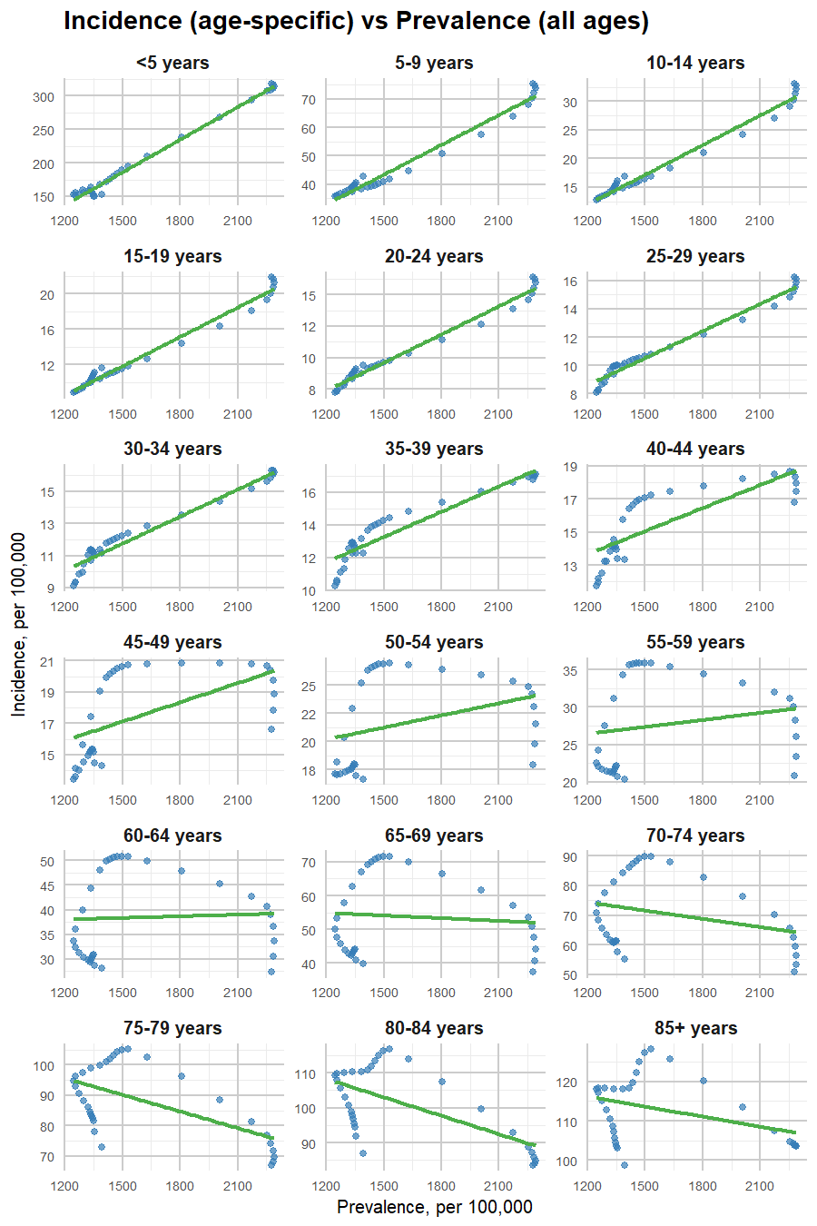

Appendix Table 4. Incidence-Prevalence Relationship for Chronic HCV in the 0–44 Age Group
Age group | Incidence, per 100,000
<5 | -57.12+0.16×prevalence
5~9 | -9.14+0.04×prevalence
10~14 | -8.78+0.02×prevalence
15-19 | -4.73+0.01×prevalence
20-24 | -1.53+0.01×prevalence
25-29 | 0.96+0.01×prevalence
30-34 | 3.37+0.01×prevalence
35-39 | 5.56+0.01×prevalence
40-44 | 8.11+0.01×prevalence

Appendix Figure 2. ARIMA-Based Prediction of HCV Incidence in the 45+ Age Group⁴
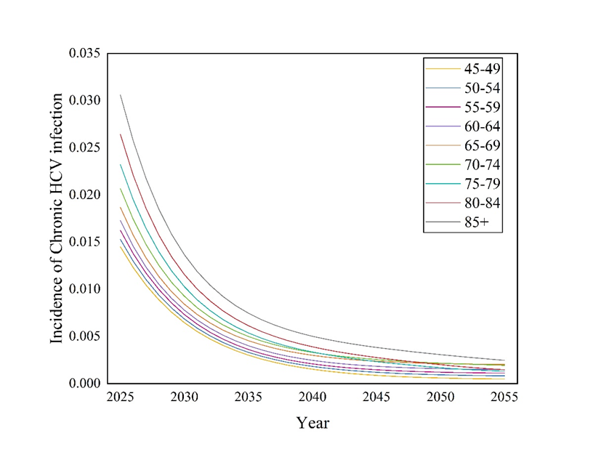

Appendix Table 5. Parameters used in Markov
Parameters | Base-case value (range) | Distribution (a, b) | Reference
Transition rate
From F0 to F1 | 11.70% (10.53%-12.87%) | Beta (264.78, 1998.32) | Thein H et al. (2008)⁵
From F1 to F2 | 8.50% (7.65%-9.35%) | Beta (274.42, 2954.00) | Thein H et al. (2008)⁵
From F2 to F3 | 12.10% (10.89%-13.31%) | Beta (263.58, 1914.76) | Thein H et al. (2008)⁵
From F3 to F4 | 11.60% (10.44%-12.76%) | Beta (265.08, 2020.12) | Thein H et al. (2008)⁵
From F3 to DC | 1.20% (1.08%-1.32%) | Beta (296.39, 24402.61) | Chahal et al. (2016)⁶
From F3 to HCC | 1.10% (0.99%-1.21%) | Beta (296.69, 26675.04) | Chahal et al. (2016)⁶
From SVR F3 to SVR F2 | 26.70% (24.03%-29.37%) | Beta (219.63, 602.96) | Maylin et al. (2008)⁷
From SVR F3 to HCC | 0.30% (0.27%-0.33%) | Beta (299.10, 99399.90) | Zhou H et al. (2020)⁸
From F4 to DC | 3.90% (3.51%-4.29%) | Beta (288.26, 7103.05) | Chahal et al. (2016)⁶
From F4 to HCC | 2.40% (2.16%-2.64%) | Beta (292.78, 11906.22) | Chahal et al. (2016)⁶
From SVR F4 to SVR F3 | 7.60% (6.84%-8.36%) | Beta (277.12, 3369.24) | Zhou H et al. (2024)⁸
From SVR F4 to DC | 0.30% (0.27%-0.33%) | Beta (299.10, 99399.90) | Zhou H et al. (2020)⁸
From SVR F4 to HCC | 0.30% (0.27%-0.33%) | Beta (299.10, 99399.90) | Zhou H et al. (2020)⁸
From SVR DC to SVR F4 | 7.60% (6.84%-8.36%) | Beta (277.12, 3369.24) | Zhou H et al. (2020)⁸
From SVR DC to HCC | 0.30% (0.27%-0.33%) | Beta (299.10, 99399.90) | Zhou H et al. (2024)⁸
From SVR DC to LT | 0.03% (0.03%-0.03%) | Beta (299.91, 999399.09) | Zhou H et al. (2020)⁸
From SVR DC to Death | 4.20% (3.78%-4.62%) | Beta (287.36, 6554.50) | Zhou H et al. (2020)⁸
From DC to HCC | 1.40% (1.26%-1.54%) | Beta (295.79, 20831.79) | Zhou H et al. (2020)⁸
From DC to LT | 0.03% (0.03%-0.03%) | Beta (299.91, 999399.09) | Zhou H et al. (2020)⁸
From DC to Death | 5.20% (4.68%-5.72%) | Beta (284.35, 5183.88) | Zhou H et al. (2020)⁸
From HCC to LT | 0.05% (0.05%-0.06%) | Beta (299.85, 599399.15) | Zhou H et al. (2020)⁸
From HCC to Death | 36.80% (33.12%-40.48%) | Beta (189.23, 324.99) | Zhou H et al. (2020)⁸
From LT to Death (1) | 21.87% (19.68%-24.06%) | Beta (234.17, 836.57) | Zhou H et al. (2020)⁸
From LT to Death (1+) | 6.68% (6.01%-7.35%) | Beta (279.89, 3910.12) | Zhou H et al. (2020)⁸
Other parameters
Detection rate without screening | 18.00% (16.20%-19.80%) | Beta (245.82, 1119.85) | Zhou H et al. (2024)⁸
Acceptability of treatment after passive diagnosis | 62.00% (55.80%-68.20%) | Beta (113.38, 69.49) | Zhou H et al. (2024)⁸
Acceptability of treatment after active screening and CHC diagnosis | 88.00% (79.20%-96.80%) | Beta (35.12, 4.79) | Liu Y et al. (2019)⁹
Pan-genotypic DAA in patients with F0-F4 | 96.00% (86.40%-105.60%) | Beta (11.04, 0.46) | Xie Q et al. (2019)¹⁰
Pan-genotypic DAA in patients with DC | 92.30% (83.07%-101.53%) | Beta (22.18, 1.85) | Tada T et al. (2021)¹¹
Screening coverage | 90.00% (81.00%-99.00%) | Beta (29.10, 3.23) | Li Jian et al. (2022)¹²
Transition rate by pregnant | 5.00% (4.50%-5.50%) | Beta (284.95, 5414.05) | Conte D et al. (2000)¹³
Sensitivity of screening | 98.10% (88.29%-100.00%) | Beta (12.91, 0.25) | Kim et al. (2022)¹⁴
Specificity of screening | 99.80% (89.82%-100.00%) | Beta (0.77, 0.00) | Kim et al. (2022)¹⁴

REFERENCES
1 Husereau D, Drummond M, Augustovski F, et al. Consolidated health economic evaluation reporting standards 2022 (CHEERS 2022) statement: updated reporting guidance for health economic evaluations. Value Health 2022;25:3-9.
2 Global Burden Of Disease. GBD results. 2021. Available: https://vizhub.healthdata.org/gbd-results/ [Accessed 3-16].
3 Zhou H, Yan M, Che D, et al. Universal screening for HCV infection in china: an effectiveness and cost-effectiveness analysis. JHEP Rep. 2024;6:101000.
4 Liu Q, Liu X, Jiang B, et al. Forecasting incidence of hemorrhagic fever with renal syndrome in china using ARIMA model. BMC Infect. Dis. 2011;11:1-7.
5 Thein H, Yi Q, Dore GJ, et al. Estimation of stage-specific fibrosis progression rates in chronic hepatitis c virus infection: a meta-analysis and meta-regression. Hepatology. 2008;48:418-31.
6 Chahal HS, Marseille EA, Tice JA, et al. Cost-effectiveness of early treatment of hepatitis c virus genotype 1 by stage of liver fibrosis in a US treatment-naive population. JAMA Intern. Med. 2016;176:65-73.
7 Maylin S, Martinot-Peignoux M, Moucari R, et al. Eradication of hepatitis c virus in patients successfully treated for chronic hepatitis c. Gastroenterology 2008;135:821-9.
8 Zhou H, Yan M, Che D, et al. Universal screening for HCV infection in china: an effectiveness and cost-effectiveness analysis. JHEP Rep. 2024;6:101000.
9 Liu Y, Zou X, Chen W, et al. Hepatitis c virus treatment status and barriers among patients in methadone maintenance treatment clinics in guangdong province, china: a cross-sectional, observational study. Int. J. Environ. Res. Public Health 2019;16.
10 Xie Q, Xuan J, Tang H, et al. Hepatitis c virus cure with direct acting antivirals: clinical, economic, societal and patient value for china. World J. Hepatol. 2019;11:421.
11 Tada T, Kurosaki M, Nakamura S, et al. Real‐world clinical outcomes of sofosbuvir and velpatasvir treatment in HCV genotype 1‐and 2‐infected patients with decompensated cirrhosis: a nationwide multicenter study by the japanese red cross liver study group. J. Med. Virol. 2021;93:6247-56.
12 Li J, Pang L, Liu Z. Interpretation of the national action plan for eliminating hepatitis c as a public health threat (2021–2030). China CDC Weekly 2022;4:627.
13 Conte D, Fraquelli M, Prati D, et al. Prevalence and clinical course of chronic hepatitis c virus (HCV) infection and rate of HCV vertical transmission in a cohort of 15,250 pregnant women. Hepatology. 2000;31:751-5.
14 Kim H, Kim K, Choi GH, et al. A cost-effectiveness study of universal screening for hepatitis c virus infection in south korea: a societal perspective. Clin. Mol. Hepatol. 2022;28:91-104.

