Supplementary Materials
Figure S1. Number or Articles in the Final Search in Each Database
- Search Results of Articles on PubMed on January 23, 2025
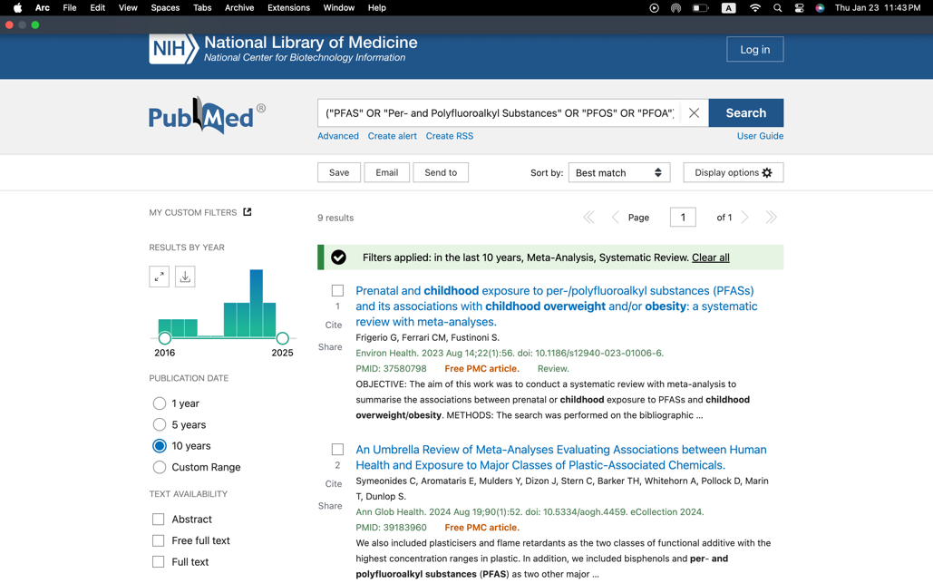
- Search Results of Articles on ScienceDirect on January 23, 2025
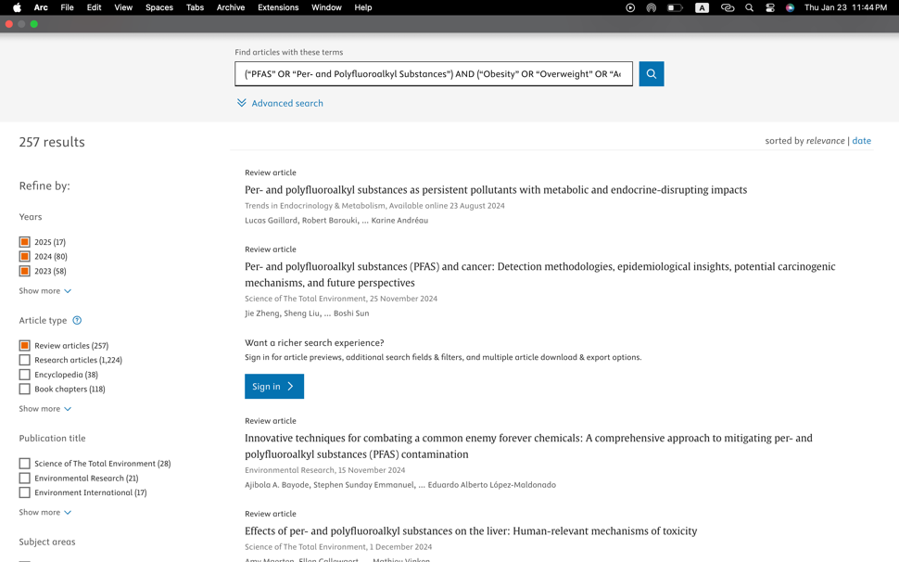

- Search Results of Articles on Biomed Central on January 23, 2025
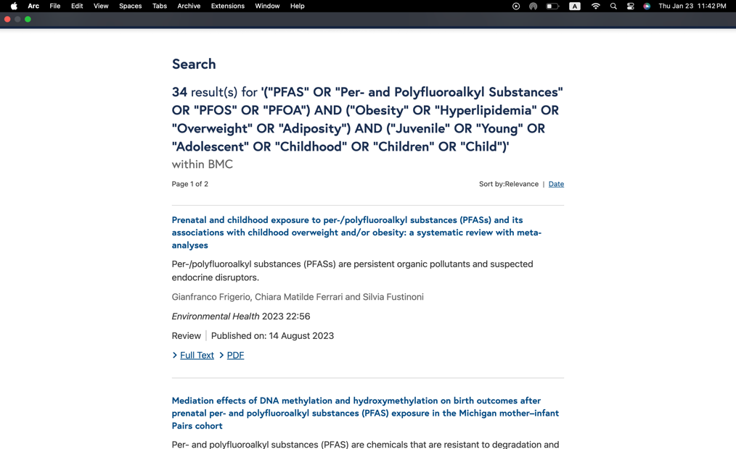

- Search Results of Articles on ProQuest on January 24, 2025
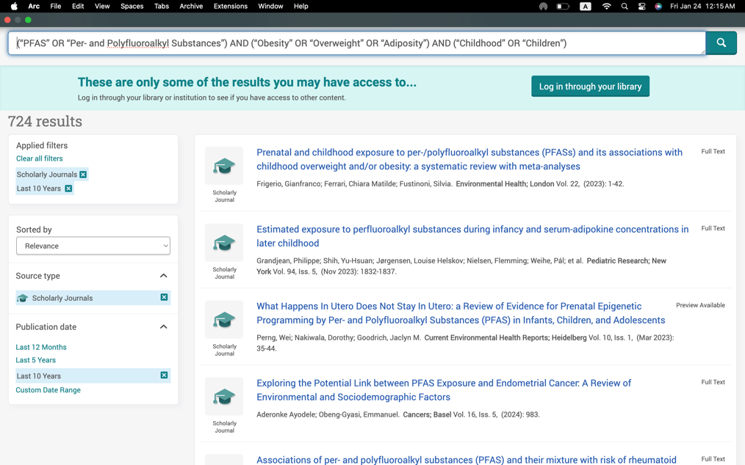

Figure S2. Research Protocol Registration on PROSPERO
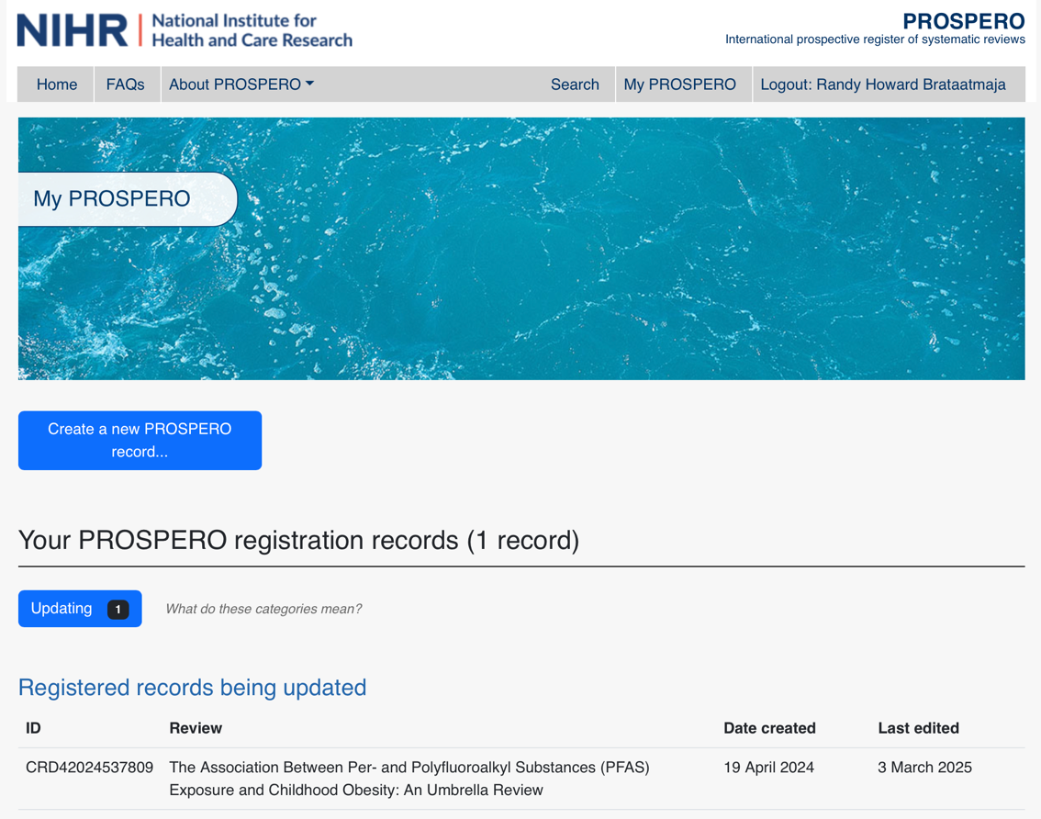

Figure S3. Joanna Briggs Institute (JBI) Checklist for Systematic Reviews and Meta-Analyses
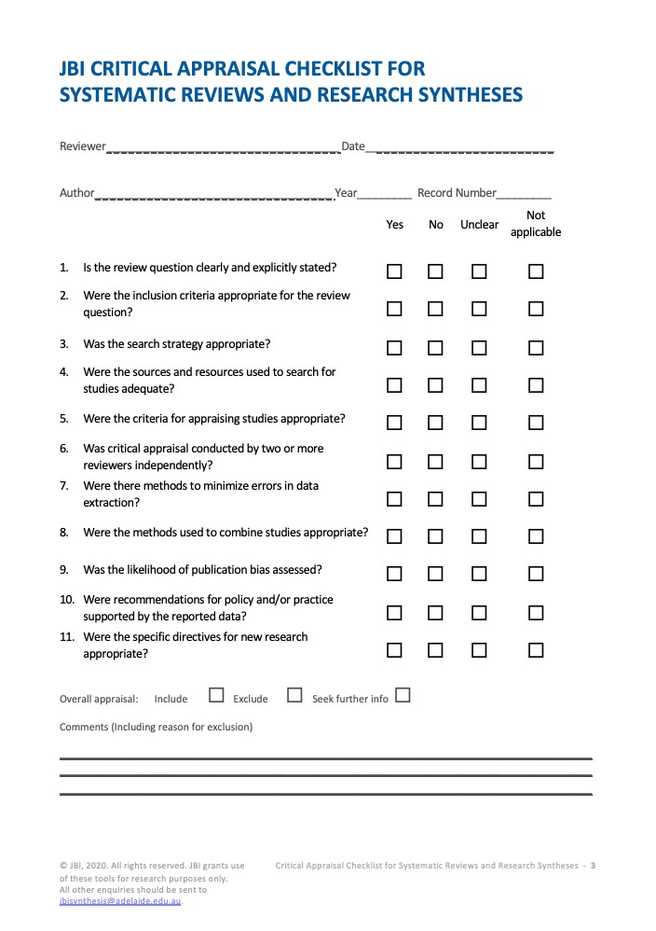

Figure S4. Assessment Results of Systematic Review and Meta-Analysis Using the JBI Checklist for Systematic Reviews and Meta-Analysis
- Results of the Systematic Review and Meta-Analysis Assessment by Frangione, et al.
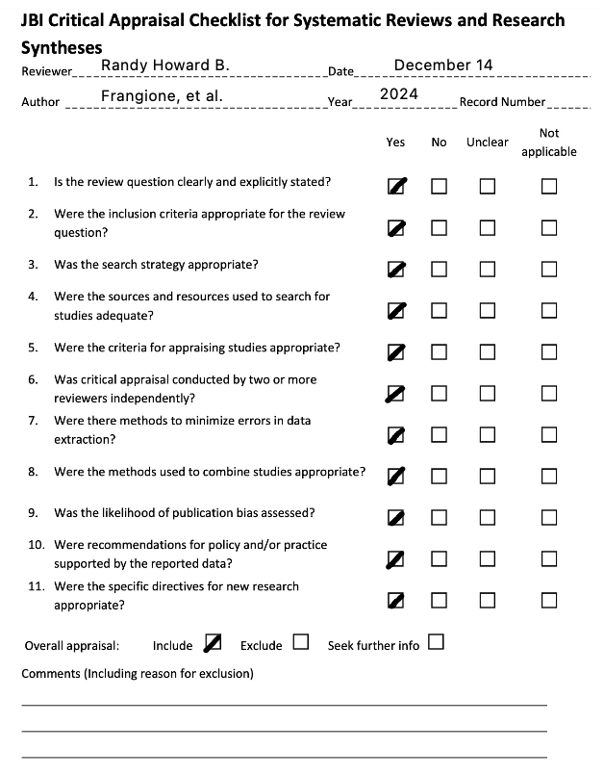

- Results of the Systematic Review and Meta-Analysis Assessment by Frigerio, et al.
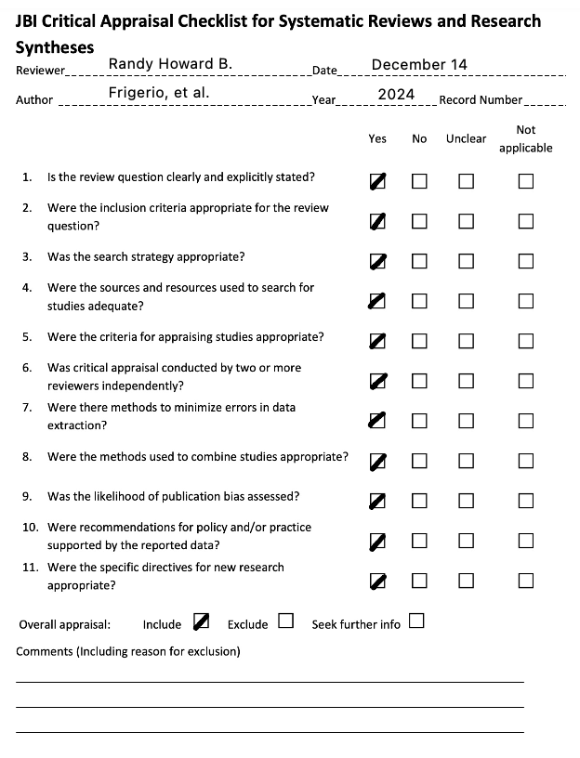

- Results of the Systematic Review Assessment by Lee, et al.
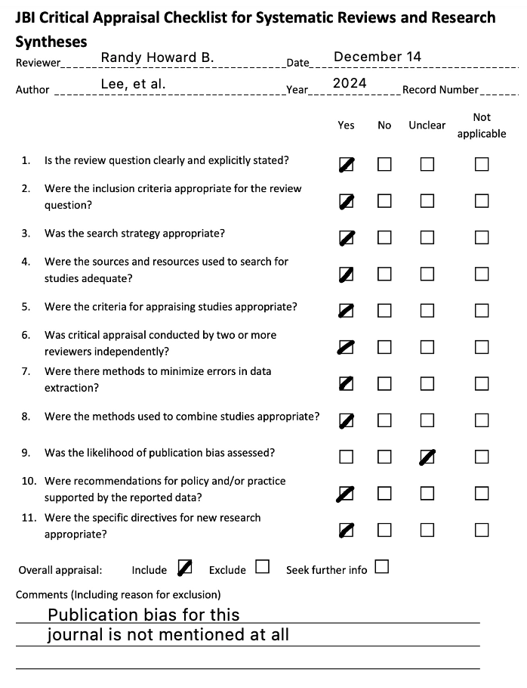

- Results of the Systematic Review and Meta-Analysis Assessment by Liu, et al.
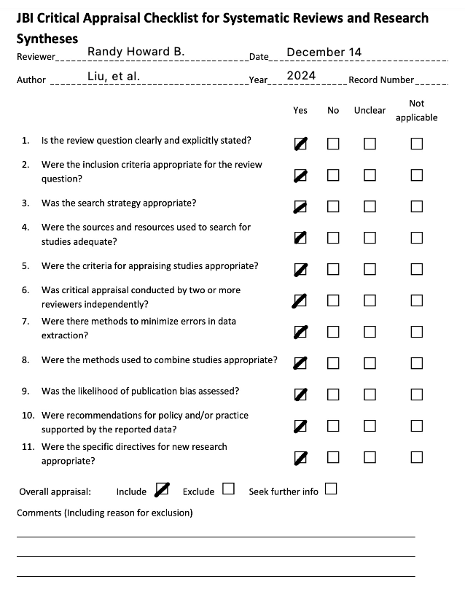

- Results of the Systematic Review and Meta-Analysis Assessment by Stratakis, et al.
