Supporting Information

SZC-6 Promotes Diabetic Wound Healing in Mice by Modulating M1/M2 Macrophage Ratio and Inhibiting MyD88/NF-κB Pathway

Supplementary Figures and Tables
A
Fig. S1. Cell viabilities of RAW264.7 cells treated with SZC-6 at different concentrations.
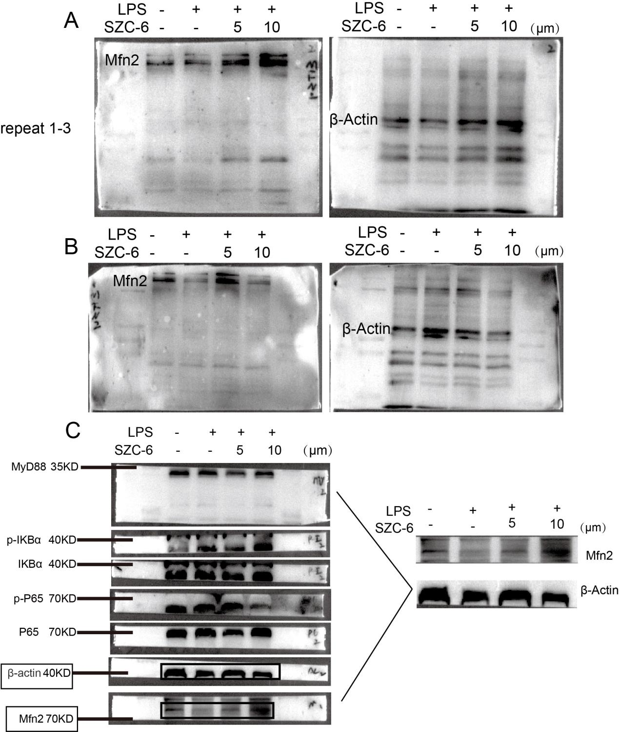

Fig. S2. Western blot analysis of β-actin, Mfn2 expression in the RAW264.7 cell(n = 3).

Fig. S3. Western blot analysis of α-Tubulin, Arg-1 expression in the RAW264.7 cell(n = 3).
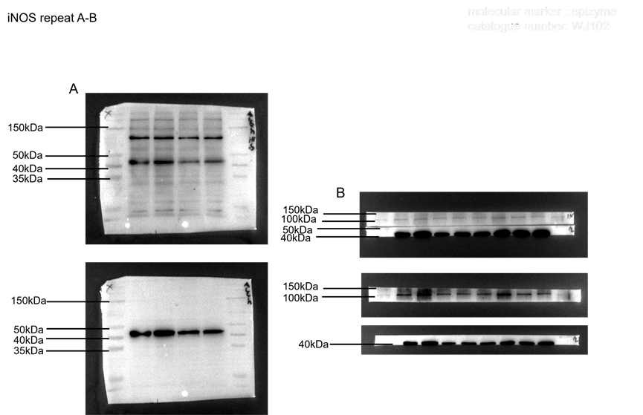

Fig. S4. Western blot analysis of iNos, β-Actin expression in the RAW264.7 cell(n = 3).

Fig. S5. Establishment of diabetic wound model.
(A)body weight level. (B)blood glucose levelof mice (n = 6).
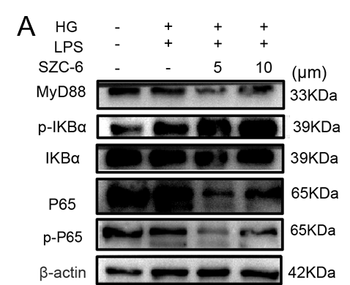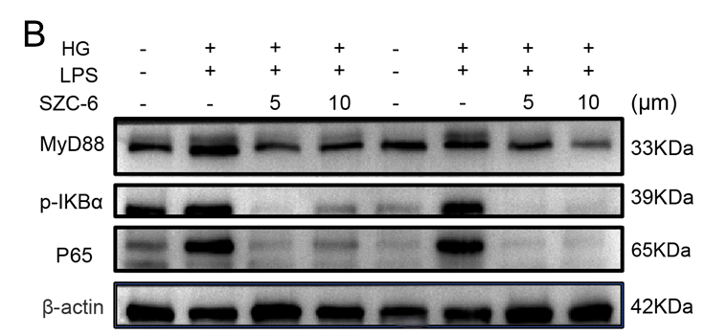
Fig. S6. Western blot analysis of β-actin,NF-χB p65, MyD88, p-IκBα expression in the RAW264.7 cell(n = 3).
Table. S1. The primer sequences used in the quantitative real-time PCR experiments.
Gene name | forward primer（5’→3’） | reverse primer（5’→3’）
β-actin | TGACAGGATGCAGAAGGAGA | GCTGGAAGGTGGACAGTGAG
Arginase-1 | CTCCAAGCCAAAGTCCTTAGAG | AGGAGCTGTCATTAGGGACATC
Retnla | CTCCACTGTAACGAAGACTC | GCAGTGGTCCAGTCAACGA
Il-6 | CAACGATGATGCACTTGCAGA | TGTGACTCCAGCTTATCTCTTGG
Tnf-α | CTCAGCGAGGACAGCAAGG | AGGGACAGAACCTGCCTGG
iNos | GCGCTCTAGTGAAGCAAAGC | AGTGAAATCCGATGTGGCCTG

