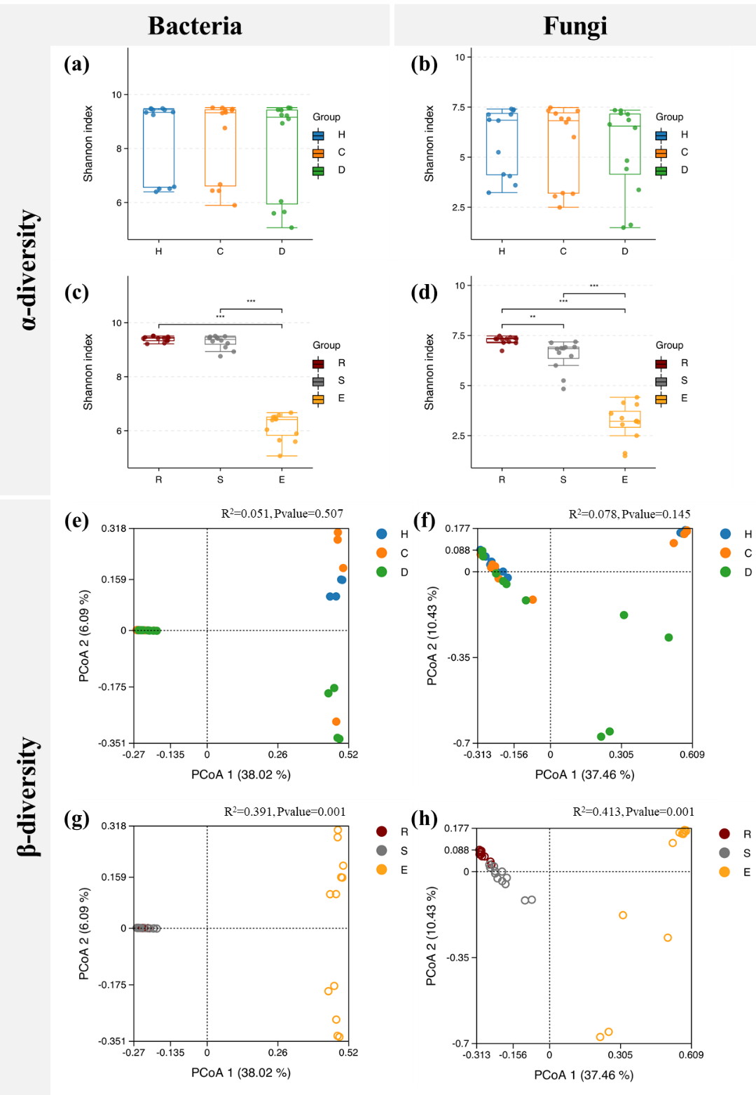

Figure S1 Bacterial and fungal α-diversity (A-D) and β-diversity (E-H) in different treatments. Principal coordinates analysis (PCoA) and permutational multivariate analysis of variance (PERMANOVA) of bacterial (E, G) and fungal (F, H) β-diversity based on Bray-Curtis distance. C, Control group; H, Healthy group; D, Disease group; E, endogenous; R, rhizosphere; S, bulk soil. Asterisks indicate statistically significant (*P < 0.05; **P < 0.01; ***P < 0.001) differences based on analysis of variance with Student’s T multiple comparison test.

Fig. S2 The relative abundance of bacteria (a-c) and fungi (d-f) in root (a, d), rhizosphere soil (b, e) and bulk soil (c, f) at the phylum level. C, control group; H, healthy group; D, diseased group.

