Supporting Information
- Synthesis of TiO₂:
Synthesis of TiO₂ nanoflower: 0.7 g of titanium isopropoxide was added to 75 mL of acetic acid under vigorous stirring for 30 min. The resulting mixture was transferred into a high-pressure autoclave and reacted at 160°C for 8 h. After completion, the solution was centrifuged to collect the product, followed by repeated washing with deionized water and ethanol. The material was subsequently dried in an oven at 100°C for 6 hours. The dried yellow powder was calcined in air at 500°C for 1 hour with a heating rate of 1°C/min, TiO₂ nanoflower was obtained.
Synthesis of TiO₂ nanosphere: The synthesis of spherical TiO₂ nanosphere was carried out using a sacrificial template method, which consists of three main steps: Step 1: Synthesis of SiO₂ Template: 10 mL of tetraethyl orthosilicate (TEOS) was added to 90 mL ethanol to form solution A. Simultaneously, 20 mL water and 10 mL ammonia solution were separately added to 70 mL ethanol under vigorous stirring to form Solution B. Solutions A and B were then mixed and stirred at 40°C for 3 hours. The product was collected by centrifugation at 4000 rpm, washed twice with methanol and water, and dried to obtain the SiO₂ template. Step 2: Synthesis of SiO₂@TiO₂ core-shell structure, 0.3 g of SiO₂ was ultrasonically dispersed in 100 mL ethanol (Solution A). Separately, 4 mL tetrabutyl titanate (TBT) was mixed with 100 mL ethanol to form Solution B. Solution B and 1.5 mL ammonia solution were then added to Solution A. The mixture was vigorously stirred at 60°C for 3 hours. The resulting product was dried at 70°C and calcined at 850°C for 2 hours to obtain the SiO₂@TiO₂ core-shell structure. Step 3: Synthesis of TiO₂ nanosphere, 0.5 g SiO₂@TiO₂ was dispersed in 60 mL water, followed by the addition of 3 mL 2.5 mol/L NaOH solution. The mixture was stirred vigorously at 30°C for 6 hours to etch away the SiO₂ template. The final product was collected by centrifugation, washed repeatedly, dried, and then TiO₂ nanosphere was obtained.
Synthesis of TiO₂ nanosheet: 1.5 g Pluronic F127, 2.4 mL acetic acid, and 3.5 mL concentrated hydrochloric acid (36 wt%) were added to 30 mL of tetrahydrofuran (THF). After vigorous stirring for 10 minutes, 3.4 mL tetrabutyl titanate (TBT) and 0.2 mL of water were added dropwise. The resulting pale yellow gel was then introduced into 15 mL ethanol and stirred vigorously to form a transparent solution. Subsequently, 15 mL glycerol was added dropwise, generating a white precipitate. The product was collected by centrifugation, washed with ethanol, and dried in an oven. Finally, the material was calcined at 350°C for 6 hours under a nitrogen atmosphere to obtain TiO₂ nanosheets.
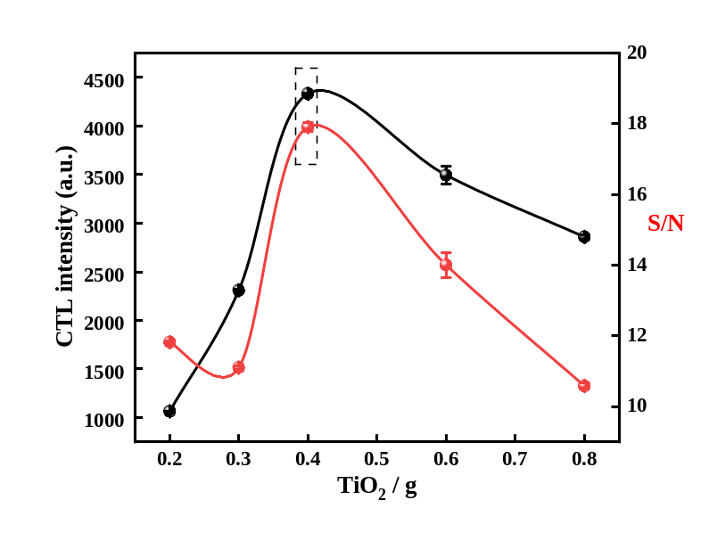
Fig.S1 The condition optimization of TiO₂ load volume.
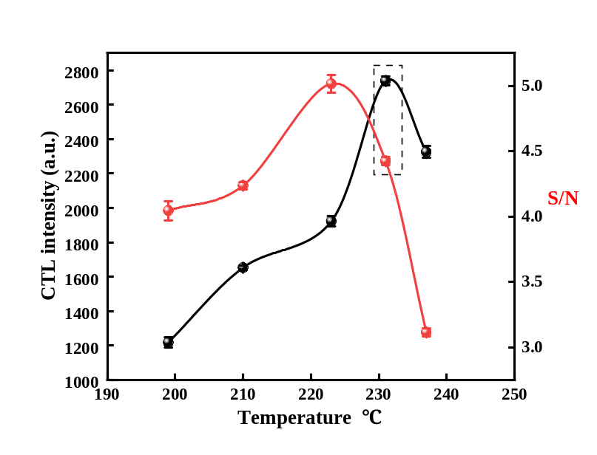
Fig.S2 The optimization of temperature
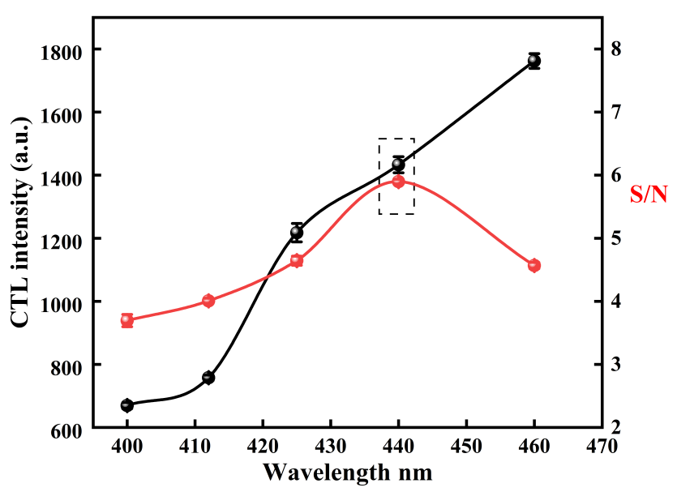
Fig.S3 The optimization of wave number
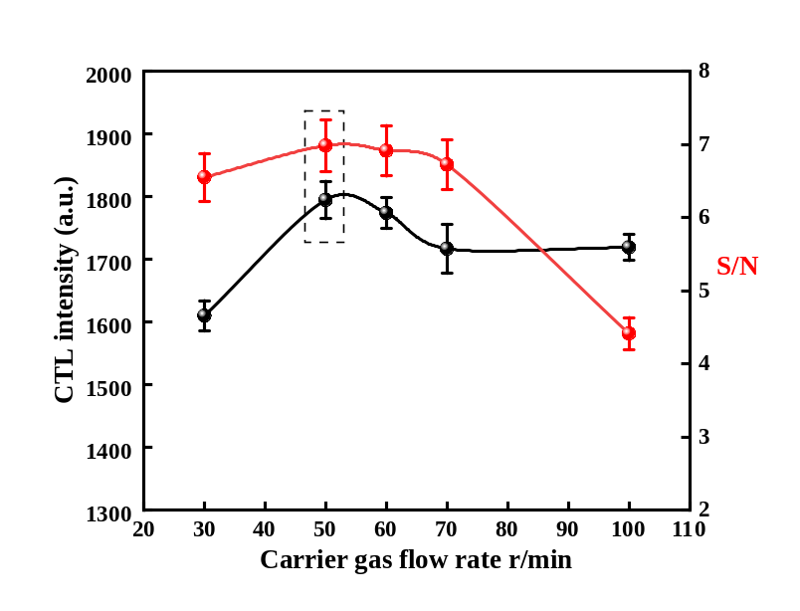
Fig.S4 The optimization of carrier gas flow rate.

