Table S1: Primer sequences used for qPCR experiments
Gene | Forward Primer | Reverse Primer
Rpl13⍺ | GCTGTGAGGGCATCAACATT | TTGGTGTTCATCCGCTTTCG
β-actin | GGCACCACACCTTCTACAATG | GGGGTGTTGAAGGTCTCAAAC
TMEM119 | TCCTTTTCCCAGAGCTGGTTC | GAAGAACCCTCAGCTTCCCC
TREM2 | AACTTCAGATCCTCACTGGACC | ATTGGATTGGCTCCTGGCTG

Figure S1: Nanoflow detection of TMEM119, TREM2, and standardized beads in rat plasma. A-B) Scatter plots of silicon beads (180 nm, 240 nm, 300 nm, 590 nm, and 880 nm) and 488-conjugated polystyrene beads (100 nm and 500 nm). C) Scatter plot of total plasma EVs. D-F) PBS in 647-, 405, and dual-gated channels. G-I) Plasma in 647-, 405-, and dual-gated channels. J-L) Plasma + TMEM119-647 antibody in 647-, 405-, and dual-gated channels. M-O) Plasma + TREM2-405 in 647-, 405-, and dual-gated channels. LALS, long angle light scatter; SALS, short angle light scatter.
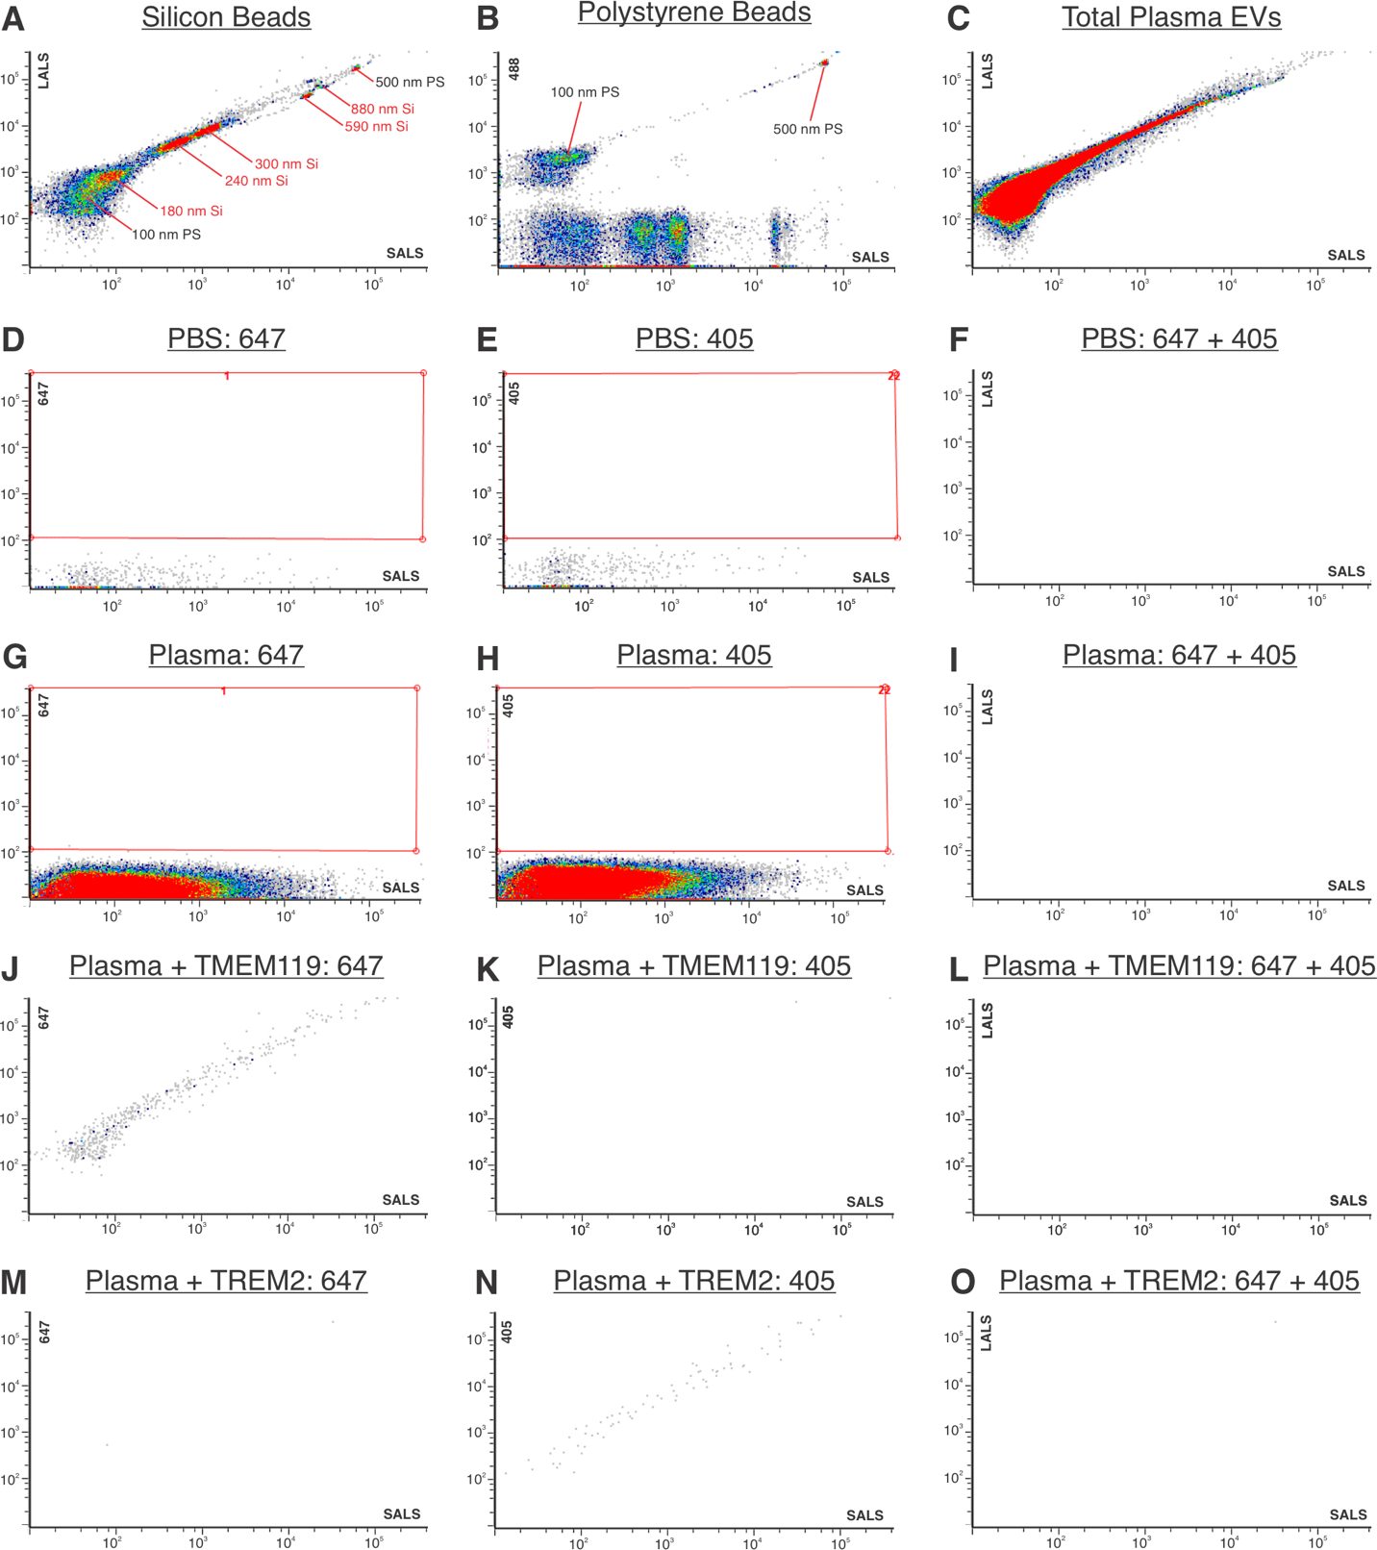
Figure S2: Hippocampus western blot imaging files
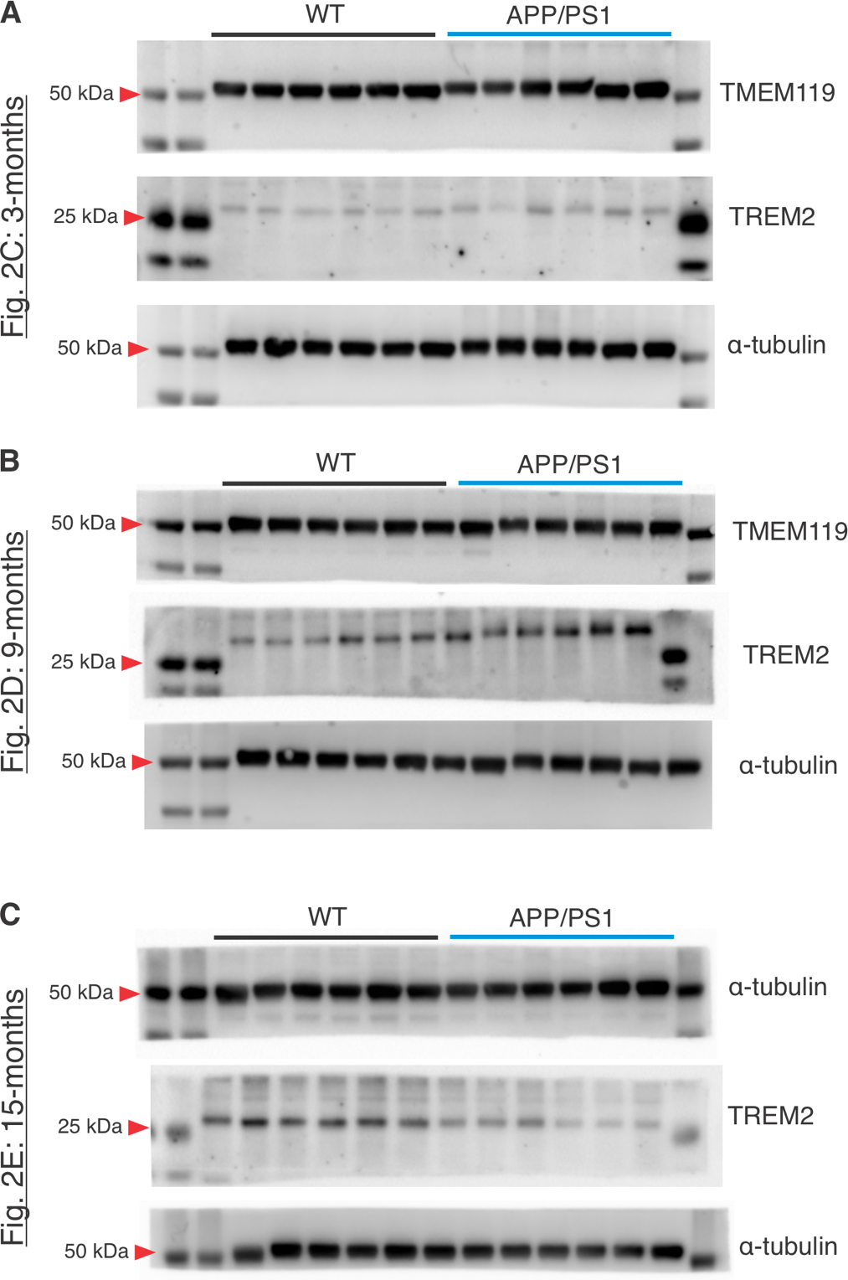

Figure S3: Corpus callosum western blot imaging files
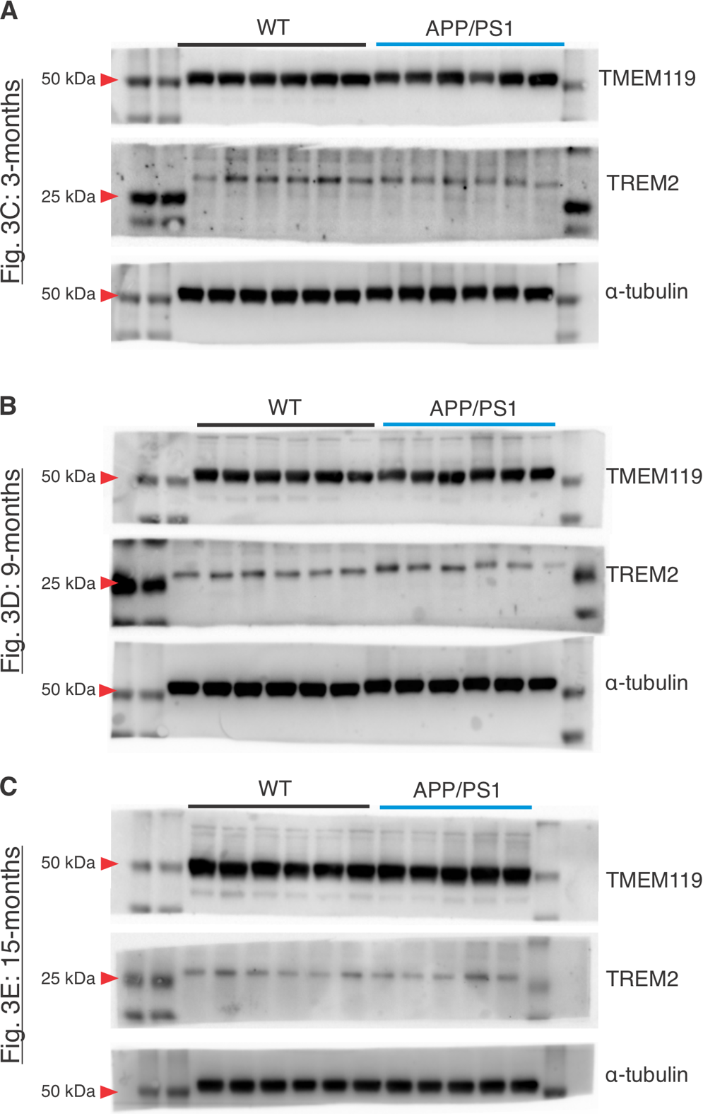

Figure S4: EV isolation western blot imaging files
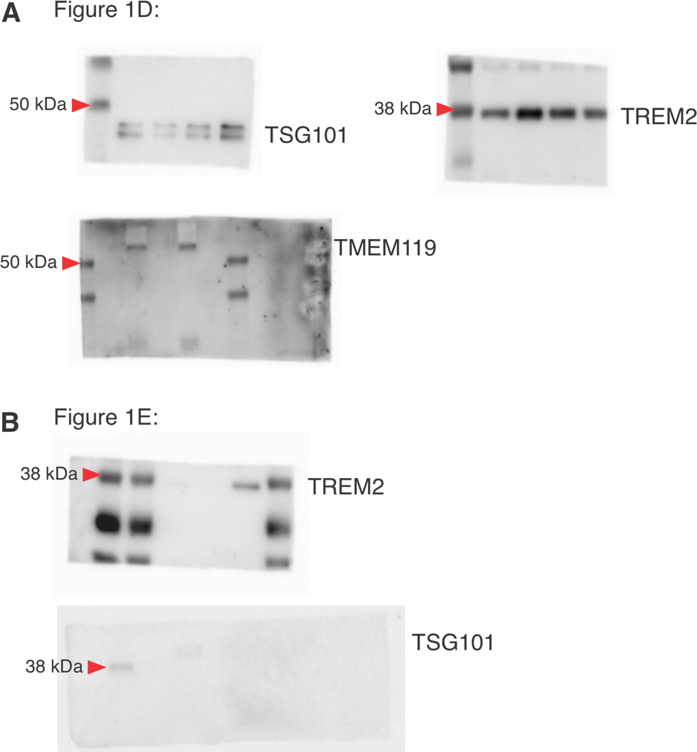

Figure S5: Discrimination of wildtype from APP/PS1 rats using TMEM119⁺/TREM2⁺ EVs. Receiver operating characteristic (ROC) curves of 3-, 9-, and 15-month rats and area under the curve (AUC) values.
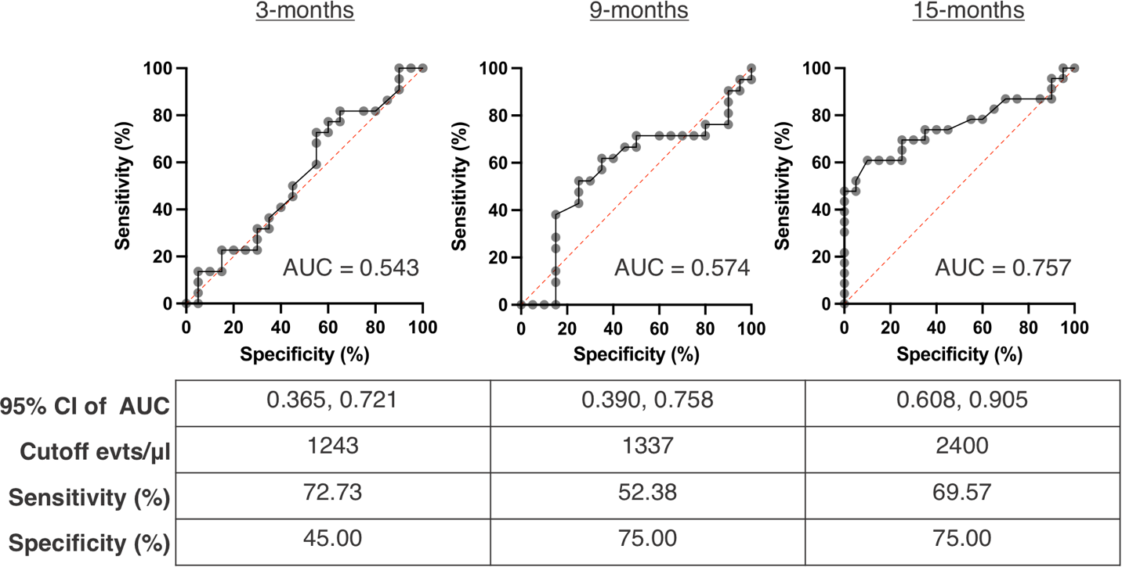

Figure S6: Immunohistochemistry of 82E1 for amyloid deposition in 3-, 9-, and 15-month APP/PS1 rats. A-C) Left panel images are 10 ✕ stitches of the hippocampus (scale bar indicates 500 µm) and right panel images are 20 ✕ captures of the outlined area (scale bar indicates 50 µm) in A) 3-month, B), 9-month, and C) 15-month APP/PS1 rats. D) Image taken at 40 ✕ magnification depicting amyloid plaque (scale bar indicates 25 µm).
