Supplementary Figure 1: IL-6 secretion into effluent media in control tubules (treated with baseline media only). A statistically significant increase (p<0.001) in IL-6 secretion was observed in flight samples compared with ground controls.

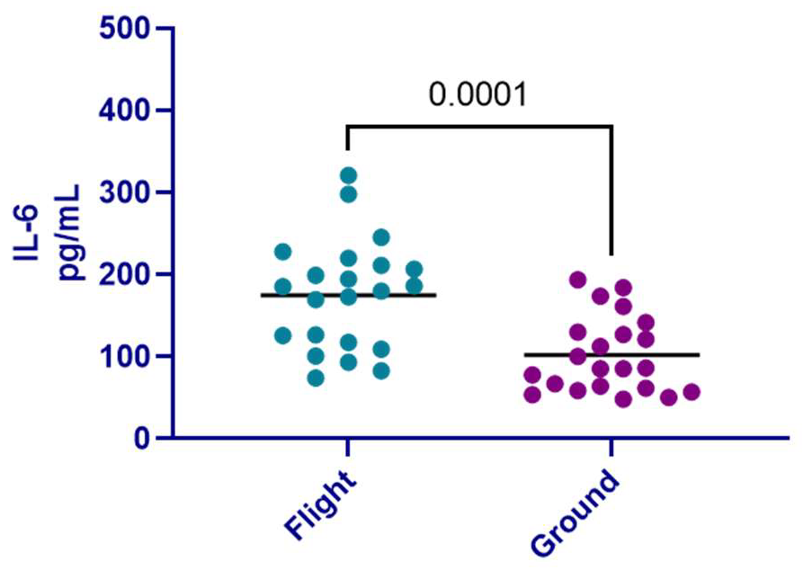

Supplementary Table 1. Kidney tissue donor demographics.

Donor ID | Sex | Age | Ethnicity | Cause of Death
PT5 | F | 47 | Hispanic | Stroke
PT6 | F | 45 | White | Stroke
PT7 | M | 49 | Hispanic | Stroke
PT8 | F | 51 | Black | Unknown
PT9 | M | 38 | White | Head trauma
PT10 | M | 49 | White | Anoxia

Supplementary Table 2. PT-MPS tubules with nominal (±20% of expected) maintenance (M) or test (T) media flow, listed by donor ID and flight condition. Nominal recovery is calculated as the percentage of tubules with nominal flow, indicating continuous media perfusion.

 |  | Chip housing |  |  |  |  |  |  |  | Nominal Recovery
Condition | Media | A | B | C | D | E | F | G | H | Nominal Recovery
Ground | M | 6/9 | 4/9 | 3/9 | 4/9 | 5/9 | 9/9 | 6/9 | 5/9 | 58%
Ground | T | 9/9 | 5/9 | 6/9 | 4/9 | 6/9 | 9/9 | 7/9 | 6/9 | 72%
Flight | M | 4/9 | 8/9 | 8/9 | 6/9 | 9/9 | 8/9 | 4/9 | 8/9 | 76%
Flight | T | 7/9 | 8/9 | 9/9 | 7/9 | 9/9 | 8/9 | 4/9 | 7/9 | 82%

Supplementary Table 3. Genes most significantly differentially expressed after 48-hour COM treatment vs. control media treatment in PT-MPS in the flight condition.

 | Flight COM vs. Flight Control DEGs
 | Upregulated |  |  |  | Downregulated
Gene |  | Log₂FC | Adj. p-value |  | Gene | Log₂FC | Adj. p-value
ADRB2 |  | 0.42 | 4.60E-02 |  | COL4A3BP | -0.13 | 4.60E-02
GPRIN3 |  | 0.41 | 2.90E-02 |  | HSPA14 | -0.18 | 2.90E-02
LTBP2 |  | 0.32 | 7.00E-03 |  | LINC01123 | -0.28 | 4.60E-02
STK17A |  | 0.17 | 7.00E-03 |  | ZNF439 | -0.30 | 1.90E-02
 |  |  |  |  | ZNF470 | -0.22 | 3.50E-02
Abbreviations: Log₂FC, Log₂ fold change; Adj p.value, adjusted p.value.

Supplementary Table 4. Cellular location and known functions of differentially expressed genes. (from Advaita iPathwayGuide 2024)

Gene | Description | Location | Possible function
ADRB2 | Adrenoceptor beta 2 | Membrane, lysosome, endosome | Signal transduction pathway associated with ADRB2 is calcium dependent and likely sensitive to elevated free Ca2+ ions.
GPRIN3 | NR subunit of Ca sensitive NMDA receptor | Plasma membrane | May assist in the maintenance of epithelial  phenotype in PTECs acting in opposition to inflammatory mediators like TGFβ
LTBP2 | Latent transforming growth factor beta binding protein 2 | Extracellular matrix protein | Multiple functions including establishment of protein localization to extracellular region which suggests a role in cell adhesion that may be disrupted by interactions with COM crystals.
STK17A | DAP kinase-related apoptosis-inducing protein kinase | Nucleus, cytoplasm | Positive regulation of apoptotic and reactive oxygen species metabolic processes.
CERT1 | Ceramide transporter 1 | Intracellular (Golgi), nucleus, ER | Lipid transfer protein that delivers ceramide from the endoplasmic reticulum to the Golgi apparatus (sphingomyelin synthesis).
HSPA14.2 | Heat shock protein | Cytoplasm | Chaperone protein which plays a role in cellular response to stress
LINC01123 | Long intergenic non-protein coding RNA | Nucleus, mitochondrion | Unknown
ZNF439 | Zinc finger  protein | Nucleus | Regulation of RNA biosynthetic  processes, RNA metabolic processes, transcription by RNA polymerase II
 | Zinc finger  protein | Nucleus | Regulation of RNA biosynthetic  processes, RNA metabolic processes, transcription by RNA polymerase II

