APPENDIX

Figure 12 shows Chikungunya electrophoresis

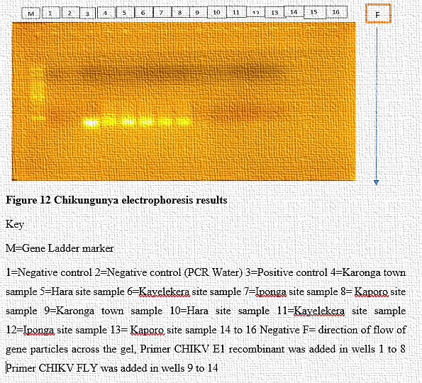

Figure 13 shows dengue electrophoresis
