Supplementary Materials

Epigenetic profiles of response to transcranial magnetic stimulation in treatment resistant depression.

Authors: Jan Dahrendorff¹, Kenneth Pages², Glenn Currier³, Md Mainul Hasan Sarker¹, Zachary Graham¹, Adetola Louis-Jacques⁴, Getachew Dagne⁵, Monica Uddin¹

Affiliations:
- Genomics Program, College of Public Health, University of South Florida, Tampa, FL, USA
- TMS of South Tampa, Tampa, FL, USA
- Department of Psychiatry and Behavioral Neurosciences, University of South Florida, Tampa, FL, USA
- Department of Obstetrics & Gynecology, College of Medicine, University of Florida, Gainesville, FL, USA
- College of Public Health, University of South Florida Tampa, Fl.

Corresponding Author:
Monica Uddin, Ph.D.
Genomics Program, College of Public Health
University of South Florida
Tampa, FL 33612
Email: monica43@usf.edu

Supplementary Figure 1 Bioinformatics Workflow

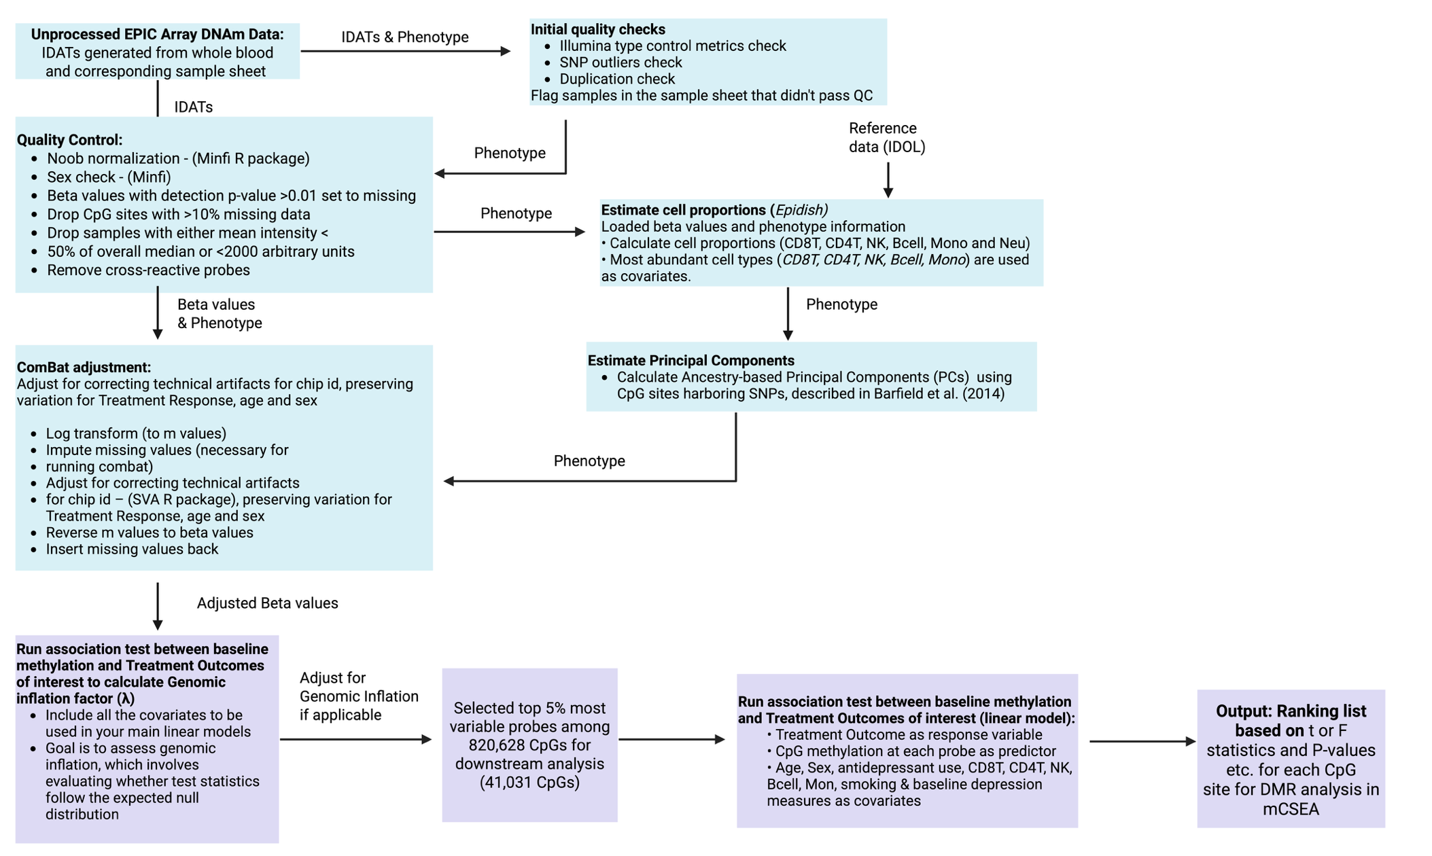

Supplementary Figure 2
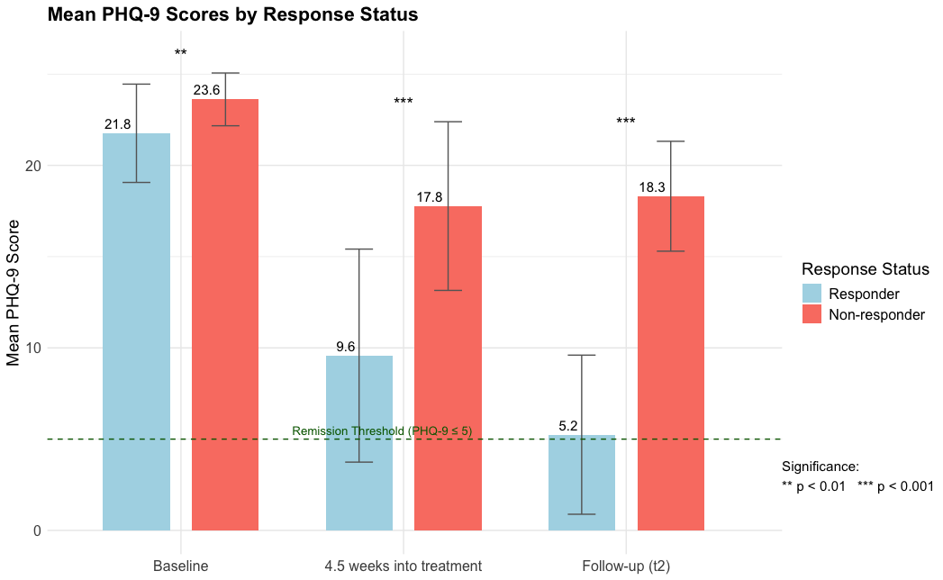
Fig. 2 Mean PHQ-9 Scores Over Time by Treatment Response Status. The bar plot displays the mean PHQ-9 scores at three timepoints: baseline (t0), approximately 4.5 weeks into treatment, and at follow-up (t2), stratified by treatment response status. Responders (blue bars) showed a greater reduction in PHQ-9 scores over time compared to non-responders (orange bars). Error bars represent standard errors of the mean (SE). The dashed green line marks the remission threshold (PHQ-9 ≤ 5), indicating a clinically significant reduction in depressive symptoms.

Supplemental Figure 3 Overlapping DMR in Treatment Outcomes identified in all 3 models
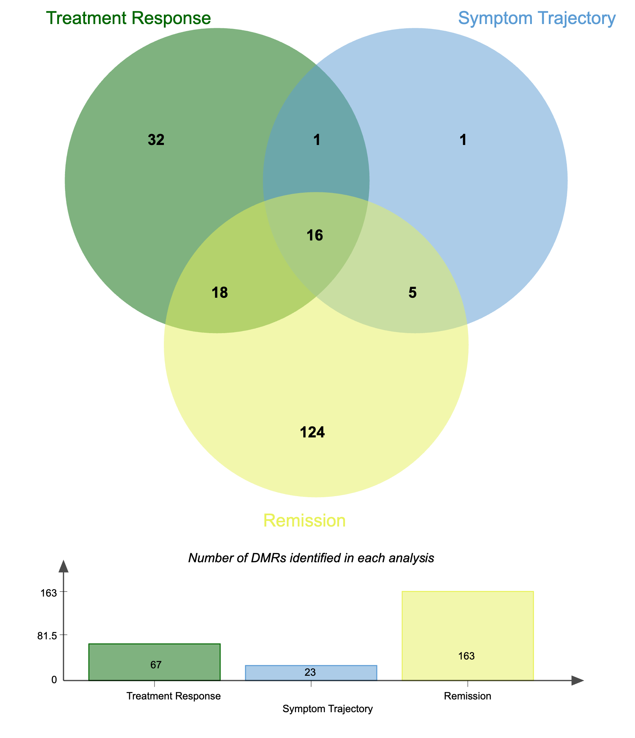
Sup. Fig. 3. Overlapping DMRs among treatment outcomes. Venn diagram showing the overlap in DMRs among our three treatment outcomes of interest; DMRs identified in treatment response are shown in green, DMRs identified in the symptom trajectory analysis are shown in blue while DMRs identified in the remission model are shown in yellow.

Code Availability
The R code implemented in this manuscript is available on GitHub.

