Supplementary Materials for

Breast imaging with ultra-low field MRI

Sheng Shen, Neha Koonjoo et al.

*Corresponding author. Email: msrosen@mgh.harvard.edu

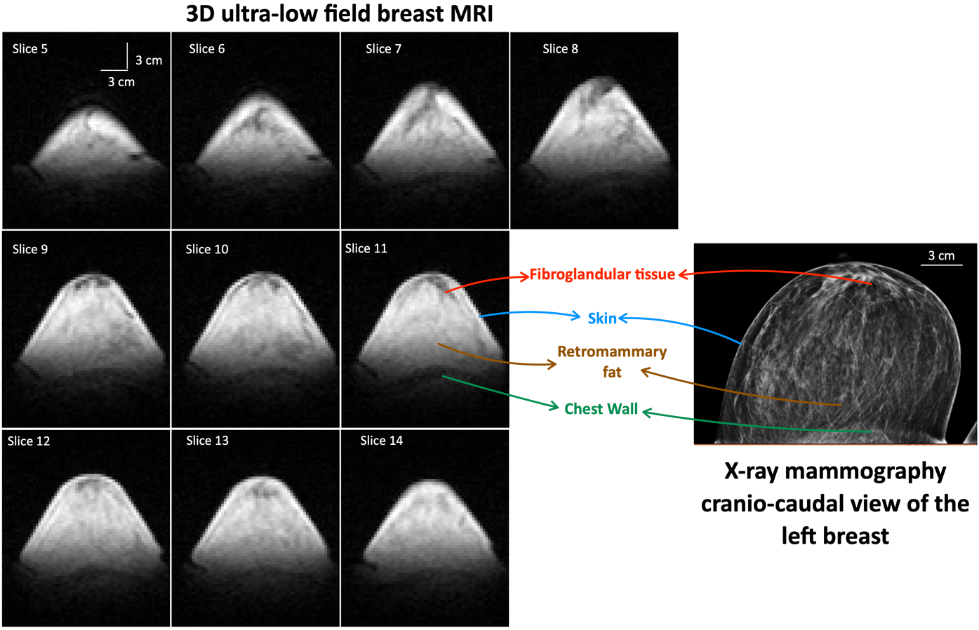

Fig. S1.
3D Ultra-low field breast MRI obtained at 6.5 mT and X-ray mammogram of a 42-year-old healthy woman with scattered fibroglandular tissue. On the left, 10 out of 21 representative sequential axial bSSFP-weighted images of the left breast are shown. No contrast agent was administered. Data was acquired in approximately 21 minutes with a spatial resolution of 3 mm × 3 mm × 8 mm. Vertical and horizontal scale bars in white are 3 cm each and are shown in slice 5. Slice 11 is a representative slice, labelled by a breast radiologist, where skin, fibroglandular tissue, retromammary fat and chest wall were visualized. On the right, the craniocaudal view of the mammogram is shown alongside the breast radiologist’s labels. The same four features were also identified on the mammogram. In the mammogram, the horizontal scale bar in white is 3 cm.

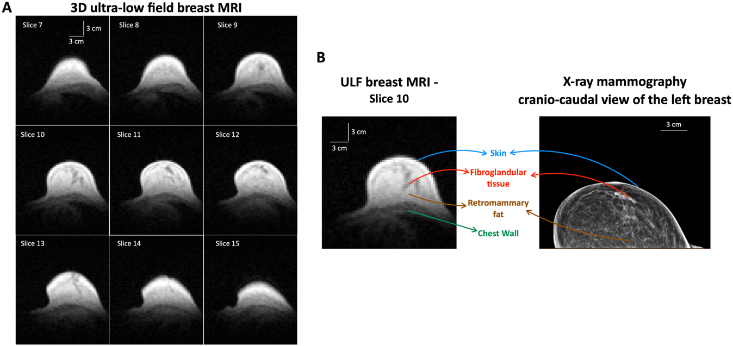
Fig. S2.
3D Ultra-low field breast MRI obtained at 6.5 mT and X-ray mammogram of a 67-year-old healthy woman with scattered fibroglandular tissue (FGT). (A) 9 out of 21 representative sequential axial bSSFP-weighted images of the left breast are shown. No contrast agent was administered. Data was acquired in approximately 21 minutes with a spatial resolution of 3 mm × 3 mm × 8 mm. Vertical and horizontal scale bars in white are 3 cm each and are shown in slice 7. (B) A representative slice of the 3D ULF MRI, slice 10, and the craniocaudal view of the mammogram were labelled by a breast radiologist. The features visualized in this study were: skin, FGT, retromammary fat, and chest wall. Vertical and horizontal scale bars in white are 3 cm each.

