Figure S1. Fitting of several continuous theoretical distributions to the empirical distribution of aboveground biomass data
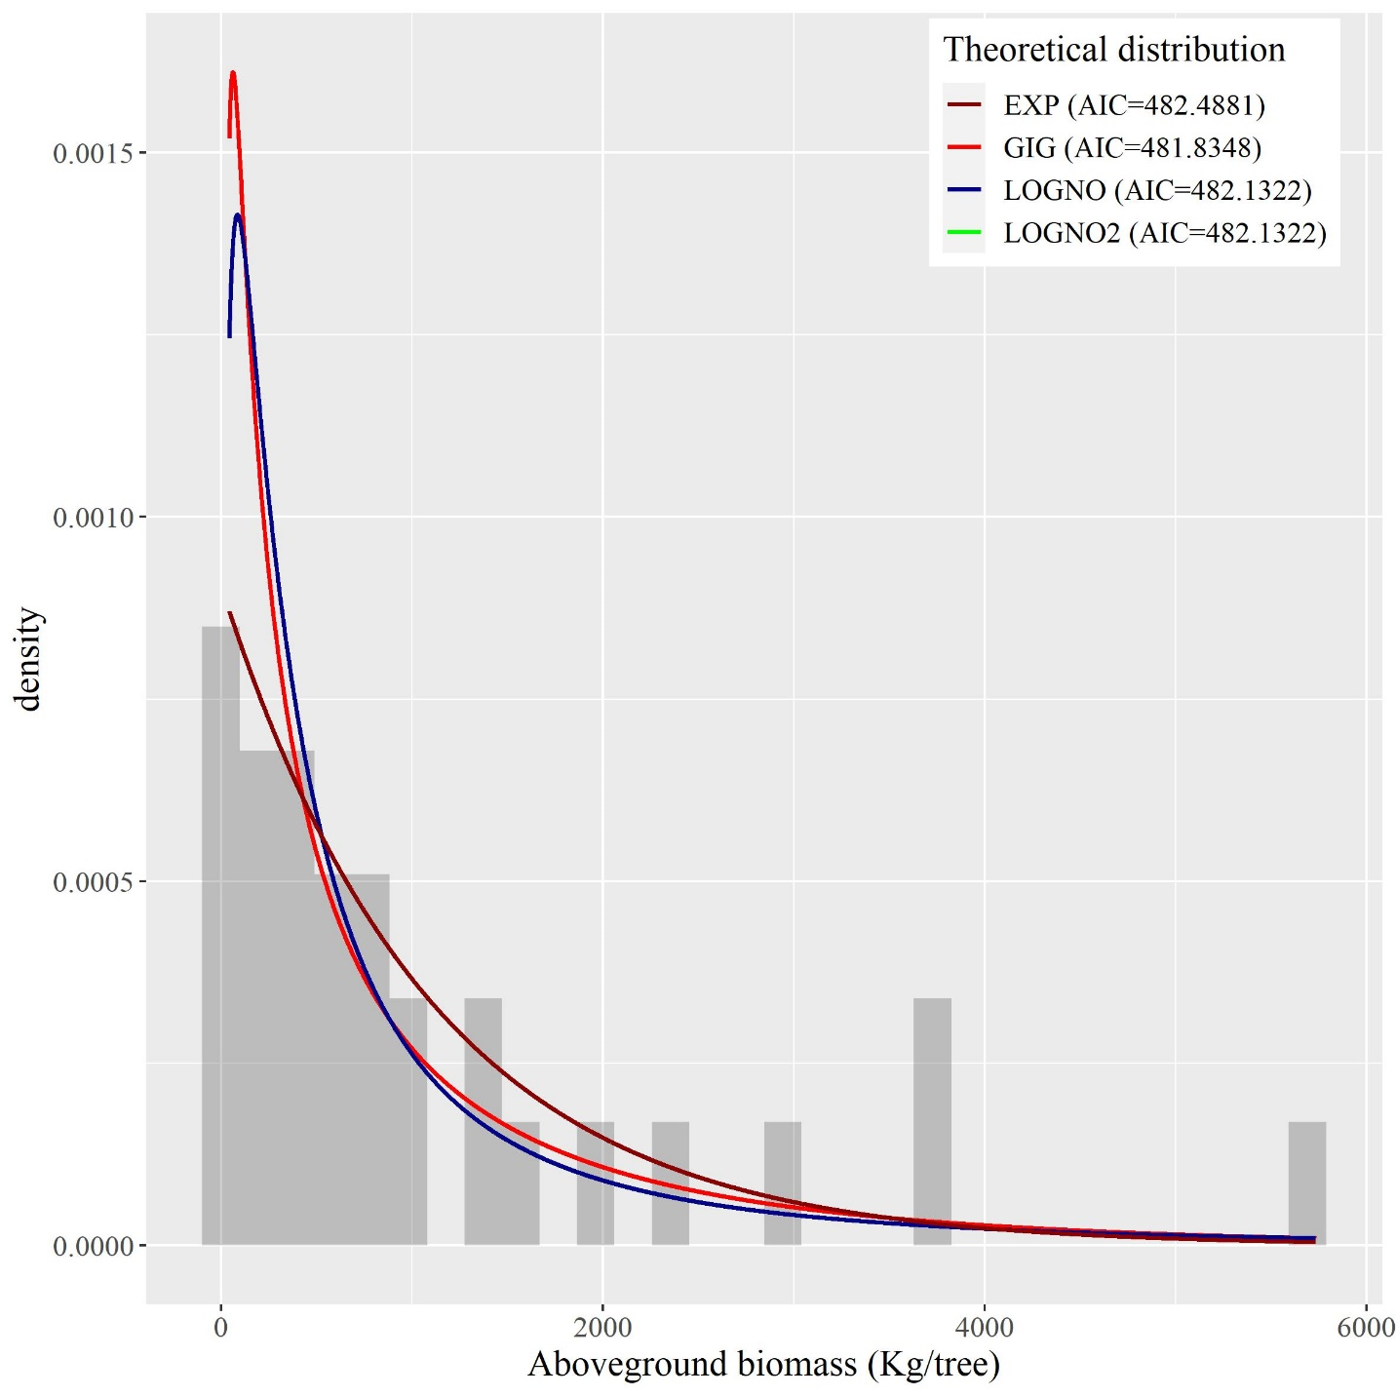

Figure S2. Fitting of several continuous theoretical distributions to the empirical distribution of belowground biomass data

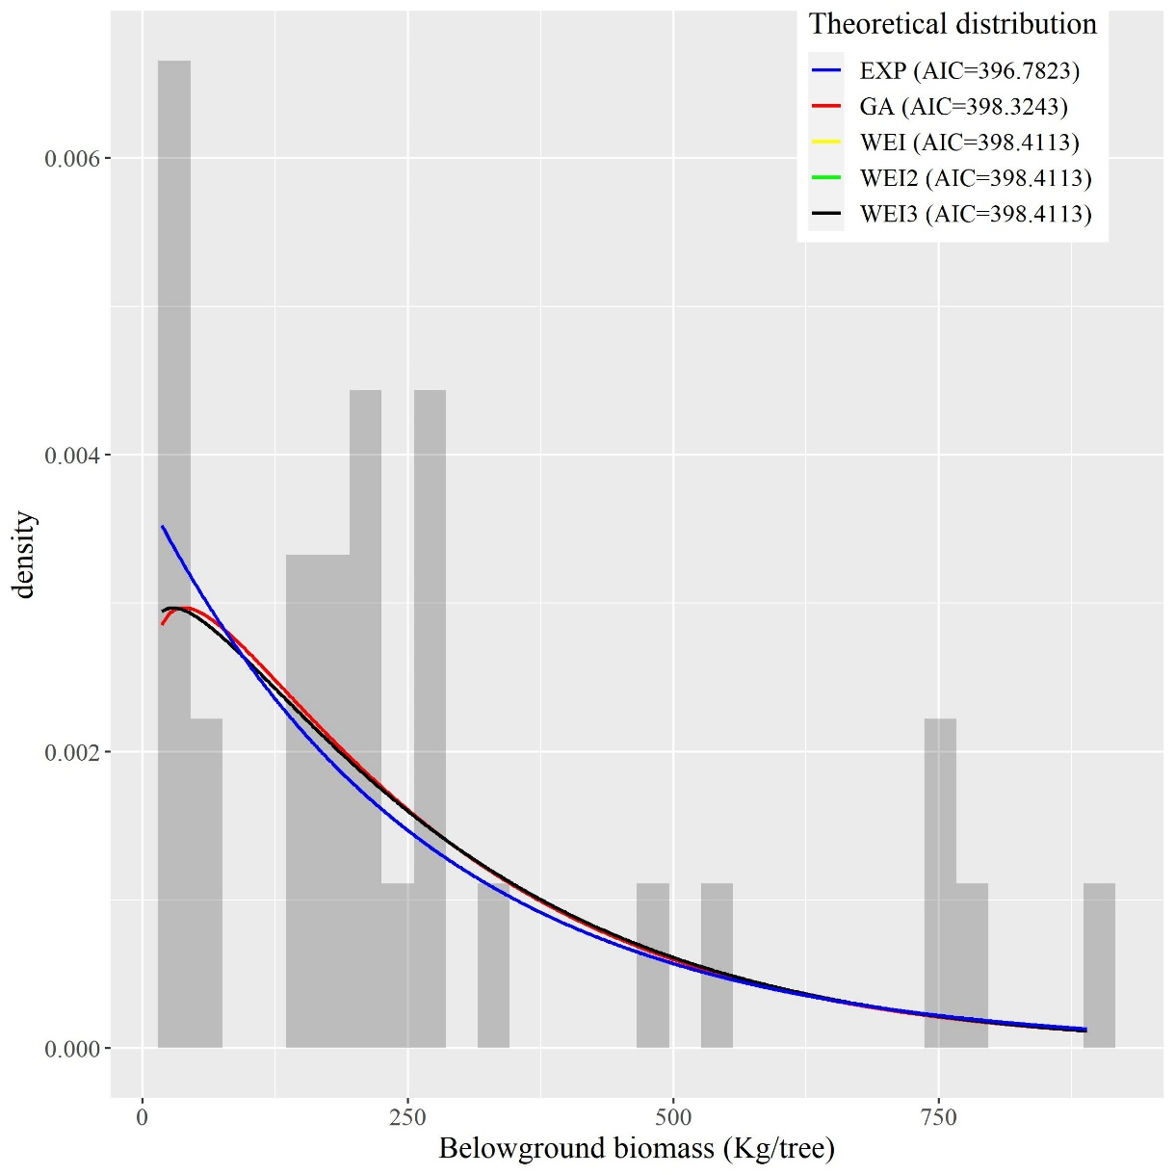

Figure S3. Fitting of several continuous theoretical distributions to the empirical distribution of tree total biomass data

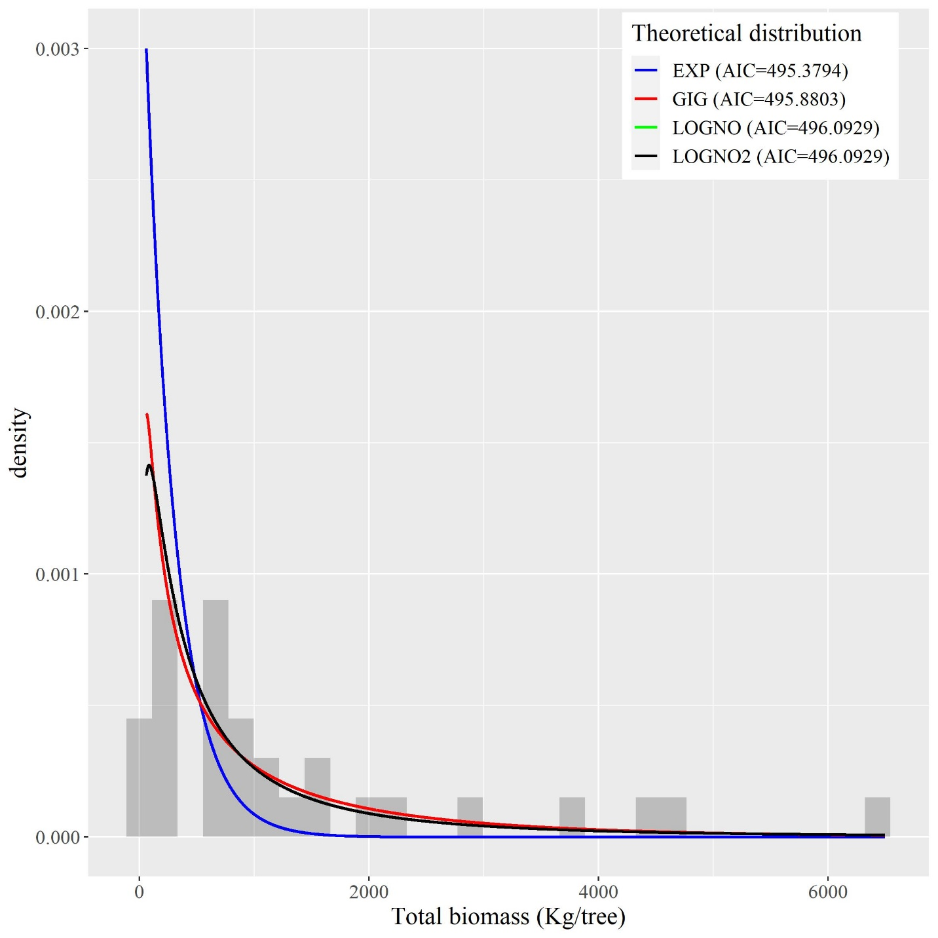
Figure S4. Fitting of several continuous theoretical distributions to the empirical distribution of carbon data
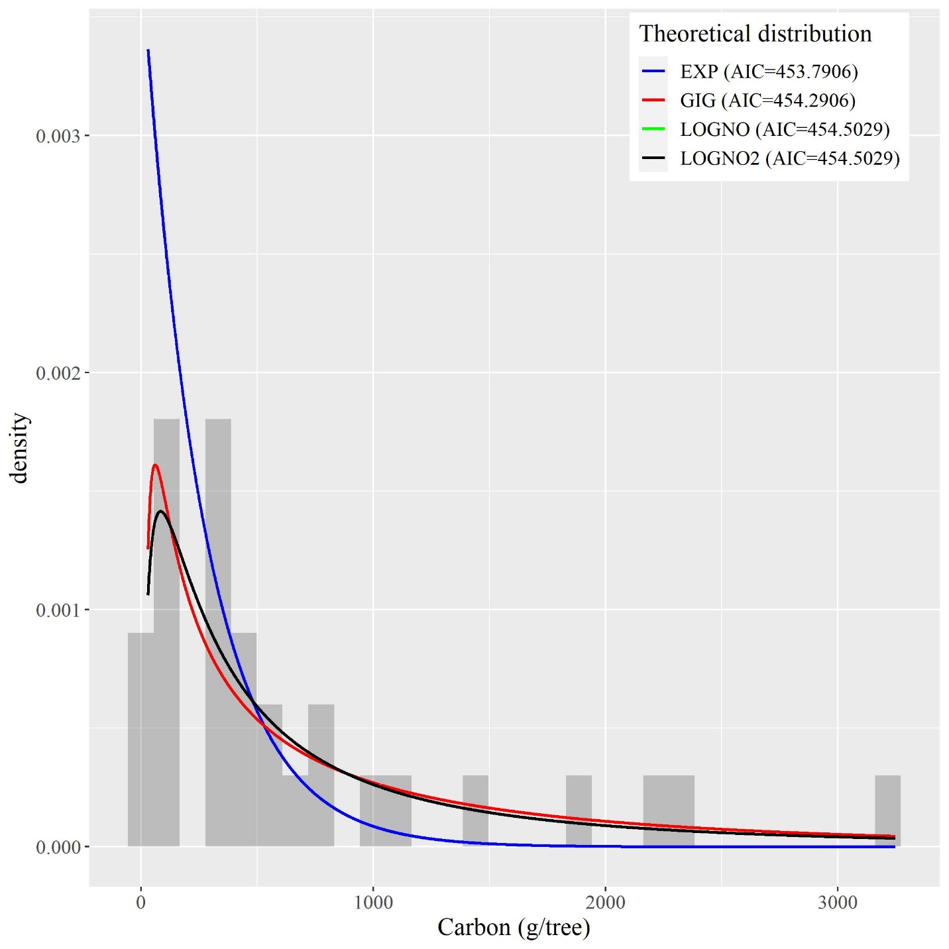

Figure S5. Fitting of several continuous theoretical distributions to the empirical distribution of Root shoot ratio data
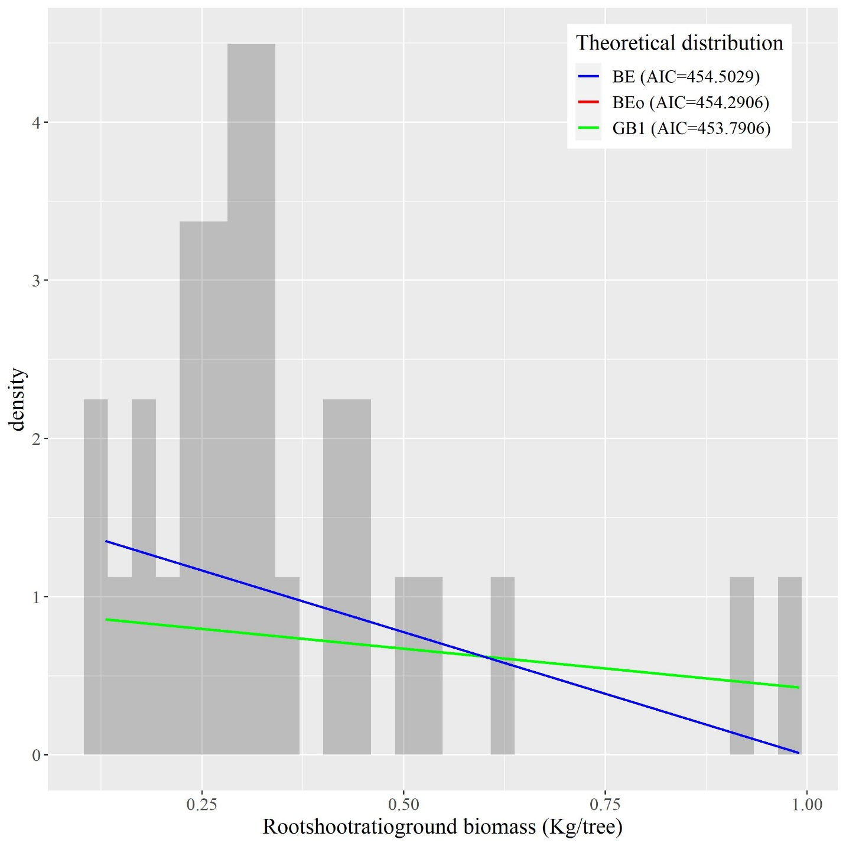
Figure S6. Above ground biomass model diagnostic
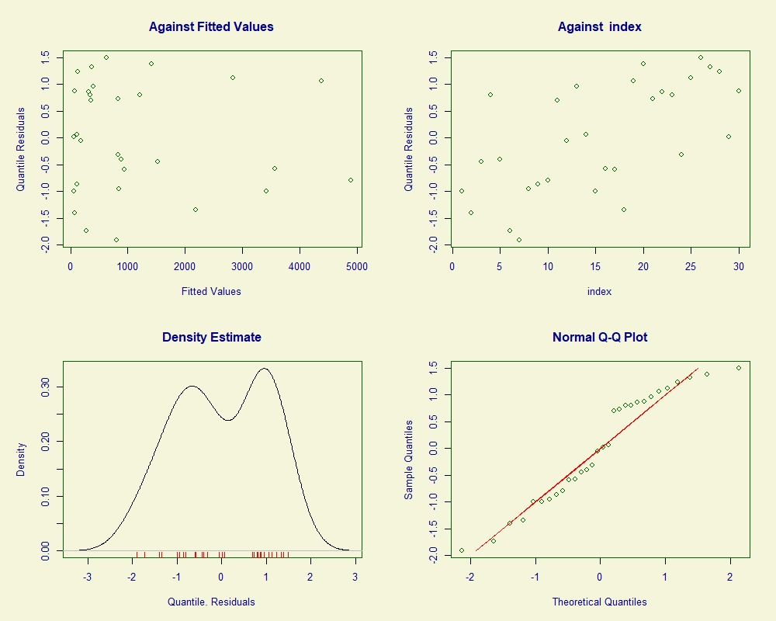
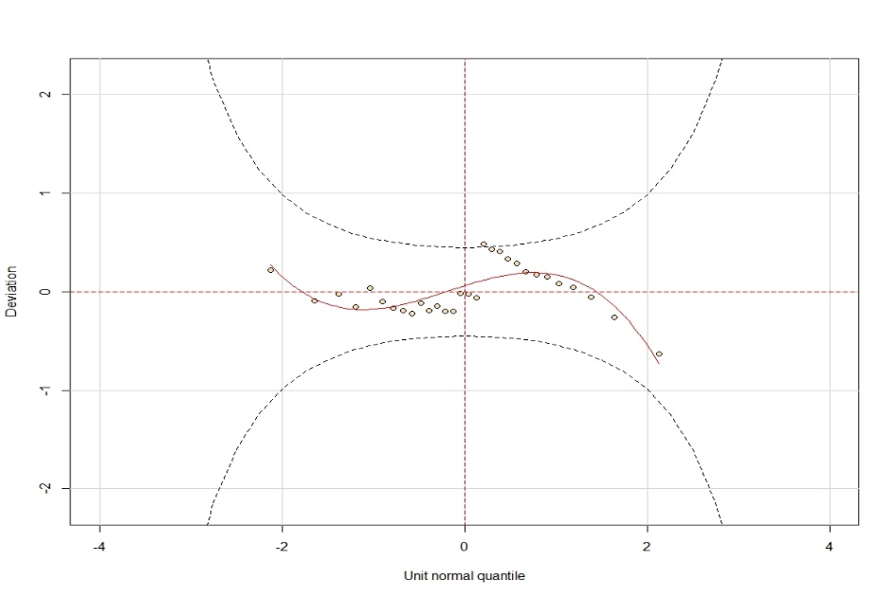
*******************************************************
Summary of the Quantile Residuals
mean = 0.000646407
variance = 1.048418
coef. of skewness = -0.1650785
coef. of kurtosis = 1.632525
Filliben correlation coefficient = 0.9714519
*******************************************************
The hypothesis of normality is rejected if the Filliben correlation coefficient is les than 0.984
Figure S7. Below ground biomass model diagnostic
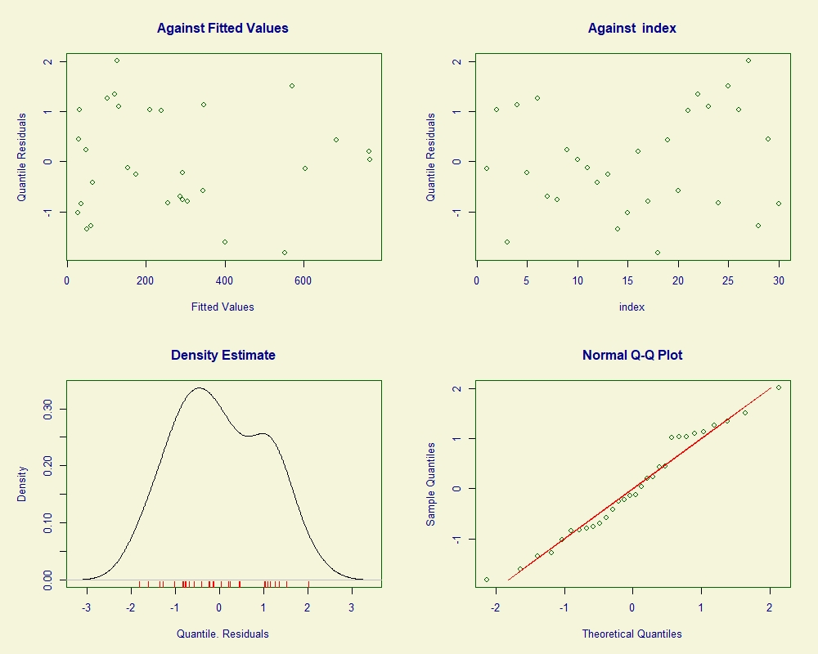

******************************************************************
Summary of the Quantile Residuals
mean = -0.0005359334
variance = 1.03431
coef. of skewness = 0.1110077
coef. of kurtosis = 1.888583
Filliben correlation coefficient = 0.9866691
******************************************************************

The hypothesis of normality is rejected if the Filliben correlation coefficient is les than 0.984
Figure S8. Total biomass model diagnostic
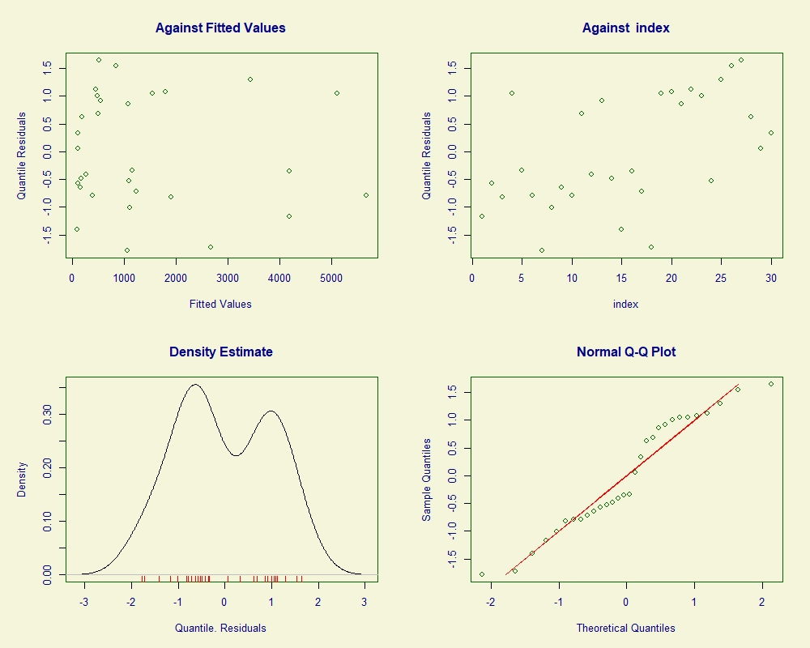
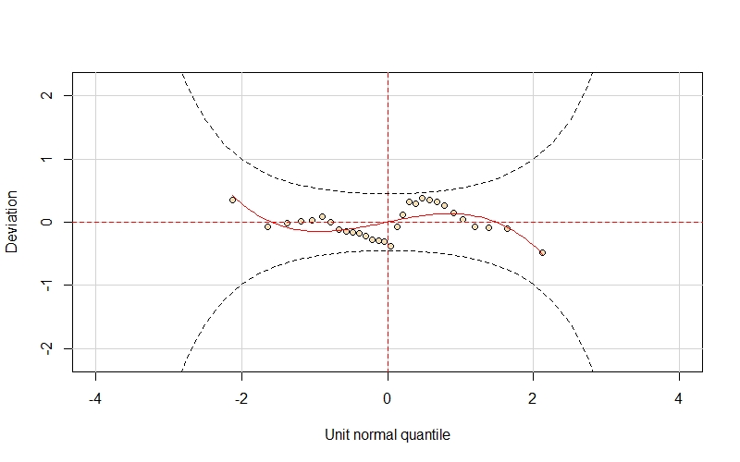
******************************************************************
Summary of the Quantile Residuals
mean = -0.008658969
variance = 1.017509
coef. of skewness = 0.005983705
coef. of kurtosis = 1.653998
Filliben correlation coefficient = 0.9724931
******************************************************************
The hypothesis of normality is rejected if the Filliben correlation coefficient is les than 0.984
Figure S9. Carbon model diagnostic
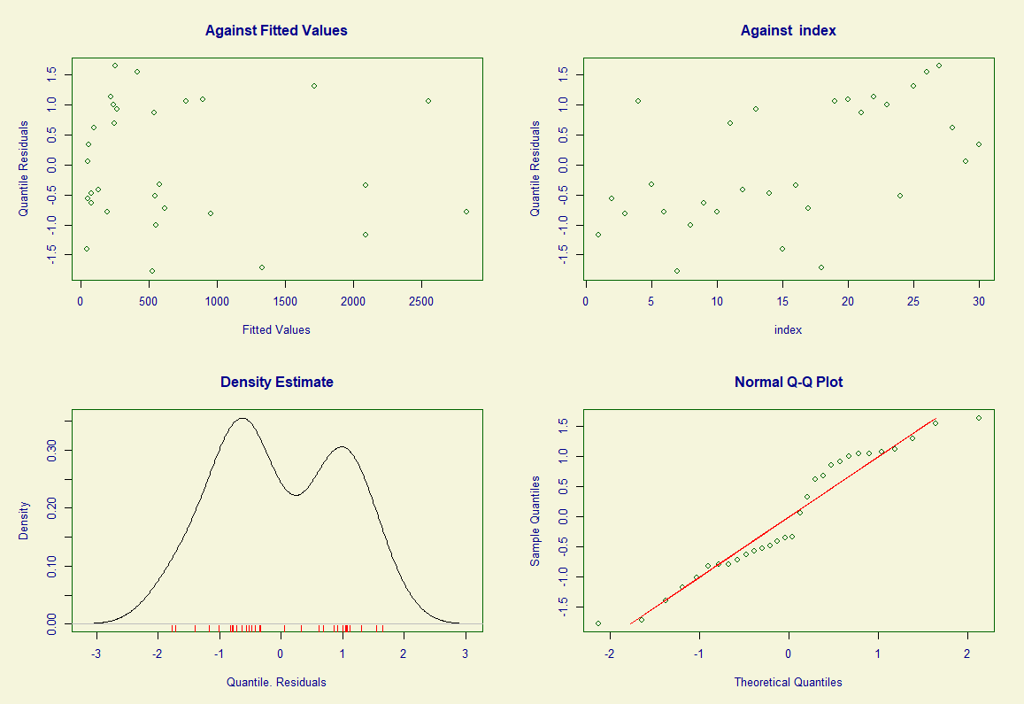
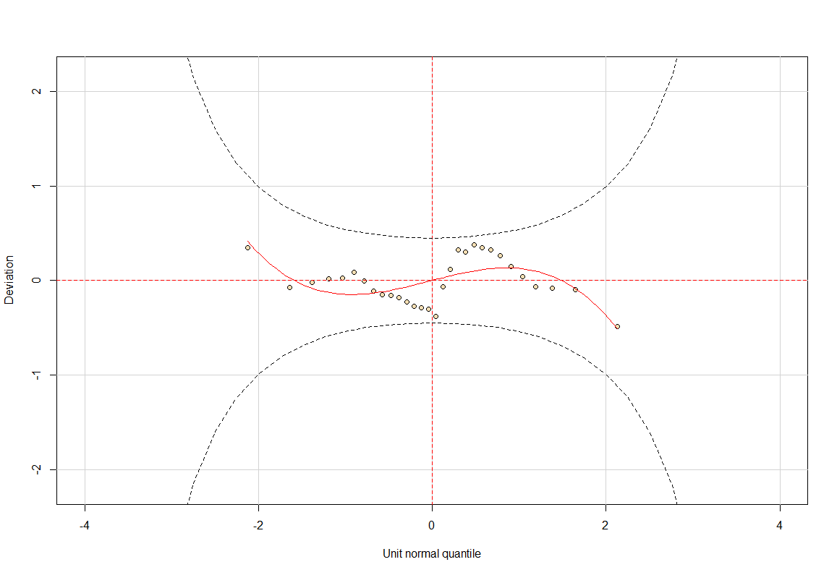
******************************************************************
Summary of the Quantile Residuals
mean = -0.008657266
variance = 1.017632
coef. of skewness = 0.006148252
coef. of kurtosis = 1.653948
Filliben correlation coefficient = 0.9724957
******************************************************************
The hypothesis of normality is rejected if the Filliben correlation coefficient is les than 0.984
Figure S10. Root shoot ratio model diagnostic
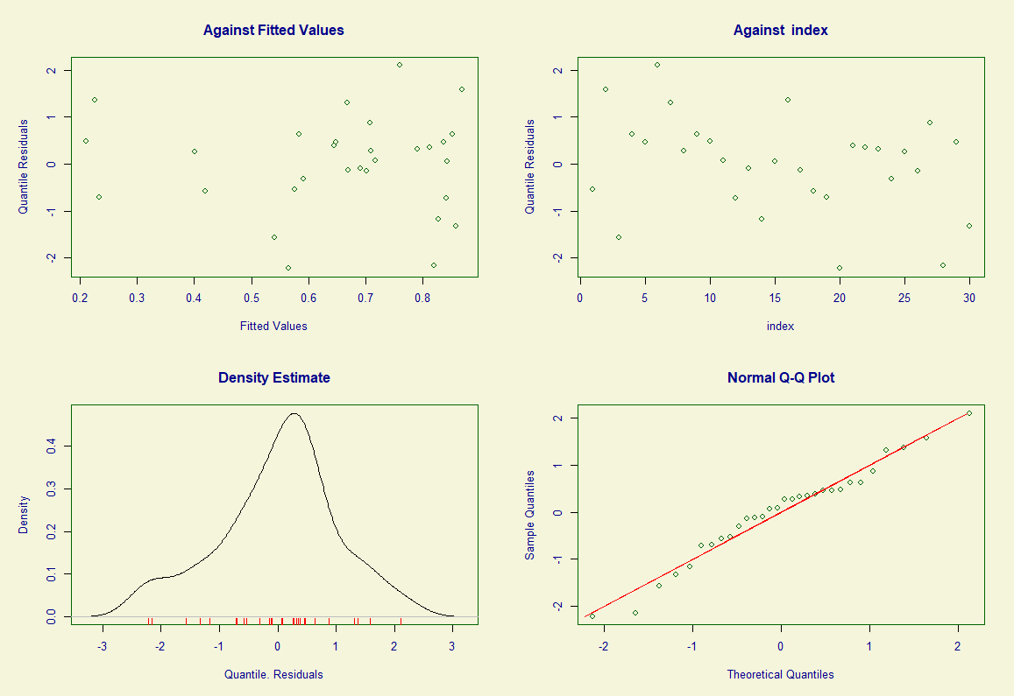
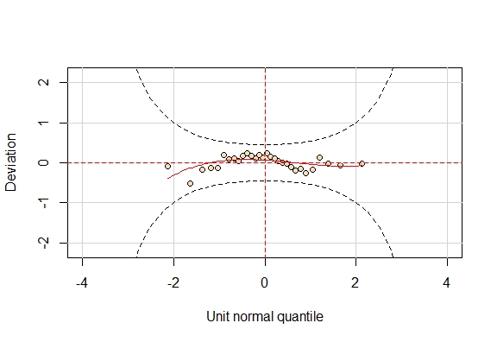
******************************************************************
Summary of the Quantile Residuals
mean = -1.911591e-05
variance = 1.040061
coef. of skewness = -0.3190016
coef. of kurtosis = 2.802528
Filliben correlation coefficient = 0.9858701
The hypothesis of normality is rejected if the Filliben correlation coefficient is les than 0.984

