Supplementary data
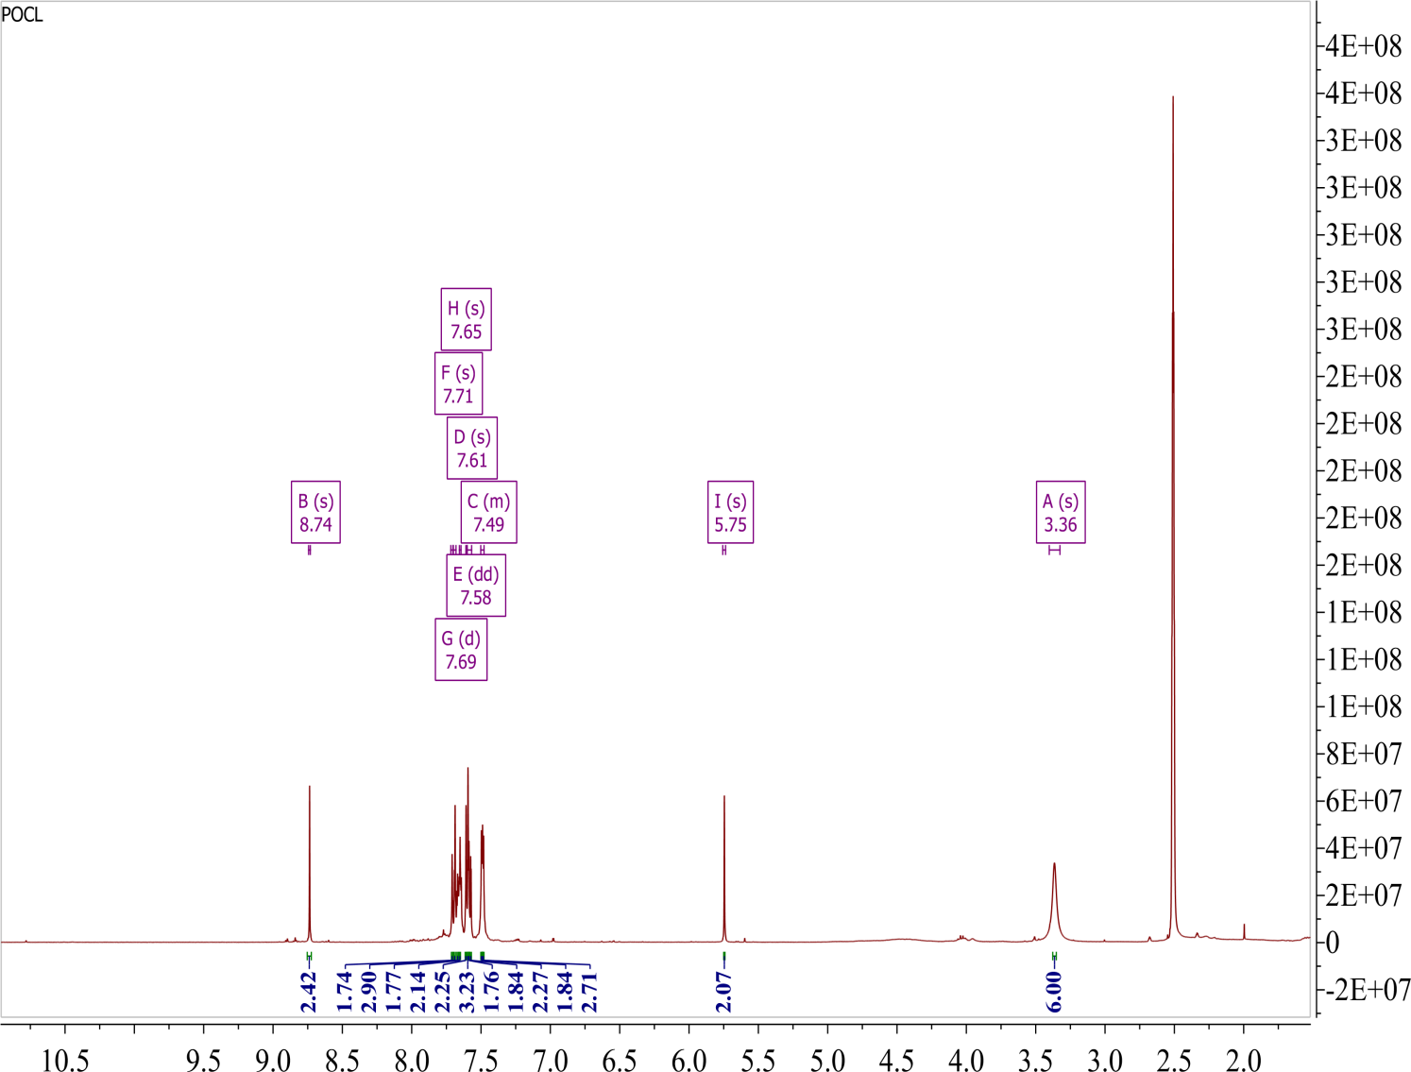
Figure S1 ¹H NMR showing attachment of sulfonyl chloride to oxacalix[4]arene and formation of DCOC
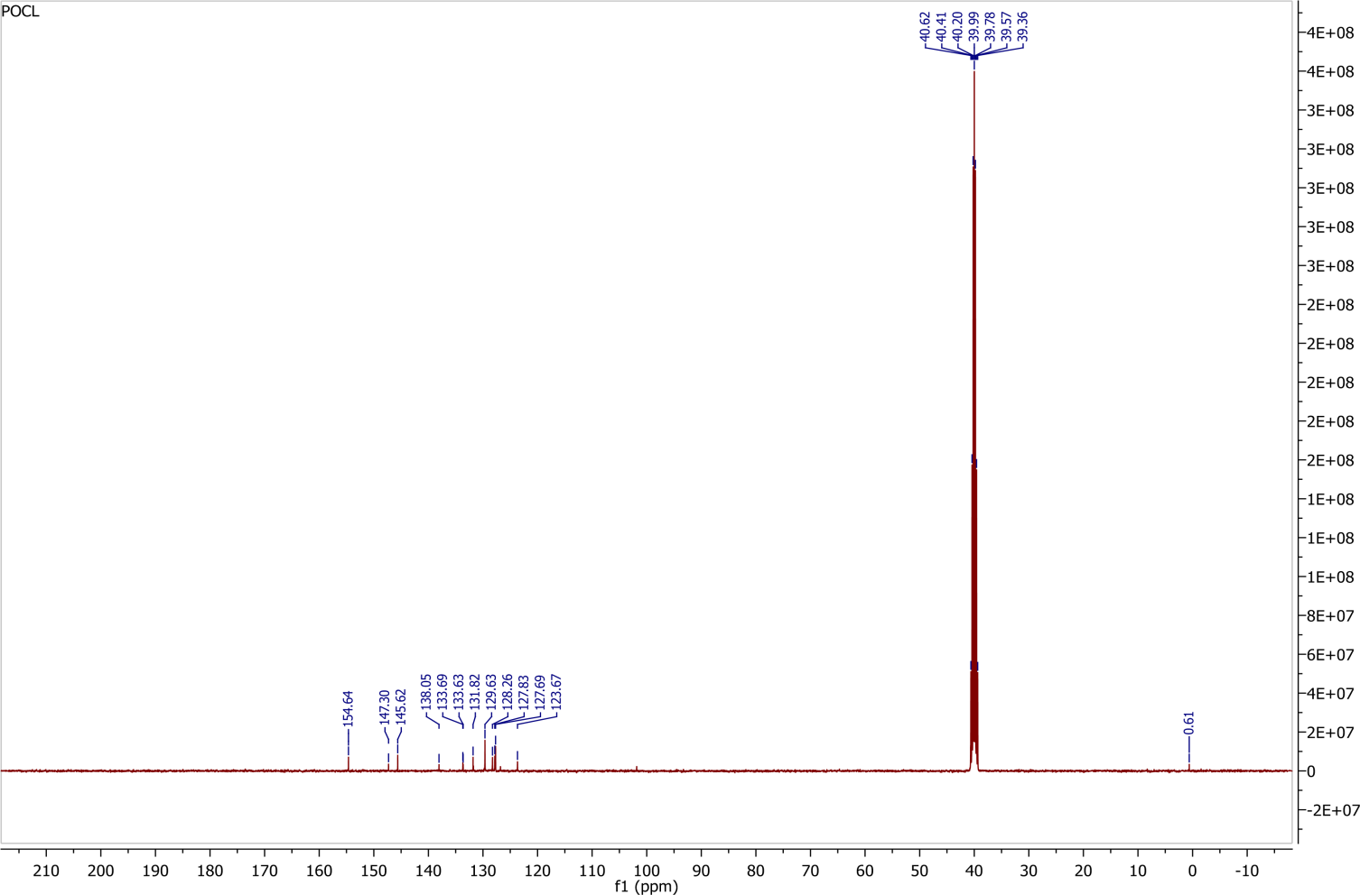
Figure S2 ¹³C NMR of DCOC

Figure S3 Competitive emission spectra of DCOC with 2,4- DNT in presence of other explosives (A= DCOC+ 2,4- DNT, B= DCOC+ 1,3- DNB, C= DCOC+ 2,3- DNT, D= 2,4- DNT, E= DCOC+ 2,6-DNT, F= DCOC+ 4-NP, G= DCOC+ 4-NT, H= DCOC+ PA)
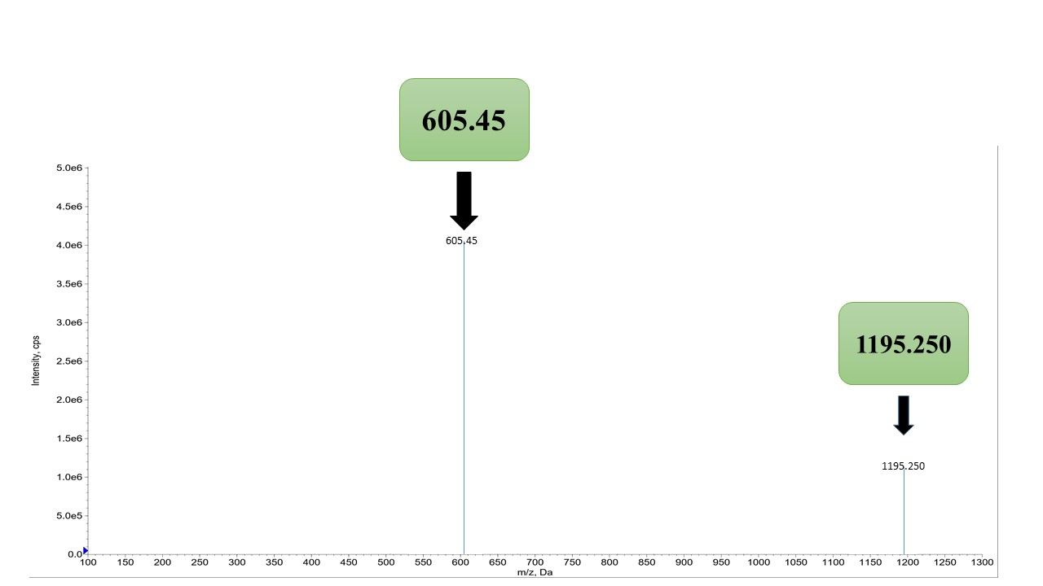
Figure S4 MS/MS of DCOC and 2,4-DNT complex

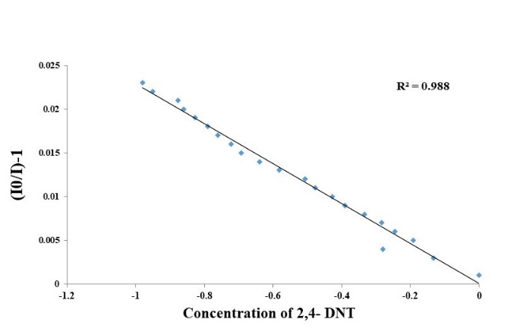
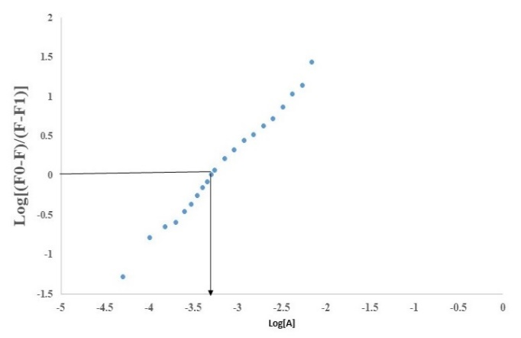
(B)
(A)

Figure S5 (A) Linear regression fit (double-logarithmic plot) of the titration data as a function of DCOC concentration (B) Stern-Volmer plot of the quenching of DCOC by 2,4-DNT (mM) in ACN

