Figure 1. Proportions of Students with BMI>85th %ile Attaining Individual Target Behaviors After One Year (N=55)

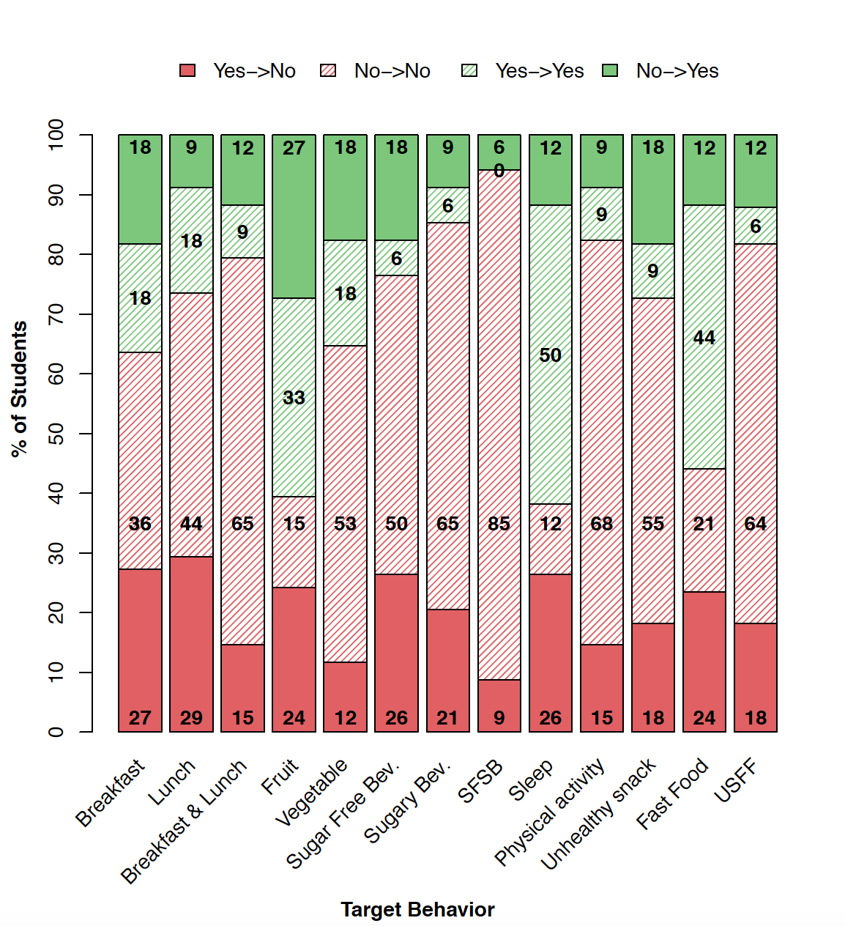

Sugar-Free Bev. –Sugar-free beverage consumption; Sugary Bev. –Sugary beverage consumption; SFSB –Sugar-free beverage and sugary beverage consumption; USFF – Unhealthy snack food and fast food consumption. Note: Target behaviors attainment standards according to American Academy of Pediatrics Expert Committee, NHLBI sleep recommendations, Physical Activity Guidelines for Americans 2nd Edition,, and USDA MyPlate guidelines.

Table 1. Target Behavior Changes Following Program Participation Including Multiple Imputation (MI) Results (N=76)

 | Beta  (MI) | 95% CI  (MI) | P-value  (MI)
Composite Score* | 0.09  (-0.13) | (-0.28, 0.46)  (-0.54-0.28) | 0.632  (0.520)
BMI Z-score | 0.01  (-0.04) | (-0.04, 0.05)  (-0.45-0.37) | 0.799  (0.838)
 | OR | 95% CI | P-value
Breakfast | 1.06  (0.49) | (0.38-2.99)  (0.2-1.22) | 0.914  (0.127)
Lunch | 0.18  (0.14) | (0.06-0.52)  (0.05-0.37) | 0.001  (6.5E-05)
Breakfast & Lunch | 0.7  (0.46) | (0.25-1.97)  (0.18-1.17) | 0.5  (0.102)
Fruit | 1.16  (0.65) | (0.56-2.42)  (0.32-1.28) | 0.688  (0.211)
Vegetable | 1.95  (2.25) | (0.72-5.27)  (0.85-5.93) | 0.186  (0.101)
Sugar Free Beverage | 1.25  (1.16) | (0.48-3.21)  (0.48-2.79) | 0.647  (0.741)
Sugary Beverage | 0.86  (1.37) | (0.32-2.3)  (0.56-3.39) | 0.756  (0.487)
Sugar-Free and Sugary Beverage | 1.49  (1.45) | (0.41-5.44)  (0.38-5.47) | 0.544  (0.584)
Sleep | 0.74  (0.70) | (0.27-2.02)  (0.26-1.84) | 0.558  (0.465)
Physical activity | 1.2  (0.79) | (0.27-2.02)  (0.28-2.22) | 0.756  (0.647)
Unhealthy snack | 1.32  (1.59) | (0.55-3.18)  (0.68-3.73) | 0.54  (0.284)
Fast Food | 0.5  (0.49) | (0.21-1.22)  (0.21-1.15) | 0.13  (0.101)
Unhealthy Snack and Fast Food | 0.77  (0.91) | (0.29-2.01)  (0.32-2.63) | 0.593  (0.867)
*Composite score is the score of 7 target variables

Table 2. Target behavior change for Low (<75%) and High (>75%) Afterschool Attendance with BMI>85th%ile (N=55)

 | Low afterschool attendance |  |  | High afterschool attendance |  |  | Interaction
 | Beta | 95% CI | P | Beta | 95% CI | P | P
Composite Score | -0.18 | (-0.7-0.33) | 0.478 | 0.03 | (-0.84-0.91) | 0.938 | 0.67
BMI.Z-score | -0.01 | (-0.07-0.04) | 0.676 | -0.01 | (-0.11-0.08) | 0.822 | 0.989
 | OR | 95% CI | P | OR | 95% CI | P | P
Breakfast | 0.67 | (0.16-2.72) | 0.571 | 0.32 | (0.03-3.31) | 0.342 | 0.602
Lunch | 0.36 | (0.08-1.67) | 0.190 | 0.00 | (0-0.05) | 0.002 | 0.007
Breakfast & Lunch | 0.86 | (0.21-3.5) | 0.833 | 0.15 | (0.01-2.43) | 0.181 | 0.27
Fruit | 0.92 | (0.35-2.41) | 0.859 | 5.93 | (0.85-41.46) | 0.073 | 0.092
Vegetable | 1.51 | (0.38-6.02) | 0.558 | 1.62 | (0.11-23.02) | 0.724 | 0.965
Sugar Free Beverage | 1.09 | (0.31-3.81) | 0.889 | 0.63 | (0.07-5.47) | 0.677 | 0.666
Sugary Beverage | 0.29 | (0.07-1.14) | 0.076 | 2.14 | (0.23-19.58) | 0.502 | 0.131
Sugar-Free and Sugary Beverage | 0.59 | (0.1-3.67) | 0.573 | 1.22 | (0.06-26.94) | 0.900 | 0.693
Sleep | 0.73 | (0.2-2.61) | 0.628 | 0.23 | (0.03-1.75) | 0.156 | 0.344
Physical activity | 0.90 | (0.21-3.84) | 0.892 | 1.70 | (0.16-18.42) | 0.664 | 0.661
Unhealthy snack | 0.63 | (0.19-2.05) | 0.443 | 1.81 | (0.24-13.61) | 0.563 | 0.374
Fast Food | 0.71 | (0.21-2.42) | 0.579 | 0.49 | (0.08-3.13) | 0.450 | 0.747
Unhealthy Snack and Fast Food | 0.49 | (0.15-1.65) | 0.252 | 0.85 | (0.07-9.94) | 0.896 | 0.698

Table 3. Association Between Target Behavior Attainment as Exposure and BMI Z-score with BMI>85th%ile (N=55)

 | Beta | 95% CI | P
Composite Score | -0.009 | (-0.027, 0.009) | 0.338
Breakfast | -0.057 | (-0.105, -0.008) | 0.024
Lunch | -0.025 | (-0.074, 0.025) | 0.327
Breakfast & Lunch | -0.05 | (-0.101, 0.001) | 0.056
Fruit | 0.006 | (-0.031, 0.044) | 0.743
Vegetable | -0.022 | (-0.073, 0.028) | 0.398
Sugar Free Beverage | -0.006 | (-0.052, 0.041) | 0.81
Sugary Beverage | -0.011 | (-0.062, 0.039) | 0.661
Sugar-Free and Sugary Beverage | 0.004 | (-0.066, 0.075) | 0.909
Sleep | -0.049 | (-0.094, -0.003) | 0.036
Physical activity | -0.016 | (-0.069, 0.036) | 0.552
Unhealthy snack | 0.038 | (-0.006, 0.083) | 0.097
Fast Food | 0.029 | (-0.016, 0.074) | 0.215
Unhealthy Snack and Fast Food | 0.061 | (0.014, 0.107) | 0.012

