Table S1. Literature search strategy.
- PubMed
Search | Query
#1 | ("Aged"[Mesh]) OR (elderly[Title/Abstract]) OR (older adult[Title/Abstract]) OR (senior[Title/Abstract])
#2 | ("exercise"[Mesh]) OR (non - drug intervention [Title/Abstract]) OR (cognitive [Title/Abstract]) OR (Education [Title/Abstract]) OR (physical exercise [Title/Abstract]) OR rehabilitation intervention [Title/Abstract] OR (sport [Title/Abstract])
#3 | ("Randomized Controlled Trial"[Publication Type]) OR ((randomized controlled trial[Title/Abstract]) OR (randomised controlled study[Title/Abstract]) OR (RCT[Title/Abstract]) OR (random*[Title/Abstract]))
#4 | ("Accidental Falls"[Mesh]) OR ((((Accidental Fall[Title/Abstract]) OR (Falling[Title/Abstract])) OR (fall[Title/Abstract])) OR (Falls[Title/Abstract]))
#5 | #1 AND #2 AND #3 AND #4

2. Cochrane Library
Search | Query
#1 | (aged):ti,ab,kw OR (elderly):ti,ab,kw OR (older adult):ti,ab,kw OR (senior):ti,ab,kw
#2 | (non-drug intervention):ti,ab,kw OR (cognitive):ti,ab,kw OR (education):ti,ab,kw OR (physical exercise):ti,ab,kw OR (rehabilitation intervention):ti,ab,kw OR (sport):ti,ab,kw
#3 | (randomized controlled trial):ti,ab,kw OR (randomised controlled study):ti,ab,kw OR (RCT):ti,ab,kw OR (random*):ti,ab,kw
#4 | (Accidental Fall):ti,ab,kw OR (Falling):ti,ab,kw OR (fall):ti,ab,kw OR (Falls):ti,ab,kw
#5 | #1 AND #2 AND #3 AND #4

3. Embase
Search | Query
#1 | 'elderly'/exp
#2 | 'older adult':ab,ti OR 'senior':ab,ti OR 'aged people':ab,ti OR 'older persons':ab,ti
#3 | #1 OR #2
#4 | 'exercise'/exp
#5 | 'non-drug intervention':ab,ti OR 'cognitive':ab,ti OR 'education':ab,ti OR 'physical exercise':ab,ti OR 'rehabilitation intervention':ab,ti OR 'sport':ab,ti
#6 | #4 OR #5
#7 | 'randomized controlled trial'/exp
#8 | 'randomized controlled trial':ab,ti OR 'randomised controlled study':ab,ti OR 'RCT':ab,ti OR 'random*':ab,ti
#9 | #7 OR #8
#10 | 'falling'/exp
#11 | 'accidental fall':ab,ti OR 'falling':ab,ti OR 'fall':ab,ti OR 'falls':ab,ti OR 'falling down':ab,ti OR 'unintentional fall':ab,ti
#12 | #10 OR #11
#13 | #3 AND #6 AND #9 AND #12

4. Web of Science
Search | Query
#1 | TS=("elderly" OR "older adult" OR "senior" OR "older people")
#2 | TS=("exercise" OR "physical exercise" OR "non-drug intervention" OR "cognitive training" OR "balance training" OR "strength training" OR "rehabilitation intervention" OR "fall prevention education")
#3 | TS=("randomized controlled trial" OR "RCT" OR "randomised controlled trial")
#4 | TS=("fall" OR "falls" OR "accidental fall" OR "unintentional fall" OR "fall risk")
#5 | #1 AND #2 AND #3 AND #4

Fig S1 League Schedule with Intervention Period ≤ 4 Months
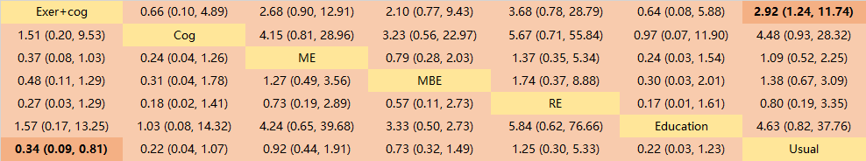
Fig S2. Forest Plot with Intervention Period ≤ 4 Months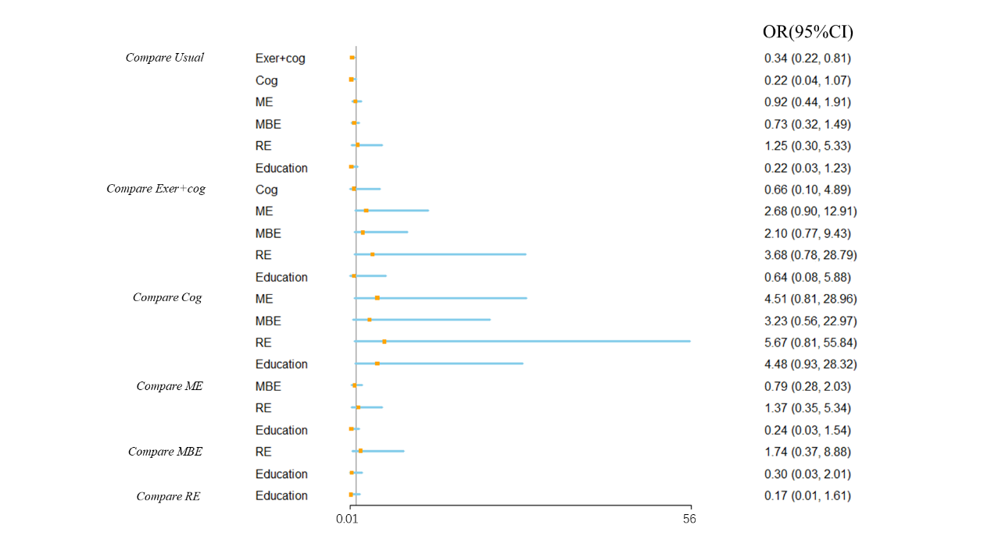

Fig S3. League Table with Intervention Period 4-8 Months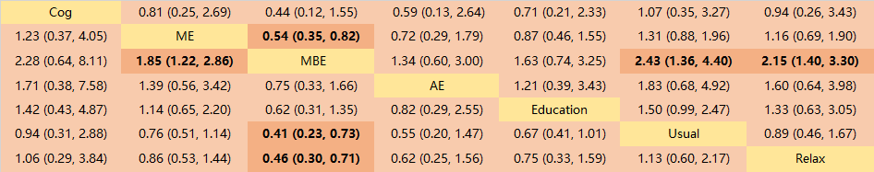
Fig S4. Forest Plot with Intervention Period 4-8 Months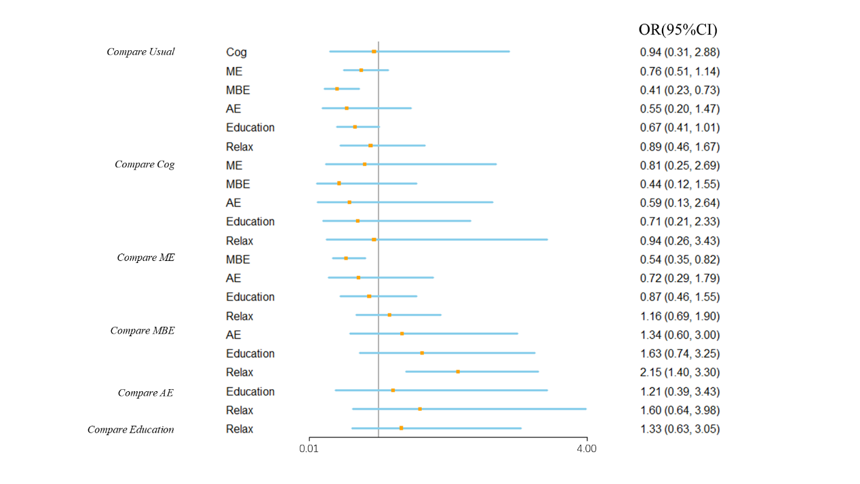
Fig S5. League Table with Intervention Period > 8 Months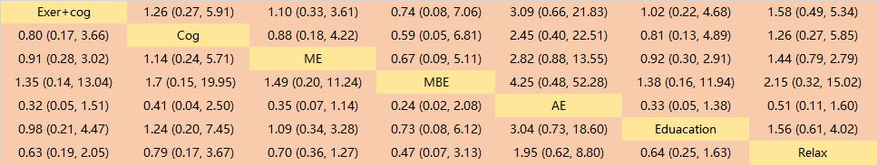

Fig S6. Forest Plot with Intervention Period > 8 Months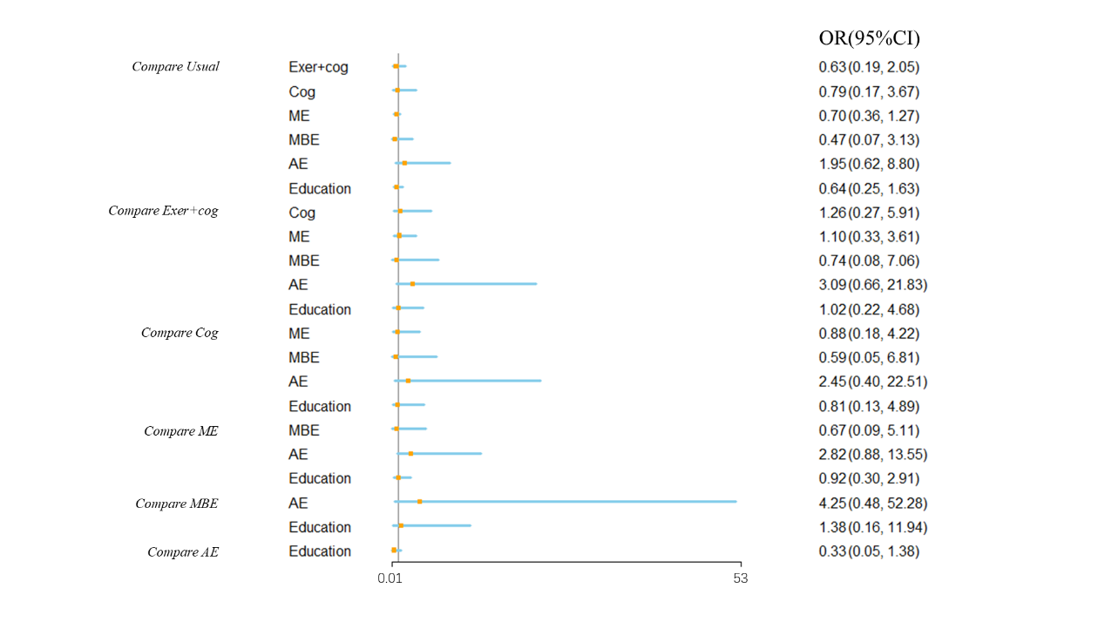
Fig S7. League Table with Female Proportion between 50-80%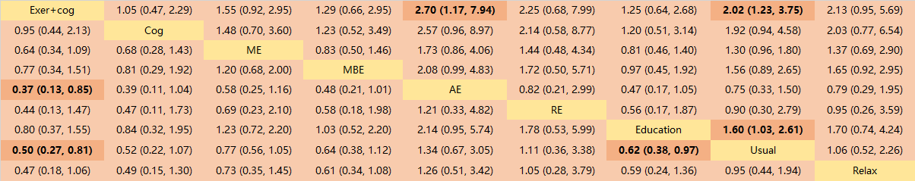
Fig S8. Forest Plot with Female Proportion between 50-80%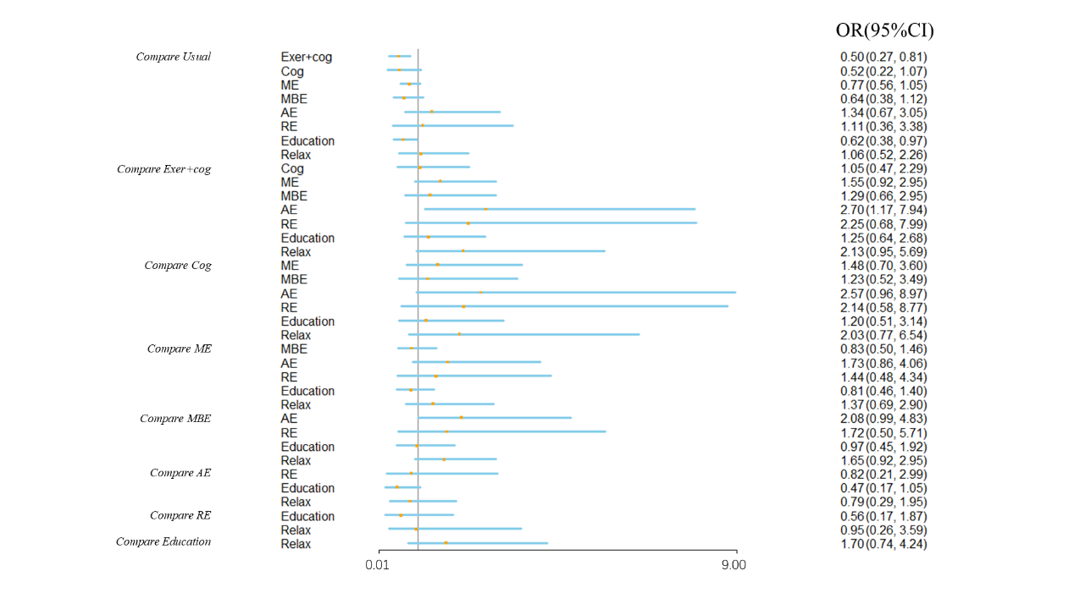
Fig S9. League Table of Sensitivity Analysis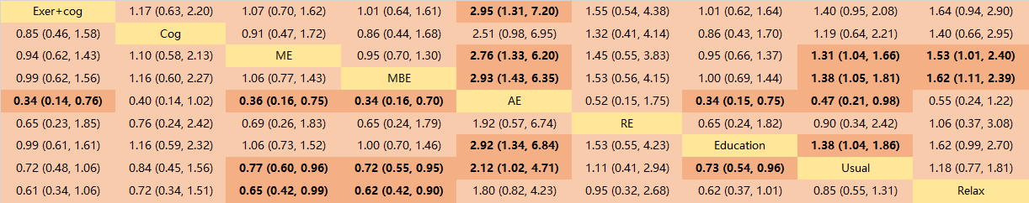
Fig S10. Forest Plot of Sensitivity Analysis