Supporting information
Synthesis of New Calixarene Derivatives and Evaluation of Their Cytotoxic Activity
Mehmet Oguzª, Ayse Yildirimª, Irem Mukaddes Durmus^{b}, Serdar Karakurt^{b}, Mustafa Yilmaz*ª

ªSelcuk University, Department of Chemistry, 42075 Konya, Turkey
^{b}Selcuk University, Department of Biochemistry, Konya 42075, Turkey

∗ Corresponding authors. E-mail address: myilmaz42@yahoo.com (M. YILMAZ).

Synthesis [4a, 4b, 7a and 7b]
Figure S1. Schematic view of compounds [4a] which are calix [4] arene derivative.
Figure S2. Schematic view of compounds [4b] which are calix [4] arene derivative.
Figure S3. Schematic view of compounds [7a] which are calix [4] arene derivative.
Figure S4. Schematic view of compounds [7b] which are calix [4] arene derivative.
¹H and ¹³C NMR, FT-IR spectra of compounds [2a, 3a and 4a]
Figure S5. The ¹H- NMR spectrum of the compound [2a]
Figure S6. The ¹H- NMR spectrum of the compound [3a]
Figure S7. The ¹³C- NMR spectrum of the compound [3a]
Figure S8. The FT-IR spectrum of the compound [3a]
Figure S9 The ¹H- NMR spectrum of the compound [4a]
Figure S10 The ¹³C- NMR spectrum of the compound [4a]
Figure S11 The FT-IR spectrum of the compound [4a]
¹H and ¹³C NMR, FT-IR spectra of compounds [2b, 3b and 4b]
Figure S12 The ¹H- NMR spectrum of the compound [2b]
Figure S13 The ¹H- NMR spectrum of the compound [3b]
Figure S14 The ¹H- NMR spectrum of the compound [4b]
Figure S15 The ¹³C- NMR spectrum of the compound [4b]
Figure S16 The FT-IR spectrum of the compound [4b]
¹H and ¹³C NMR, FT-IR spectra of compounds [5a, 6a and 7a]
Figure S17 The ¹H- NMR spectrum of the compound [5a]
Figure S18 The ¹³C- NMR spectrum of the compound [5a]
Figure S19 The ¹H- NMR spectrum of the compound [6a]
Figure S20 The ¹H- NMR spectrum of the compound [7a]
Figure S21 The ¹³C- NMR spectrum of the compound [7a]
Figure S22 The FT-IR spectrum of the compound [7a]
¹H and ¹³C NMR, FT-IR spectra of compounds [5b, 6b and 7b]
Figure S23 The ¹H- NMR spectrum of the compound [5b]
Figure S24 The ¹H- NMR spectrum of the compound [6b]
Figure S25 The FT-IR spectrum of the compound [6b]
Figure S26 The ¹H- NMR spectrum of the compound [7b]
Figure S27 The ¹³C- NMR spectrum of the compound [7b]
Figure S28 The FT-IR spectrum of the compound [7b]

Synthesis [4a, 4b, 7a and 7b]
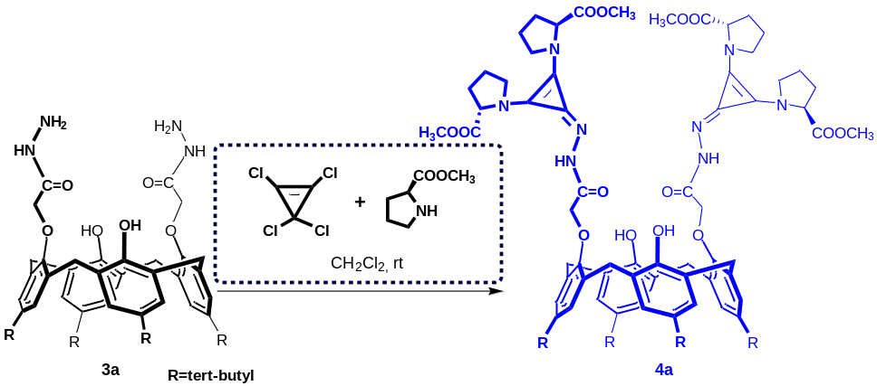
Figure S1. Schematic view of compounds [4a] which are calix [4] arene derivative.
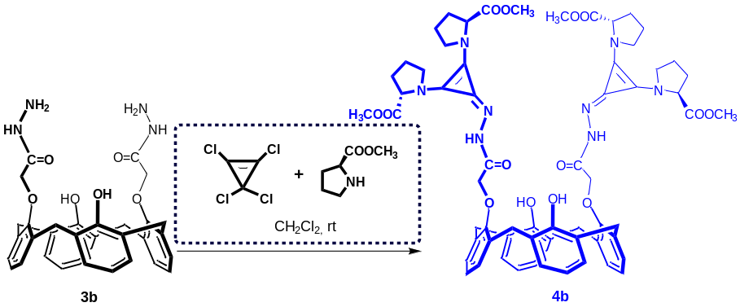
Figure S2. Schematic view of compounds [4b] which are calix [4] arene derivative.
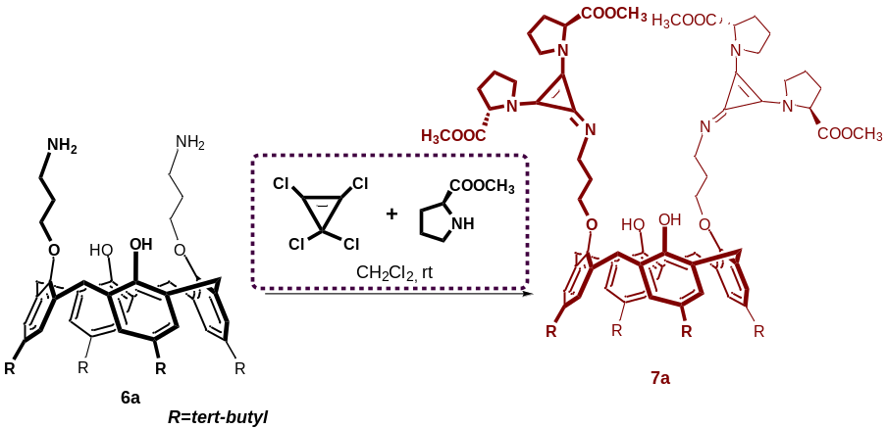
Figure S3. Schematic view of compounds [7a] which are calix [4] arene derivative.
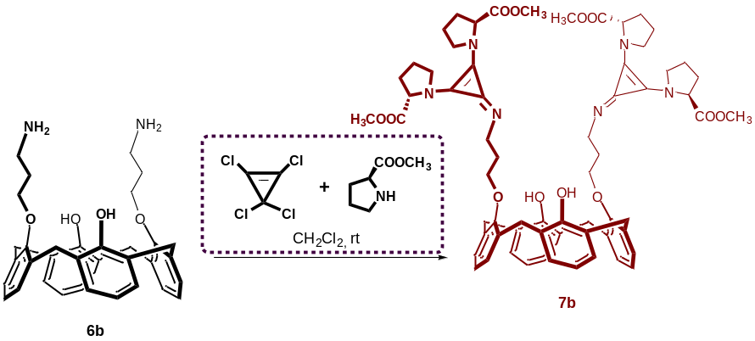
Figure S4. Schematic view of compounds [7b] which are calix [4] arene derivative.

¹H and ¹³C NMR, FT-IR spectra of compounds [2a, 3a and 4a]
Figure S5. The ¹H- NMR spectrum of the compound [2a]

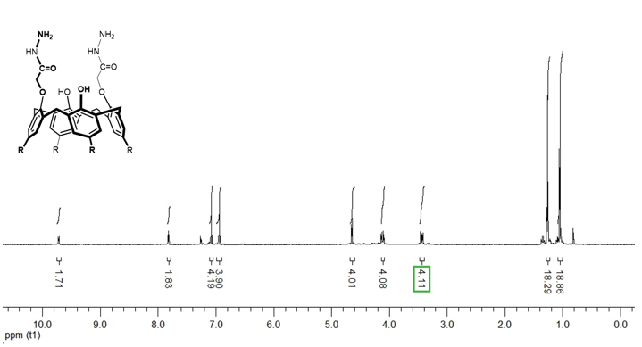
Figure S6. The ¹H- NMR spectrum of the compound [3a]
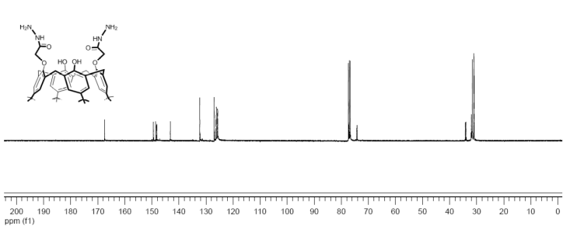
Figure S7. The ¹³C- NMR spectrum of the compound [3a]
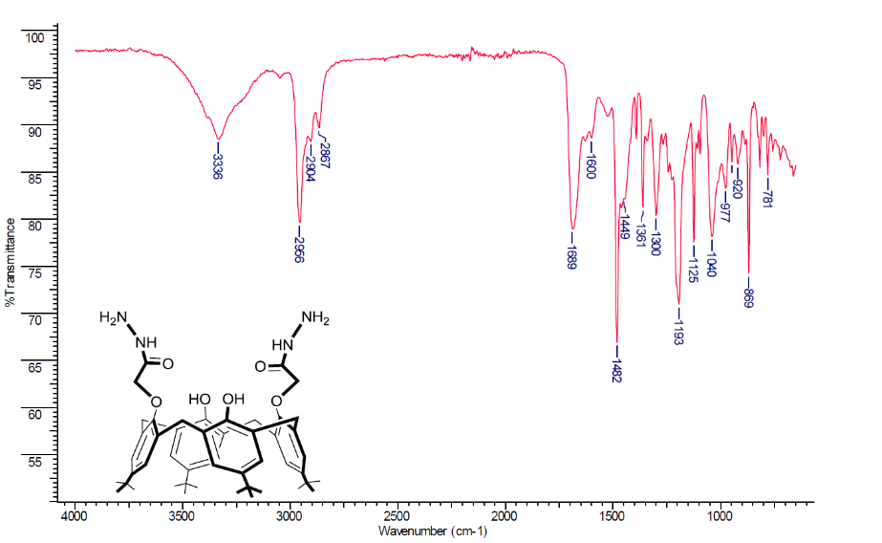
Figure S8. The FT-IR spectrum of the compound [3a]

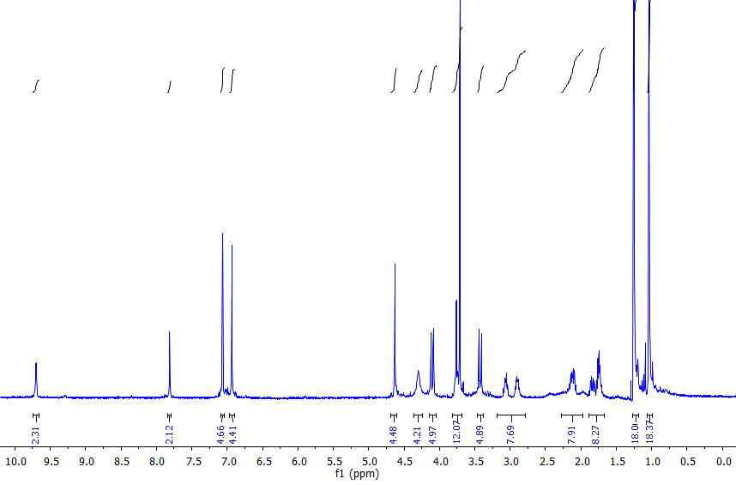
Figure S9 The ¹H- NMR spectrum of the compound [4a]

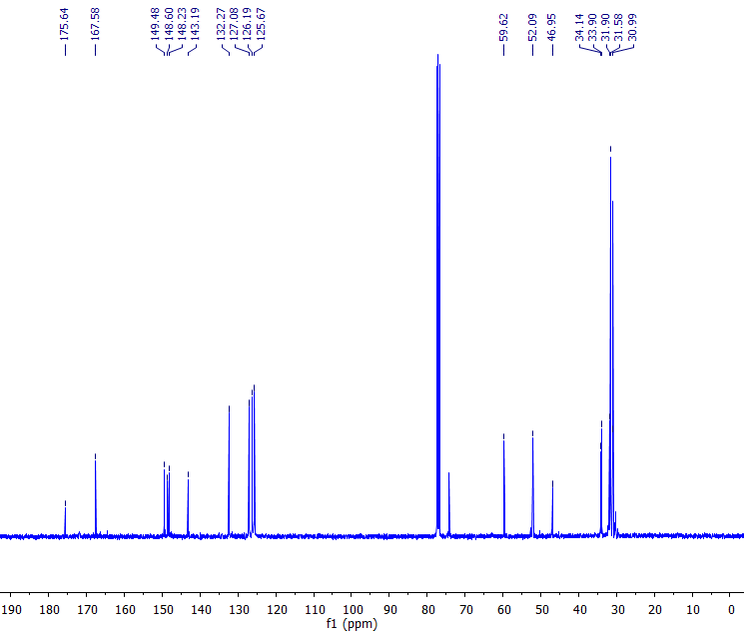
Figure S10 The ¹³C- NMR spectrum of the compound [4a]
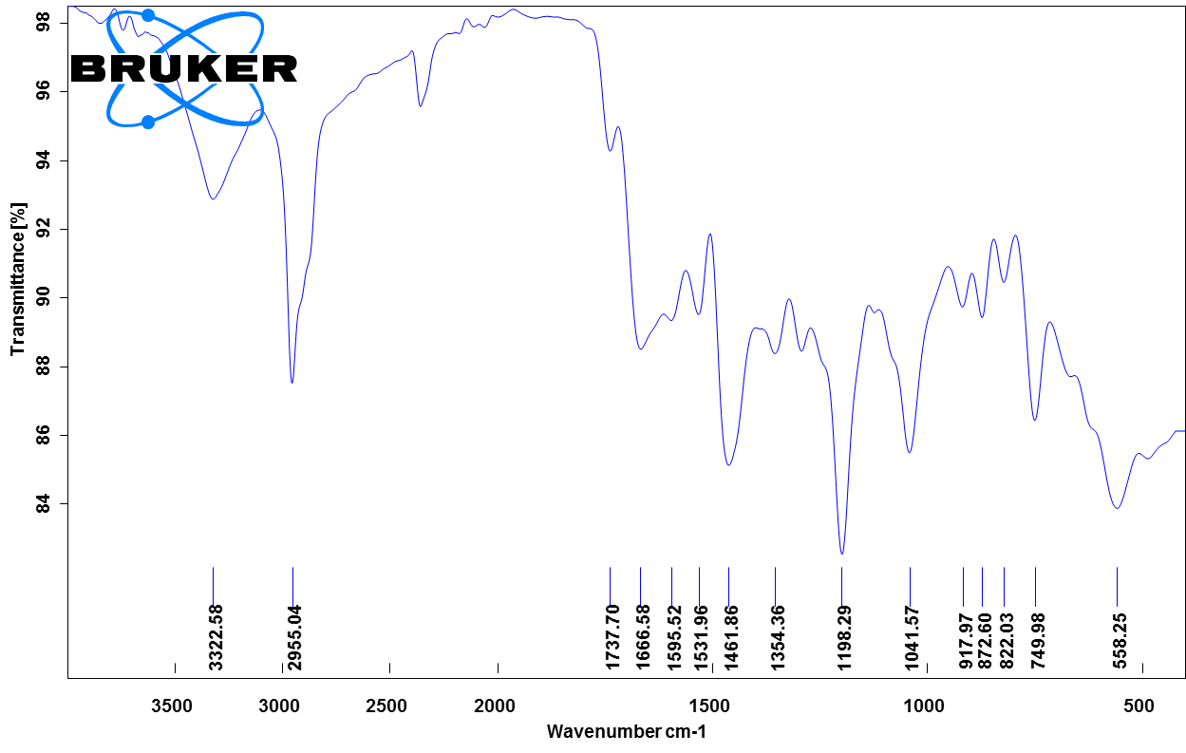
Figure S11 The FT-IR spectrum of the compound [4a]

¹H and ¹³C NMR, FT-IR spectra of compounds [2b, 3b and 4b]
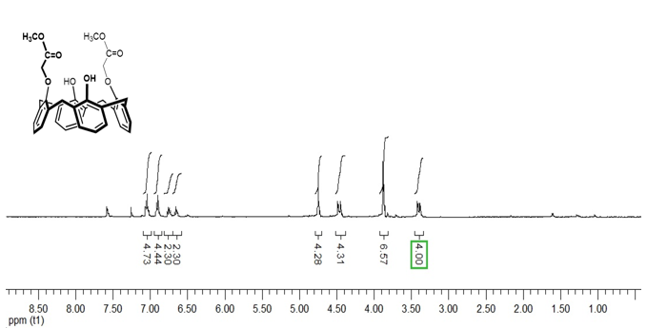
Figure S12 The ¹H- NMR spectrum of the compound [2b]
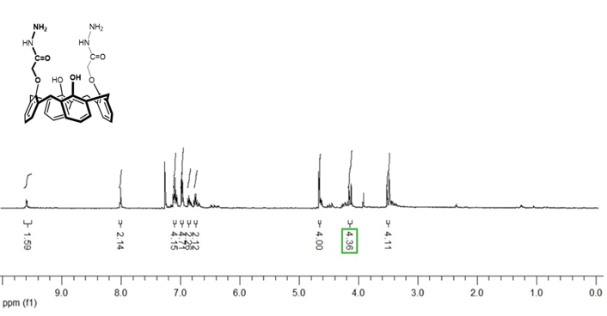
Figure S13 The ¹H- NMR spectrum of the compound [3b]
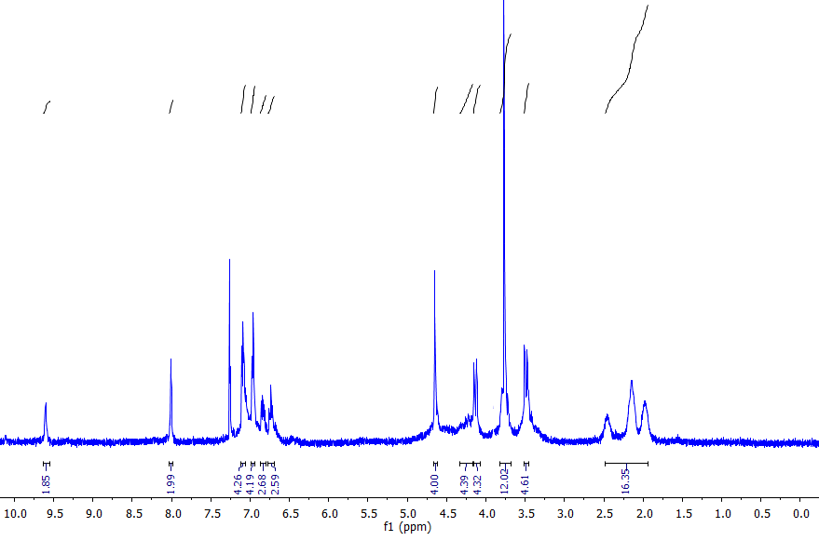
Figure S14 The ¹H- NMR spectrum of the compound [4b]

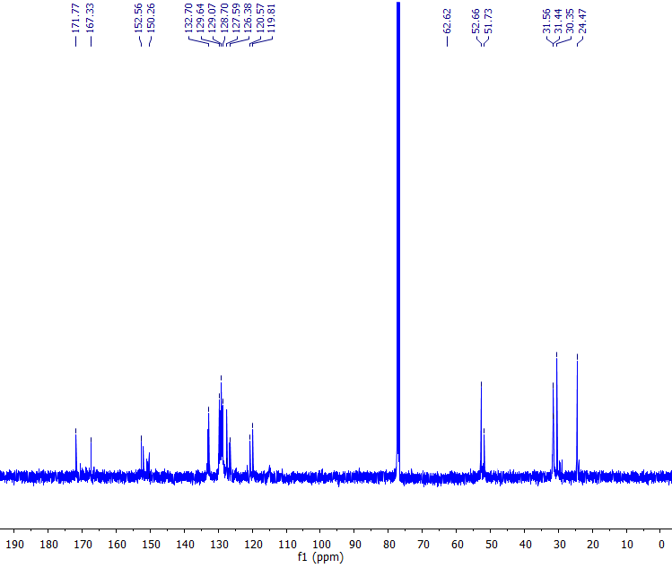
Figure S15 The ¹³C- NMR spectrum of the compound [4b]
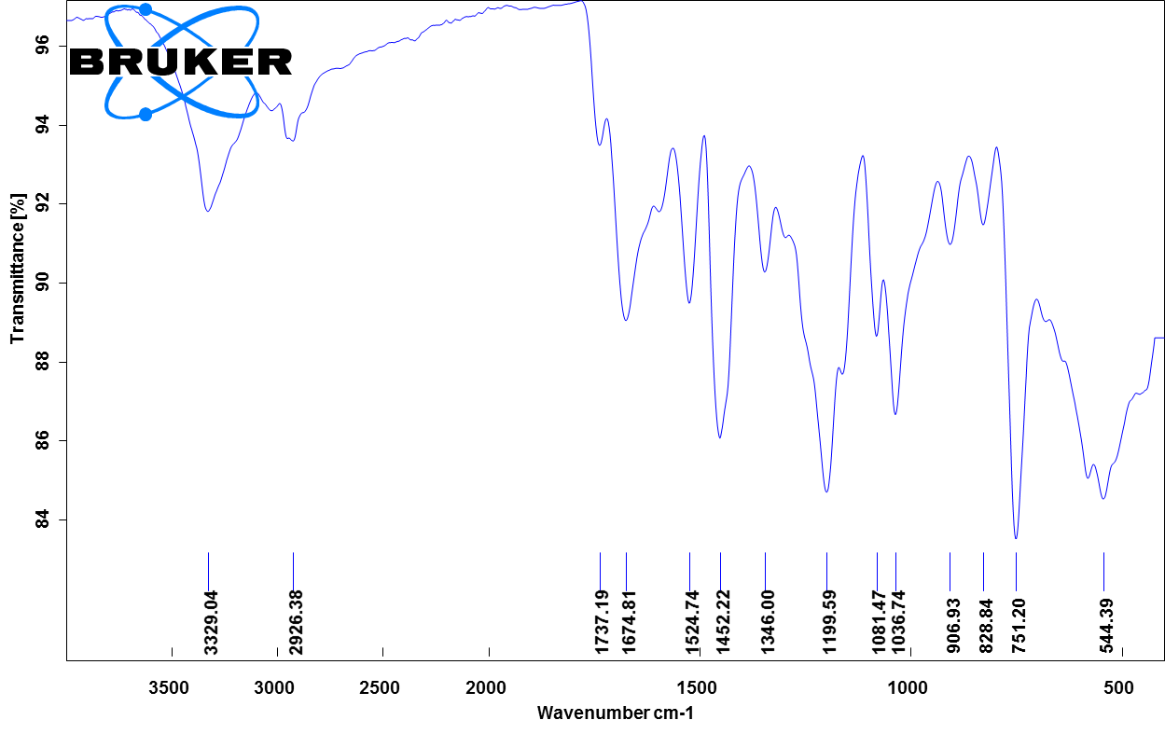
Figure S16 The FT-IR spectrum of the compound [4b]

¹H and ¹³C NMR, FT-IR spectra of compounds [5a, 6a and 7a]
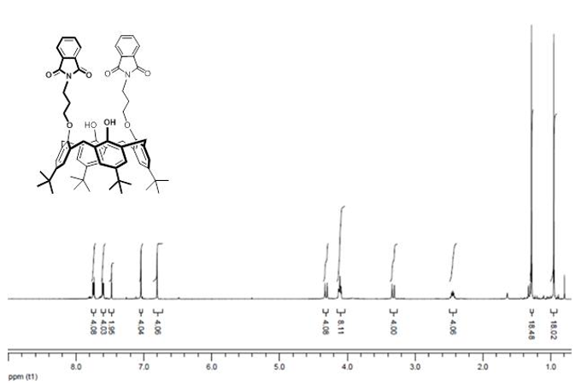
Figure S17 The ¹H- NMR spectrum of the compound [5a]

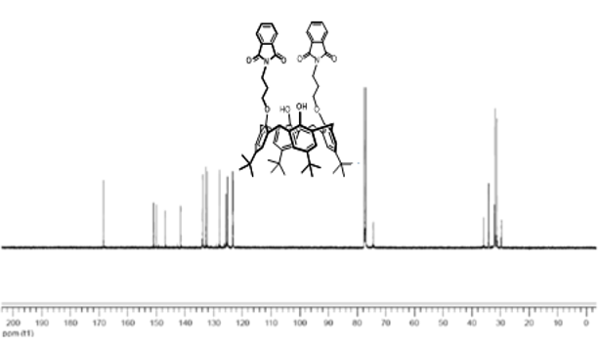
Figure S18 The ¹³C- NMR spectrum of the compound [5a]
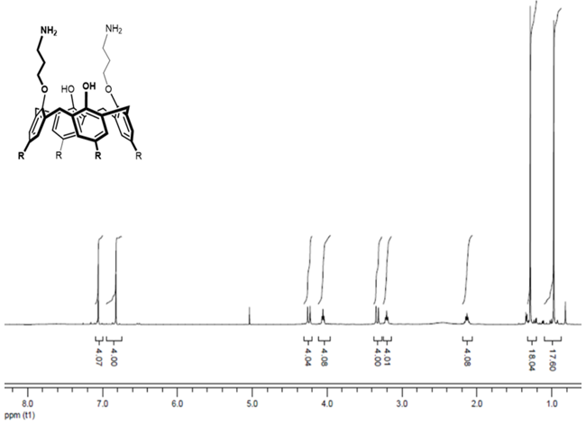
Figure S19 The ¹H- NMR spectrum of the compound [6a]

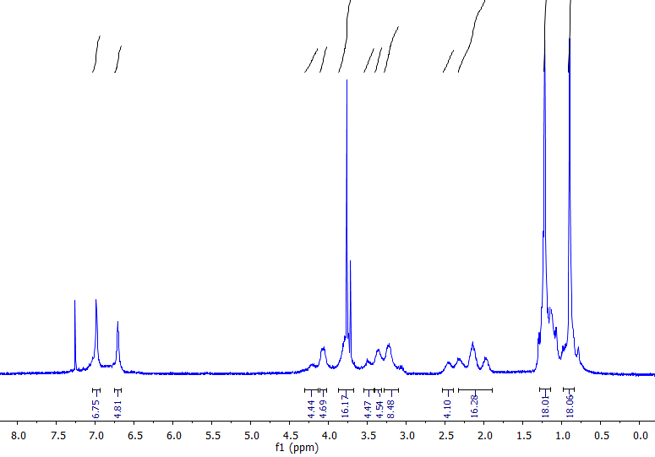
Figure S20 The ¹H- NMR spectrum of the compound [7a]
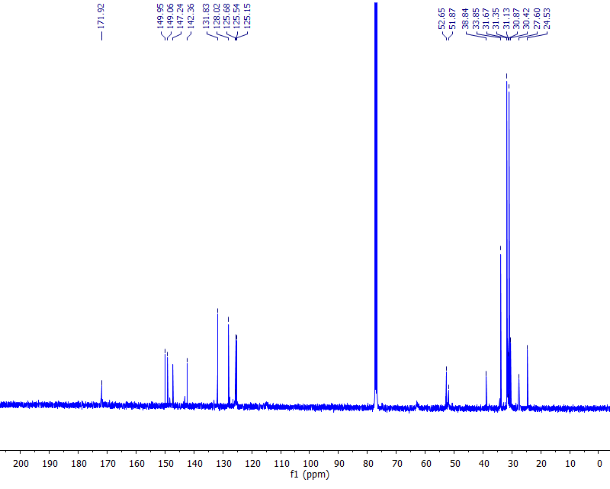
Figure S21 The ¹³C- NMR spectrum of the compound [7a]

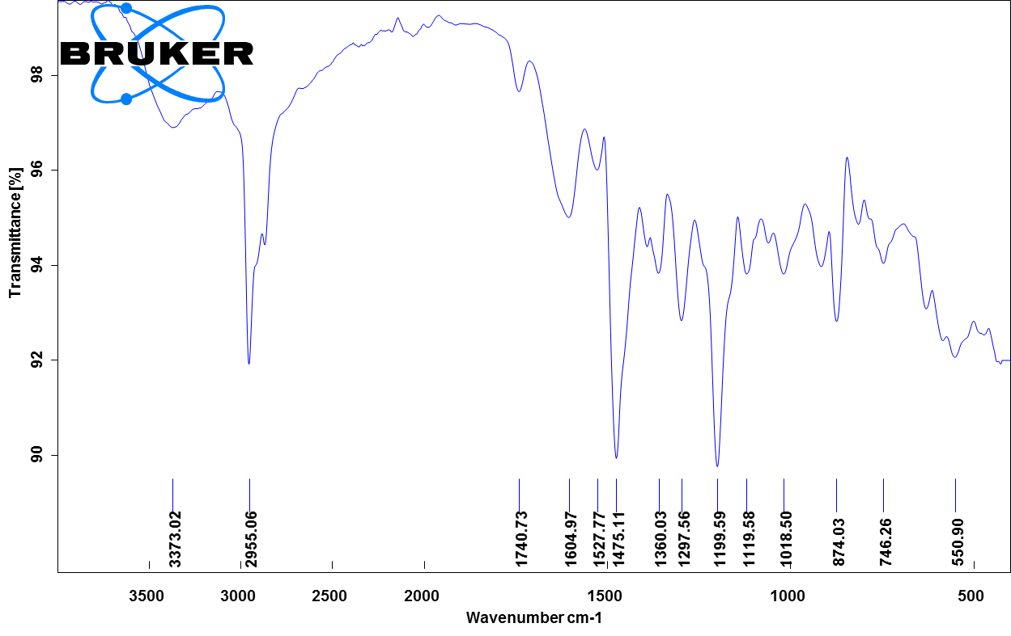
Figure S22 The FT-IR spectrum of the compound [7a]

¹H and ¹³C NMR, FT-IR spectra of compounds [5b, 6b and 7b]
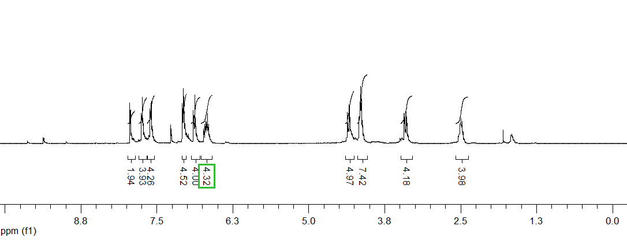
Figure S23 The ¹H- NMR spectrum of the compound [5b]

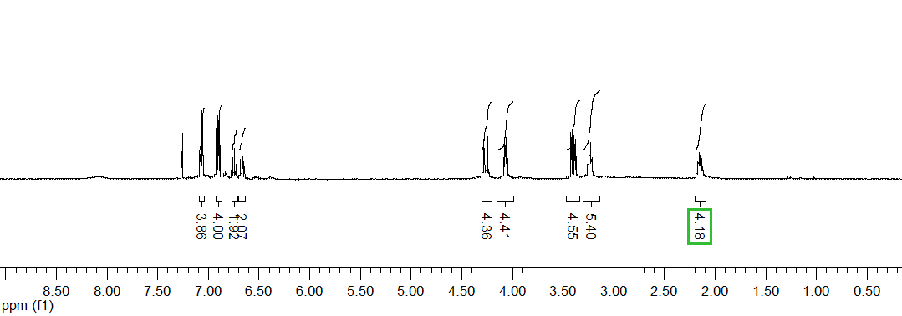
Figure S24 The ¹H- NMR spectrum of the compound [6b]

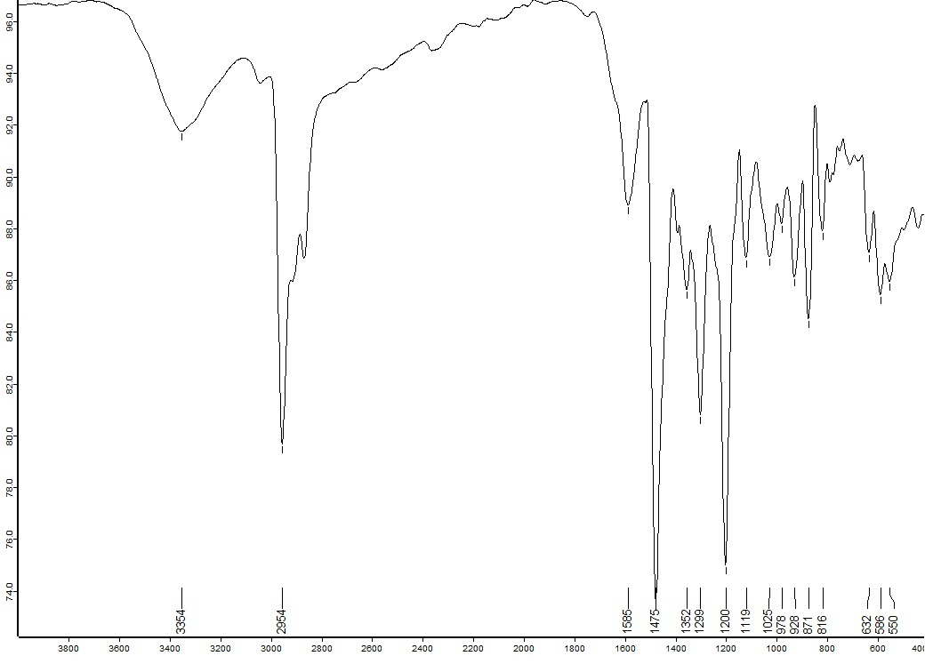
Figure S25 The FT-IR spectrum of the compound [6b]

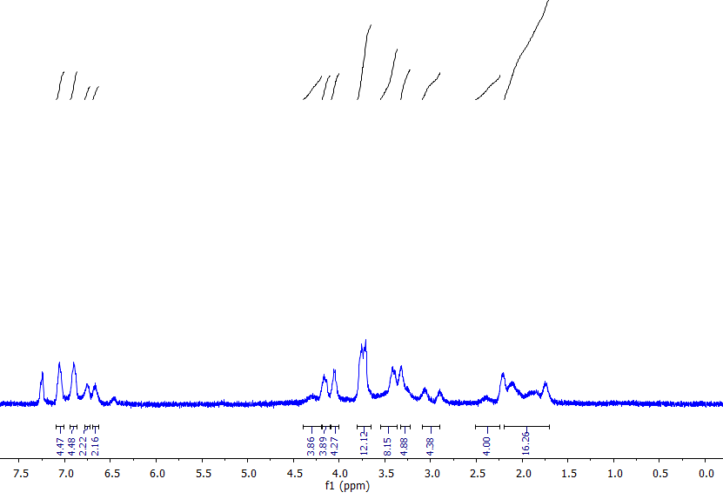
Figure S26 The ¹H- NMR spectrum of the compound [7b]
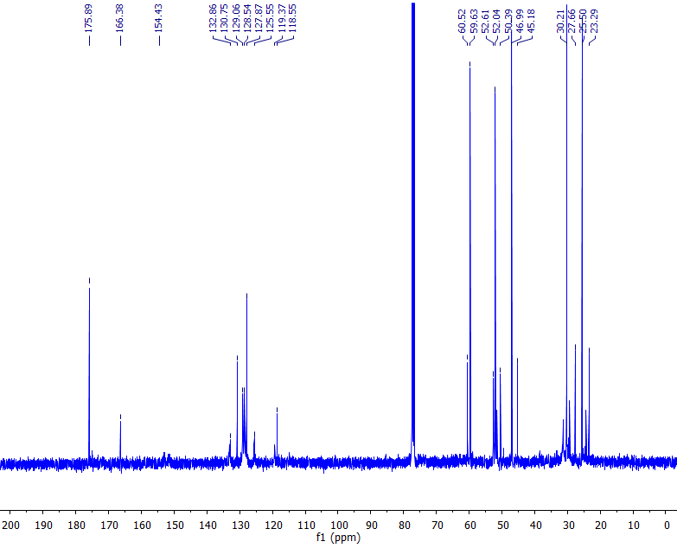
Figure S27 The ¹³C- NMR spectrum of the compound [7b]
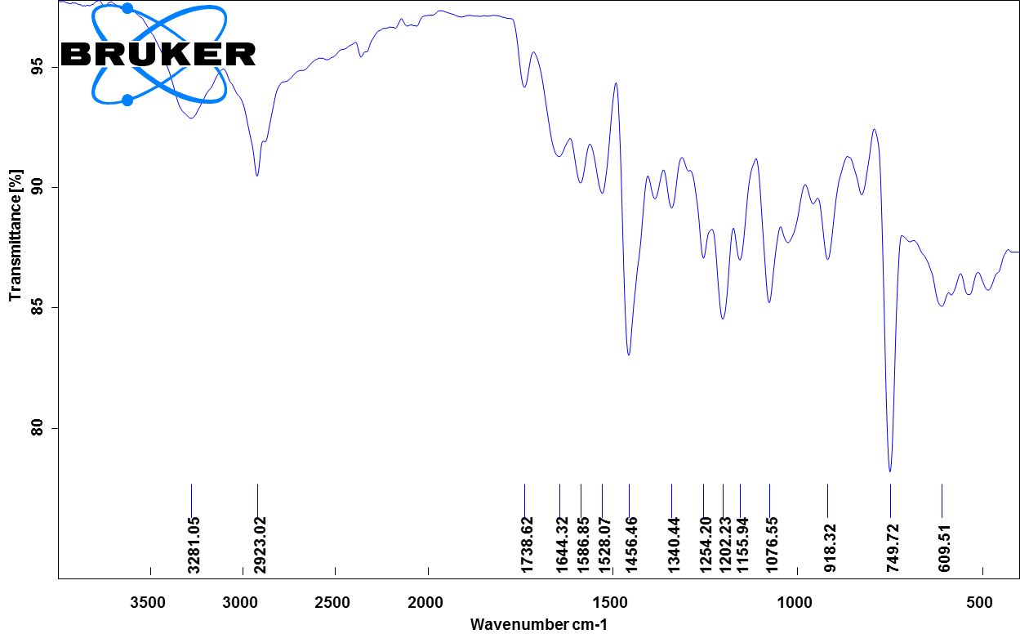
Figure S28 The FT-IR spectrum of the compound [7b]

