Figure S1. （A-C）Quantitative analysis of scratch, migration, and invasion（D-F）Relative fluorescence intensity of Vimentin, α-SMA, and CTGF.（G-I）Quantitative analysis of related proteins. n=3, * p < 0.05, ** p < 0.01, *** p < 0.001.

Figure S2. （A-C）Quantitative analysis of scratch, migration, and invasion（D-F）Relative fluorescence intensity of Vimentin, α-SMA, and CTGF.（G-I）Quantitative analysis of related proteins. n=3, * p < 0.05, ** p < 0.01, *** p < 0.001.
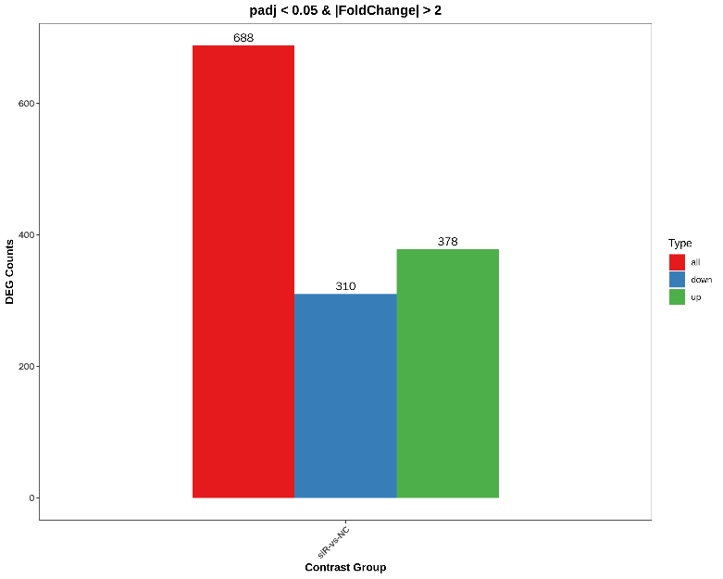
Figure S3. Identification and Analysis of Gene Variations through Transcriptome Sequencing

