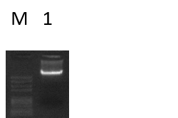
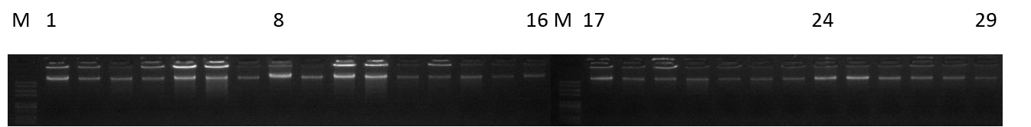
Figure 1.DNA quality detection gel electrophoresis

Figure 2.Statistics of sequencing results and alignment results

Figure 3.Expression of DBNDD1 and DEF8 in reproductive tissues

