Table 3 Contact angle and drop filtration time of untreated, hot-pressed and functionalized cellulose acetate membranes.
MEMBRANE | CONTACT ANGLE (°) | COMPLETE FILTRATION | FIGURE
MCA | 104 ± 1 | 100 min | 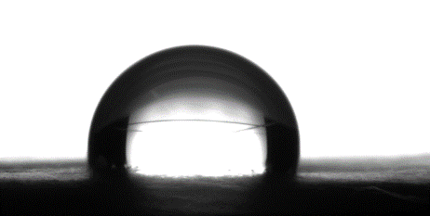
MCA-HP | 55 ± 2 | 5 min | 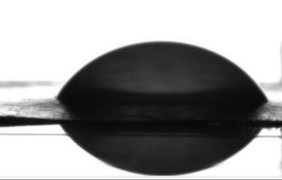
MCA-1%CNC-HP | 43 ± 4 | 24 s | 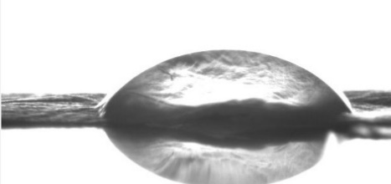
MCA-3%CNC-HP | 37 ± 1 | 33 s | 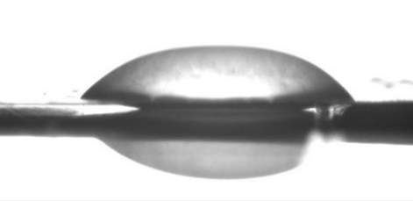
MCA-1%CNC_{TEMPO}-HP | 44 ± 1 | 21 s | 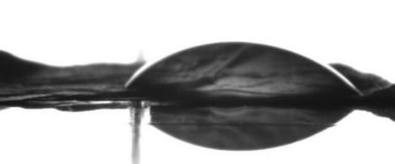
MCA-3%CNC_{TEMPO}-HP | 37 ± 2 | 23 s | 