Enhanced water filtration performance in electrospun cellulose acetate membranes via TEMPO-mediated cellulose nanocrystal incorporation and hot pressing
Ane Arrizabalaga-Luzuriaga, Stefano Torresi, Ainara Saralegi*, Arantxa Eceiza*
Group ‘Materials + Technologies’, Department of Chemical and Environmental Engineering, Faculty of Engineering of Gipuzkoa, University of the Basque Country UPV/EHU, Plaza Europa 1, 20018 Donostia-San Sebastian, Spain
*corresponding authors: ainara.saralegi@ehu.eus; arantxa.eceiza@ehu.eus

Fig. S1 OM and SEM micrographs of electrospun samples from different CA concentrations (8, 10, and 12 wt.%), acetone/acetic acid solvent ratios (A:AA: 4:1, 3:1, 2:1, 1:1, and 1:2) and flow rates.

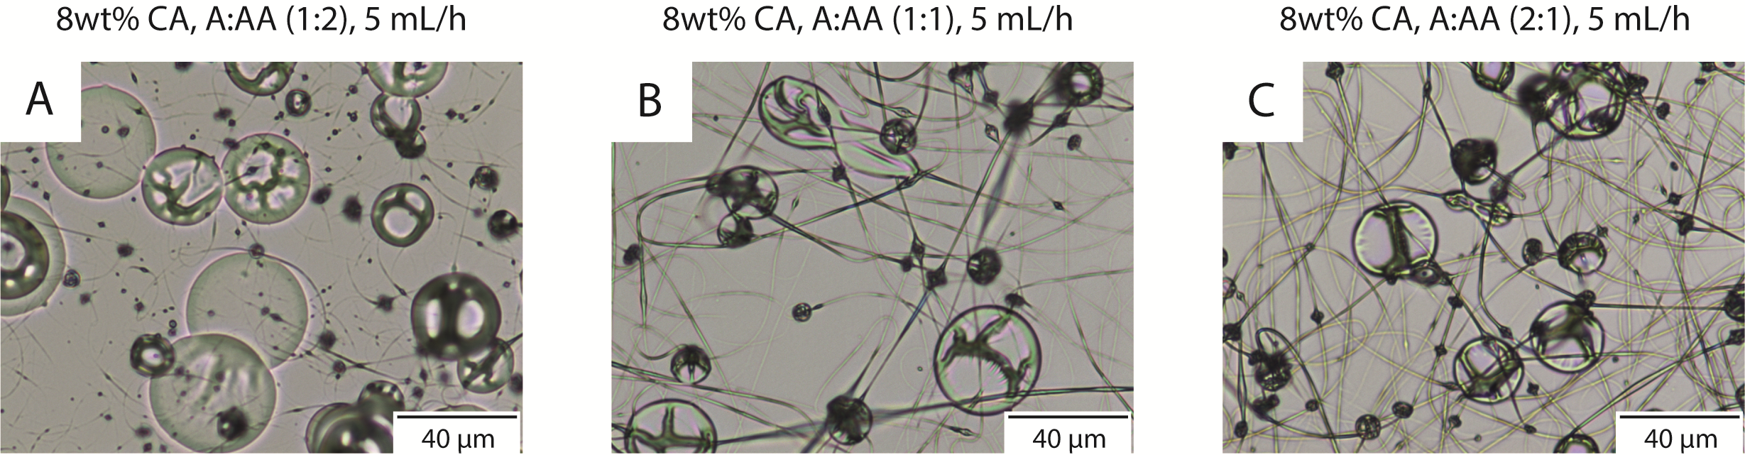
Fig. S1a OM micrographs of 8 wt.% CA in A:AA (1:2) (A), A:AA (1:1) (B) and A:AA (2:1) (C) at 5 mL/h and 40% humidity.

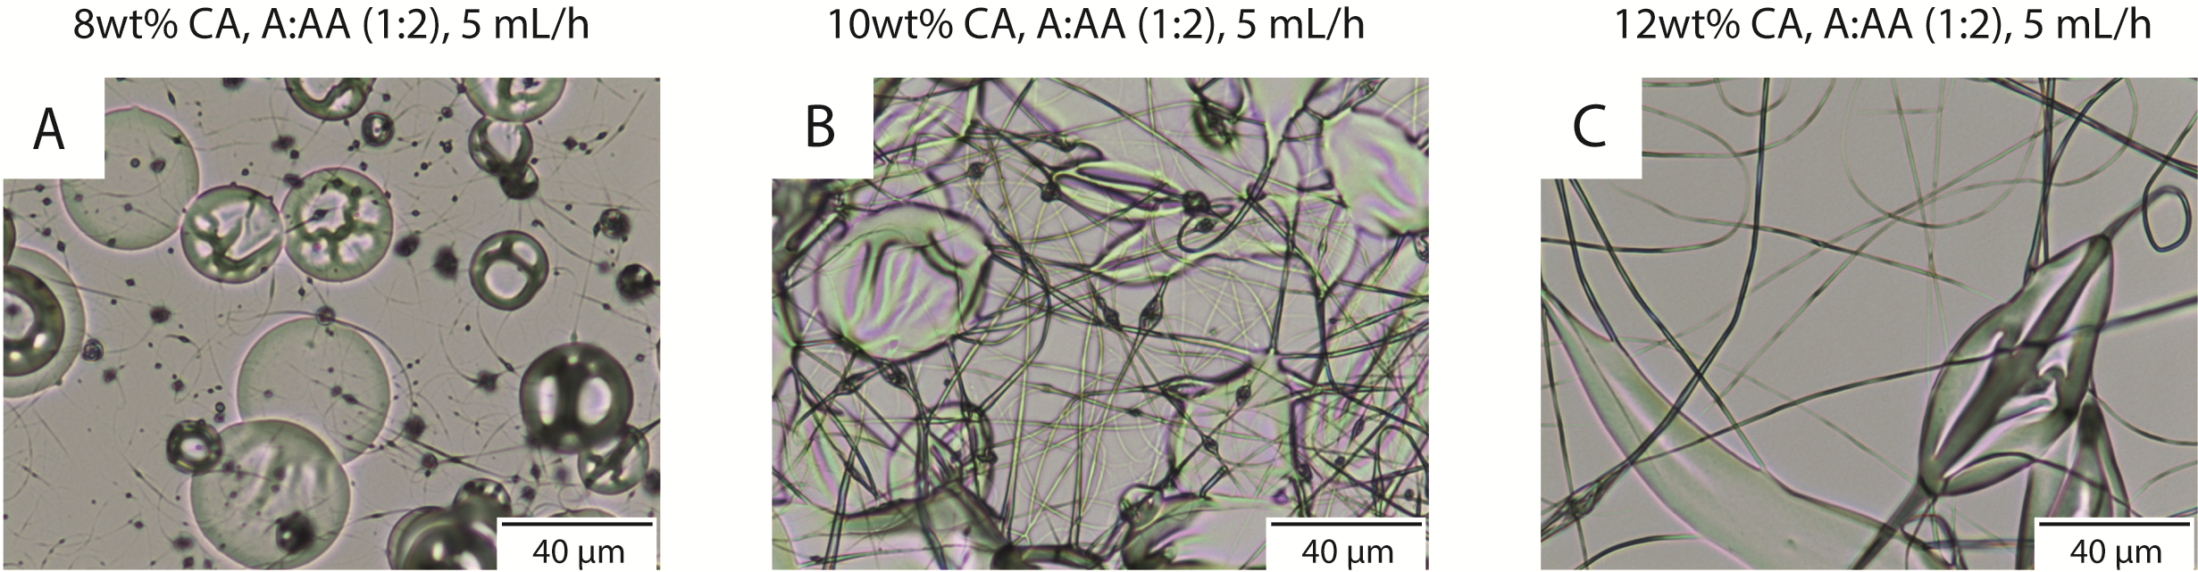
Fig. S1b OM micrographs of 8 (A), 10 (B) and 12 (C) wt.% CA in A:AA (1:2) at 5 mL/h and 40% humidity.

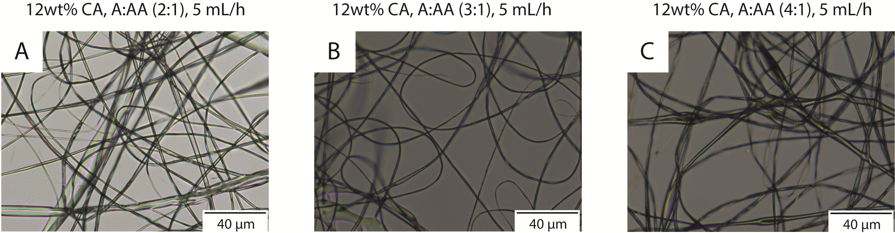
Fig. S1c OM micrographs of 12 wt.% CA in A:AA (2:1) (A), A:AA (3:1) (B), and A:AA (4:1) (C), at 5 mL/h and 40% humidity.

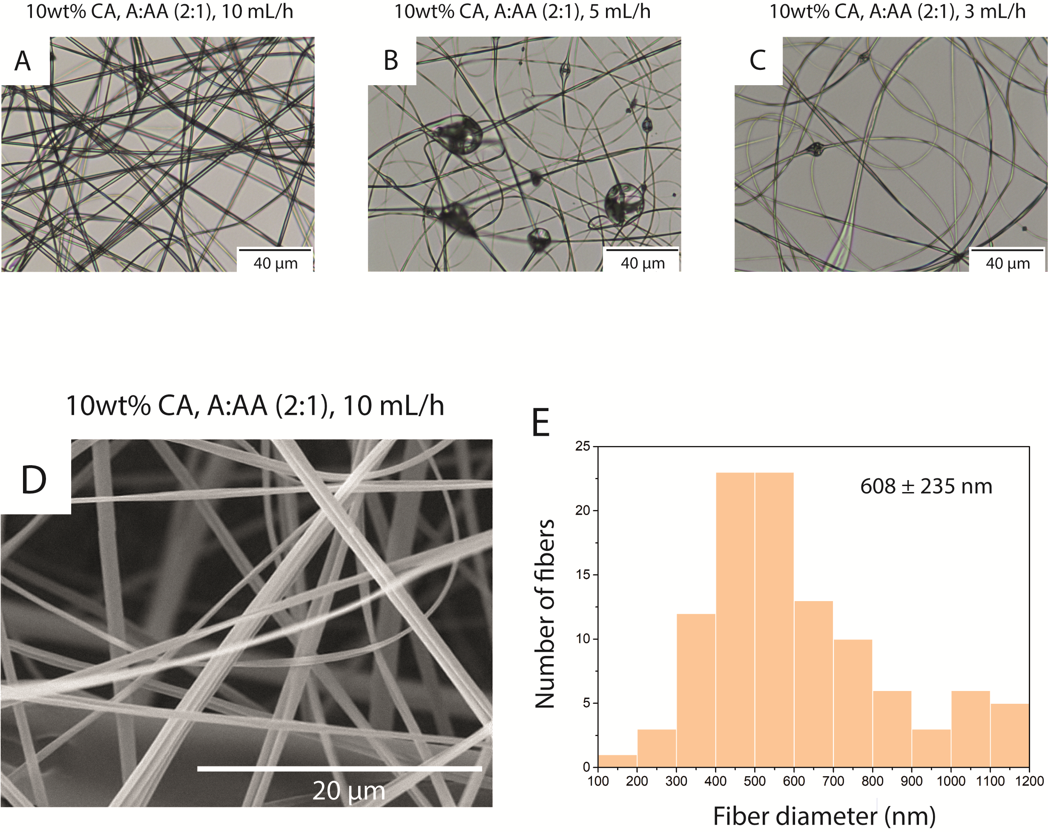
Fig. S1d OM micrograph of 10 wt.% CA in A:AA (2:1) at 10 mL/h (A), 5 mL/h (B) and 3 mL/h (C) flow rates at 40% humidity. SEM micrograph of 10 wt.% CA in A:AA (2:1) at 10 mL/h flow rate at 40% humidity (D) and diameter distribution of nanofibers (E).

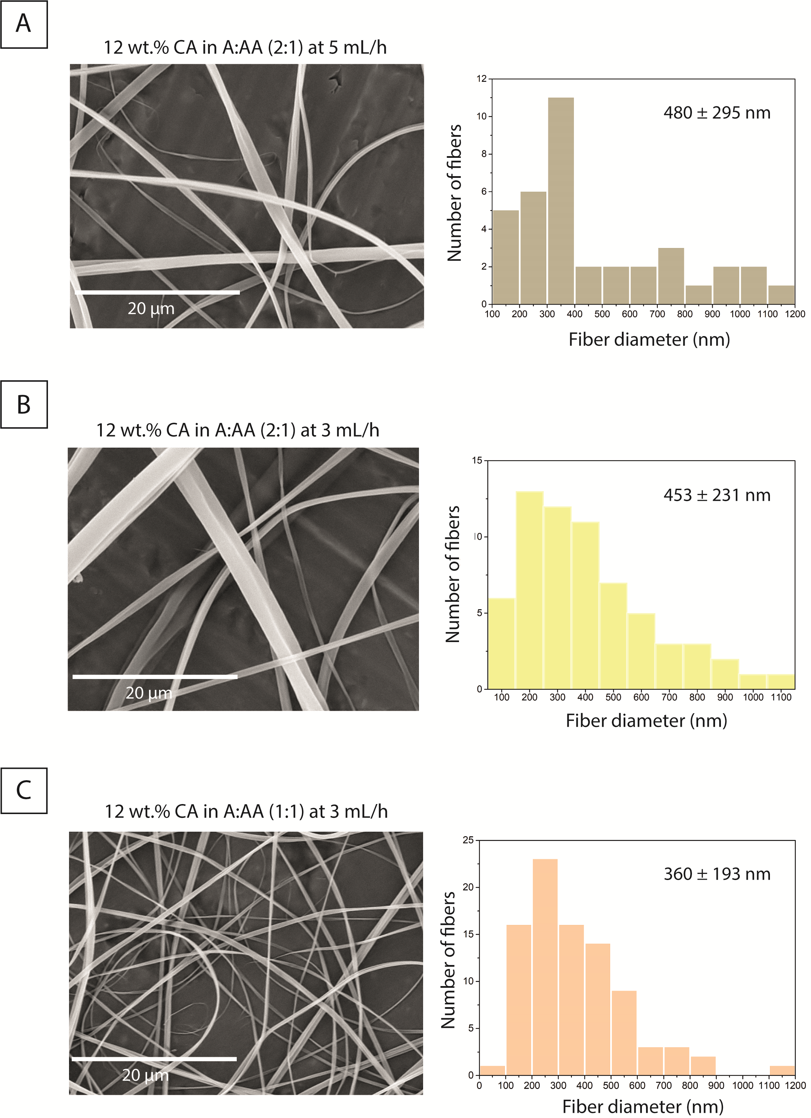
Fig. S1e SEM micrographs and diameter distribution of fibers of 12 wt.% CA in A:AA (2:1) at 5 (A) and 3 mL/h (B) flow rate and of 12 wt.% CA in A:AA (1:1) at 3 mL/h (C) flow rate at 40% humidity.

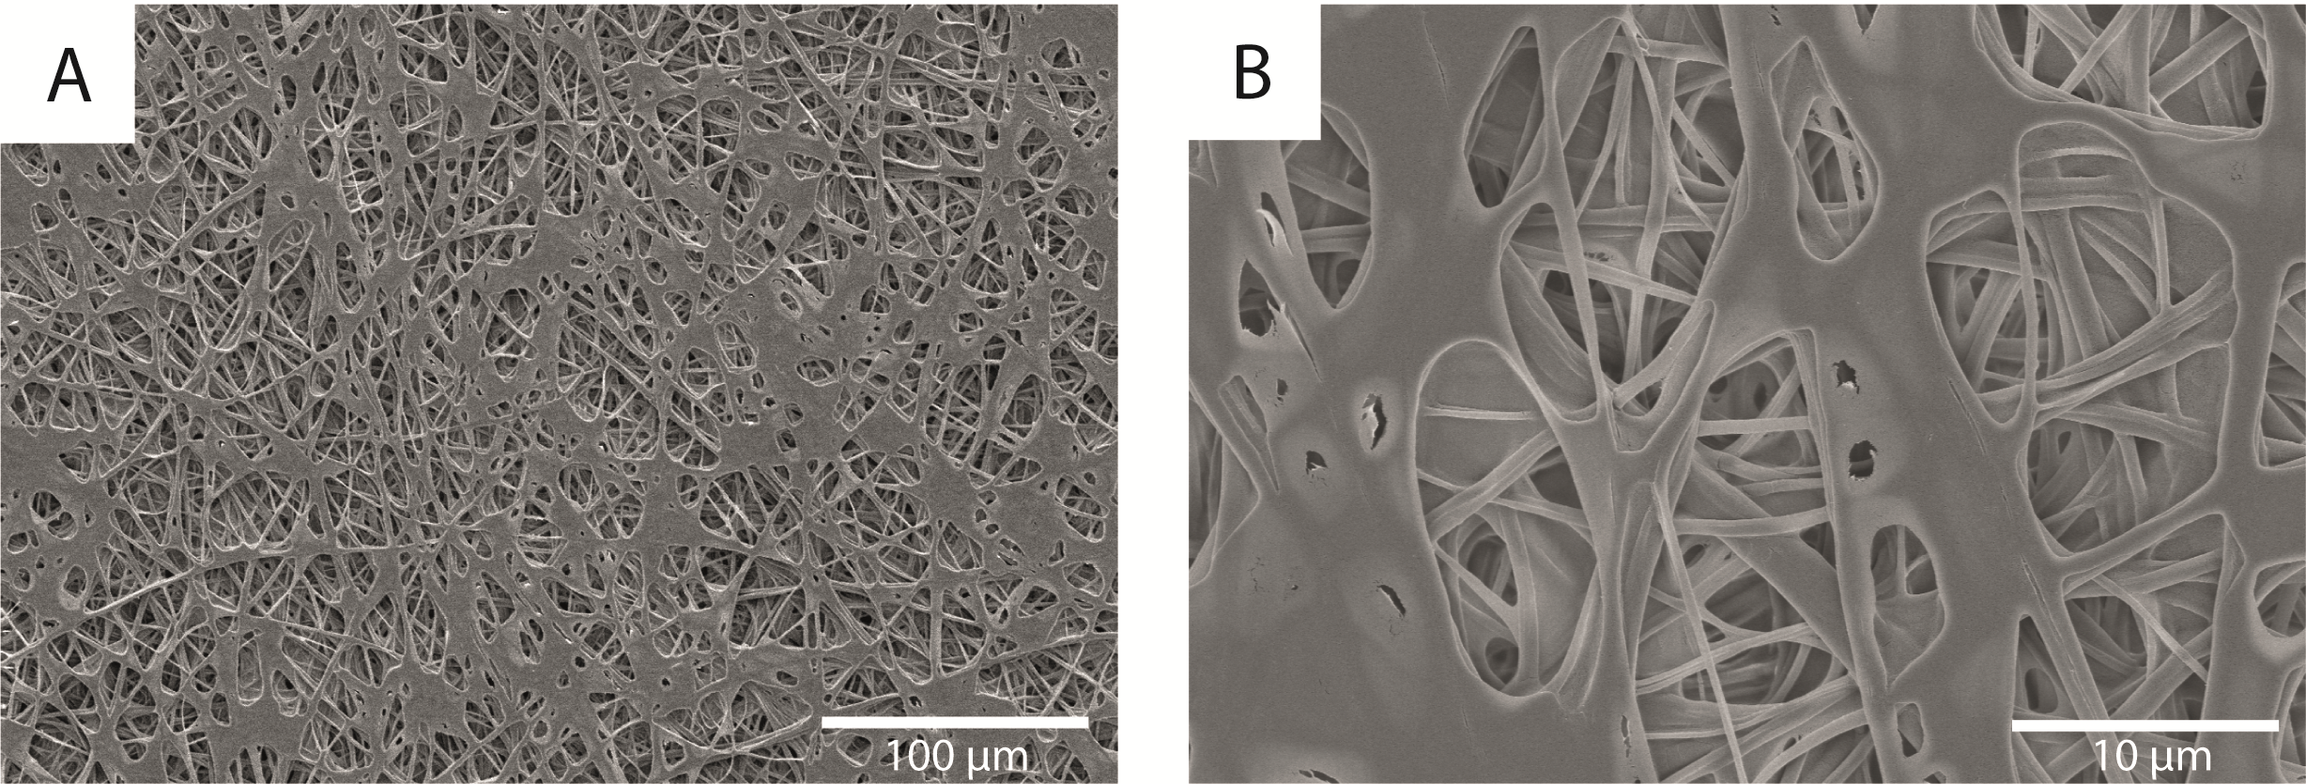
Fig. S2 SEM micrographs from upper surface of electrospun CA fibers with 5 wt.% CNC dispersion impregnation at low (a) and high magnification (b).

