Appendix I – PROSPERO protocol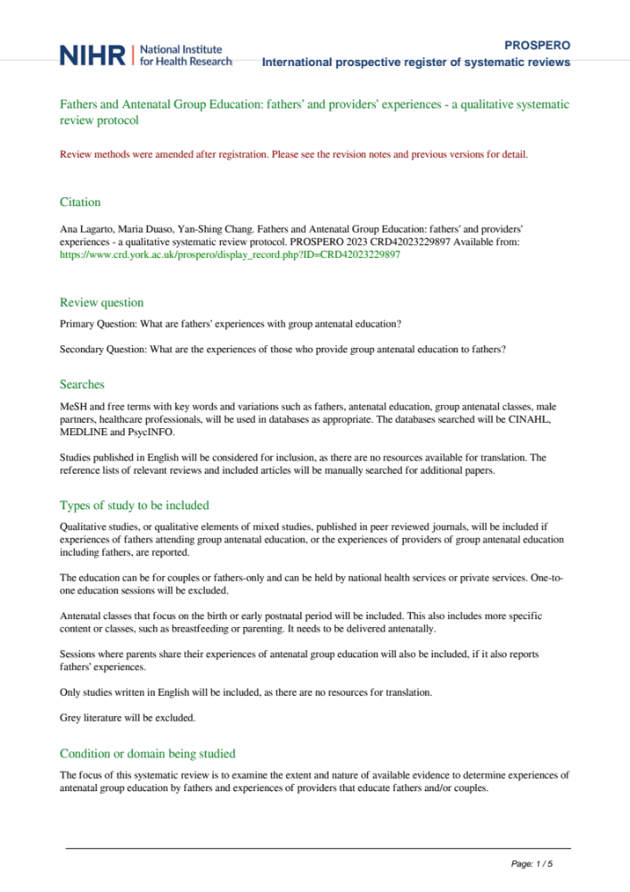
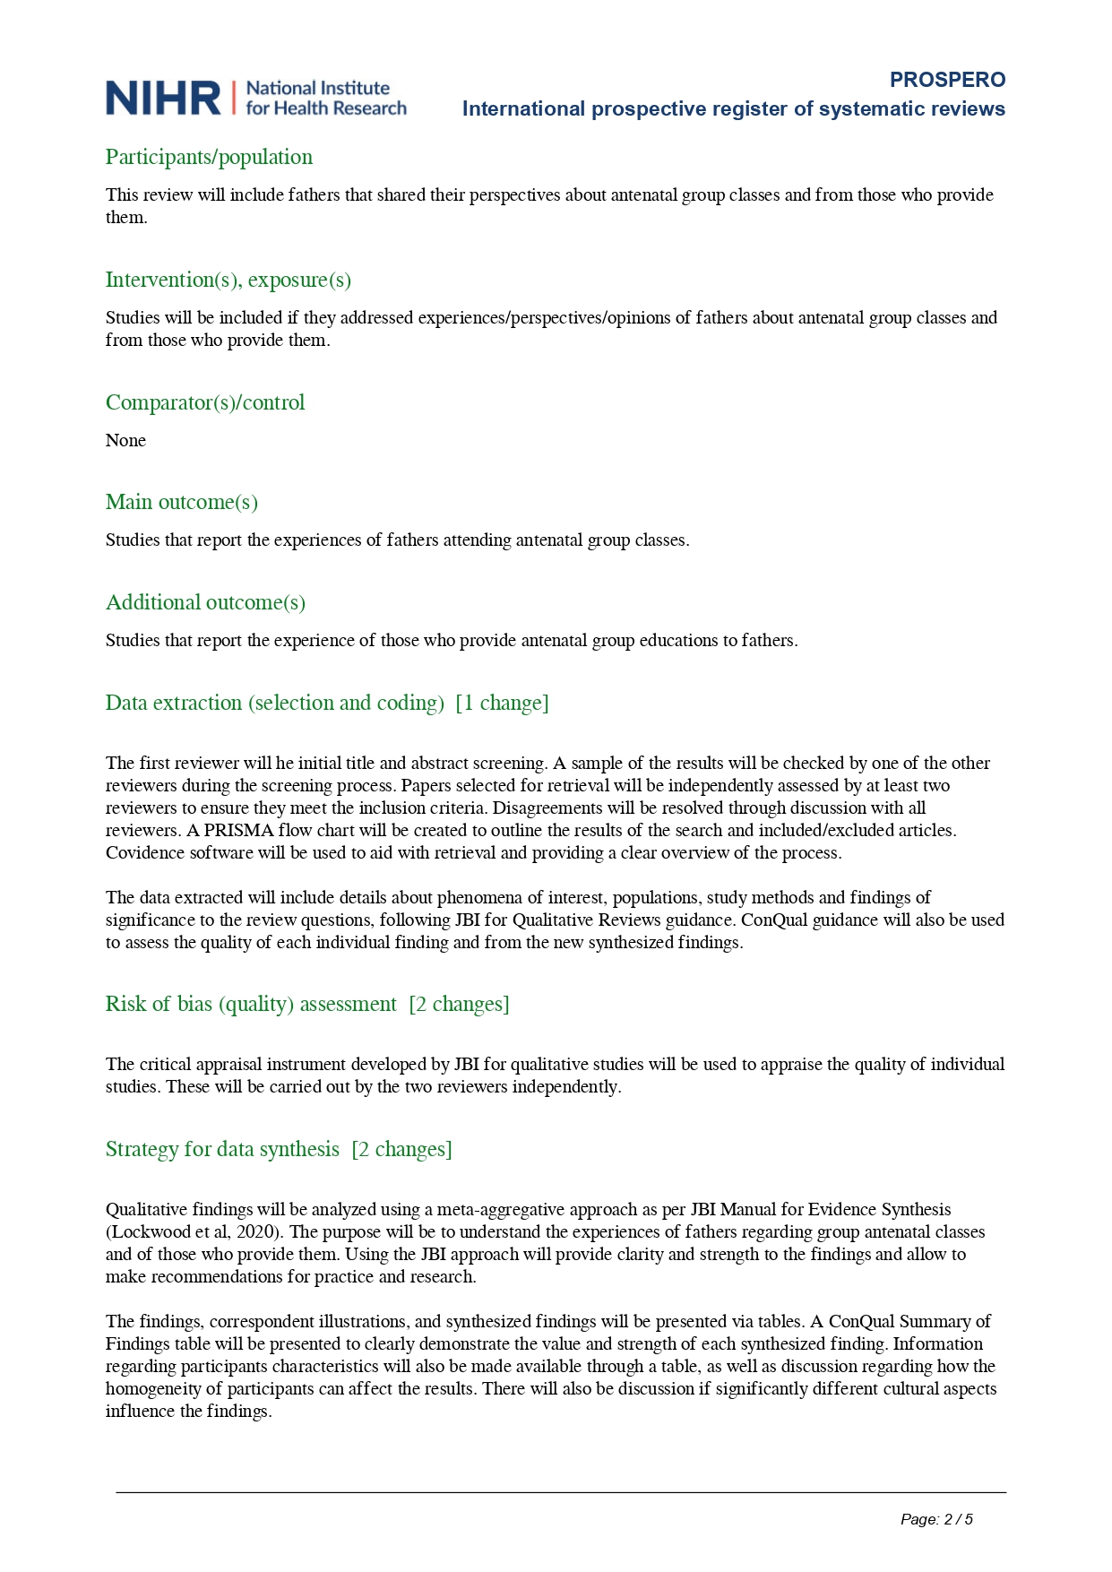

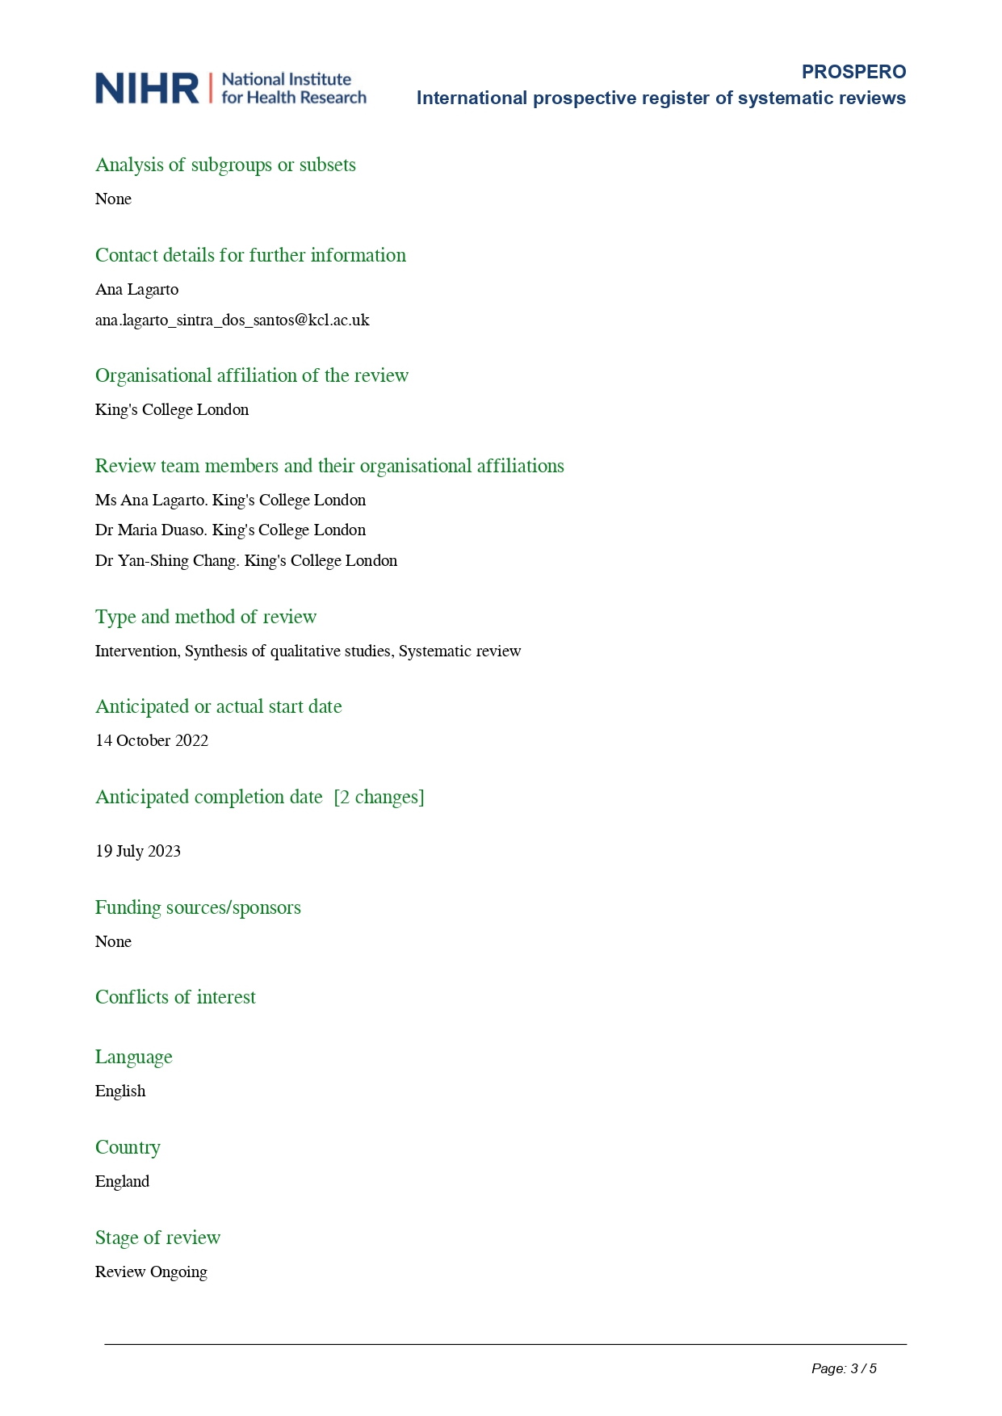

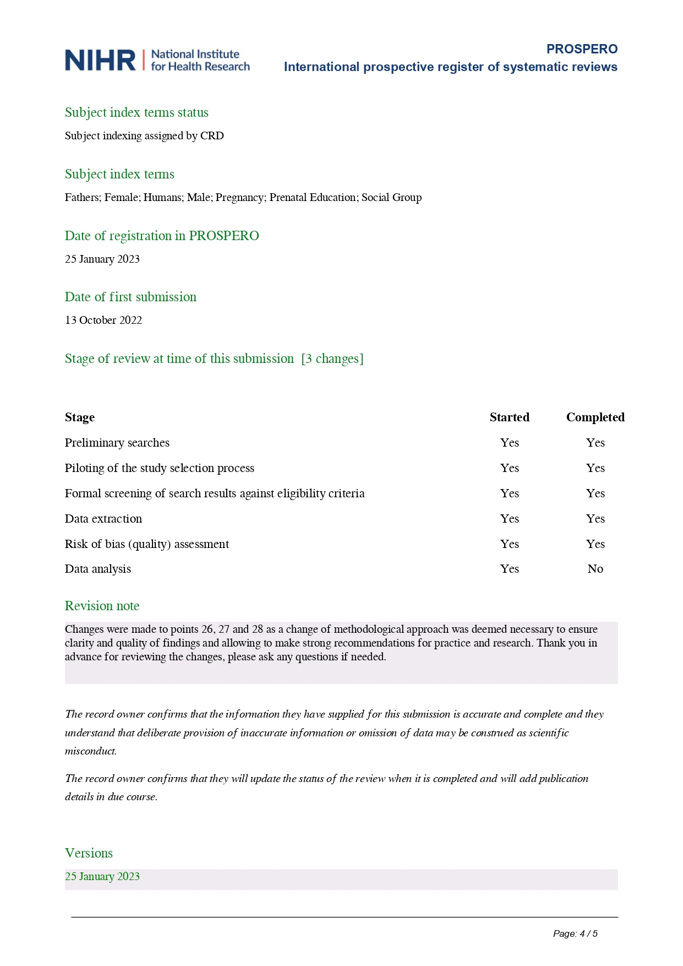



Appendix II – Search strategies for each database

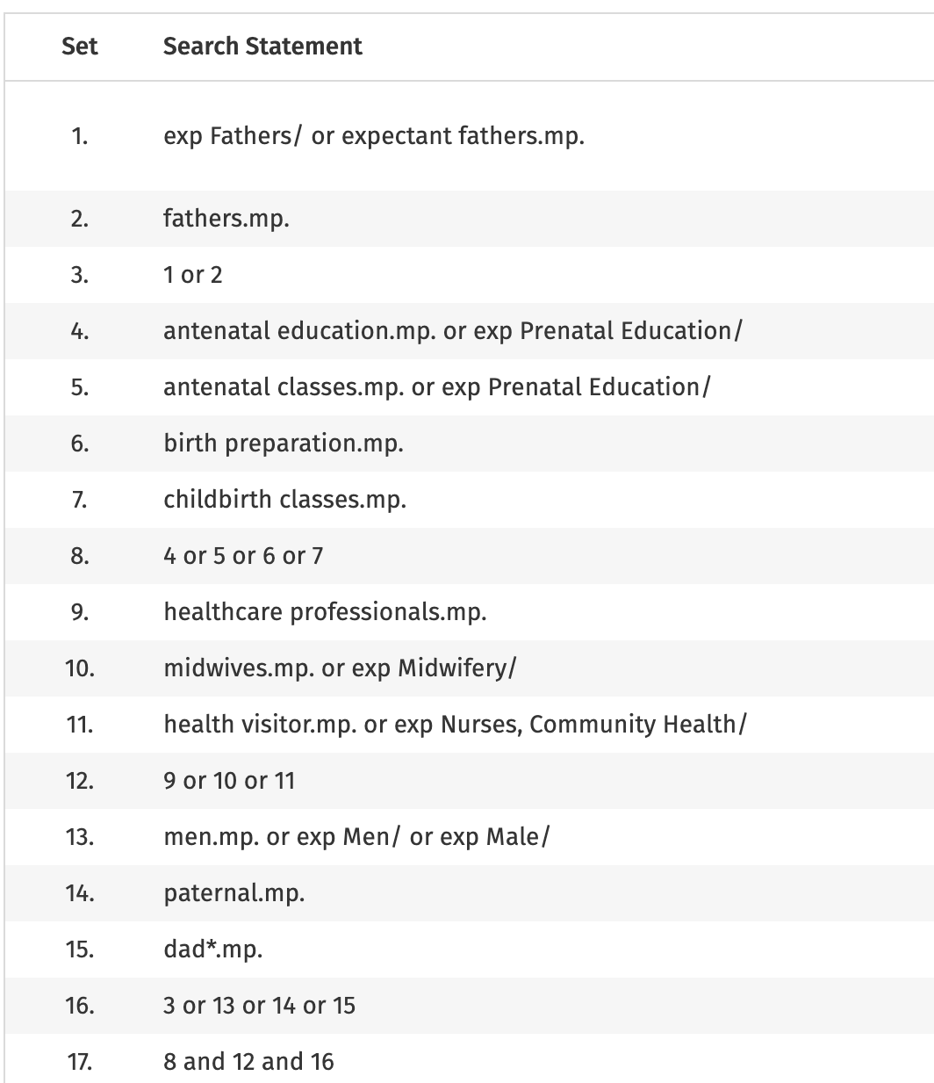
Medline search

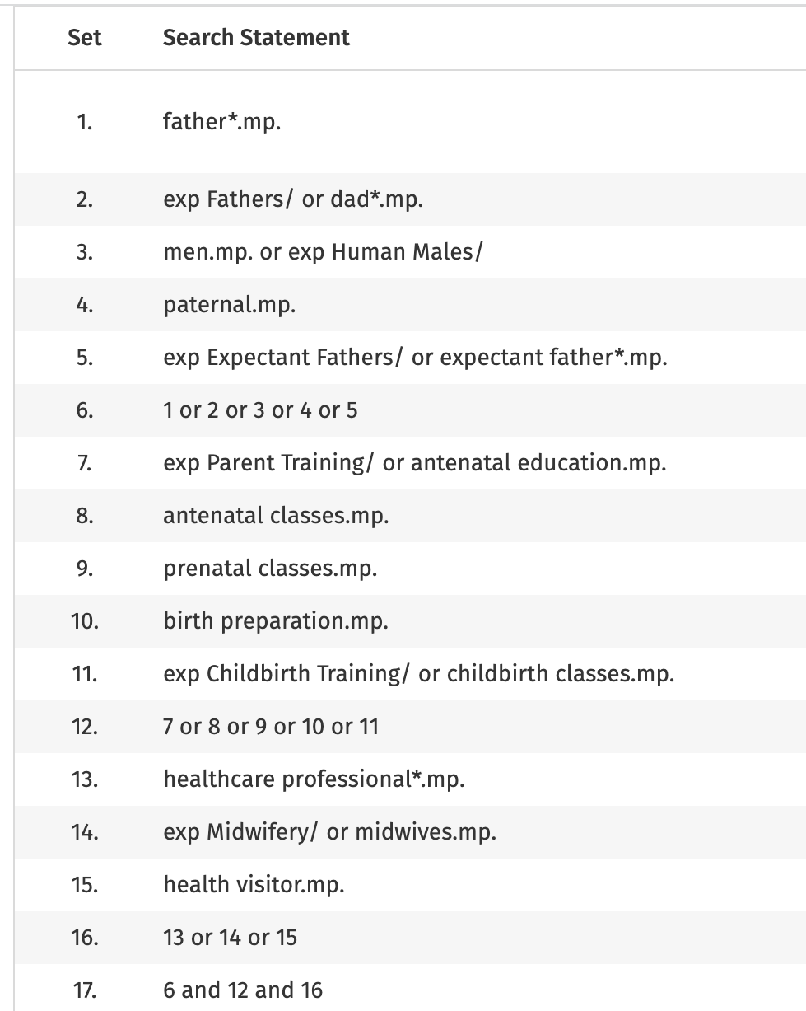
PsycInfo search

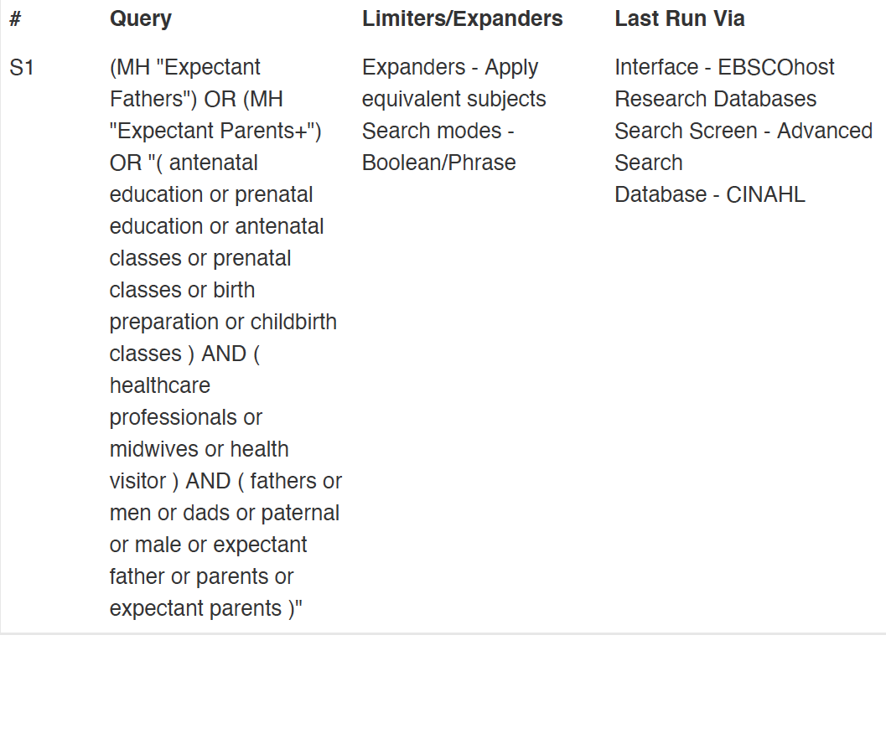CINHAL search

Appendix III – Table of findings and illustrations

Study | Findings | Illustrations | Credibility level
Ahldén et al (2008)  D(4/5) | - There is value in emphasizing the changes of roles and relations related to parenthood | “…the men’s situations must be affirmed…we must involve men to a greater extent, they must not feel marginalized.” (p.24) | U
Ahldén et al (2008)  D(4/5) | - In the fathers-to-be groups, male leaders are recommended as mandatory | “…these group contacts can be a very important way of attaching to others for social contact and support…belonging is important…” (p.24) | C
Ampim et al (2021)  D(4/5) | - They performed some roles in the form of seeking knowledge and providing emotional and physical support for their partners | “I always want to come here to know more about pregnancy, so I do not take anything for granted. Sometimes, the woman may complain of a headache, and you would not know what that means, but when you come here, and they teach, you would know how to treat such things. It helps me to take good care of her. Sometimes she forgets the thing they teach here as well, so when I go there, I take notes like a student so that I do not forget the lessons.” (p.6) | U
Ampim et al (2021)  D(4/5) | - Inadequate physical space | “The women at antenatal care are usually very plenty. Sometimes they (men) enter there, and they see plenty of women there, and they will go back. We do not even have space (physical) for the men. Therefore, we are not making it comfortable for men to involve themselves” (p.7) | U
Ampim et al (2021)  D(4/5) | - Would make their work much more manageable | “As I said before it (male inclusion) is something very good and makes the work simple for us. When you tell them what to do and what not to do, the men remind them (expectant mothers) at home to comply with the instructions. They (men) are always there to check their wives for us)” (p.7-8) | U
Andersson et al (2012)  D(4/5) | - They expected that the midwife would take a different approach in group sessions, focusing less on medical issues and more on parents’ and partners’ perspectives on childbirth | “discussion related often to the mothers, as a bonus the midwive asked, ‘-do you fathers think the same way’” (p.505) | NS
Andersson et al (2012)  D(4/5) | - Partners’ main priority was obtaining information | “If the husband is not present at the group sessions, he only gets knowledge through his woman…” (p.505) | C
Andersson et al (2012)  D(4/5) | - Preparation exercises were said to be appreciated and helpful. Most men, however, said they lacked preparation for the postnatal period | No data provided to support | NS
Andersson et al (2012)  D(4/5) | - Partner felt that he was unprepared to meet the ambient prejudices and other paternal norms that fathers face | “You need to be prepared for the ambient expectations of what a father should be able to do – to share parent leave, the courage to go against the stream” (p.505) | U
Andersson et al (2012)  D(4/5) | - Only a few men were present, making such groups imbalanced and also resulting in the men dropping out | No data provided to support | NS
Andersson et al (2012)  D(4/5) | - Fathers felt that they had passive roles | “Dads are shy, are novices, and are not socially trained to speak on traditionally female topics therefore it is difficult to speak in groups like this” (p.506) | U
Andersson et al (2012)  D(4/5) | - Men observed that when they shared their situations with other group members, they felt less anxiety | No data provided to support | NS
Andersson et al (2012)  D(4/5) | - Group sessions did not provide increased networking opportunities | No data provided to support | NS
Andersson et al (2012)  D(4/5) | - Nearly all participants requested more focus on couples, rather than pregnant woman | No data provided to support | NS
 | - [Partners] who were invited to attend three times expressed a desire to be present more often | No data provided to support | NS
Carlson et al (2014)  D(4/5) | - Fathers desired more instruction on how to be supportive during labour | “I think what would have been helpful support during the pregnancy if they had better birthing support classes for fathers because a lot of the classes I went to was for women and rightly it should be because most of the work on her, but there’s not enough instruction on how to support her. They just tell you, “don’t ask her no questions. Don’t expect her to make decisions.” So it’s like going in there and you really don’t have any idea on how to be supportive…I think it would’ve been nice if there were some men in some of those classes to say…”Hey guys, this is what you do” (p.250) | U
Carlson et al (2014)  D(4/5) | - Family relationships (…) would be a comparable and preferable alternative to formal childbirth classes | “It was more like she asked me to go and I didn’t want to go in the first place, but I just did it to kind of support her, ‘cause I told her we don’t need no pregnancy class. If you want a one-on-one pregnancy class, you can just come over to the crib, talk it over with my mom, tell you wassup.” (p.251) | U
Chandler & Field (1997)  D(4/5) | - They were dissatisfied with their own performance, which contrasted with their pre- natal belief that they would be able to comfort and support their wives | No data provided to support | NS
Darwin et al (2017)  D(4/5) | - The lack of preparation appeared heightened for men, who often noted an absence of information and resources that were tailored and targeted towards them | No data provided to support | NS
Darwin et al (2017)  D(4/5) | - Experiences of mother and baby groups and the lack of equivalent groups for fathers | “I think in some ways it would be helpful before and after to make sure that dads are prepared and that they’re coping and maybe even if it was just away from the mums for some people maybe, because I think some dads might find it a bit embarrassing to sort of say I don’t know what I’m doing.” (p. 10) | U
Darwin et al (2017)  D(4/5) | - ‘war stories’ and ‘banter’ | “You know we do talk to each other about parenting stuff but…it’s never a serious conversation, it’s all, done over a beer you know and a few jokes, which is good.” (p.10) | C
Darwin et al (2017)  D(4/5) | - Some men did not feel comfortable accessing classes and recognised that written materials may be more acceptable to some men | “Perhaps if there was some sort of dads thing, like a bounty pack which is just for dads. Okay, yeah, it’s got baby stuff in it as well, but it’s baby stuff that the dads would – and I know it’s hard because it shouldn’t matter whether you’re a male or a female really should I…So I don’t think you necessarily want to say right, here is a thing just for dads. But I do think you need something that’s quite directed at them” (p.11)  “I really enjoyed reading (the Dads’ handbook)…because a lot of it was based on other people’s experiences so you realise you’re not in the boat by yourself, that there are other people that have been through it and obviously it’s a natural thing that everyone does every day…it made me think about things that I hadn’t thought about or think less about things that I had been thinking about. So that was probably a big thing for me.” (p.11) | C
Deave & Johnson (2008)  D(5/5) | - They often felt excluded from antenatal appointments and classes | “The classes are a great help, but if you’re not involved in it, you’re sort of put to the back of the class, so to speak.” (p.629) | U
Deave & Johnson (2008)  D(5/5) | - For many men it was difficult to take time off work | “They don’t actually sort of involve you as a couple anywhere along the line…I felt very sort of left out…I felt sort of punished for working…” (p.629) | U
Deave & Johnson (2008)  D(5/5) | - A one-off antenatal session devised specifically for them | “They could have probably put what was relevant to me in one class instead of spreading it out, really…I’m not one to read a book, so to be told, it’s quite good.” (p.629) | U
Deave & Johnson (2008)  D(5/5) | - They emphasized how useful (…) to have heard from new parents | “I think that is the main sort of key factor in it, that you want to know what everyone else has been through.” (p.629) | C
Dolan & Coe (2011)  D(5/5) | - The focus was primarily on mothers and babies, which was deemed understandable and appropriate (…) lack of knowledge about childbirth and what it would be like for them as men | “That’s natural like. Because she’s carrying the baby.” (p.1024)  “It could be a bit more directed towards fathers. As regards information…There could be a bit more for fathers. There could be a little booklet telling you all the information you need.” (p.1024) | U
Dolan & Coe (2011)  D(5/5) | - Other more ‘comfortable’ environments | “They’re not happy…They fidget. They can’t sit still…It’s painfully obvious many don’t want to be here” (p.1026)  “I think really away from the hospital would be best. Some community venue where men already meet. Possibly a rugby club, social club, those sort of places…We need to go where the men are. Seek them out…Find the places where they’re comfortable” (p.1027) | U
Downer et al (2020)  D(4/5) | - Tactile objects were especially important for the men | “You could see a lot of the dads just zoning out, so it was good for them to be given something to play with and look at and wake up again.” (p.5) | U
Downer et al (2020)  D(4/5) | - Large classes can leave participants feeling intimidated and teachers frustrated | “The nights where we have the really little numbers, where it’s not viable for me to be doing it, are the best. Eight to 10, it’s perfect, because I set up a table that we just sit around a big table and our meals are served and we stay in the one place. It’s like going out to dinner with friends. So (there is) conversation of the guy sitting opposite, and the talking is really enhanced. Once the numbers get up, it’s a bit more to get through.” (p.8) | C
Erlandsson & Häggström-Nordin (2010)  D(5/5) | - The fathers perceived that the normal birth process focuses physically and psychologically on the mother | “Mothers first, and that may be right, but not always” (p.22) | C
Erlandsson & Häggström-Nordin (2010)  D(5/5) | - Mother-infant dyad should not be disturbed (…) must be supported | “We attended parental education and thought it would be a normal birth. My role was everything practical around mother and baby, the bed, the room, and such things” (p.22-23) | U
Erlandsson & Häggström-Nordin (2010)  D(5/5) | - Parental education classes (…) did not encourage fathers to say in close proximity to the mother and child | “The midwife puts the baby on the mothers’ breast – of course she should! But later on, when the mother may need to rest, the midwife could tell the fathers, “Please sit down, do this and do that.” To be involved is very important! It is this isolation of fathers that otherwise often becomes automatic. One will miss so much at the beginning of the infant’s life. In this way, one can experience a sense of unity (with the mother and child).” (p.23) | C
Erlandsson & Häggström-Nordin (2010)  D(5/5) | - They did not know what would happen to the father and the baby during maternal-infant separation | “The parental education touched on complications such as vacuum extraction and caesarean section, but there was nothing about the consequences for mother, father and child” (p.24) | U
Erlandsson & Häggström-Nordin (2010)  D(5/5) | - Re-assuring effect on the mother (..) because she knew the father could take care of their baby | “I believe it gave her (the mother) a peace of mind during separation, when she knew that I was with the baby up there (on the maternity ward), with less stress and less pain. It created a coherent experience and a feeling of safety” (p.24) | U
Erlandsson & Häggström-Nordin (2010)  D(5/5) | - Positive effects of skin-to-skin contact should be discussed more fully in (…) classes | “There is probably already research showing the positive effects of skin-to-skin care. They (leaders of parental education classes) could talk a little about that, and the potential risk that the mother may not be able to keep the baby skin-to-skin. And if she cannot breastfeed, she can still keep the baby skin-to-skin, and so on. And if the mother should not feel well or if she is just tired or has to do something else, it is the father that should give the child the skin-to-skin contact that the baby needs” (p.24) | U
Erlandsson & Häggström-Nordin (2010)  D(5/5) | - No emphasis on the father’s responsibility or early relationship with the baby | “…the mother was the one that should raise the child, and the father could come and play with the child sometimes” (p.25)  “The only time the father was mentioned (in parental education classes) was when we received information about social insurance, including paternity leave; otherwise, the attitude was that the mother was having the baby, not that we together, as a couple, were having a baby” (p.25)  “My opinion is that a father can be as important as a mother for a baby, except that he cannot breastfeed…and I believe that it is good, both for the mother and the father, to get the feeling at once that both of them can experience the baby” (p.25) | U
Finbogadóttir et al (2003)  D(4/5) | - Antenatal classes were a forum for meeting people in the same social situation | “The antenatal classes were good, because then I got to meet others in the same situation, that I could share questions and thoughts with.” (p.101) | U
Finbogadóttir et al (2003)  D(4/5) | - Antenatal classes were an excellent forum to quench their thirst for this [knowledge] | No data provided to support | NS
Henderson & Brouse (1991)  D(4/5) | - Frustration and anger at the confusion they felt (…) based on conflicting information | “We went to prenatal classes and they make it sound like the pain starts in twenty minutes and they get less and less and more frequent and then there’s a kid – well forget it I mean that’s not life So I was a little worried. They didn’t prepare you that it would go bang, bang, bang!” (p.295) | U
Henderson & Brouse (1991)  D(4/5) | - Expectations were of limited value | “I think they are useful from an information point of view (but) they can’t prepare you for it. They tell you what it’s going to be like and they try to give you a feeling for it – you can’t get a feeling until you do it yourself” (p.296) | U
Iwata (2014)  D(4/5) | - Developed participants’ feeling as a father (…) participating in prenatal classes | No data provided to support | NS
Iwata (2014)  D(4/5) | - Unexpectedly experienced a feeling of anger | “Fathers were treated like criminals from the beginning. I mean, the message was like women were exhausted because men didn’t help them. Many printings were written from such a perspective, so I got mad about it.” (p.163) | U
Johnsen et al (2017)  D(4/5) | - Fathers felt external pressure to attend (…) also expressed a personal willingness to share responsibilities | “It’s an expectation from myself, from her and from society…” (p.229) | C
Johnsen et al (2017)  D(4/5) | - Experiences and feelings confirmed by others in the same situation strengthened their supporting role | “…the first time, when we discussed generally how you felt, you got to know the others who were in the same boat, they have the same thoughts.” (p.231) | U
Johnsen et al (2017)  D(4/5) | - Sceptical when discussing deeper feelings (…) need for more practical advice and factual information | “Instead of having to sit and talk emotions…we don’t need to talk about that…so see some (video) where you get wiser from what you see, where you get some knowledge.” (p.231) | U
Jones et al (2019)  D(5/5) | - Expectations were vague and more general | “Learn a bit more knowledge” (p.238)  “Learn new things” (p.238)  “Learn things we haven’t thought of yet” (p.238) | U
Jones et al (2019)  D(5/5) | - There was a shift from a need for non-specific and at times vague aspects of knowledge gain | No data provided to support | NS
Kerstis et al (2018)  D(4/5) | - Arena for supporting fatherhood | No data provided to support | NS
Kerstis et al (2018)  D(4/5) | - Groups empowered fathers to be prepared for parenthood by encouraging them to have faith in their own ability to parent | “Fathers felt more encouraged to discuss issues with their partners that they were not able to before” (p.945)  “This is about being present and showing the importance of fathers in their role as a parent. They are incredibly important as a parent; their child need them to be present at home.” (p.946)  “You can start a discussion from a gender perspective, which also eventually teaches kids to be able to talk about it. It’s not that women and men do certain tasks, but they can do them in different ways” (p.946) | U
Kerstis et al (2018)  D(4/5) | - Those conversations encouraged fathers to take more responsibility (…) and more parental leave | No data provided to support | NS
Kerstis et al (2018)  D(4/5) | - How good it felt to meet other fathers in similar situations and to share experience | “To participate in these groups and talk about your fears and concerns and to see that they are not alone with these fears” (p.946)  “The thought it to build up a network that can continue afterward” (p.946) | U
Kerstis et al (2018)  D(4/5) | - Guide them to be more comfortable in their parenting role | “The (fathers’) attachment to the child might lead to his relationship with his partner being able to stand greater strain than it would have if we had not talked about this” (p.947) | C
Kerstis et al (2018)  D(4/5) | - Expectations of a macho climate (…) leaders counteracted it | “Sometimes I have seen that there has been a macho culture in father groups. Some expect that we come to father groups so that they can drink a beer. We have enough of macho cultures, which I have never understood. Father groups are about being a parent, about being present and demonstrating the importance of the father in his role as a parent” (p.947) | U
Kerstis et al (2018)  D(4/5) | - The father group leaders described that the groups could facilitate gender changes in society, as the participants and the leaders positively inspire the fathers to involve themselves more in family life | No data provided to support | NS
Kerstis et al (2018)  D(4/5) | - Women sometimes tended to take over the conversation | “Women tend to dominate the conversations when it’s mixed groups, and there may not be enough time to discuss the psychosocial aspects (of becoming a parent)” (p.947) | U
Kerstis et al (2018)  D(4/5) | - Policy makers who determine the father groups’ existence sometimes had negative attitude | “The policy makers think they are already working on the (fathers’) issues and are already doing enough of this. With that, I think they mean that the midwives are already doing the work” (p.947) | U
Lönnberg et al (2018)  D(4/5) | - Fathers also mentioned feeling well informed and prepared by the course | “I could give this good, this really, really, good support…if she lost it a bit I could simply remind her, lead her back on track again. Incredibly good, not just for the woman but for the guy as well.” (p.5) | C
Mottram (2008)  D(5/5) | - Felt very differently when attending NCT classes | “…the NCT classes, you’re there, there is definitely two of you being considered all the time…” (p.585) | C
Mottram (2008)  D(5/5) | - Felt quite safe and in control (…) explained by the level and quality of information that he had received via the NCT classes | “Yeah, I mean I don’t know what it would have been like if I hadn’t, but yeah, if I myself hadn’t been to NCT um, you’d obviously be relying on information that my partner had got from NHS classes I guess…I wouldn’t be in such a good position to make a decision on that. The home birth stuff, the information the NCT gave out every week was brilliant…” (p. 587) | C
Nash (2018)  D(4/5) | - Father-only antenatal groups (…) provided the men with a different perspective from which to understand their own experiences as expectant fathers | “The guy we spoke to about the fatherhood program, he said back when, he only said he was about 50, it was probably 30 years ago now, he was not really included in the pregnancy at all; it was all about her, and he was not allowed in the room. It made you realize how much things have progressed since then, and us as fathers were included in the pregnancy a lot more, and also we play a bigger part in the child’s life as well.” (p. 301)  “It’s really interesting because Dad (saying) that he regrets not spending more time at home actually is more helpful, I think, than someone actually doing it, like being there all the time or whatever…He’s your dad, he’s quite rough and whatever. It obviously does mean something to him, so probably, from my point of view now, I’ll take that onboard and go, “Oh well, I’ll definitely make sure that I do not commit the sins of the father” I guess, in many respects.” (p.301) | C
Nash (2018)  D(4/5) | - Motivated to attend the sessions because they were not asking for or receiving much personal support in relation to pregnancy and birth | “Dad and I do not – well, we talk and that sort of thing, but we’re not really sharing type of guys, I guess, that have big deep and meaningful conversation. So it’s – I probably haven’t really talked to many people about, I guess, fatherhood and that sort of thing.” (p. 301) | C
Nash (2018)  D(4/5) | - By seeking help (…) men worry that their masculine identities will be endangered | “I do not feel confident, because I do not – as much as we were told the gruesome detail (of birth) – I still do not really know what it’s going to be like, and as far as I can gather it’s different for everybody…But I do not need support, as a general rule, for even very difficult things. I tend to deal with them myself” (p.301) | C
Nash (2018)  D(4/5) | - Men confirmed that having a male facilitator who was a father was important | “(The facilitator) talked about his experiences as a father, and that I guess relaxed us a little bit…So it was good to get that bit of man-talk out in the open…Just talking about how we felt about being fathers, because in the Group 1, guess not many of the guys spoke much in that open group with the other ladies.” (p.302)  “I found it very useful just to know that – to hear from a guy. We heard all the time about the lady’s perspective what to expect in birth, but never from, I guess, the guy’s point of view.” (p.302) | U
Nash (2018)  D(4/5) | - Ambivalence about and resistance to the expression of vulnerability and the rejection of hegemonic masculine norms | “I think (the GBADC group) should probably be less of a “let’s talk about our feelings” class, which guys on the whole aren’t good at, especially Australian guys, and more of a hands-on thing…Put something together that’s more informal, like just, “Here’s the information. Any questions?” It was more of a touchy-feely depression-style identifying session. I didn’t really get heaps out of it, to be honest.” (p.302)  “The guy that runs it is just no-nonsense, and he knows what he’s talking about because he’s a midwife and he grabs the most – well, the stuff that you’d want to know about the birth process – and just gives you hands-on information. Doesn’t ask you, you know, what are your deepest, darkest fears or anything, just says here's the runner for 99% of births, and as you’re going along you can ask a question like, so, you know, on this scale, when does the water break? Or when does – you can just – we can get more facts” (p. 303) | U
Nash (2018)  D(4/5) | - Men (…) see themselves as involved fathers, compared to the other men, who are “bogans” | “There was a big emphasis on (women as) primary carers and (men as) secondary carers and…you know, things like that. And it was sort of like, “Okay, completely not relevant.” For a minute there, I was sort of like, “Am I stuck in here in a class that is meant for bogans?”” (p.303) | U
Nash (2018)  D(4/5) | - Men did provide suggestions as to how they thought that antenatal support services for fathers could be extended and improved | “I reckon if there was maybe one (class) at the start (of Pregnancy) and one toward the end (of pregnancy) instead of just having one at the end, that would have maybe, from my point of view,  would have probably given me more confidence to share more in those other weeks. I reckon, yeah, if there was a class at the start and then you came back at the end to say, “Okay, how has your thinking progressed, whatever it is?” that could have probably been more beneficial.” (p.304)  ‘Maybe a guy’s not so much a helpline but just somewhere where you go or ring someone to just chat to. Maybe another guy, you know, this is what I’m going through kind of thing. Just something to share with someone else that maybe you do not know, just because they will not judge you and they do not know you” (p.304)  “I just think we should have a fathers’ group…I wouldn’t mind doing that sort of thing up here, but the turnout probably wouldn’t be that great.” (p.304) | U
Pålson et al (2017)  D(4/5) | - Fathers wanted to know about how to care for their healthy infants well as being able to know and react when the baby was unwell or not developing normally | “Every baby is different. You have to expect the unexpected and not have too many preconceptions about how the baby should behave.” (p.88) | C
Pålson et al (2017)  D(4/5) | - Fathers wanted realistic information and preparation with a focus on problem-solving in order to be better prepared for the challenge | “I have to say that there I was not prepared at all but had a mental picture that it’s just a matter of laying the baby to the breast and it all works. When it didn’t work you stood there: aha, what the hell do we do now?” (p.88) | U
Pålson et al (2017)  D(4/5) | - Little attention was given to birth complications | “It’s probably to do with the complications that the pregnancy led to…and that she hasn’t recovered at the expected rate…that it’s extra hard work, not just having a baby to take care of…and that’s something one wasn’t prepared for.” (p.89) | U
Pålson et al (2017)  D(4/5) | - It could take time to adjust to becoming a father (…) was something worth talking about and preparing for | “You don’t need to feel this great surge of happiness that everyone writes about on Facebook. I can still feel…yes it’s happiness but it’s stressful…I still haven’t adjusted to it…” (p.89) | U
Pålson et al (2017)  D(4/5) | - New parents should be invited to share their experiences with the expectant parents | “Parents…get them to ask people who have three kids to join in a discussion…because they’ve already got the gen.” (p.90) | U
Pålson et al (2017)  D(4/5) | - Parental groups as a good way to prepare [but] there wasn’t enough time to cover all areas of interest | “Parental groups are an excellent way to prepare but they were too short…we hardly spoke of the time after birth.” | U
Pålson et al (2017)  D(4/5) | - Rather than asking the fathers what they wanted to know, the midwife should be pro-active in guiding them towards the information they might need | “The midwife was very nice…and she asked: do you have any questions? But you don’t have any questions if you don’t know what is coming. I would know now (after birth) what to ask” (p.90) | U
Pålson et al (2017)  D(4/5) | - Using humour could be a way of capturing interest | “Information needs to be well choreographed; it needs to capture our interest; it needs to be given in a fun way. Use humour: situations can afterwards be looked at as funny or comic but when you are in it, it’s like a matter of life or death.” (p.90) | U
Pålson et al (2017)  D(4/5) | - An open discussion climate was enhanced by limited group size | No data provided to support | NS
Pålson et al (2017)  D(4/5) | - The groups could be seen as too intimate and the climate could also be experienced as competitive | No data provided to support | NS
Pålson et al (2017)  D(4/5) | - Fathers who had attended a fathers-only discussion session, led by a man, appreciated it | No data provided to support | NS
Poh et al (2014)  D(4/5) | - Too theoretical | “Uuhh…through those er…I mean, I believe er…practice makes perfect. Hands-on la, better. Cos if the class itself is…we looked through the slides most of the time, I would say 99%. Then the rest is the baby doll, the dummy…(laughs).” (p.785) | U
Poh et al (2014)  D(4/5) | - Some fathers either do not know about its existence or felt that they could readily obtain the information elsewhere | No data provided to support | NS
Premberg & Lundgren (2006)  D(4/5) | - The information given through child-birth education classes was not viewed as anything unique | “There is always something new to learn (in childbirth education)…but I think you can get a lot of advice and information in books, as well as from friends and relatives, I think that’s useful…” (p.24) | U
Premberg & Lundgren (2006)  D(4/5) | - It would be important for more information to be addressed directly to the fathers | “some kind of lecture discussing the father’s role” (p.24) | C
Premberg & Lundgren (2006)  D(4/5) | - The fathers also described childbirth education as being too basic | No data provided to support | NS
Premberg & Lundgren (2006)  D(4/5) | - Sharing other parents’ stories contributed to a wider understanding [but] some of the stories as being too extreme | “There were narratives told by the other parents about their earlier pregnancies and deliveries…but they varied, so you can’t rely on it…it would not be the same for us…but it is interesting to hear what they have experienced” (p.24)  “They told us about their experiences – horror stories – nothing I could consider at all” (p.24) | U
Premberg & Lundgren (2006)  D(4/5) | - Sharing experiences and talking in the groups with other men, without female presence, was described as essential | “There was another kind of talk…Everyone experienced that we talked more freely…when the wives and girlfriends were not around. It was the same for me.” (p.24) | U
Premberg & Lundgren (2006)  D(4/5) | - A role in supporting and encouraging the woman | “It is natural that everyone concentrates on the woman, but it is good for me to hear that I’m a great support, just to be there giving support, it means a lot.” (p.24) | U
Premberg & Lundgren (2006)  D(4/5) | - The course (sh)ould include physical exercises, such as breathing or relaxation techniques, and to prepare for the birth | “…such as a joint breathing exercise. I’ve seen it on pictures, people sitting on the floor…and the father holds the mother in his arms, and exercises like that…But we had nothing of that in our course…” (p.25) | U
Rominov et al (2017)  D(5/5) | - Targeted education about fathers would enable them to enhance the antenatal classes they provide | “The antenatal classes are really inadequate…they don’t seem to address a lot of the intimate concerns that fathers do have.” (p.313) | U
Sansiriphun et al (2010)  D(4/5) | - The men needed more information beyond the methods of supporting pregnant women | “The classes are very basic…most instructions focus on the woman, not on the baby or the husband…I got some information…but it was not as much as I had expected…” (p.406) | U
Sheriff et al (2009)  D(4/5) | - Fathers probably don’t see breastfeeding as something they can help with | “…I was always at work…it wasn’t an evening which would have been easier to attend…there was a separate breastfeeding session which dads were invited to but…one person attended apparently, but that wasn’t me…it was probably a bit funny because this isn’t something I can help with, probably was the impression.” (p. 224) | U
Smith (1999)  D(4/5) | - The role of the labour partner was ‘completely omitted’ | “My role as a labour partner wasn’t really dealt with…the classes were interesting from an intellectual point of view…but I felt detached from them because they didn’t affect me directly” (p.25) | U
Tarlazzi et al (2009)  D(4/5) | - Fathers were equally unprepared for their own role | “I believed it would be a bit easier…I couldn’t imagine you had to think how to behave – what can I say? You don’t have to show if you lose confidence, I didn’t think about that before. I thought it had to be an easy way to support…but you discover you have to provide quite a strong support…that you have to insist…I was scared about needles…driven…you don’t know what to expect…her way of acting…so calm but determined in telling me what she was expecting from me…it was a surprise.” (p. 192) | C
Tohotoa et al (2009)  D(5/5) | - Fathers had often attended antenatal education classes they still felt inadequately prepared | “You want similar information that mothers are given in mother’s group on how to feed, nurture and bond. Antenatal classes give the impression that fathers have nothing to do with their child.” (p.6) | U
Tohotoa et al (2009)  D(5/5) | - Need for reassurance and support for fathers | “It is easy to feel that the mother knows what to do and for the dad to stand back because he is a bit scared of doing it wrong. Confirmation that the mother is just as out of her depth as the fathers, and that it is a team effort.” (p.6) | U
Uengwongsapat et al (2018)  D(5/5) | - Feeling determined to learn how to care for their girlfriends and unborn baby | “I searched information about how to take care of a baby. I have to learn how to be a father…I asked advice from my mother.” (p.249)  “In this class I learned how to take care of my newborn baby, how to bathe the newborn, how to change the baby’s clothes…” (p.249) | C
Vahtel et al (2021)  D(5/5) | - Prenatal classes had a positive effect on being at their birth | “The antenatal classes give me an idea of what I might see during the birth. The midwife always gave us the chance to ask questions” (p.4) | C
Vahtel et al (2021)  D(5/5) | - They supported antenatal classes that were just for fathers | “The chance to talk to other men released pressure and took away worries, that something might happened to their partner or the baby during pregnancy and birth.” (p.5) | C
Vahtel et al (2021)  D(5/5) | - They wanted to talk about that they did not particularly want their partners to hear | No data provided to support | NS
Notes: D(x/5) – Dependability Score; U – unequivocal; C – credible; NS – Not supported

Appendix IV – Synthesized Finding 1
Findings | Categories | Synthesized Finding
They performed some roles in the form of seeking knowledge and providing emotional and physical support for their partners U  (Ampim et al, 2021) | To be part of the process and not just a support person | Father’s role needs to be acknowledged  Fathers expressed they felt involved in the pregnancy with their partner, but excluded from the process when it came to professionals and available resources.  They felt their role was either not mentioned, or talked about as a minor supportive role instead of an equal parent.  Fathers real want to be acknowledged and educated for their own unique role and how to be “better” at it.
The fathers perceived that the normal birth process focuses physically and psychologically on the mother C  (Erlandsson & Häggström-Nordin, 2010) | To be part of the process and not just a support person
Mother-infant dyad should not be disturbed (…) must be supported U  (Erlandsson & Häggström-Nordin, 2010) | To be part of the process and not just a support person
Parental education classes (…) did not encourage fathers to say in close proximity to the mother and child C  (Erlandsson & Häggström-Nordin, 2010) | To be part of the process and not just a support person
Fathers felt external pressure to attend (…) also expressed a personal willingness to share responsibilities C  (Johnsen et al, 2017) | To be part of the process and not just a support person
Fathers also mentioned feeling well informed and prepared by the course C  (Lönnberg et al, 2018) | To be part of the process and not just a support person
Felt very differently when attending NCT classes C  (Mottram, 2008) | To be part of the process and not just a support person
A role in supporting and encouraging the woman U  (Premberg & Lundgren, 2006) | To be part of the process and not just a support person
The course (sh)ould include physical exercises, such as breathing or relaxation techniques, and to prepare for the birth U  Premberg & Lundgren (2006) | To be part of the process and not just a support person
Fathers felt that they had passive roles U  (Andersson et al, 2012) | Feeling left out and being the second parent
They often felt excluded from antenatal appointments and classes U  (Deave & Johnson, 2008) | Feeling left out and being the second parent
For many men it was difficult to take time off work U  (Deave & Johnson, 2008) | Feeling left out and being the second parent
The focus was primarily on mothers and babies, which was deemed understandable and appropriate (…) lack of knowledge about childbirth and what it would be like for them as men U  (Dolan & Coe, 2011) | Feeling left out and being the second parent
Other more ‘comfortable’ environments U  (Dolan & Coe, 2011) | Feeling left out and being the second parent
Unexpectedly experienced a feeling of anger U  (Iwata, 2014) | Feeling left out and being the second parent
Fathers probably don’t see breastfeeding as something they can help with U  (Sheriff et al, 2009) | Feeling left out and being the second parent
The role of the labour partner was ‘completely omitted’ U  (Smith, 1999) | Feeling left out and being the second parent
Need for reassurance and support for fathers U  (Tohotoa et al, 2009) | Feeling left out and being the second parent
Inadequate physical space U  (Ampim et al, 2021) | Feeling left out and being the second parent

Appendix V – Synthesized Finding 2
Findings | Categories | Synthesized Finding
Partners’ main priority was obtaining information C  (Andersson et al, 2012) | Fathers want knowledge and clarification about their role | Antenatal classes do not prepare fathers  Fathers understand that there is a lot they don’t know about this topic, so sometimes it is hard to express what they want to know beforehand. However, content was thought to be quite basic and not focusing in important matters for fathers, such as their unique role, how to prepare and support in case of complications (in pregnancy, labour and after). Therefore, many fathers felt unprepared by classes and gave many suggestions for improvement.
Expectations were vague and more general U  (Jones et al, 2019) | Fathers want knowledge and clarification about their role
Fathers wanted to know about how to care for their healthy infants well as being able to know and react when the baby was unwell or not developing normally C  (Pålson et al, 2017) | Fathers want knowledge and clarification about their role
Rather than asking the fathers what they wanted to know, the midwife should be pro-active in guiding them towards the information they might need U  (Pålson et al, 2017) | Fathers want knowledge and clarification about their role
It would be important for more information to be addressed directly to the fathers C  (Premberg & Lundgren, 2006) | Fathers want knowledge and clarification about their role
Feeling determined to learn how to care for their girlfriends and unborn baby C  (Uengwongsapat et al, 2018) | Fathers want knowledge and clarification about their role
Partner felt that he was unprepared to meet the ambient prejudices and other paternal norms that fathers face U  (Andersson et al, 2012) | Content could be too basic and not addressing fathers’ needs
Fathers desired more instruction on how to be supportive during labour U  (Carlson et al, 2014) | Content could be too basic and not addressing fathers’ needs
Positive effects of skin-to-skin contact should be discussed more fully in (…) classes U  (Erlandsson & Häggström-Nordin, 2010) | Content could be too basic and not addressing fathers’ needs
Too theoretical U  (Poh et al, 2014) | Content could be too basic and not addressing fathers’ needs
Men did provide suggestions as to how they thought that antenatal support services for fathers could be extended and improved U  (Nash, 2018) | Content could be too basic and not addressing fathers’ needs
Parental groups as a good way to prepare [but] there wasn’t enough time to cover all areas of interest U  (Pålson et al, 2017) | Content could be too basic and not addressing fathers’ needs
The men needed more information beyond the methods of supporting pregnant women U  (Sansiriphun et al, 2010) | Content could be too basic and not addressing fathers’ needs
Some men did not feel comfortable accessing classes and recognised that written materials may be more acceptable to some men C  (Darwin et al, 2017) | Content could be too basic and not addressing fathers’ needs
Re-assuring effect on the mother (..) because she knew the father could take care of their baby U  (Erlandsson & Häggström-Nordin, 2010) | Classes did not always prepared fathers for what was to come
Frustration and anger at the confusion they felt (…) based on conflicting information U  (Henderson & Brouse, 1991) | Classes did not always prepared fathers for what was to come
Expectations were of limited value U  (Henderson & Brouse, 1991) | Classes did not always prepared fathers for what was to come
Felt quite safe and in control (…) explained by the level and quality of information that he had received via the NCT classes C  (Mottram, 2008) | Classes did not always prepared fathers for what was to come
Fathers wanted realistic information and preparation with a focus on problem-solving in order to be better prepared for the challenge U  (Pålson et al, 2017) | Classes did not always prepared fathers for what was to come
It could take time to adjust to becoming a father (…) was something worth talking about and preparing for U  (Pålson et al, 2017) | Classes did not always prepared fathers for what was to come
Fathers were equally unprepared for their own role C  (Tarlazzi et al, 2009) | Classes did not always prepared fathers for what was to come
Prenatal classes had a positive effect on being at their birth birth C  (Vahtel et al, 2021) | Classes did not always prepared fathers for what was to come
They did not know what would happen to the father and the baby during maternal-infant separation U  (Erlandsson & Häggström-Nordin, 2010) | Classes did not always prepared fathers for what was to come
Little attention was given to birth complications U  (Pålson et al, 2017) | Classes did not always prepared fathers for what was to come
Fathers had often attended antenatal education classes they still felt inadequately prepared U  (Tohotoa et al, 2009) | Classes did not always prepared fathers for what was to come

Appendix VI – Synthesized Finding 3
Findings | Categories | Synthesized Finding
Family relationships (…) would be a comparable and preferable alternative to formal childbirth classes U  (Carlson et al, 2014) | Value of informal support networks | What works for fathers  Fathers valued classes mostly due to the element of experience sharing and understanding that they are not alone in their situation. However, some fathers didn’t like to discuss feelings and sharing experiences and preferred a “no-nonsense”, hands-on approach.  Many fathers spoke about their informal support networks (such as family and friends) and some even prefer this to antenatal classes.  Fathers that attended father-only groups were very satisfied with that experience as it allowed for different type of discussions (without inhibition of women being present) and also for a better understanding of the father´s role. Some fathers that didn´t had the chance to attend such groups, suggested that this could be the way forward. Within this topic, having male facilitators in these groups was also valued as they see this person as experienced and knowledgeable about “being a father”.
‘war stories’ and ‘banter’ C  (Darwin et al, 2017) | Value of informal support networks
The information given through child-birth education classes was not viewed as anything unique U  (Premberg & Lundgren, 2006) | Value of informal support networks
How good it felt to meet other fathers in similar situations and to share experience U  (Kerstis et al, 2018) | Value of father-only sessions/groups
Experiences of mother and baby groups and the lack of equivalent groups for fathers U  (Darwin et al, 2017) | Value of father-only sessions/groups
A one-off antenatal session devised specifically for them U  (Deave & Johnson, 2008) | Value of father-only sessions/groups
Guide them to be more comfortable in their parenting role C  (Kerstis et al, 2018) | Value of father-only sessions/groups
Father-only antenatal groups (…) provided the men with a different perspective from which to understand their own experiences as expectant fathers C  (Nash, 2018) | Value of father-only sessions/groups
Motivated to attend the sessions because they were not asking for or receiving much personal support in relation to pregnancy and birth C  (Nash, 2018) | Value of father-only sessions/groups
Sharing experiences and talking in the groups with other men, without female presence, was described as essential U  (Premberg & Lundgren, 2006) | Value of father-only sessions/groups
They emphasized how useful (…) to have heard from new parents C  (Deave & Johnson, 2008) | Value of sharing
Antenatal classes were a forum for meeting people in the same social situation U  (Finbogadóttir et al, 2003) | Value of sharing
Experiences and feelings confirmed by others in the same situation strengthened their supporting role U  (Johnsen et al, 2017) | Value of sharing
They supported antenatal classes that were just for fathers C  (Vahtel et al, 2021) | Value of sharing
New parents should be invited to share their experiences with the expectant parents U  (Pålson et al, 2017) | Value of sharing
Sharing other parents’ stories contributed to a wider understanding [but] some of the stories as being too extreme U  (Premberg & Lundgren, 2006) | Value of sharing
Sceptical when discussing deeper feelings (…) need for more practical advice and factual information U  (Johnsen et al, 2017) | Value of hands-on knowledge
Ambivalence about and resistance to the expression of vulnerability and the rejection of hegemonic masculine norms U  (Nash, 2018) | Value of hands-on knowledge
In the fathers-to-be groups, male leaders are recommended as mandatory C  (Ahldén et al, 2008) | Value of male facilitators
Men confirmed that having a male facilitator who was a father was important U  (Nash, 2018) | Value of male facilitators

Appendix VII – Synthesized Finding 4
Findings | Categories | Synthesized Finding
There is value in emphasizing the changes of roles and relations related to parenthood U  (Ahldén et al, 2008) | How professionals feel about educating fathers | Gateway to equal parenting  Most professionals recognised the value of fatherhood education and its importance towards family health and happiness.  Male facilitators for father-only groups also see these groups as a way to empower fathers, thus promoting equal parenting.  Professionals also recognise that there is still a big lack of resources and support for fathers and that this is also not greatly supported by policy makers.  Facilitators also discussed the different teaching techniques they use with fathers to make the sessions more engaging and successful for fathers.  However, some fathers felt the discourse in these groups can still be very stereotypical and they might feel offended by this. Even so, some men still felt they shouldn’t need or try to find help as “they don’t usual need to do it”. Most professionals claimed that they were against, and would tone down, this type of behaviour (“macho culture”).
Groups empowered fathers to be prepared for parenthood by encouraging them to have faith in their own ability to parent U  (Kerstis et al, 2018) | How professionals feel about educating fathers
Women sometimes tended to take over the conversation U  (Kerstis et al, 2018) | How professionals feel about educating fathers
Policy makers who determine the father groups’ existence sometimes had negative attitude U  (Kerstis et al, 2018) | How professionals feel about educating fathers
Targeted education about fathers would enable them to enhance the antenatal classes they provide U  (Rominov et al, 2017) | How professionals feel about educating fathers
Would make their work much more manageable U  (Ampim et al, 2021) | How professionals feel about educating fathers
Large classes can leave participants feeling intimidated and teachers frustrated C  (Downer et al, 2020) | Use of different teaching styles
Using humour could be a way of capturing interest U  (Pålson et al, 2017) | Use of different teaching styles
Tactile objects were especially important for the men U  (Downer et al, 2020) | Use of different teaching styles
Expectations of a macho climate (…) leaders counteracted it U  (Kerstis et al, 2018) | Stereotypes are still felt
Men (…) see themselves as involved fathers, compared to the other men, who are “bogans” U  (Nash, 2018) | Stereotypes are still felt
By seeking help (…) men worry that their masculine identities will be endangered C  (Nash, 2018) | Stereotypes are still felt
No emphasis on the father’s responsibility or early relationship with the baby U  (Erlandsson & Häggström-Nordin, 2010) | Stereotypes are still felt

