Supplementary file
Supplementary Table 01: Incidence of Age-Wise Enteric Fever Stratified by Diagnostic Test Across Districts in Mizoram (N=30000)
Districts | Widal test  (Cases/ 100 000 person-years) |  |  | Typhidot  (Cases/ 100 000 person-years) |  |  | Culture  (Cases/ 100 000 person-years) |  |  | Total  (Cases/ 100 000 person-years)
Districts | Below 15 | 15 and above | Total | Below 15 | 15 and above | Total | Below 15 | 15 and above | Total | Below 15 | 15 and above | Total
Aizawl | 260 [244.3 - 276.0] | 221 [210.9 - 230.9] | 233 [224.9 - 241.8] | 315 [297.9 - 332.8] | 421 [407.8 - 435.5] | 387 [376.6 - 398.4] | 39 [32.9 - 45.4] | 28 [24.3 - 31.5] | 31 [28.2 - 34.5] | 614 [589.6 - 638.2] | 670 [652.7 - 687.6] | 652 [637.9 - 666.2]
Champhai | 959 [896.5 - 1024.8] | 533 [500.9 - 566.5] | 669 [639.6 - 700.0] | 251 [219.8 - 286.0] | 204 [184.4 - 225.1] | 219 [202.3 - 237.0] | 3 [0.7 - 9.6] | 4 [1.5 - 7.4] | 4 [1.7 - 6.5] | 1214 [1143.2 - 1287.3] | 741 [702.7 - 779.9] | 892 [857.6 - 927.3]
Hnahthial | 636 [550.5 - 730.0] | 884 [814.0 - 958.0] | 804 [749.3 - 862.4] | 645 [559.4 - 740.2] | 640 [580.8 - 703.7] | 642 [592.6 - 693.7] | 54 [31.5 - 86.5] | 67 [49.1 - 90.0] | 63 [48.3 - 80.8] | 1335 [1210.1 - 1468.6] | 1591 [1497.0 - 1689.7] | 1509 [1433.3 - 1587.9]
Khawzawl | 610 [528.3 - 700.6] | 297 [258.0 - 340.4] | 397 [359.5 - 437.7] | 247 [196.2 - 307.0] | 222 [188.8 - 260.4] | 230 [201.9 - 261.7] | 3 [0.1 - 17.0] | 3 [0.3 - 10.4] | 3 [0.6 - 8.6] | 860 [762.5 - 966.4] | 522 [470.1 - 578.9] | 630 [582.8 - 681.0]
Kolasib | 292 [258.6 - 328.2] | 164 [146.8 - 182.5] | 205 [189.0 - 221.8] | 223 [193.9 - 254.8] | 194 [175.3 - 214.1] | 203 [187.4 - 220.0] | 28 [18.6 - 41.1] | 27 [20.0 - 34.7] | 27 [21.5 - 33.7] | 543 [497.2 - 591.7] | 384 [358.0 - 412.4] | 435 [411.9 - 459.5]
Lawngtlai | 453 [416.7 - 490.6] | 288 [268.2 - 308.5] | 341 [322.8 - 359.0] | 181 [158.2 - 205.2] | 103 [91.1 - 115.4] | 128 [116.9 - 139.1] | 37 [27.2 - 48.9] | 43 [35.6 - 51.5] | 41 [35.1 - 47.8] | 670 [626.3 - 716.0] | 434 [409.3 - 458.8] | 509 [487.5 - 531.6]
Lunglei | 569 [527.0 - 612.6] | 450 [424.2 - 476.3] | 488 [465.8 - 510.5] | 1339 [1275.2 - 1406.0] | 879 [842.8 - 915.5] | 1026 [994.1 - 1058.7] | 55 [42.7 - 69.9] | 26 [20.4 - 33.3] | 35 [29.8 - 42.0] | 1963 [1885.2 - 2043.4] | 1355 [1310.1 - 1400.2] | 1549 [1510.0 - 1589.4]
Mamit | 698 [643.6 - 756.3] | 538 [504.6 - 572.3] | 589 [560.4 - 618.7] | 88 [69.5 - 110.3] | 136 [119.6 - 153.9] | 121 [107.9 - 134.5] | 9 [4.0 - 18.3] | 19 [12.9 - 25.9] | 16 [11.2 - 21.1] | 796 [737.2 - 857.5] | 692 [654.5 - 731.3] | 725 [693.4 - 758.1]
Saiha | 10 [2.6 - 24.7] | 18 [10.4 - 29.4] | 15 [9.4 - 23.8] | 1064 [967.6 - 1168.5] | 750 [694.2 - 809.7] | 851 [801.4 - 902.5] | 104 [74.9 - 139.5] | 103 [83.0 - 126.6] | 103 [86.5 - 122.3] | 1178 [1075.6 - 1286.8] | 872 [811.0 - 935.4] | 969 [916.7 - 1024.6]
Saitual | 1047 [959.2 - 1140.0] | 669 [621.1 - 720.0] | 790 [746.7 - 835.1] | 177 [142.0 - 217.5] | 140 [118.7 - 164.5] | 152 [133.2 - 172.4] | 6 [1.2 - 17.4] | 5 [1.5 - 10.9] | 5 [2.2 - 10.0] | 1229 [1134.4 - 1330.2] | 814 [760.9 - 869.9] | 947 [899.5 - 996.3]
Serchhip | 965 [885.7 - 1050.2] | 888 [834.8 - 942.7] | 912 [868.2 - 958.3] | 685 [618.3 - 757.2] | 903 [850.3 - 959.1] | 834 [791.4 - 877.5] | 62 [43.5 - 86.9] | 65 [51.0 - 80.8] | 64 [52.7 - 76.9] | 1713 [1606.3 - 1824.8] | 1856 [1779.1 - 1934.6] | 1810 [1747.5 -1874.1]
Mizoram | 487 [474.7 - 500.4] | 363 [355.3 - 370.5] | 403 [396.1 - 409.3] | 426 [413.7 - 437.8] | 399 [391.4 - 407.4] | 408 [401.2 - 414.5] | 36 [32.4 - 39.5] | 31 [28.4 - 32.8] | 32 [30.4 - 34.1] | 949 [931.1 - 967.0] | 793 [781.5 - 804.0] | 843 [833.2 - 852.3]
Note: The population was taken from Harvard population estimates for 2022 except for Saitual.
The population for Saitual was calculated from the percentage increase of Aizawl and the population of the 2011 census of Saitual.
Incidence was calculated as cases per 100 000 child-years for <15 years age group and cases per 100000 person-years for ≥ 15 years age group.
Cumulative incidence calculates the incidence during the study period (2 years, 9 months)

Supplementary Table 02: Socio-demographic and clinical profile of enteric fever affecting hospitalization in Mizoram from 2022- September 2024 (n=30000)
 | Hospitalization |  |  | p-value
 | IPD | OPD | Total | p-value
 | n (%) | n (%) | n (%) | p-value
Sex (n=29996)ª |  |  |  | 0.538
Male | 921 (48%) | 13285 (47%) | 14206 (47.4%) | 0.538
Female | 996 (52%) | 14794 (53%) | 15790 (52.6%) | 0.538
Pathogen type (n=15448)^{b} |  |  |  | ≤0.001*
S. Typhi | 1011 (87%) | 10711 (75%) | 11722 (75.9%) | ≤0.001*
S. Paratyphi | 153 (13%) | 3573 (25%) | 3726 (24%) | ≤0.001*
Place of residence |  |  |  | ≤0.001*
Urban | 1099 (57%) | 7096 (25%) | 8195 (27%) | ≤0.001*
Rural | 818 (43%) | 20987 (75%) | 21805 (73%) | ≤0.001*
Age |  |  |  | ≤0.001*
Below 2 years | 142 (7.4%) | 1152 (4.1%) | 1294 (4.3%) | ≤0.001*
2-4 years | 142 (7.4%) | 2645 (9.4%) | 2787 (9.3%) | ≤0.001*
5-14 years | 241 (12.6%) | 6488 (23.1%) | 6729 (22.4%) | ≤0.001*
15-44 years | 777 (40.5%) | 11662 (41.5%) | 12439 (41.5%) | ≤0.001*
45 years and above | 615 (32.1%) | 6136 (21.8%) | 6751 (22.5%) | ≤0.001*
Provisional diagnosis |  |  |  | ≤0.001*
Only fever < 7 days | 1045 (54.5%) | 12811 (45.6%) | 13856 (46.2%) | ≤0.001*
Only fever >= 7 days | 280 (14.6%) | 3817 (13.6%) | 4097 (13.7%) | ≤0.001*
Typhoid^{c} | 592 (30.9%) | 11455 (40.8%) | 12047 (40.2%) | ≤0.001*
Test performed |  |  |  | ≤0.001*
Widal test | 1037 (54.1%) | 13299 (47.4%) | 14336 (47.8%) | ≤0.001*
Rapid diagnostic test kits | 751 (39.2%) | 13766 (49%) | 14517 (48.4%) | ≤0.001*
Culture | 129 (6.7%) | 1018 (3.6%) | 1147 (3.8%) | ≤0.001*
Hospital type |  |  |  | ≤0.001*
Public | 645 (34%) | 22896 (82%) | 23541 (78%) | ≤0.001*
Private | 1272 (66%) | 5187 (18%) | 6459 (22%) | ≤0.001*
Total | 1917 | 28083 | 30000
A chi-square test was carried out, and variables were considered significant at p < 0.05. Dependent variable – hospitalization. ªThe transgenders in the dataset are considered missing values due to their negligible count (n=4); ^{b}Pathogen type for Cases tested with Rapid diagnostic kits is not defined; ^{c}Typhoid symptoms – Fever, headache, diarrhoea, and rashes in some cases; *statistically significant associations found.

Supplementary Table 03: Incidence of age-wise enteric fever among the districts in Mizoram from 2022- September 2024 (n= 30000)
Districts |  | 2022  (Cases/ 100 000 person-years) |  |  | 2023  (Cases/ 100 000 person-years) |  |  | 2024 (until September)  (Cases/ 100 000 person-years) |  |  | Average incidence (2022- September 2024)  (Cases/ 100 000 person-years)
 |  | Below 15 | 15 and above | Total | Below 15 | 15 and above | Total | Below 15 | 15 and above | Total | Below 15 | 15 and above | Total
Aizawl | Cases | 457 | 926 | 1383 | 1371 | 3004 | 4375 | 640 | 1797 | 2437 | 2468 | 5727 | 8195
Aizawl | Incidence | 312 [284-341] | 298 [279-317] | 303 [287-318] | 937 [888-987] | 966 [932-1001] | 957 [929-985] | 583 [538-629] | 771 [735-806] | 711 [683-739] | 614 [565-662] | 670 [619-721] | 652 [602-702]
Champhai | Cases | 260 | 205 | 465 | 502 | 584 | 1086 | 344 | 645 | 989 | 1106 | 1434 | 2540
Champhai | Incidence | 785 [689-880] | 291 [251-331] | 449 [408-490] | 1515 [1382-1647] | 829 [762-897] | 1049 [986-1111] | 1384 [1238-1530] | 1221 [1127-1316] | 1273 [1194-1353] | 1214 [1145-1282] | 741 [687-794] | 892 [833-950]
Hnahthial | Cases | 135 | 312 | 447 | 185 | 450 | 635 | 100 | 302 | 402 | 420 | 1064 | 1484
Hnahthial | Incidence | 1180 [981-1379] | 1283 [1141-1425] | 1250 [1134-1366] | 1617 [1384-1850] | 1851 [1680-2022] | 1776 [1638-1914] | 1165 [937-1394] | 1656 [1469-1843] | 1499 [1352-1645] | 1335 [1263-1406] | 1591 [1513-1669] | 1509 [1433-1585]
Khawzawl | Cases | 23 | 42 | 65 | 196 | 193 | 389 | 63 | 129 | 192 | 282 | 364 | 646
Khawzawl | Incidence | 193 [114-272] | 166 [116-216] | 174 [132-217] | 1644 [1414-1874] | 762 [654-869] | 1044 [940-1148] | 704 [531-878] | 679 [562-796] | 687 [590-784] | 860 [803-917] | 522 [478-567] | 630 [581-680]
Kolasib | Cases | 100 | 119 | 219 | 327 | 450 | 777 | 92 | 212 | 304 | 519 | 781 | 1300
Kolasib | Incidence | 288 [231-344] | 161 [132-190] | 202 [175-228] | 941 [839-1043] | 609 [553-666] | 715 [665-766] | 353 [281-425] | 383 [331-434] | 373 [331-415] | 543 [497-589] | 384 [346-423] | 435 [394-476]
Lawngtlai | Cases | 112 | 113 | 225 | 494 | 645 | 1139 | 266 | 441 | 707 | 872 | 1199 | 2071
Lawngtlai | Incidence | 237 [193-280] | 112 [92-133] | 152 [132-172] | 1044 [952-1136] | 641 [592-691] | 770 [725-815] | 749 [659-839] | 585 [530-639] | 637 [590-684] | 670 [619-721] | 434 [393-474] | 509 [465-553]
Lunglei | Cases | 243 | 383 | 626 | 1277 | 1712 | 2989 | 869 | 1408 | 2277 | 2389 | 3503 | 5892
Lunglei | Incidence | 549 [480-618] | 407 [366-448] | 453 [417-488] | 2886 [2727-3044] | 1821 [1734-1907] | 2161 [2084-2239] | 2618 [2444-2792] | 1996 [1892-2101] | 2195 [2105-2286] | 1963 [1876-2050] | 1355 [1282-1427] | 1549 [1472-1626]
Mamit | Cases | 83 | 190 | 273 | 418 | 706 | 1124 | 185 | 372 | 557 | 686 | 1268 | 1954
Mamit | Incidence | 265 [208-322] | 285 [245-326] | 279 [246-312] | 1333 [1205-1461] | 1060 [982-1138] | 1147 [1080-1214] | 787 [673-900] | 744 [669-820] | 758 [695-821] | 796 [740-851] | 692 [641-744] | 725 [672-778]
Saiha | Cases | 45 | 96 | 141 | 284 | 388 | 672 | 160 | 285 | 445 | 489 | 769 | 1258
Saiha | Incidence | 298 [211-385] | 299 [239-359] | 299 [249-348] | 1881 [1662-2100] | 1209 [1089-1330] | 1424 [1317-1532] | 1413 [1194-1632] | 1184 [1047-1322] | 1257 [1141-1374] | 1178 [1110-1245] | 872 [814-929] | 969 [908-1031]
Saitual | Cases | 43 | 59 | 102 | 339 | 368 | 707 | 237 | 444 | 681 | 619 | 871 | 1490
Saitual | Incidence | 235 [165-305] | 152 [113-190] | 178 [144-213] | 1852 [1654-2049] | 946 [849-1042] | 1236 [1145-1327] | 1726 [1506-1946] | 1522 [1380-1663] | 1587 [1468-1706] | 1229 [1161-1298] | 814 [758-870] | 947 [887-1007]
Serchhip | Cases | 212 | 341 | 553 | 413 | 887 | 1300 | 335 | 982 | 1317 | 960 | 2210 | 3170
Serchhip | Incidence | 1040 [900-1180] | 787 [704-871] | 868 [796-941] | 2026 [1831-2222] | 2048 [1913-2183] | 2041 [1930-2152] | 2192 [1957-2426] | 3023 [2834-3212] | 2757 [2608-2906] | 1713 [1632-1794] | 1856 [1771-1940] | 1810 [1727-1893]
Mizoram | Cases | 1713 | 2786 | 4499 | 5806 | 9387 | 15193 | 3291 | 7017 | 10308 | 10810 | 19190 | 30000
Mizoram | Incidence | 414 [394-433] | 316 [305-328] | 348 [337-358] | 1402 [1365-1438] | 1066 [1045-1088] | 1174 [1155-1192] | 1059 [1023-1095] | 1063 [1038-1088] | 1062 [1041-1082] | 949 [889-1009] | 793 [738-848] | 843 [786-900]
Note: The population was taken from Harvard population estimates for 2022 except for Saitual.
The population for Saitual was calculated from the percentage increase of Aizawl and the population of the 2011 census of Saitual.
Incidence was calculated as cases per 100 000 child-years for <15 years age group and cases per 100000 person-years for ≥ 15 years age group.
Cumulative incidence calculates the incidence during the study period (2 years, 9 months)

Supplementary figure 01: month-wise distribution of enteric fever among in Mizoram from January 2022- September 2024 (n= 30000)
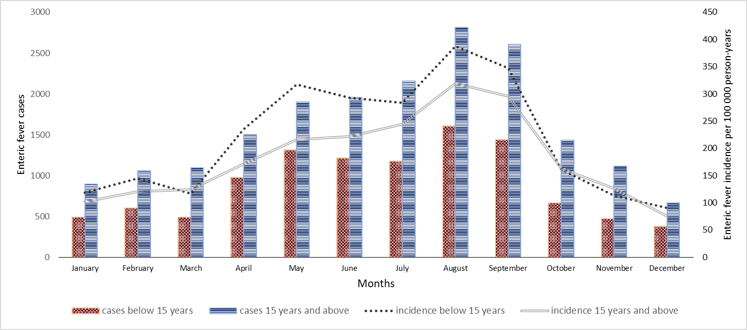
The bar graph represents the month-wise enteric fever cases among children below 15 years (red blocks) and age group ≥ 15 years (blue stripes). The incidence of cases among <15 years and ≥ 15 years age groups are represented by a dotted line and a double line, respectively.

Supplementary figure 02: Area under the ROC Curve
ROC curve representing the performance of the model. The area under the curve (AUC) is 0.8266

Supplementary figure 03: Enteric fever cases in Mizoram from 2012-2021 (n= 25,647)
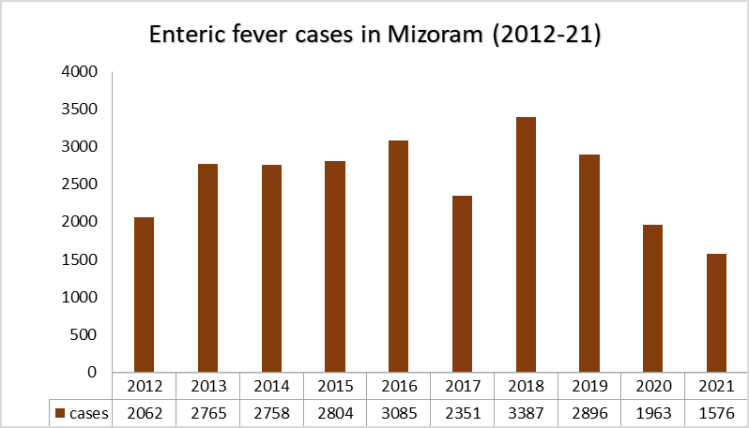
Source: Ministry of Health and Family Welfare, Govt. of India. Data retrieved from the Indiastat (https://www.indiastat.com). Note: Figures are Provisional

