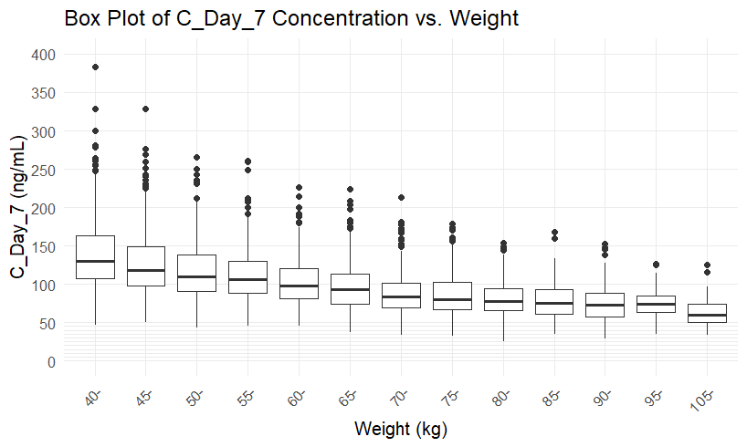

Figure S1 - Box Plots of Desethylamodiaquine Simulated Adult Day 7 Concentrations versus Weight

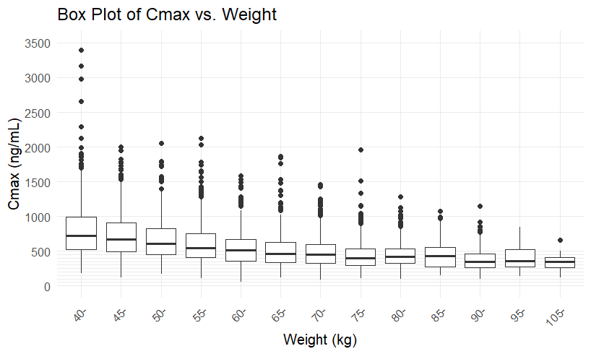

Figure S2 - Box Plots of Desethylamodiaquine Simulated Adult Maximum Concentrations versus Weight

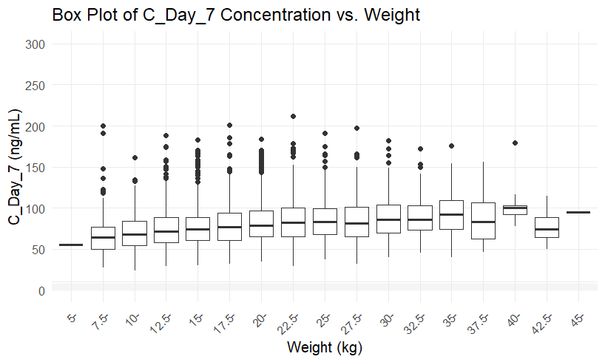

Figure S3 - Box Plots of Desethylamodiaquine Simulated Paediatrics Day 7 Concentrations versus Weight

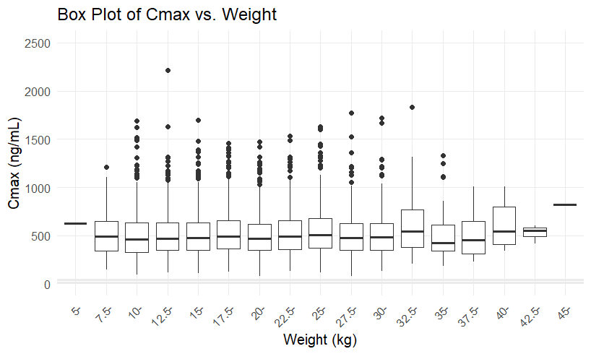

Figure S4 - Box Plots of Desethylamodiaquine Simulated Maximum Concentrations versus Weight

