Supporting Information

Forest structural changes after tree dieback affect dung beetle communities and dung removal rates in forests

Julian Lunow^{1*}; Katja Wehner^{2,3}; Matteo Trevisan³; Michael Heethoff³; Nico Blüthgen^{2a}; Nadja K. Simons^{1a}

*Corresponding author: Julius-Maximilians-University Würzburg, Biocenter, Department of Conservation Biology and Forest Ecology, Applied Biodiversity Science, 97074 Würzburg, Germany, julian.lunow@uni-wuerzburg.de

1: Julius-Maximilians-University Würzburg, Biocenter, Department of Conservation Biology and Forest Ecology, Applied Biodiversity Science, 97074 Würzburg, Germany
2: Technical University Darmstadt, Ecological Networks, 64287 Darmstadt, Germany
3: Technical University Darmstadt, Animal Evolutionary Ecology, 64287 Darmstadt, Germany
a: both senior-authors contributed equally to this study

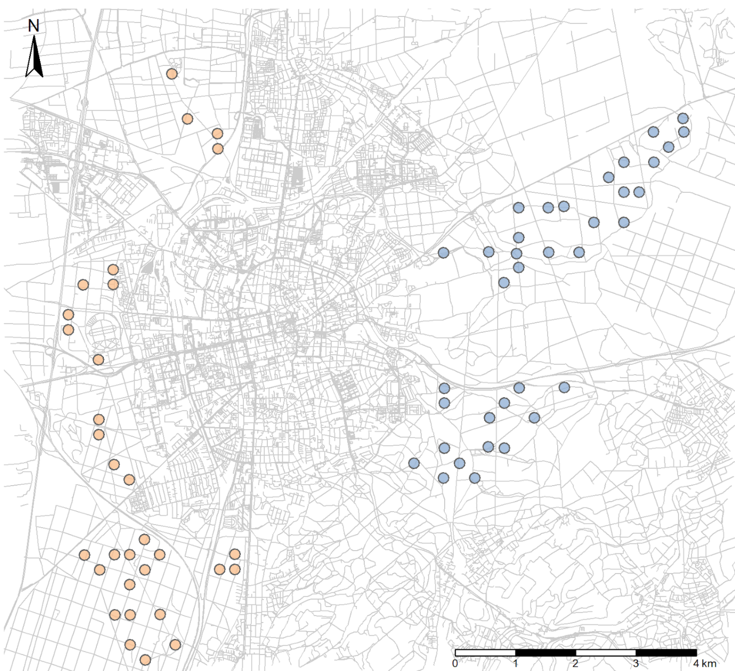
Figure S1: Location of the surveyed plots within the study region in the Darmstadt city forest. The coloured points represent the two different study areas (blue = eastern forest, orange = western forest).

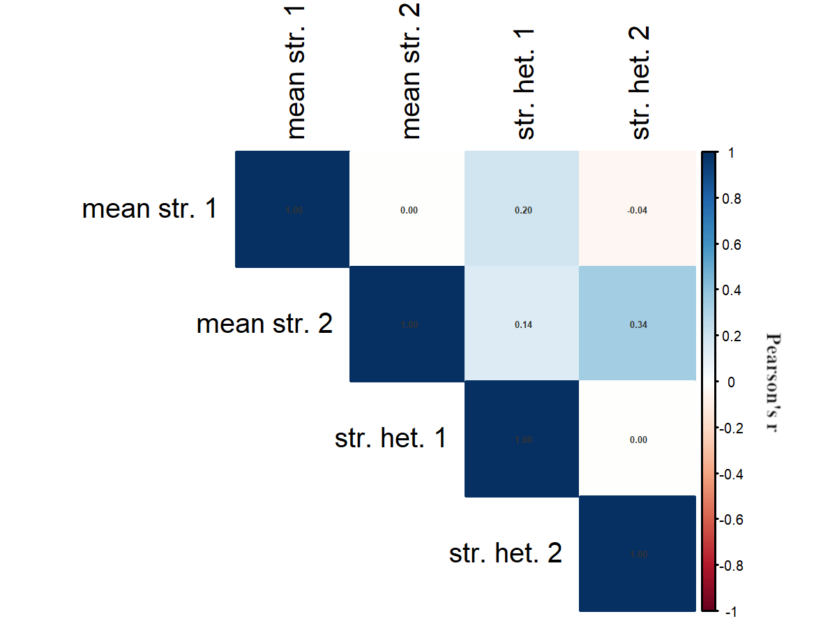
Figure S2: Pearson’s r correlation between the explanatory variables mean forest structure PCA axes (mean str. 1 and mean str. 2) and structural heterogeneity PCA axes (str. het. 1 and str. het. 2) used in our models.

Table S1: Included variables in the mean forest structure and structural variability PCA. PC1 and PC2 values indicate the correlation of the environmental variables to the two different axes of the different PCAs. R2 is the association of the environmental variable to the ordination and the p-values show if this association is significant. Bold correlations were shown in the graph in the main text.
PCA | variable | PC1 | PC2 | R2 | p-value
mean forest | mean DBH | -0.6980 | 0.7161 | 0.8147 | 0.001
structure | mean height | -0.9451 | 0.3268 | 0.8069 | 0.001
 | mean canopy openness | 0.7770 | 0.6296 | 0.6383 | 0.001
 | foliage cover | -0.9936 | -0.1133 | 0.7280 | 0.001
 | moss cover | 0.4007 | -0.9162 | 0.1496 | 0.002
 | bare ground cover | -0.6945 | -0.7195 | 0.0310 | 0.351
 | deadwood cover | -0.8338 | -0.5520 | 0.0116 | 0.676
 | herb cover | 0.9461 | 0.3240 | 0.7818 | 0.001
 | small tree cover | 0.9537 | 0.3008 | 0.0833 | 0.055
 | large tree cover | -0.2139 | -0.9769 | 0.0529 | 0.159
 | basal area | -0.9999 | 0.0167 | 0.5994 | 0.001
 | prop. non-nat. trees | 0.9886 | -0.1506 | 0.2072 | 0.001
 | deadwood volume | 0.7563 | 0.6542 | 0.3395 | 0.001
 | defoliation | 0.3831 | 0.9237 | 0.6819 | 0.001
 | stand age | -0.5370 | 0.8436 | 0.6912 | 0.001
 | foliage height | -0.9987 | 0.0504 | 0.6401 | 0.001
structural | DBH CV | -0.8707 | 0.4917 | 0.8669 | 0.001
heterogeneity | height CV | -0.8776 | 0.4795 | 0.8565 | 0.001
 | CV canopy openness | -0.6243 | 0.7812 | 0.1444 | 0.010
 | gc hetero | -0.6893 | -0.7245 | 0.1353 | 0.005
 | tree richness | -0.6838 | -0.7297 | 0.8351 | 0.001
 | tree diversity | -0.7195 | -0.6945 | 0.7755 | 0.001

Table S2: Correlation matrix p-values of our included explanatory variable (mean forest structure PCA axis 1, mean forest structure PCA axis 2, structural heterogeneity PCA axis 1, structural heterogeneity PCA axis 1)
p-values | mean forest structure PCA 1 | mean forest structure PCA 2 | structural heterogeneity PCA 1 | structural heterogeneity PCA 2
mean forest structure PCA 1 | 0.00 | 0.36 | 0.99 | 0.34
mean forest structure PCA 2 | 0.36 | 0.00 | 0.64 | 0.68
structural heterogeneity PCA 1 | 0.99 | 0.64 | 0.00 | 0.39
structural heterogeneity PCA 2 | 0.34 | 0.68 | 0.39 | 0.00

Table S3: The abundance and biomass of the surveyed species in our study region. The macrohabitat is the preferred habitat of the species according to (Buse et al., 2018; Koch, 1992; Rössner, 2012).
species | abundance | biomass [g] | macrohabitat
Acrossus depressus  (Kugelann, 1792) | 109 | 0.643 | semi-open and forest habitat
Acrossus rufipes  (Linnaeus, 1758) | 2 | 0.081 | semi-open and forest habitat
Anoplotrupes stercorosus  (Scriba, 1791) | 2032 | 262.433 | semi-open and forest habitat
Bodilopsis rufa  (Moll, 1782) | 1 | 0.007 | open and semi-open habitat
Esymus pusillus  (Herbst, 1789) | 10 | 0.039 | open and semi-open habitat
Euorodalus coenosus  (Panzer, 1798) | 68 | 0.201 | open and semi-open habitat
Limarus zenkeri  (Germar, 1813) | 16 | 0.047 | semi-open and forest habitat
Melinopterus prodromus  (Brahm, 1790) | 5 | 0.027 | open and semi-open habitat
Onthophagus coenobita  (Herbst, 1783) | 1112 | 24.030 | semi-open habitat
Onthophagus ovatus  (Linnaeus, 1767) | 77 | 0.217 | open and semi-open habitat
Onthophagus similis  (Scriba, 1790) | 2 | 0.022 | semi-open habitat
Onthophagus verticicornis  (Laicharting, 1781) | 392 | 10.898 | semi-open and forest habitat
Trypocopris vernalis  (Linnaeus, 1758) | 204 | 47.153 | open and semi-open habitat
Typhaeus typhoeus  (Linnaeus, 1758) | 1 | 0.144 | semi-open habitat
Volinus sticticus  (Panzer, 1798) | 6712 | 24.969 | semi-open and forest habitat
Total | 10743 | 370.909

Table S4: Summary of the effects of the PCAs on biomass (sqrt-transformed) and Shannon diversity (e^{H}). Significant values are in bold. R2m is the marginal explained variance by the overall model.
response | predictor | estimate | std. error | z-value | p-value | sign. | R2m
biomass | str. PCAax1 | -2.3921 | 0.4951 | -4.8311 | < 0.001 | *** | 0.22
(sqrt-trans.) | str. PCAax2 | -0.3248 | 0.5188 | -0.6261 | 0.5313
 | het. PCAax1 | -0.5954 | 0.5027 | -1.1844 | 0.2363
 | het. PCAax2 | -1.4723 | 0.5321 | -2.7671 | 0.0057 | **
Shannon | str. PCAax1 | 2.1656 | 0.6511 | 3.3263 | < 0.001 | *** | 0.09
diversity | str. PCAax2 | -0.4847 | 0.6823 | -0.7105 | 0.4774
 | het. PCAax1 | -0.2791 | 0.6612 | -0.4221 | 0.673
 | het. PCAax2 | -0.5982 | 0.6996 | -0.8550 | 0.3925

Table S5: Results of the PERMANOVA on the correlation of dung beetle (db) community distances and the forest structure and forest heterogeneity. Reported are response variables, predictor variables, degrees of freedom (Df), Sum of squares (SumOfSqs), R², F-values and p-values.
response | predictor | Df | SumOfSqs | R2 | F | p value | sign
db community | str. PCAax1 | 1 | 0.215 | 0.006 | 0.861 | 0.456
(abundance | str. PCAax2 | 1 | 0.401 | 0.012 | 1.604 | 0.185
based) | het. PCAax1 | 1 | 0.159 | 0.005 | 0.636 | 0.633
 | het. PCAax2 | 1 | 0.375 | 0.011 | 1.500 | 0.200
 | Residual | 128 | 31.961 | 0.965
 | Total | 132 | 33.110 | 1.000
db community | str. PCAax1 | 1 | 0.663 | 0.028 | 3.850 | 0.009 | **
(biomass | str. PCAax2 | 1 | 0.094 | 0.004 | 0.545 | 0.695
based) | het. PCAax1 | 1 | 0.342 | 0.014 | 1.985 | 0.124
 | het. PCAax2 | 1 | 0.531 | 0.022 | 3.085 | 0.037 | *
 | Residual | 128 | 22.036 | 0.931
 | Total | 132 | 23.665 | 1

Table S6: Summary of the effects of the PCAs on single species occurrence of Anoplotrupes stercorosus, Trypocopris vernalis and Volinus sticticus. Significant values are in bold. R2m is the marginal explained variance by the overall model.
response | predictor | estimate | std. error | z-value | p-value | sign. | R2m
A. stercorosus | str. PCAax1 | -5.631 | 2.875 | -1.958 | 0.050 | . | 0.25
 | str. PCAax2 | -6.566 | 2.888 | -2.273 | 0.023 | *
 | het. PCAax1 | -1.308 | 2.367 | -0.553 | 0.581
 | het. PCAax2 | -0.443 | 2.647 | -0.168 | 0.867
T. vernalis | str. PCAax1 | 12.414 | 2.301 | -5.822 | < 0.001 | *** | 0.62
 | str. PCAax2 | 5.536 | 2.069 | -4.243 | 0.007 | **
 | het. PCAax1 | -1.966 | 1.839 | 0.553 | 0.285
 | het. PCAax2 | -1.053 | 2.160 | 0.943 | 0.626
V. sticticus | str. PCAax1 | -16.122 | 2.769 | 5.394 | < 0.001 | *** | 0.44
 | str. PCAax2 | -11.108 | 2.618 | 2.676 | < 0.001 | ***
 | het. PCAax1 | 1.128 | 2.038 | -1.069 | 0.580
 | het. PCAax2 | 2.348 | 2.489 | -0.488 | 0.345

Table S7: Summary of the effects of biomass (sqrt-transformed), Shannon diversity (e^{H}) and the environmental PCA axes on dung removal. Significant values are in bold. R2m is the marginal explained variance by the overall model.
response | predictor | estimate | std. error | z-value | p-value | sign. | R2m
dung removal | biomass (sqrt) | 0.090 | 0.037 | 2.449 | 0.014 | * | 0.24
 | shannon div | -0.009 | 0.031 | -0.272 | 0.786
 | str. PCAax1 | -0.574 | 0.235 | -2.449 | 0.014 | *
 | str. PCAax2 | -0.269 | 0.227 | -1.188 | 0.235
 | het. PCAax1 | 0.176 | 0.221 | 0.799 | 0.424
 | het. PCAax2 | 0.048 | 0.242 | 0.198 | 0.843

Table S8: Results of the PERMANOVA on the correlation of dung beetle (db) community distances and dung removal. Reported are response variables, predictor variables, degrees of freedom (Df), Sum of squares (SumOfSqs), R², F-values and p-values.
response | predictor | Df | SumOfSqs | R2 | F-value | p-value
db community | dung removal | 1 | 0.295 | 0.014 | 0.927 | 0.460
(abundance based) | Residual | 64 | 20.384 | 0.986
 | Total | 65 | 20.680 | 1.000
db community | dung removal | 1 | 0.201 | 0.011 | 0.686 | 0.632
(biomass based) | Residual | 64 | 18.797 | 0.989
 | Total | 65 | 18.998 | 1.000

References
Buse, J., Šlachta, M., Sladecek, F.X.J., Carpaneto, G.M., 2018. Summary of the morphological and ecological traits of Central European dung beetles. Entomological Science 21, 315–323. https://doi.org/10.1111/ens.12313
Koch, K., 1992. Die Kaefer Mitteleuropas. Oekologie. Goecke & Evers, Krefeld.
Rössner, E., 2012. Die Hirschkäfer und Blatthornkäfer Ostdeutschlands (Coleoptera: Scarabaeoidea). Verein der Freunde und Förderer des Naturkundemuseums Erfurt, Erfurt.

