Supplementary information: Cascaded frequency conversion of highly charged femtosecond spatiotemporal optical vortices
Qingqing Liang,¹ Qiyuan Zhang,¹ Dan Wang,¹ Enliang Zhang,¹ Jianhua Hu,¹ Ming Wang,¹ Jinxin Wu,¹ Grover A. Swartzlander,² Yi Liu,^{1, *}
¹Shanghai Key Lab of Modern Optical System, University of Shanghai for Science and Technology, 516, Jungong Road, 200093 Shanghai, China
²Chester F. Carlson Center for Imaging Science, Rochester Institute of Technology, Rochester, New York, USA
* Corresponding author: yi.liu@usst.edu.cn.

Here we present comprehensive simulations and experimental results that further illustrate our capacity to precisely manipulate spatiotemporal optical vortices (STOVs) during nonlinear processes. These data highlight two pivotal advancements: (i) broadband wavelength tunability achieved by spectral singularity engineering, and (ii) increased conversion efficiency through crystallographic phase-matching optimization in BBO nonlinear crystals.

Section 1: Theoretical Validation and Experimental Benchmarking of STOV Generation
We confirmed our STOV generating approach through simulations and experiments. Employing the space-time coupling framework [1,2], we calculated diffraction patterns for STOV fields with topological charges from $l^{\left(ω\right)}$= 0 to 14 (Supplementary Fig. 1). These simulations incorporated actual experimental parameters, including the 35-fs pulse duration and 4 mm beam width. Experimentally, our 4f pulse shaper using SLM produced well-defined 800 nm STOV fields. Their diffraction patterns consistently produced black fringes (Fig. 2), matching our calculations completely across all topological charges. Spectral measurements found important differences: conventional Gaussian pulses ($l^{\left(ω\right)}$=0) maintained position-independent spectra centered at 800 nm. In contrast, STOV fields ($l^{\left(ω\right)}$=4) exhibited distinct spatial-spectral chirp across the beam profile (Fig. 3a; Supplementary Fig. 2). This pattern coincides with theoretical expectations of spatiotemporal phase gradients [2], demonstrating both our technique's reliability and the intrinsic space-time coupling in STOV fields.
Section 2: Nonlinear Crystal Thickness-Dependent Topological Charge Conservation
In this section, we explored how BBO crystal thickness impacts topological charge preservation during harmonic conversion. For second-harmonic generation (SHG) with 0.3-mm-thick crystals, diffraction patterns preserved crisp features with excellent contrast (γ=0.92 ± 0.03 at $l^{\left(2ω\right)}$​=20), demonstrating good topological charge conservation. However, thicker 1.0-mm crystals dramatically reduced contrast (γ=0.61 ± 0.05). We explain this blurring (Supplementary Fig. 3) to spatiotemporal astigmatism produced by group velocity mismatch (Δv_{g}​=v_{g}⁽⁸⁰⁰⁾​−v_{g}⁽⁴⁰⁰⁾​=0.87 mm/ps), where temporal walk-off affects the harmonic field's phase structure. Third-harmonic generation demonstrated greater sensitivity to crystal thickness. With 1-mm crystals, the 299-fs temporal walk-off showed substantial pattern degradation for $l^{\left(3ω\right)}≥15$ (Supplementary Fig. 4). Detailed research indicated these fuzzy patterns relate to mixed topological charges ($l^{\left(3ω\right)}=3l^{​\left(ω\right)}±δ$) due to partial decoherence between fundamental and harmonic fields. These findings show crystals should meet d_{max​}<τ_{FWHM} ​/(2Δv_{g​}) to sustain topological integrity.
Section 3: Spectral-Temporal Control of Harmonic STOV Wavelengths
We tuned harmonic wavelengths by altering the spectral position of the phase singularity. Shifting the vortex center throughout the basic spectrum (786–819 nm in ~2.5 nm steps) while optimizing the BBO angle (~0.2°/nm offset) regulated phase matching. As seen in Supplementary Fig. 5, this asymmetrically transformed fundamental STOV diffraction patterns while keeping high-quality second harmonics. The harmonic wavelength shifted linearly with the singularity position ${(∆λ}^{\left(2ω\right)}≈{2 ∆λ}^{\left(ω\right)}$), covering 393–409.5 nm without impacting topological charge conservation ($l^{\left(2ω\right)}=2l^{​\left(ω\right)}$) or diffraction clarity. This tunability—achieved through coordinated spectral-phase control and nonlinear optics—enables wavelength-specific UV STOV production for applications like OAM communications and ultrafast spectroscopy.

Figures
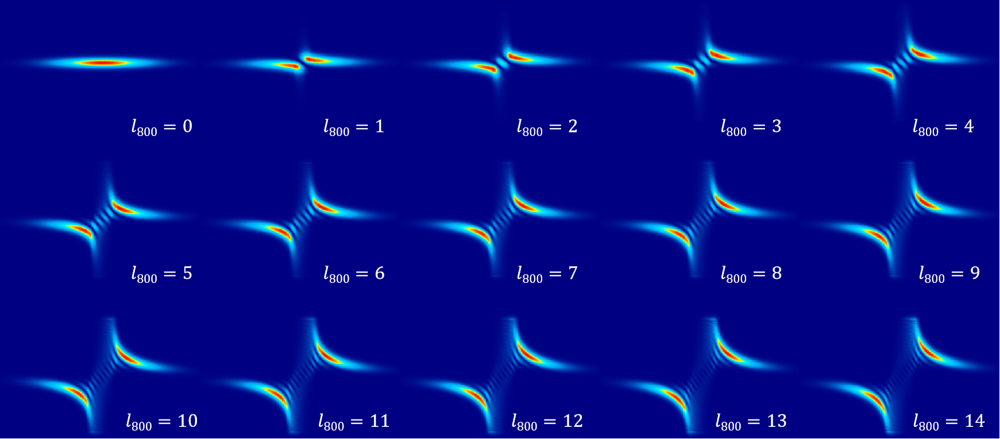
Supplementary Fig. 1. Calculated diffraction patterns of the 800 nm STOV field with different topological charges. With the calculated parameters chosen to those of the experiments.

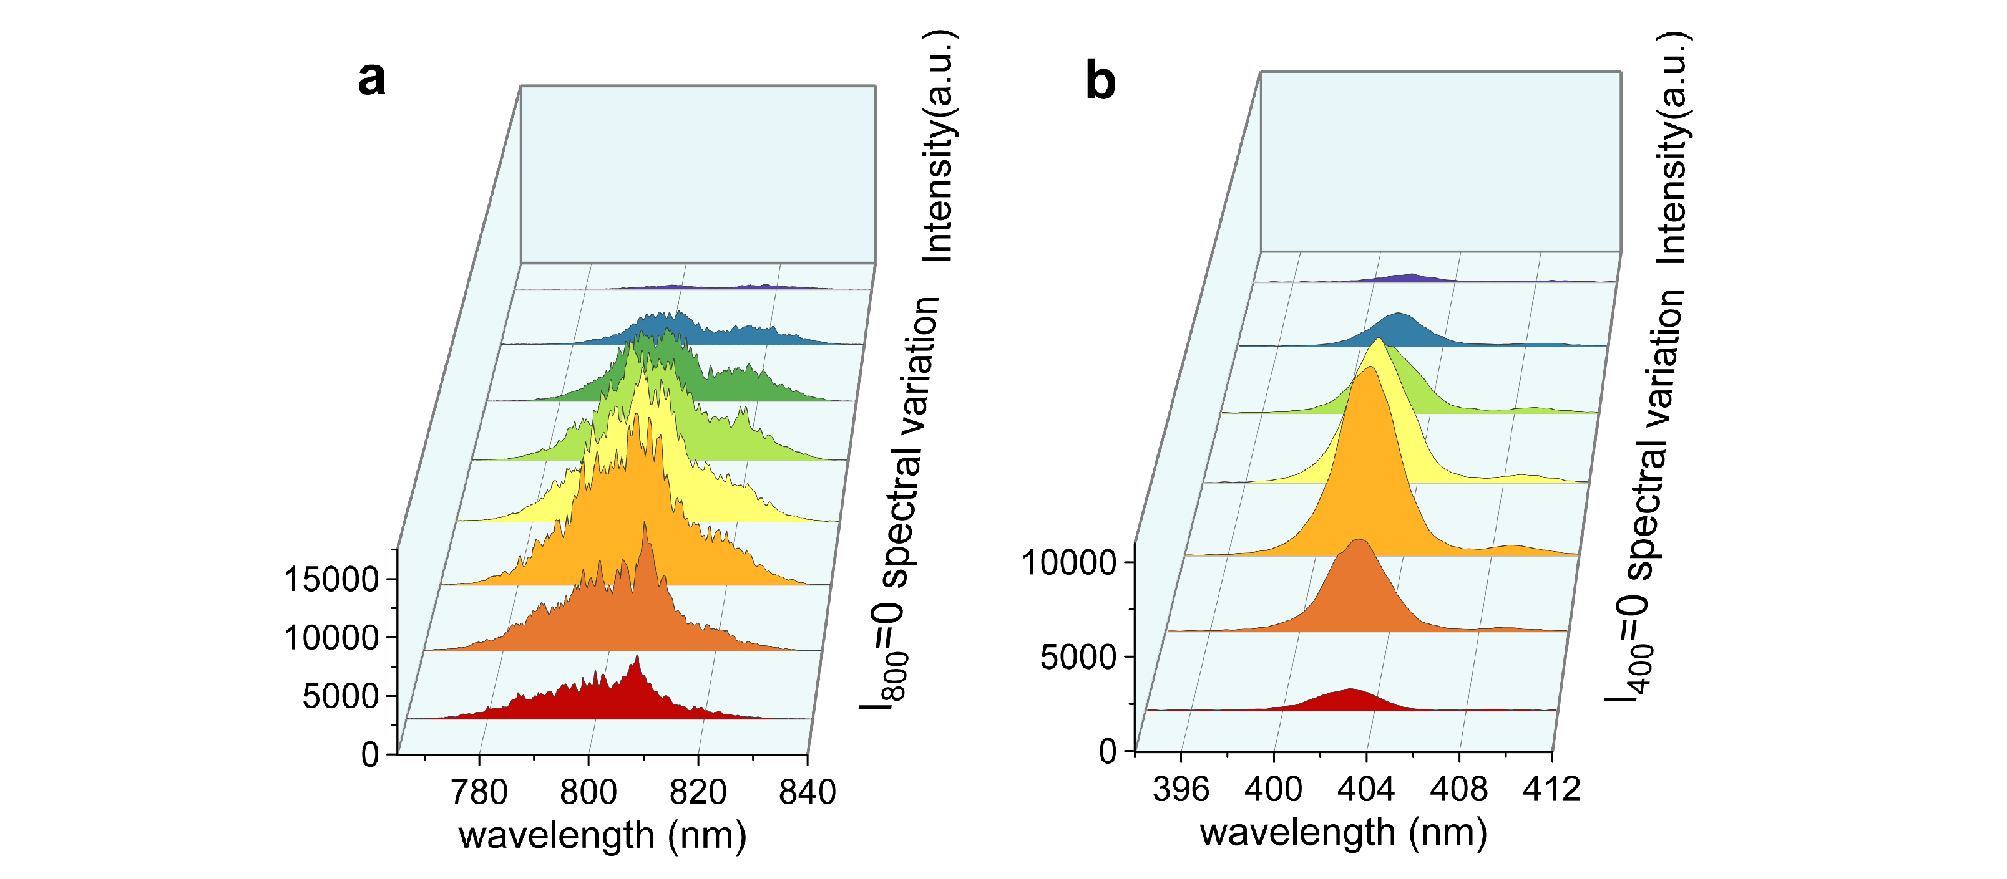
Supplementary Fig. 2. Spectrum measurement across the transverse direction of the 800 nm and 400 nm beam without topological charge. a, results for 800 nm field with $l^{\left(ω\right)}=0$. b, results for 400 nm field with $l^{\left(2ω\right)}=0$.

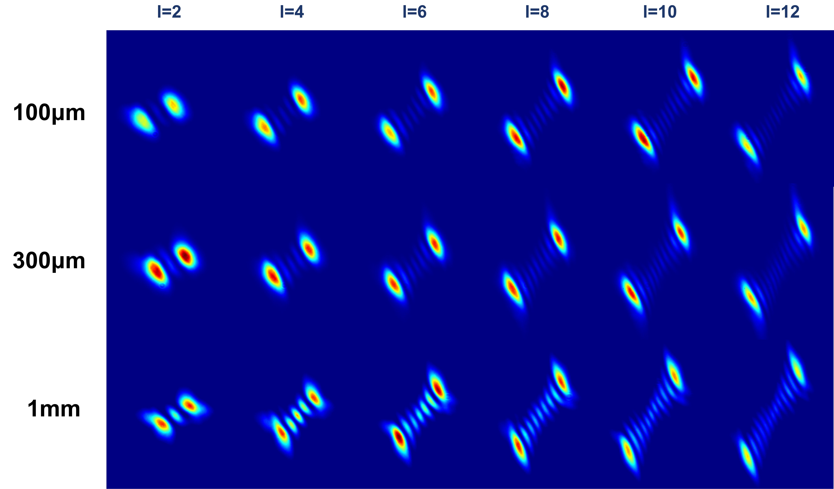
Supplementary Fig. 3. Diffraction patterns of the STOV field for different thickness of SHG crystals. The topological charge and the thickness of the crystals are denoted in the figure. With crystal of 1 mm, the diffraction patterns become blurred due to the spatiotemporal astigmatism.

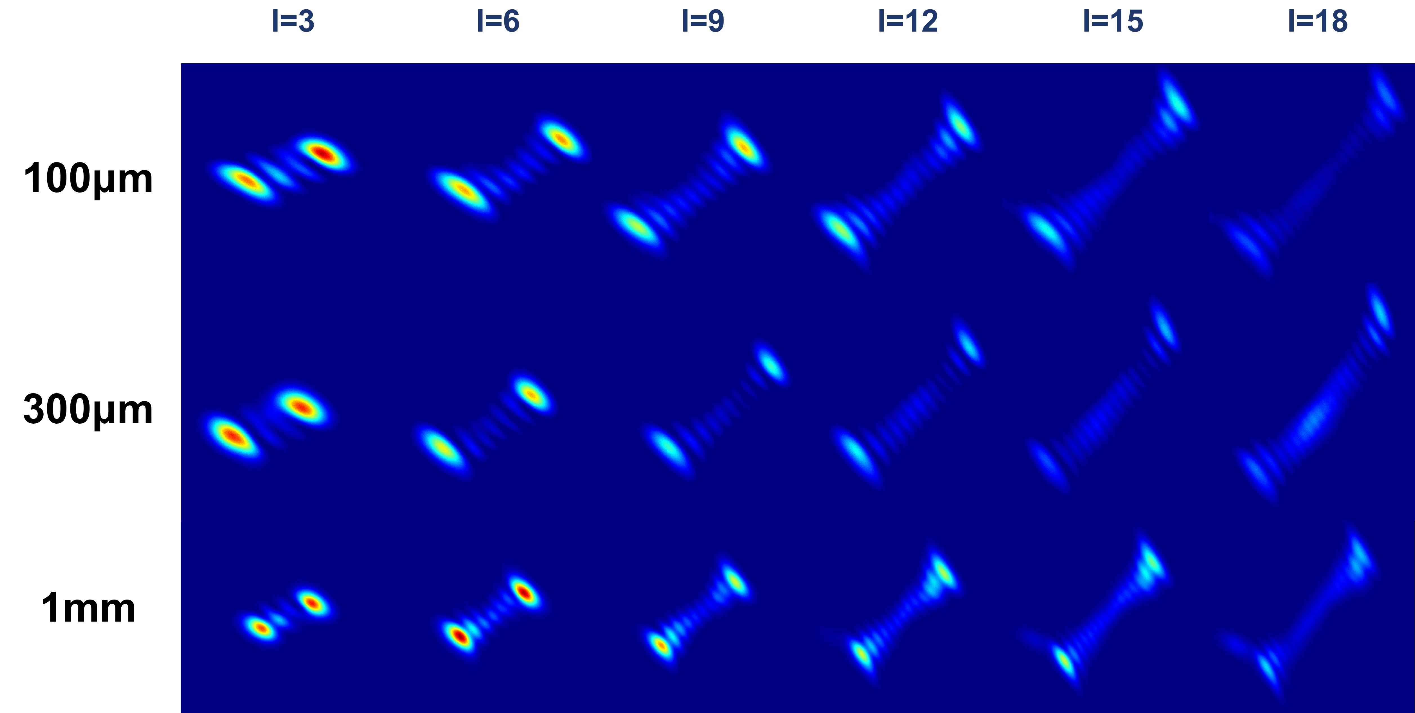
Supplementary Fig. 4. Diffraction patterns of the third harmonic STOV field at 266 nm for different thickness of SFG crystals. The topological charge and the thickness of the crystals are denoted. For higher topological charges and with SFG crystal of 1 mm, the diffraction patterns become blurred due to the spatiotemporal astigmatism and temporal walkoff inside the SFG crystal.

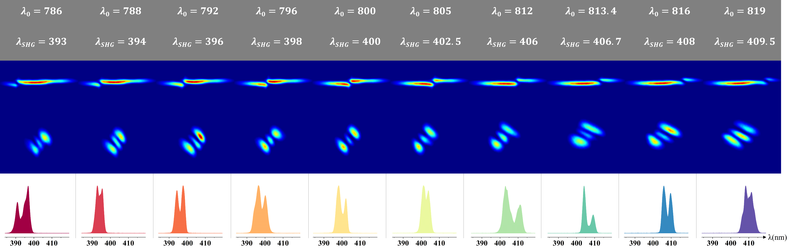
Supplementary Fig. 5. Tunability of the second harmonic STOV field. Top row: the diffraction patterns of the 800 nm STOV field with the topological charge located at varying wavelength, with the corresponding wavelength indicated in the tables above. Second row: the corresponding 400 nm STOV field. Third row : the measured spectrum of the second harmonic STOV field, with its central wavelength tuned from 393 nm to 409.5 nm. The numbers above the figure present the central wavelength where the phase singularity was applied on the SLM and the central wavelength of the second harmonic STOV.

References :
- Hancock, S. W., Zahedpour, S., Goffin, A. & Milchberg, H. M. Free-space propagation of spatiotemporal optical vortices. Optica 6, 1547 (2019).
- Huang, S., Wang, P., Shen, X., Liu, J. & Li, R. Diffraction properties of light with transverse orbital angular momentum. Optica 9, 469 (2022).

