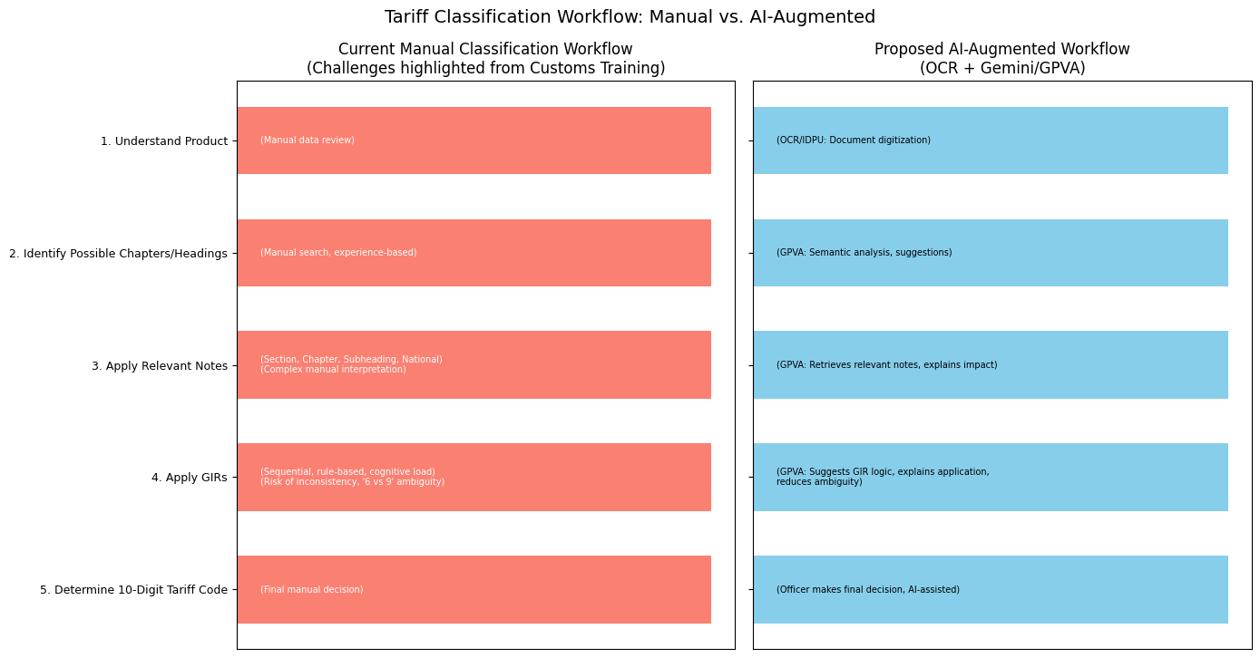
- Appendix

Figure 14: Differentiation between tariff classification workflow

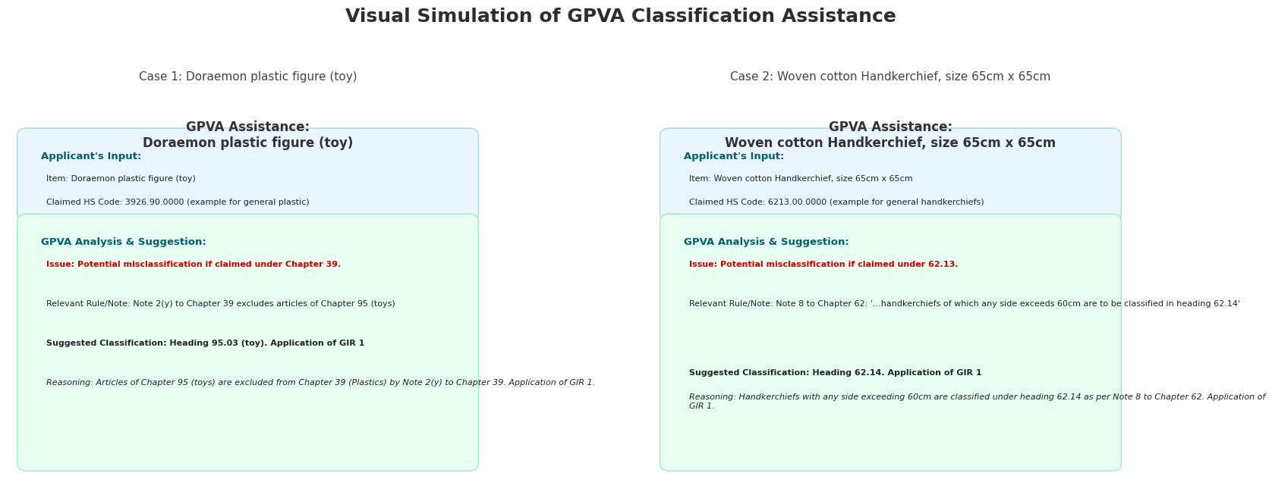

Figure 15: Visual simulation of GPVA Classification Assistance

