Supporting Information for
Ultrastrong helical dichroism from a chiral molecular nanoassembly
Yusheng Jin¹, Xinghao Wang¹, Xiaomei Chen², Kaixuan Li², Yucheng Jiang^{2,3}, Jinlei Zhang³, Cheng-Wei Qiu²*, Dong Wu¹, Jincheng Ni¹*
¹CAS Key Laboratory of Mechanical Behavior and Design of Materials, Department of Precision Machinery and Precision Instrumentation, University of Science and Technology of China, Hefei 230027, China.
²Department of Electrical and Computer Engineering, National University of Singapore, Singapore 117583, Singapore.
³Jiangsu Key Laboratory of Intelligent Optoelectronic Devices and Chips, School of Physical Science and Technology, Suzhou University of Science and Technology, Suzhou, 215009, China.
*To whom correspondence should be addressed: chengwei.qiu@nus.edu.sg; njc@ustc.edu.cn

Supplementary Note 1: SAM to OAM conversion
The non-local nature of circularly polarized light presents a challenge, requiring a considerable number of chiral nanoassemblies for effective CD measurements. This limitation arises because the tight focusing of circularly polarized light can lead to the SAM to OAM conversion¹.
Circularly polarized light rotates its electric field along a circular path at a constant angular velocity in a plane perpendicular to the direction of propagation. This rotation is uniform and non-local, making circularly polarized light effectively a periodic optical field with arbitrary period. Due to this property, chiral microstructures can be arranged in a periodic manner to enhance the CD signal. Meanwhile, when circularly polarized light is focused by a high numerical aperture (NA) lens^{2,3}, SAM is partially converted into OAM due to spin-orbit interaction of light^{4–7}. For nonparaxial circularly polarized beams with wavevectors forming a cone at an angle θ, SAM and OAM can be defined as:
$$\begin{aligned}S=σ\cos{θ}\frac{P}{P}\#\left(S1\right)\end{aligned}$$
$$\begin{aligned}L=\left[l+σ\left(1-\cos{θ}\right)\right]\frac{P}{P}\#\left(S2\right)\end{aligned}$$
Where $S$ is the SAM, $L$ is the OAM.
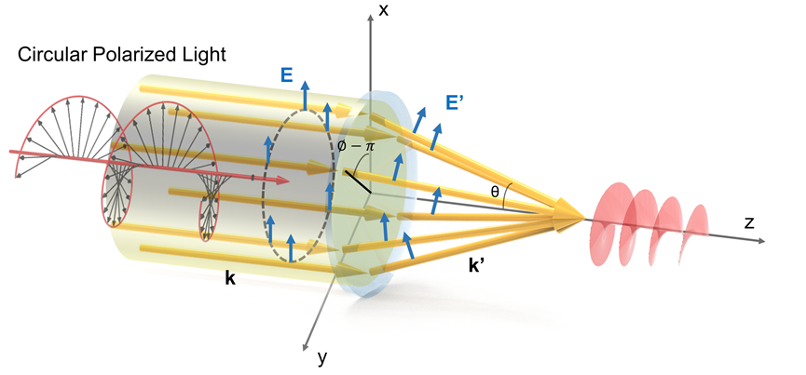
Fig. S1. Focusing of circular polarized light by a spherical high-NA lens.

In the following, we will break down the derivation of this conclusion into three distinct sections: 1) transformation relations of the electric field before and after incidence; 2) separation of SAM and OAM components of the electric field; 3) the incidence of circularly polarized light with OAM.
- Transformation relations of the electric field before and after incidence
According to the adiabatic approximation that does not consider the polarization dependence of the refraction coefficients, the Debye–Wolf theory assumes that partial waves do not change their polarization state in the local coordinate system attached to the ray. For the electric field deflected at an angle $∅$, its local coordinate system first rotates counterclockwise by $∅$ around the z-axis, then rotates by θ around the y-axis. Let the rotation matrix for a rotation around the axis by an angle θ be denoted as $R_{i}\left(θ\right),i=x,y,z$,then we have
$$\begin{aligned}E_{0}^{'}=R_{z}\left(∅\right)R_{y}\left(-θ\right)R_{z}\left(-∅\right)E_{0}\#\left(S3\right)\end{aligned}$$
where $E_{0}$ is the direction vector of the incident electric field, $E_{0}^{'}$ is the direction vector of refracted electric field, $R_{y}\left(-θ\right)$ is the transformation matrix representing the refraction in the local coordinate system and $R_{z}\left(-∅\right)$ denotes the transformation matrix that maps the basis vectors of the global coordinate system to those of the local coordinate system. Then $\begin{aligned}E_{0}^{'}=\left(\begin{matrix}\cos^{2}{∅\cos{θ+\sin^{2}{∅}}} & \sin{∅\cos{∅}cos{θ-\sin{∅}}}cos∅ & sinθcos∅ \\ \sin{∅\cos{∅}cos{θ-\sin{∅}}}cos∅ & \sin^{2}{∅\cos{θ+\cos^{2}{∅}}} & sin∅sinθ \\ -sinθcos∅ & -sinθsin∅ & cosθ\end{matrix}\right)E_{0} \\ \#\left(S4\right)\end{aligned}$
For convenience, we rewrite the equation in the circular polarization basis:
$$\begin{aligned}E_{0}^{'}={V^{-1}R}_{z}\left(∅\right)R_{y}\left(-θ\right)R_{z}\left(-∅\right)VE_{0},V=\frac{1}{\sqrt{2}}\left(\begin{matrix}1 & 1 & 0 \\ i & -i & 0 \\ 0 & 0 & \sqrt{2}\end{matrix}\right)\#\left(S5\right)\end{aligned}$$
where V is the transformation matrix between the circular polarization basis and the Cartesian orthogonal basis. Therefore,
$$\begin{aligned}E_{0}^{'}=\left(\begin{matrix}a & -be^{-2i∅} & \sqrt{2ab}e^{-i∅} \\ -be^{2i∅} & a & \sqrt{2ab}e^{i∅} \\ -\sqrt{2ab}e^{-i∅} & -\sqrt{2ab}e^{-i∅} & a-b\end{matrix}\right)E_{0}\#\left(S6\right)\end{aligned}$$
where $a=\cos^{2}\left(\frac{θ}{2}\right),b=\sin^{2}\left(\frac{θ}{2}\right)$.
Considering energy conservation, we have
$$\begin{aligned}E^{'}=\sqrt{\cos{θ}}\left(\begin{matrix}a & -be^{-2i∅} & \sqrt{2ab}e^{-i∅} \\ -be^{2i∅} & a & \sqrt{2ab}e^{i∅} \\ -\sqrt{2ab}e^{-i∅} & -\sqrt{2ab}e^{-i∅} & a-b\end{matrix}\right)E\#\left(S7\right)\end{aligned}$$
Here, $E$ is the incident electric field, $E^{'}$ is the refracted electric field.
- Separation of SAM and OAM components of the electric field
First, we provide the SAM and OAM operators for the z-component in the Cartesian coordinate system
$$\begin{aligned}L_{z}=-i\frac{∂}{∂∅},{\left(S_{z}\right)}_{ij}=-ε_{zij}\#\left(S8\right)\end{aligned}$$
where $∅$ is the azimuthal angle (either in coordinate or momentum space, depending on representation) and $ε_{zij}$ is the Levi-Civita symbol.
For convenience, we rewrite the equation in the circular polarization basis:
$$\begin{aligned}L_{z}=-i\frac{∂}{∂∅},σ=diag\left(1,-1,0\right)\#\left(S9\right)\end{aligned}$$
For a given electric field $E$, the OAM and SAM densities can be calculated as follows:
$$\begin{aligned}l_{z}=-i\frac{E^{*}∙∂_{∅}E}{E^{*}∙E},s_{z}=\frac{E^{*}∙σE}{E^{*}∙E}\#\left(S10\right)\end{aligned}$$
- Circularly-polarized vortex beam incidence
The electric field of the incident circularly-polarized vortex beam can be written as:
$$\begin{aligned}E_{l}^{σ}≈e^{σ}E_{l}\left(θ,∅\right),E_{l}\left(θ,∅\right)=F_{\left|l\right|}\left(θ\right)e^{il∅}\#\left(S11\right)\end{aligned}$$
and $F_{\left|l\right|}\left(θ\right)∝\sin^{\left|l\right|}θ$ for the vortex beams with the waist much larger than the entrance pupil. From Eq. (S5) the refracted field is:
$$\begin{aligned}E^{'}=\sqrt{\cos{θ}}e^{σ}F_{\left|l\right|}\left(θ\right)e^{il∅}\left(\begin{matrix}a & -be^{-2i∅} & \sqrt{2ab}e^{-i∅} \\ -be^{2i∅} & a & \sqrt{2ab}e^{i∅} \\ -\sqrt{2ab}e^{-i∅} & -\sqrt{2ab}e^{-i∅} & a-b\end{matrix}\right)\#\left(S12\right)\end{aligned}$$
If $σ=+$,
$$\begin{aligned}E_{+}^{'}=\sqrt{cosθ}F_{\left|l\right|}\left(θ\right)\left(\begin{matrix}\cos^{2}\frac{θ}{2}e^{il∅} \\ {-sin}^{2}\frac{θ}{2}e^{i\left(l+2\right)∅} \\ -\sqrt{2}sin\frac{θ}{2}cos\frac{θ}{2}e^{i\left(l+1\right)∅}\end{matrix}\right)\#\left(S13\right)\end{aligned}$$
If $σ=-$,
$$\begin{aligned}E_{-}^{'}=\sqrt{cosθ}F_{\left|l\right|}\left(θ\right)\left(\begin{matrix}{-sin}^{2}\frac{θ}{2}e^{i\left(l-2\right)∅} \\ \cos^{2}\frac{θ}{2}e^{il∅} \\ -\sqrt{2}sin\frac{θ}{2}cos\frac{θ}{2}e^{i\left(l-1\right)∅}\end{matrix}\right)\#\left(S14\right)\end{aligned}$$
Eq. (S8) brings about
$$\begin{aligned}s_{z}=σ\cos{θ}\#\left(S15\right)\end{aligned}$$
$$\begin{aligned}l_{z}=\left[l+σ\left(1-\cos{θ}\right)\right]\#\left(S16\right)\end{aligned}$$
When the lens diameter is much larger than its focal length, most regions on the incident surface refract at angles close to 90 degrees relative to the optical axis, leading to almost complete conversion of circularly polarized light into the vortex light.

Supplementary Note 2: Experimental characterization of vortex beams
The optical field distributions of vortex beams at the focal plane, captured by a charge-coupled device (CCD) camera, exhibit a characteristic donut-shaped intensity profile (Fig. S2b). Vortex beams with opposite OAM modes theoretically exhibit identical intensity patterns but feature opposite phase gradients along the azimuthal direction in the transverse plane. The donut-shaped profile’s diameter d is determined by measuring the distance between the two highest intensity points in the cross-sectional intensity distribution. Experimental results, as shown in Fig. S2a, reveal that the diameter d of the focused vortex beam grows linearly with the topological charge. This behavior is in agreement with the expected dependent scaling relationship under focusing conditions:
$$\begin{aligned}d∝\frac{2λ}{NA}\left(1+\frac{\left|l\right|}{l_{0}}\right)\#\left(S17\right)\end{aligned}$$
where $λ$ is the wavelength of light, NA is the numerical aperture of objective lens and $l_{0}$ is the constant. We also measure the three-dimensional intensity distribution of vortex beam with topological charge =+30 (Fig. S3).

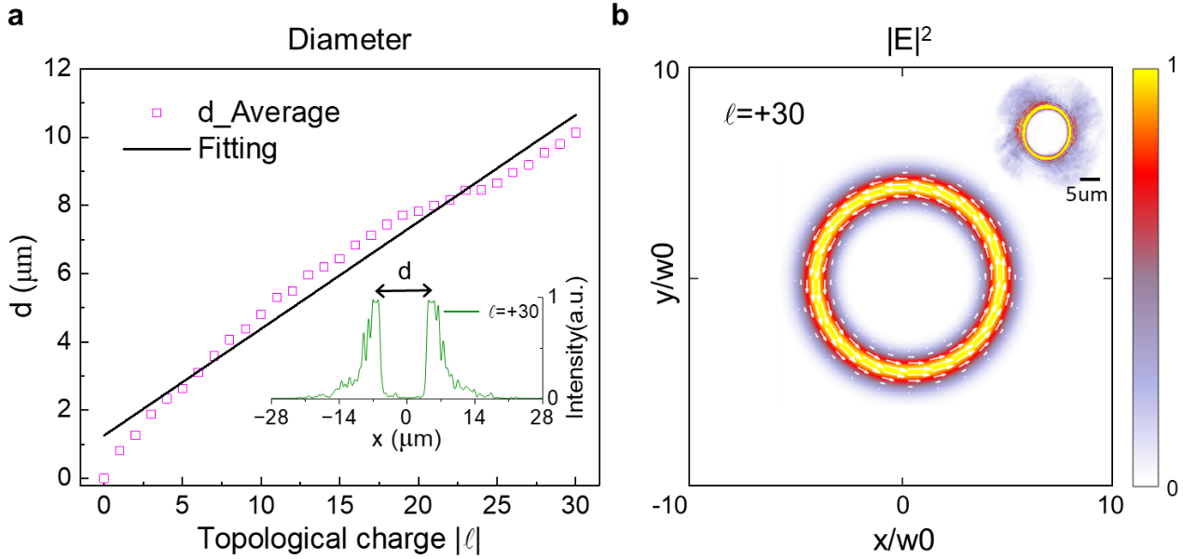
Fig. S2. Two-dimensional characterization of the vortex beams used in the experiment. a, Measured diameter d of the vortex beam as a function of topological charge. The results presented here are the average of the positive and negative topological charge cases for each topological charge value l. (Inset) Intensity distribution along the central axis of the donut-shaped profile. The distance between the two intensity peaks represents the diameter of the vortex beam. The solid line represents the linear fitting of measured diameter d. b, The simulated optical field distribution of the incident vortex beams with topological charge l = +30. The length and orientation of the white arrow are indicative of the magnitude and direction of the momentum density in the x-y plane, respectively. (Inset) The corresponding experimental optical field distribution.

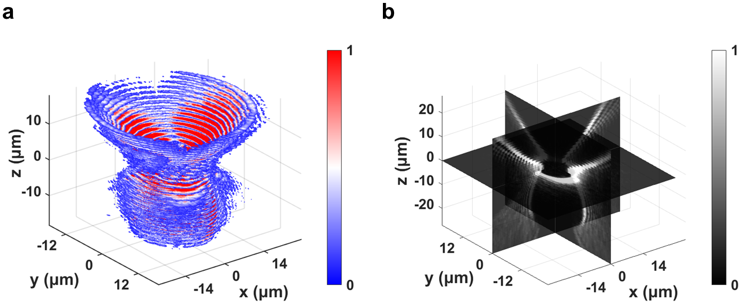

Fig. S3. Experimental three-dimensional intensity distribution of vortex beam with topological charge  = +30. a, Experimental three-dimensional intensity distribution. b, Slices from three cross-sections.

Supplementary Note 3: Simulation of angular momentum flux densities without structures
Simulations of angular momentum flux densities without structures are conducted to better understand the differences between using circularly polarized light and vortex beams for the chiroptical detection of microstructures (Fig. S4). To ensure consistent total angular momentum of the incident photons, circularly polarized light with σ = +1 and vortex light with topological charge  = +1 are used in the simulation, both with the same power. As expected, in the absence of a structure, the angular momentum flux density of circularly polarized light is primarily its spin component, while that of vortex light is primarily its orbital component. The higher local angular momentum flux density for vortex beams, despite equal total angular momentum flux, suggests an advantage using vortex light for chiroptical detection.
Fig. S4. Local angular momentum flux densities for circularly polarized light and vortex beam without structures. The angular momentum flux density of circularly polarized light primarily manifests as a spin component $M_{spin}$, while that of vortex light primarily manifests as an orbital component $M_{orbit}$.

Supplementary Note 4: Simulation of intensity distributions
We present the simulated intensity distributions of vortex beams with topological charge  =$±4$ after interaction with the D-Cys structure (Fig. S5). Electromagnetic field simulations provide a direct visualization of the physical principles governing chiroptical HD: vortex beams with opposite topological charges generate clearly distinguishable optical intensity patterns. Stronger light-matter coupling in the D-Cys structure is observed with vortex beams possessing a topological charge of  = -4, as evidenced by the higher internal electric field intensity compared to beams with  = +4.
Fig. S5. Simulated intensity distributions of vortex beams with topological charge  =$±4$ after interaction with the D-Cys structure. The cross-section at z=0 represents the structure’s midplane; z=2 and z=-2 correspond to the reflection and transmission planes, respectively. Differences in the intensity distributions confirm the existence of chiral light-matter interaction.

Supplementary Note 5: Influence of geometric parameters on HD signals
To further elucidate the chiroptical properties of L/D-Cys structures, we simulated the HD responses of chiral microstructures under different geometric parameters: the number of slices, rotation angle α, and thickness t (Fig. S6). Analysis of the simulation results in conjunction with the experimental data (dashed line) reveal that the closest match is achieved with a geometry comprising seven layers, a 5° angle of twist, and a layer thickness of 0.05 μm. In the synthesis process, maintaining a constant amino acid concentration, a decrease in cadmium chloride concentration result in an increase in the size of the resulting chiral microstructures⁸. The observed increase in the peak position of the chiroptical HD signal (Fig. S7) further supports this finding and aligns with previously reported results⁹.
Fig. S6. Simulated HD signal by varying the number of slices, rotation angle α, and thickness t. a Schematic diagram of the different structural parameters: the number of slices, rotation angle α, and thickness t. b-d The influence of the three parameters on the chiroptical HD signal for D-cys structures. The dashed line represents the experimental data, as shown in Fig. 3f.
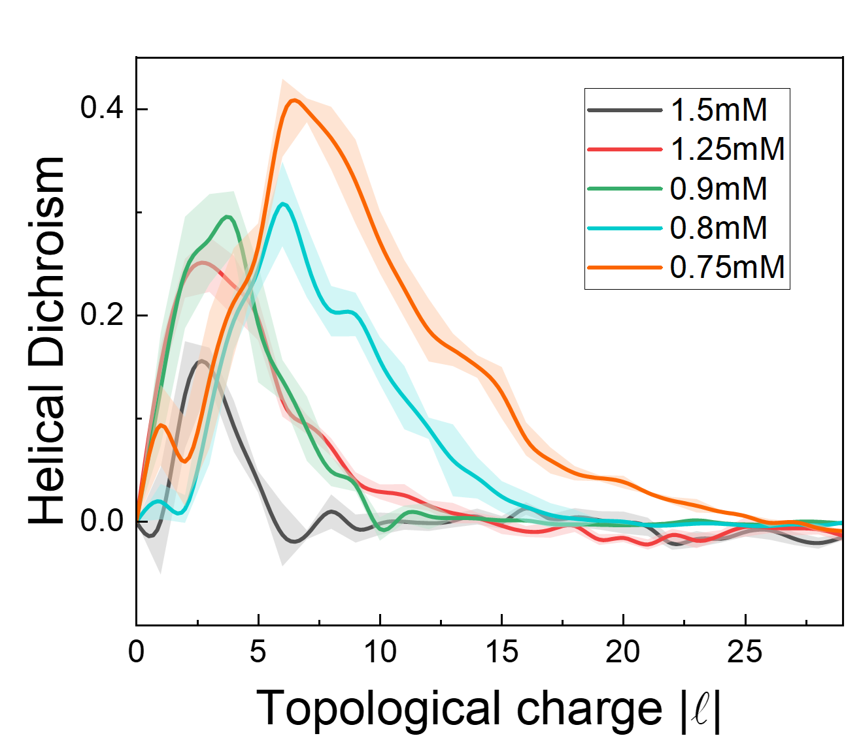
Fig. S7. Experimental HD signal measurements by varying the concentration of cadmium chloride solution while holding the concentration of D-cystine solution constant at 1 mM. As the concentration of cadmium chloride solution decreases, the size of the synthesized structures increases, and the topological charge corresponding to the peak in the chiroptical HD spectra gradually increases.

Table S1: Comparison of relevant reports for chiroptical molecular sensing.
Type | Geometry | Molecules | Method | Optical characterization | Wavelength | g factor | Reference
Metasurface | Gammadia | Tryptophan and the β-sheet proteins | Lithography | CD | ~650nm | 0.1 | Nat. Nanotechnol.  5, 783–787 (2010)
Metasurface | Acute angle | 1,2-Propanediol | Lithography | CD | ~1000nm | <0.1 | Nat. Commun.  8, 14180 (2017)
Direct measurement | Chiral molecules | cysteine | / | CD | 215nm | 0.005 | Nature  556, 360–365 (2018)
Direct measurement | Chiral molecules | Fenchone | Nonlinear effects | HD | 800nm | 0.05 | Nat. Photon.  17, 82–88 (2023)
Direct measurement | Chiral molecules | [Fe(4,4′-diMebpy)₃]²⁺ | Hard X-ray | HD | ~0.17nm | 0.05 | Nat. Photon.  16, 570–574 (2022)
Chemical synthesis | Nanoparticles  (Co3O4) | Cysteine | Chemical synthesis | CD | ~550nm | 0.02 | Science  359, 309–314 (2018)
Chemical synthesis | Nanorods (Au) | Bovine serum albumin (BSA) | Self-assembly | CDS | ~790nm | 0.3 | Science  365, 1475–1478 (2019)
Chemical synthesis | Micelle | 1,1′-binaphthyl-2,2′-diamine (BBINAMINE) | Micelle-directed growth | CD | ~1000nm | 0.2 | Science  368, 1472–1477 (2020)
Chemical synthesis | Nanoparticle-on-mirror (Au) | Oligoamide | Drop-cast | CDS | ~650nm | 0.2 | Nat. Commun.  15,2 (2024)
Chemical synthesis | Helices (CdTe) | Cysteine | Self-assembly | CD | ~900nm | 0.01 | Sci. Adv.  3, e1601159 (2017)
Chemical synthesis | Nanoparticles (Au) | Cysteine，glutathione | Chemical synthesis | CD | 622nm | 0.2 | Nature  556, 360–365 (2018)
Chemical synthesis | Nanoparticles (Au) | Cysteine | Chemical synthesis +  Circular polarized light | CD | ~600nm | 0.4 | Nature  612, 470–476 (2022)
Chemical synthesis | Nanohelices (CdTe) | Cysteine | Self-assembly | THMS (Third-harmonic Mie scattering) | 365nm | 0.2 | Nat. Photon.  16, 126–133 (2022)
Chemical synthesis | Nanoassemblies | Cystine | Self-assembly | HD | 800nm | 0.53 (FW)  1.18 (PL) | This work
FW: fundamental wavelength; PL: photoluminescence.
References
1. Leutenegger, M. & Lob, E. S. I. Fast focus field calculations. Opt.Express 14, 11277-11291 (2006).
2. Lin, J., Rodríguez-Herrera, O. G., Kenny, F., Lara, D. & Dainty, J. C. Fast vectorial calculation of the volumetric focused field distribution by using a three-dimensional Fourier transform. Opt. Express 20, 1060 (2012).
3. Hu, Y. et al. Efficient full-path optical calculation of scalar and vector diffraction using the Bluestein method. Light Sci. Appl. 9, 119 (2020).
4. Allen, L., Beijersbergen, M. W., Spreeuw, R. J. C. & Woerdman, J. P. Orbital angular momentum of light and the transformation of Laguerre-Gaussian laser modes. Phys. Rev. A 45, 8185–8189 (1992).
5. Babiker, M., Bennett, C. R., Andrews, D. L. & Dávila Romero, L. C. Orbital Angular Momentum Exchange in the Interaction of Twisted Light with Molecules. Phys. Rev. Lett. 89, 143601 (2002).
6. Bliokh, K. Y., Dressel, J. & Nori, F. Conservation of the spin and orbital angular momenta in electromagnetism. New J. Phys. 16, 093037 (2014).
7. Bliokh, K. Y., Rodríguez-Fortuño, F. J., Nori, F. & Zayats, A. V. Spin–orbit interactions of light. Nat. Photon. 9, 796–808 (2015).
8. Kumar, P. et al. Photonically active bowtie nanoassemblies with chirality continuum. Nature 615, 418–424 (2023).
9. Ni J. et al. Gigantic vortical differential scattering as a monochromatic probe for multiscale chiral structures. Proc. Natl Acad. Sci. USA 118, e2020055118 (2021).

