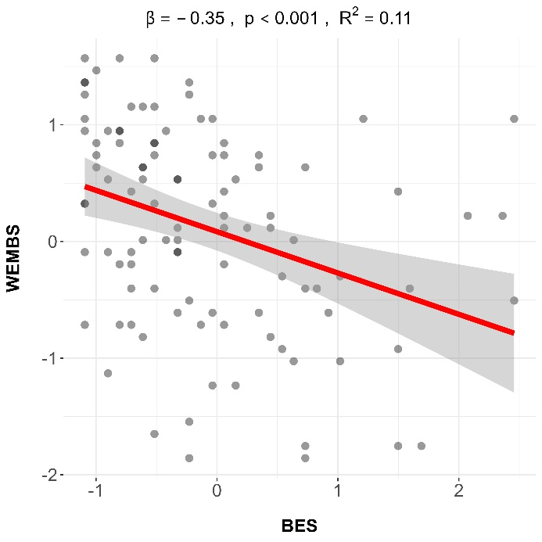
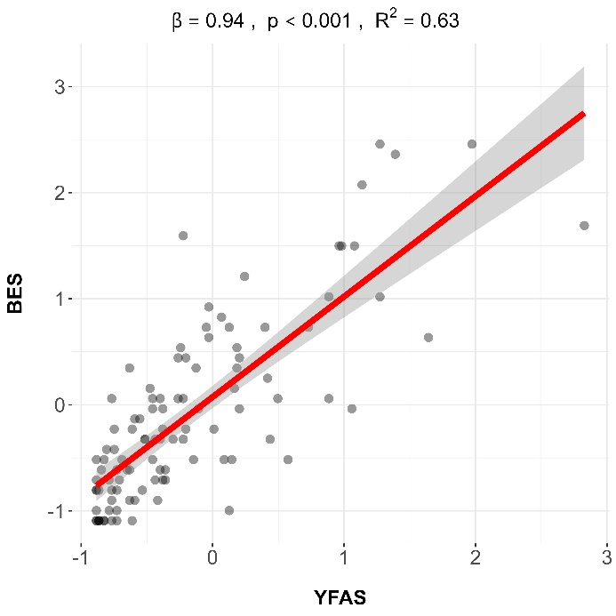
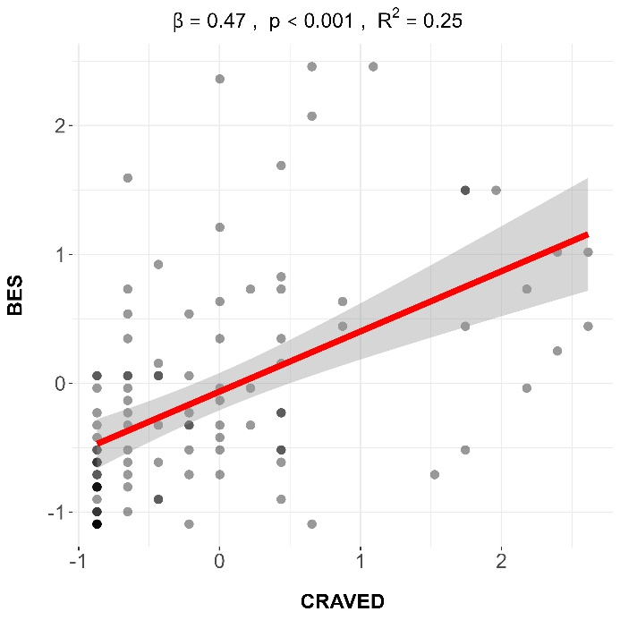
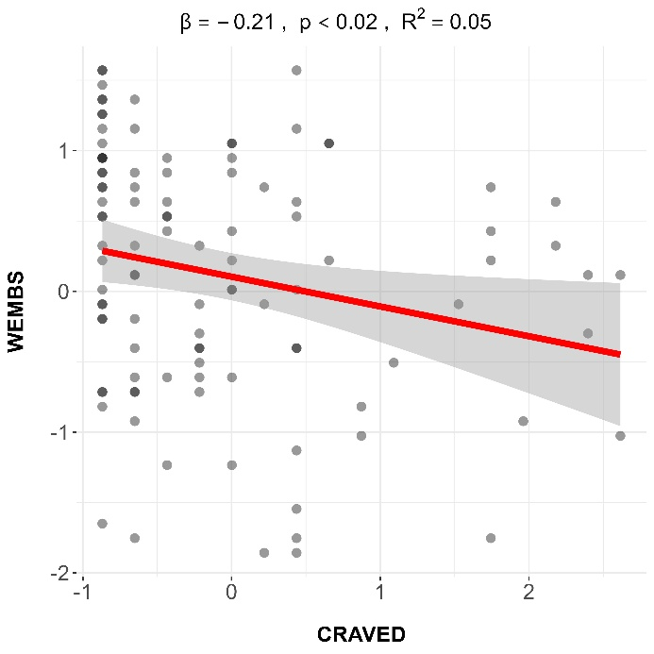
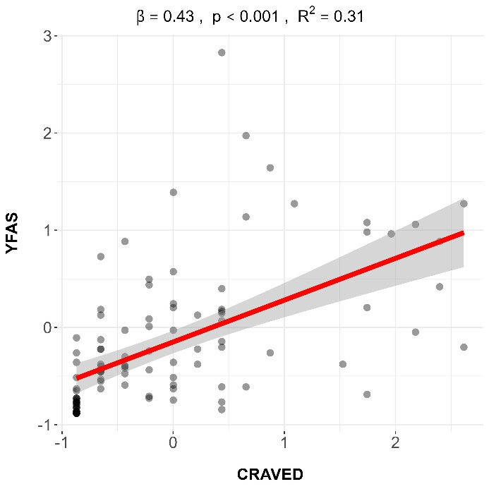
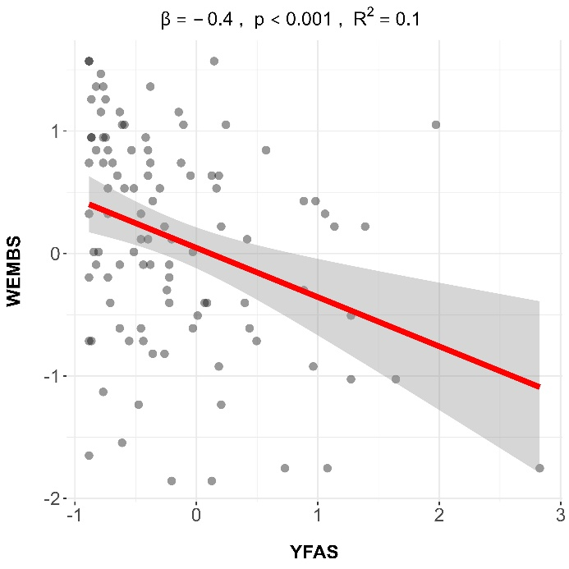
Supplemental Figure 1. Association Between All Evaluated Scores.

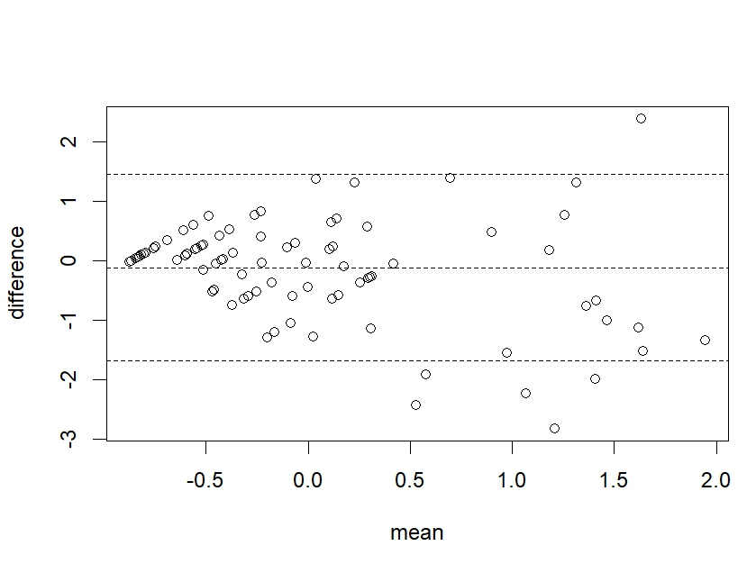

Supplemental Figure 2. Bland-Altman test between Food Addiction Screening Tools (YFAS and CRAVED).

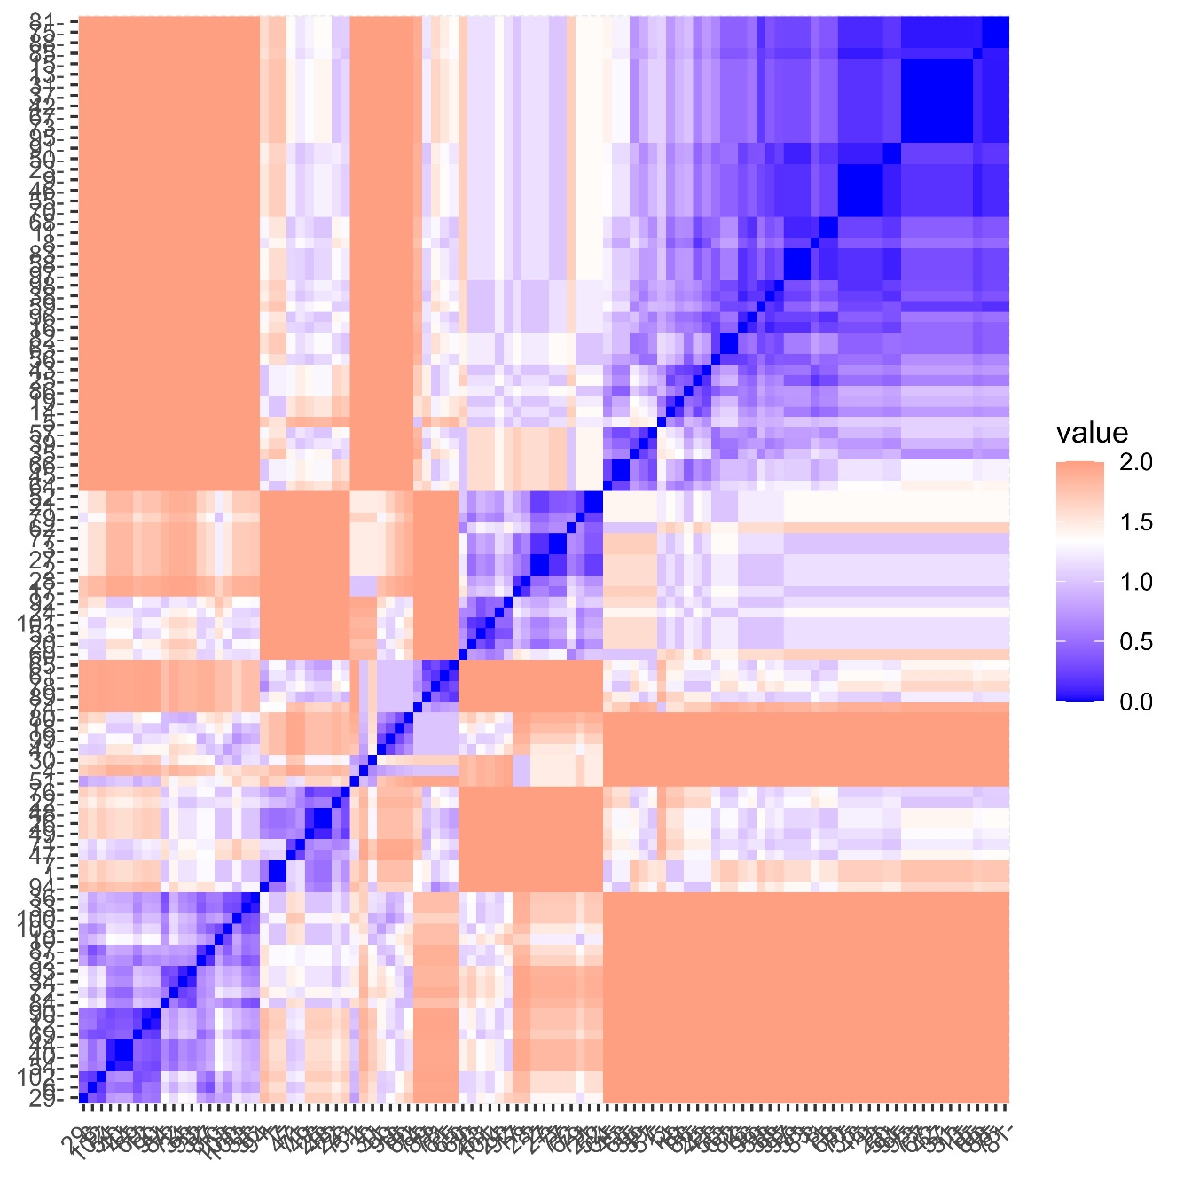
Supplemental Figure 3. Correlation Matrix of BES and CRAVED scores.
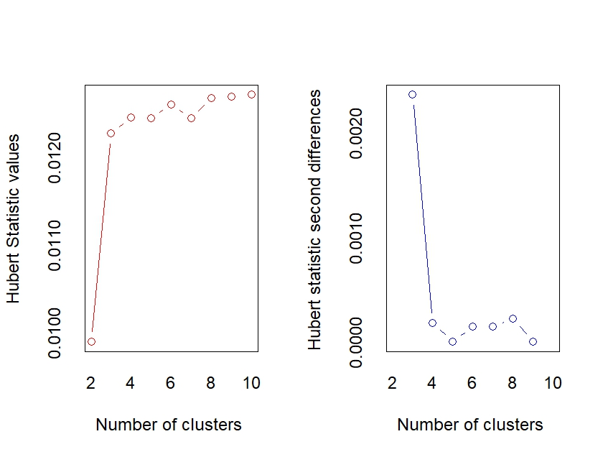
Supplemental Figure 4. Huber Statistic Value Plots.

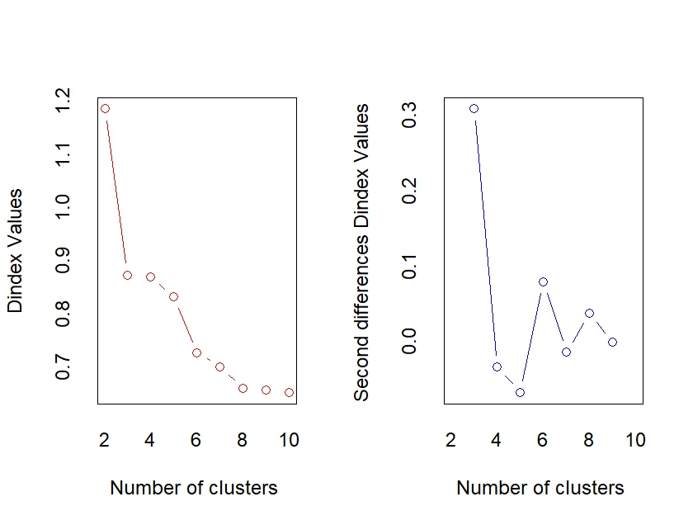
Supplemental Figure 5. D-index Value Plots.

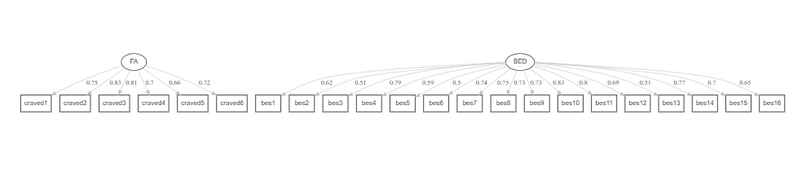
Supplemental Figure 6. Factor weights in Confirmatory Factor Analyses.

