PVB synthesis experiment
1. Experimental Equipments
This study presents the experimental design, PVB synthesis procedures, and the various equipment and instruments used for response surface methodology (RSM) and machine learning modeling. Particular attention is given to the sequence of instrument usage, their specific applications, and corresponding operational procedures.
Table 1. Experimental Equipment Information.
Equipment | Model | Application
Constant temperature stirrer | Digital 6-position multi-head magnetic heating temperature-controlled stirrer | Reaction vessel for PVB synthesis experiments
Laser diffraction particle size analyzer | Mastersizer 9000+ laser particle size analyzer | Analytical equipment for PVB product particle size information
Nuclear magnetic resonance spectrometer | 400 MHz NMR spectrometer | Analytical equipment for molecular structure information of PVB products
DOE experimental design software | Design Expert 10 | Software for experimental design and data feasibility assessment
Mathematical analysis software | MATLAB 2023b | Software for AI-based PVB product parameter training and evaluation
The experimental instruments listed in Table 1 correspond to the apparatus shown in Figure 1. The specific applications of the experimental instruments are clearly indicated in the table and will be elaborated in detail below.
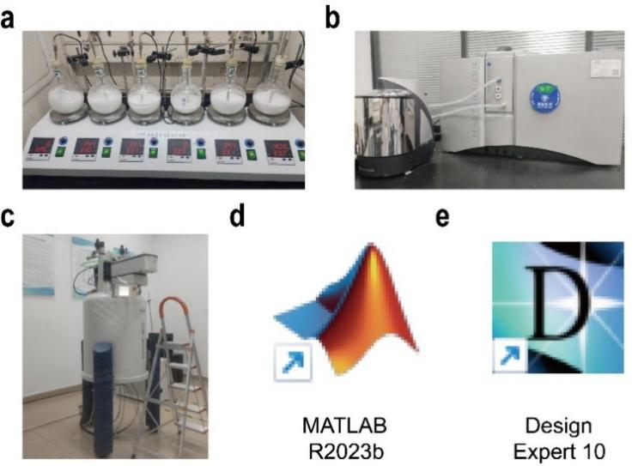
Figure 1. Experimental Equipment Illustration. (a) Digital 6-position multi-head magnetic heating temperature-controlled stirrer. (b) Mastersizer 9000+ laser particle size analyzer. (c) 400 MHz NMR spectrometer. (d) Design Expert 10. (e) MATLAB 2023b.
2. Synthesis Steps of PVB
PVB was synthesized via co-precipitation method through a series of operations to obtain the target product. The detailed PVB synthesis procedure is described as follows. PVA and n-butyraldehyde undergo continuous acetalization under acid catalysis, with continuous changes over time.
(1) Dissolution of 10% PVA: Weigh 120 g PVA and transfer to a 2000 mL round-bottom flask. Add 1080 mL deionized water to the container, heat to 90°C, and maintain heating for 2 hours to form a homogeneous solution.
(2) Preparation of emulsifier: Place 0.4 g SDS in a test tube, add 10 mL deionized water, and dissolve completely in a 50-60°C oven for 30 min.
(3) PVA pretreatment: Place 200 mL cooled room-temperature PVA (10%) in a 500 mL round-bottom flask. Add SDS emulsifier, corresponding proportion of n-butyraldehyde (12.95 mL), control temperature at 28°C (monitored by temperature probe inserted into the solvent), and mix thoroughly with magnetic stirring at 300 rpm for 30 min.
(4) PVB synthesis reaction: Add concentrated nitric acid (1.34 mL) and allow sufficient reaction for 120 min.
(5) Neutralization reaction: Stop magnetic stirring, transfer the sample to a 500 mL beaker, add appropriate amount of prepared NaOH solution to the beaker, and allow solid-liquid separation after standing.
(6) Sample drying: Perform multiple vacuum filtrations to wash away impurities, label the samples, and dry in an oven at 45°C for 1-2 days.
Table 2. Experimental Conditions for PVB Synthesis.
No. | PVA concentration (wt%) | Aldehyde feeding ratio | Acid concentration (mol L⁻¹) | Time (min)
6 | 10 | 0.32 | 0.1 | 120
The PVB synthesis experimental procedure is demonstrated using Run 6, with detailed experimental steps described according to the experimental conditions of Run 6 from the CCD experimental design.
3. Determination of the acetal degree of PVB
The acetal degree (AD) of PVB was measured and characterized through ¹H-NMR spectral analysis. Using d₆-DMSO as solvent, ¹H-NMR spectra of PVB were recorded on a nuclear magnetic resonance spectrometer and analyzed using MestraNova x64 software. The acetal degree (AD) of PVB was calculated through peak area integration. The ¹H-NMR chemical shift range is 0-5 ppm, and spectral data should not exceed this shift range. Figure 3 shows a typical ¹H-NMR spectral analysis of PVB. The AD calculation is based on the following equation, and according to the spectrum analysis, Figure 2 shows an AD value of 0.283. Figure 3 presents the NMR measurement data for the acetal degree of 30 PVB samples from the CCD design experiments.
$\overline{AD}= \frac{2}{3}×\frac{A_{8}}{A_{2+4}}$ (1)
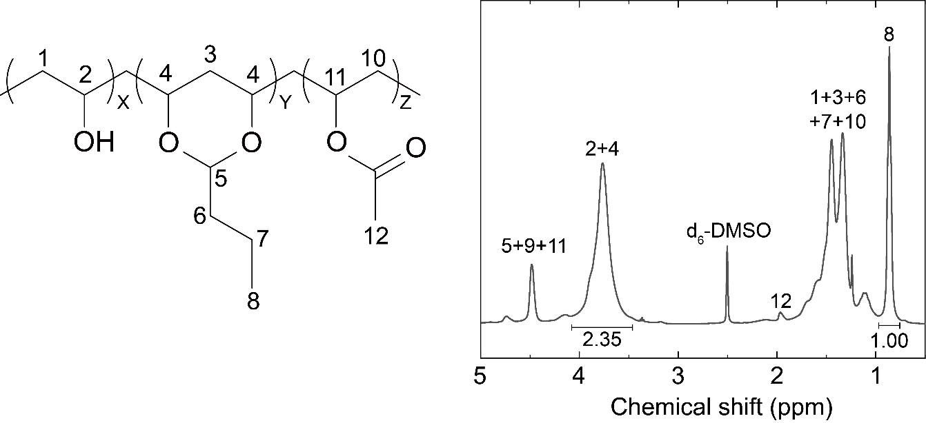
Figure 2. Typical ¹H-NMR spectrum of PVB. AD is defined as the molar ratio of substituted OH groups to original OH groups. Based on the segment ratios shown in Figure 3, AD is defined as: AD = 2y/(x+2y+z).
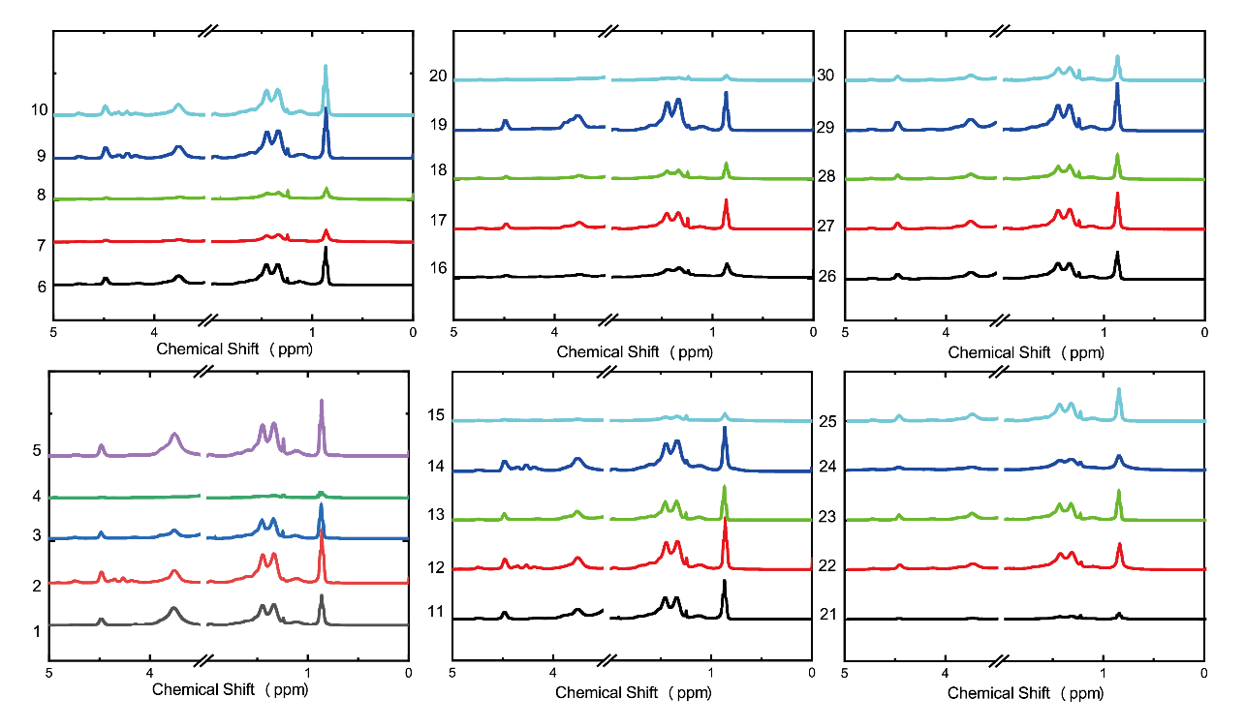
Figure 3. NMR spectral data for 30 samples from CCD experimental design.
4. Determination of PVB particle size
When a laser beam passes through a dispersed particle system, particles scatter the incident light, and the intensity and angular distribution of scattered light depend on particle size. Based on Mie scattering theory (applicable to any particle size-to-wavelength ratio) or Fraunhofer approximation (applicable when particle size is much larger than light wavelength), particle size analysis is performed by detecting scattered light patterns and back-calculating particle dimensions. For PVB particle size measurement and data characterization, based on laser diffraction principles, the Mastersizer 9000+ laser particle size analyzer was used with volume mean diameter D[4,3] as the particle size measurement standard for data recording and analysis. Table 2 presents the particle size analysis results, clearly showing various indicators of PVB product particle size data analysis. Figure 4 shows the particle size distribution of this PVB product, while Figure 5 presents the measurement data for particle sizes of 30 PVB samples from the CCD design experiments.
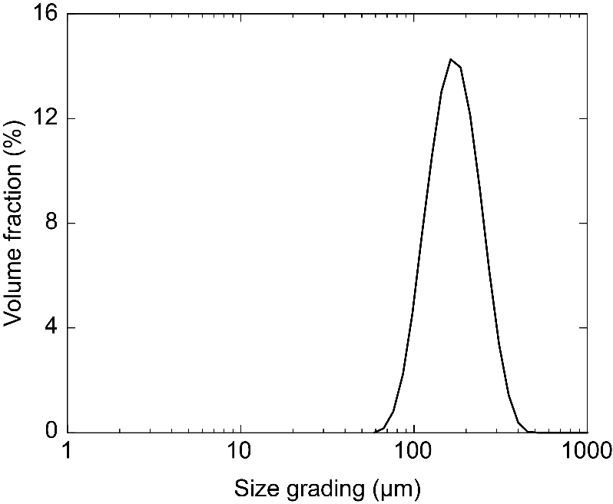
Figure 4. PVB product particle size distribution data.
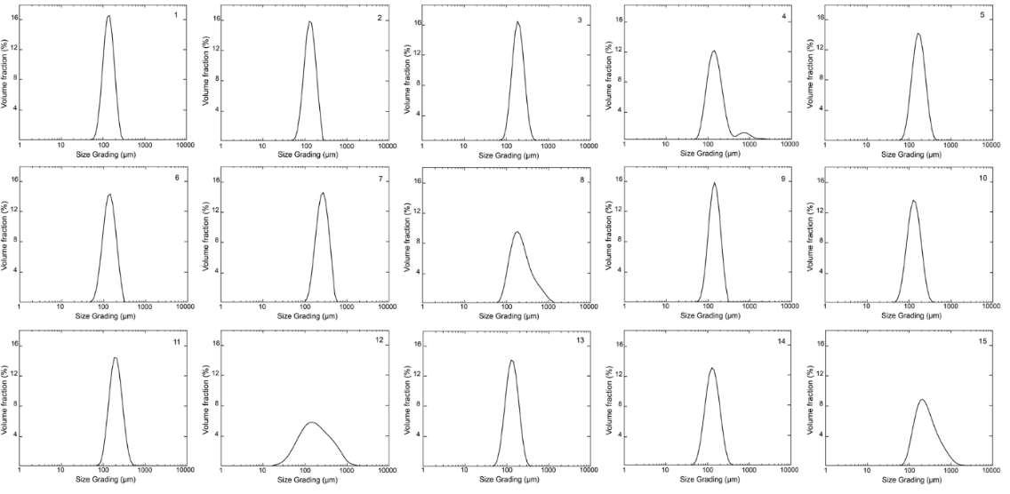
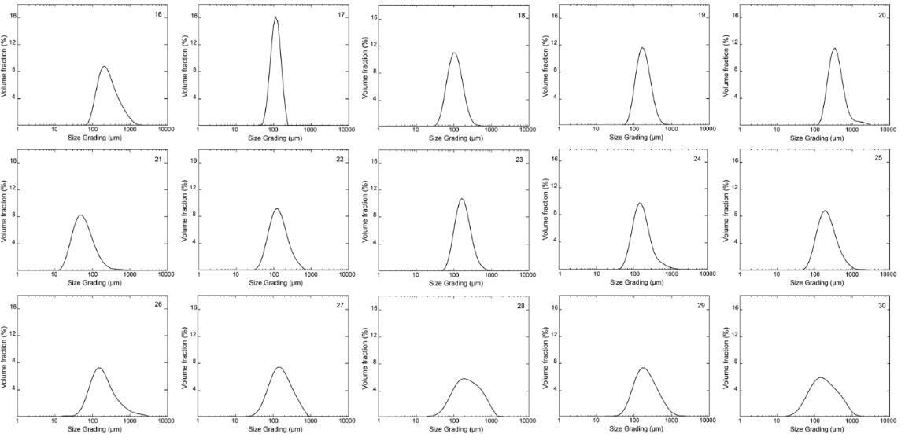
Figure 5. Particle size distribution data for 30 samples from CCD experimental design.
Table 3. PVB Particle Size Analysis.
Particle Size Characteristics | Data Results
Concentration (%) | 0.0881
Span | 0.764
Uniformity | 0.238
Specific surface area (m²kg⁻¹) | 40.43
D[3,2] (μm) | 139
D[4,3] (μm) | 150
The particle size analysis data presented is one component of the data analysis content, derived from No.1 of the CCD experimental results. Detailed data can be referenced in the RSM model construction section of the main text.

