Table 2: 2D structure of Glycitein with different receptors
2D Interactions | Constituent | Docking Score (kcal/mol)
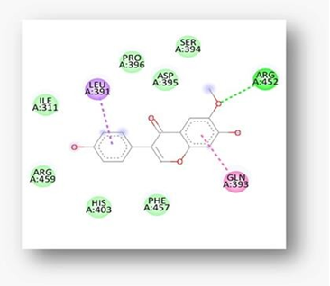 | Glycitein | -6.5
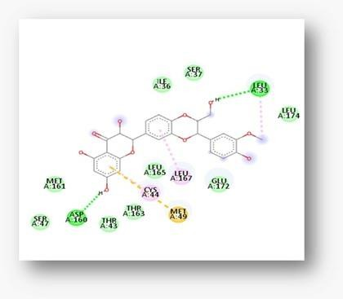 | Glycitein | -6.4
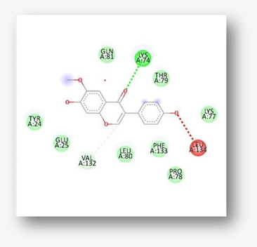 | Glycitein | -6.4
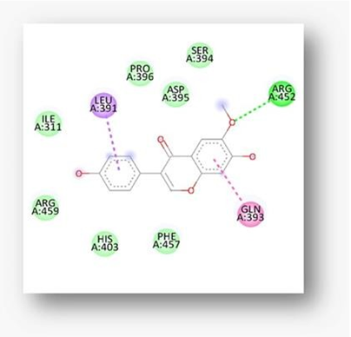 | Glycitein | -6.8

Table 3: 3D and crystal structure of Glycitein with different targets against hepatotoxicity
3D Interactions | Constituents
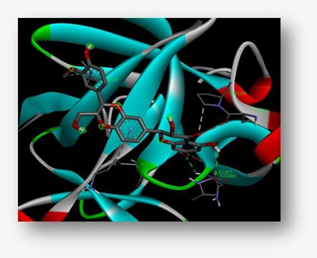 | TNF-α (4M4E)
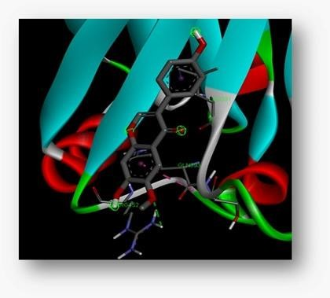 | IL-6 (1ALu)
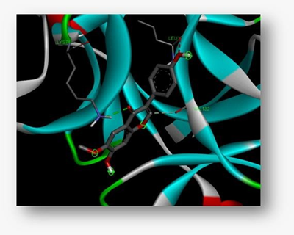 | IL-1β (3LTQ)
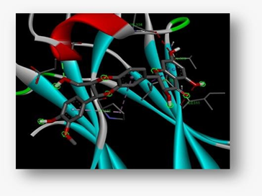 | Estrogen Receptor (1A52)

